

TITLE: Business Continuity Plan
ORGANIZATION: Northwind Analytics, Inc.
DEPARTMENT: Operations
SENSITIVITY: Confidential
VERSION: 2.1
EFFECTIVE_DATE: 2026-01-01
_______________________________________________________________________________________________

Business Continuity Plan

1. Purpose
Defines how the company maintains critical operations during a disruption (natural disaster, major outage, pandemic, facility loss).

2. Critical Functions
Critical Function | Maximum Tolerable Downtime
Payroll processing | 24 hours
Customer support | 24 hours
Core product infrastructure | 24 hours
Executive communication | 24 hours

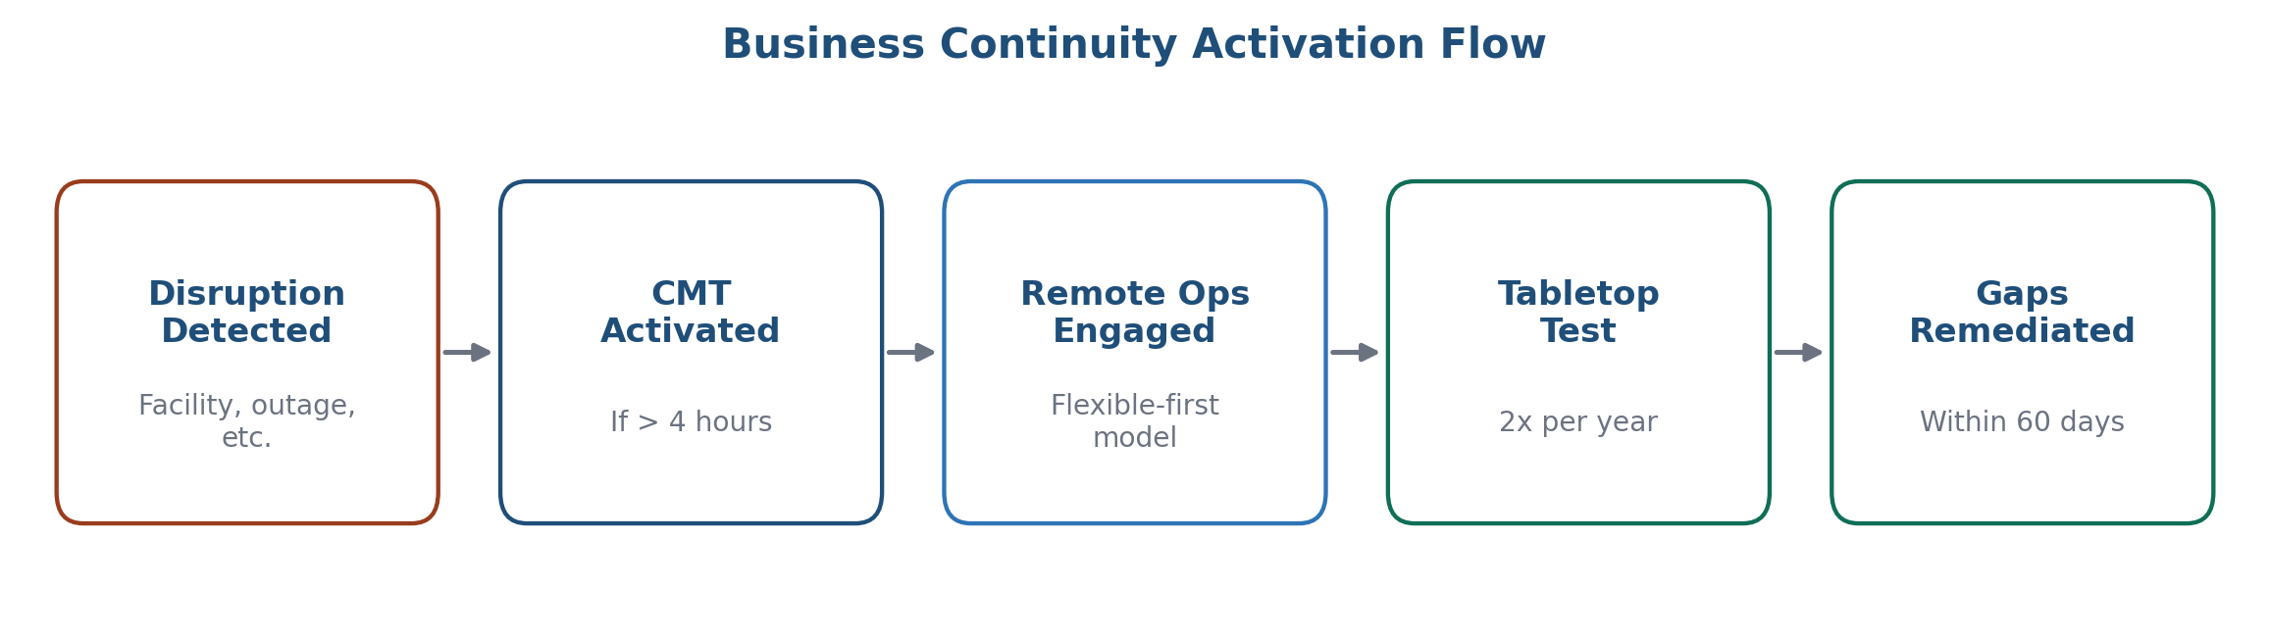
Figure 1: Business continuity activation flow

3. Response Structure
A Crisis Management Team (CMT), led by the COO, is activated for any disruption expected to last more than 4 hours. The CMT includes leads from IT, HR, Facilities, and Communications.

4. Remote Operations
Given the company's flexible-first remote work model, most functions can continue via remote work during a facility disruption. Facilities-dependent functions (e.g., hardware lab work) have a designated backup site in a separate region.

5. Testing
The BCP is tested via a tabletop exercise twice per year (typically March and September) with results and gaps documented and remediated within 60 days.

6. Frequently Asked Questions

Who decides when to activate the Crisis Management Team?
Any leader who identifies a disruption likely to exceed 4 hours should notify the COO or their designated backup, who makes the activation decision.

What if a disruption affects a function not listed as "critical"?
Non-critical functions are addressed after critical functions are stabilized; the CMT prioritizes based on the critical functions table above during any active response.

7. Contact
business-continuity@company.com

