

TITLE: Facilities Access Policy
ORGANIZATION: Northwind Analytics, Inc.
DEPARTMENT: Operations
SENSITIVITY: Internal
VERSION: 1.0
EFFECTIVE_DATE: 2025-04-01
_______________________________________________________________________________________________

Facilities Access Policy

1. Badge Access
All employees and long-term contractors receive a building badge upon Day 1 onboarding, provisioned by Facilities in coordination with IT. Badges grant access to general office areas during standard hours (7 AM - 8 PM, Monday-Saturday).

2. After-Hours Access
After-hours or weekend access requires manager approval submitted via the Facilities Portal at least 24 hours in advance.

3. Visitor Policy
All visitors must be pre-registered by their host at least 2 hours before arrival, sign in at reception, and be escorted at all times in non-public areas.

4. Restricted Areas
Area | Access Requirement
General office areas | Standard badge (Day 1 onboarding)
Server rooms | Additional permission + Department Head approval, logged for audit
Hardware labs | Additional permission + Department Head approval, logged for audit
Executive floors | Additional permission + Department Head approval, logged for audit

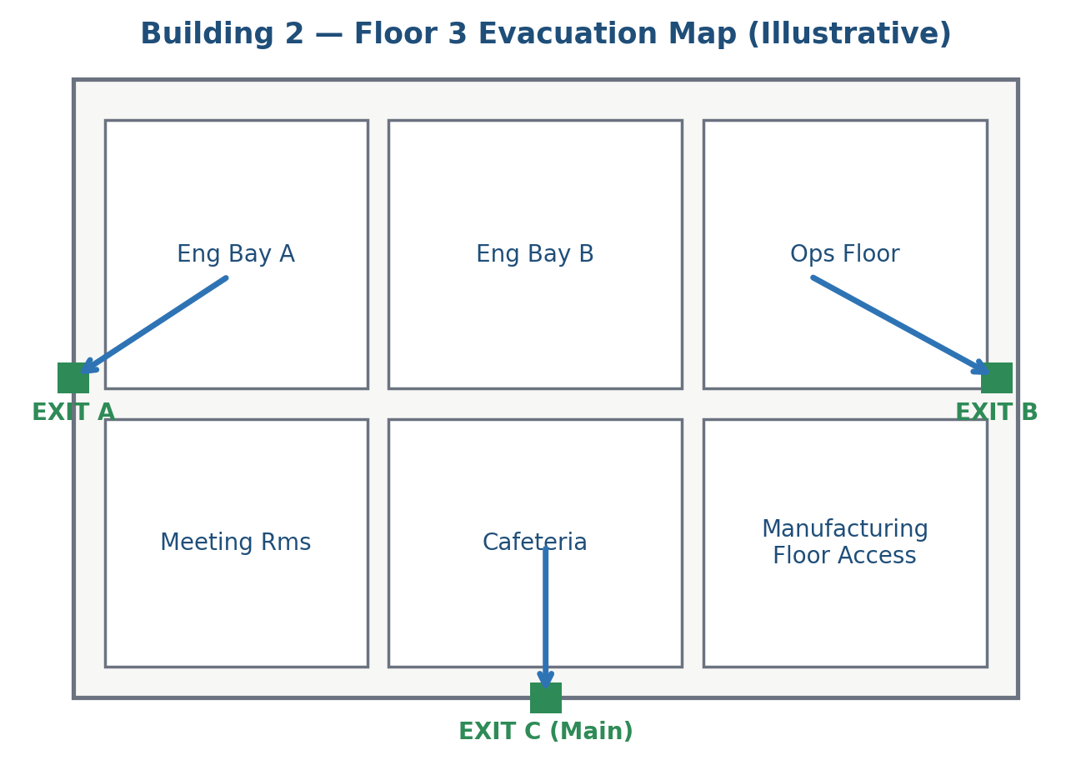
Figure 1: Example floor evacuation and access zone map (illustrative)

5. Lost Badge
Lost or stolen badges must be reported to Facilities and IT Security within 1 hour of discovery; the badge is deactivated immediately.

6. Frequently Asked Questions

What happens if I forget my badge at home?
Reception can issue a temporary day pass after verifying your identity; report to Facilities to have a permanent replacement badge issued if the original is not located.

Can visitors access restricted areas like server rooms?
No -- restricted areas require Department Head approval for any access, including visitor access, and all such access is logged for audit purposes regardless of visitor or employee status.

7. Contact
facilities@company.com

