

TITLE: Vendor Management Standard Operating Procedure
ORGANIZATION: Northwind Analytics, Inc.
DEPARTMENT: Operations
SENSITIVITY: Internal
VERSION: 1.0
EFFECTIVE_DATE: 2025-11-01
_______________________________________________________________________________________________

Vendor Management Standard Operating Procedure

1. Vendor Tiering
Tier | Description | Review Frequency
Tier 1 (Critical) | Vendors whose failure would halt business operations (e.g., cloud infrastructure, payroll processor) | Quarterly
Tier 2 (Important) | Significant but not business-critical (e.g., travel booking, catering) | Semi-annually
Tier 3 (Standard) | Low-impact vendors | Annually

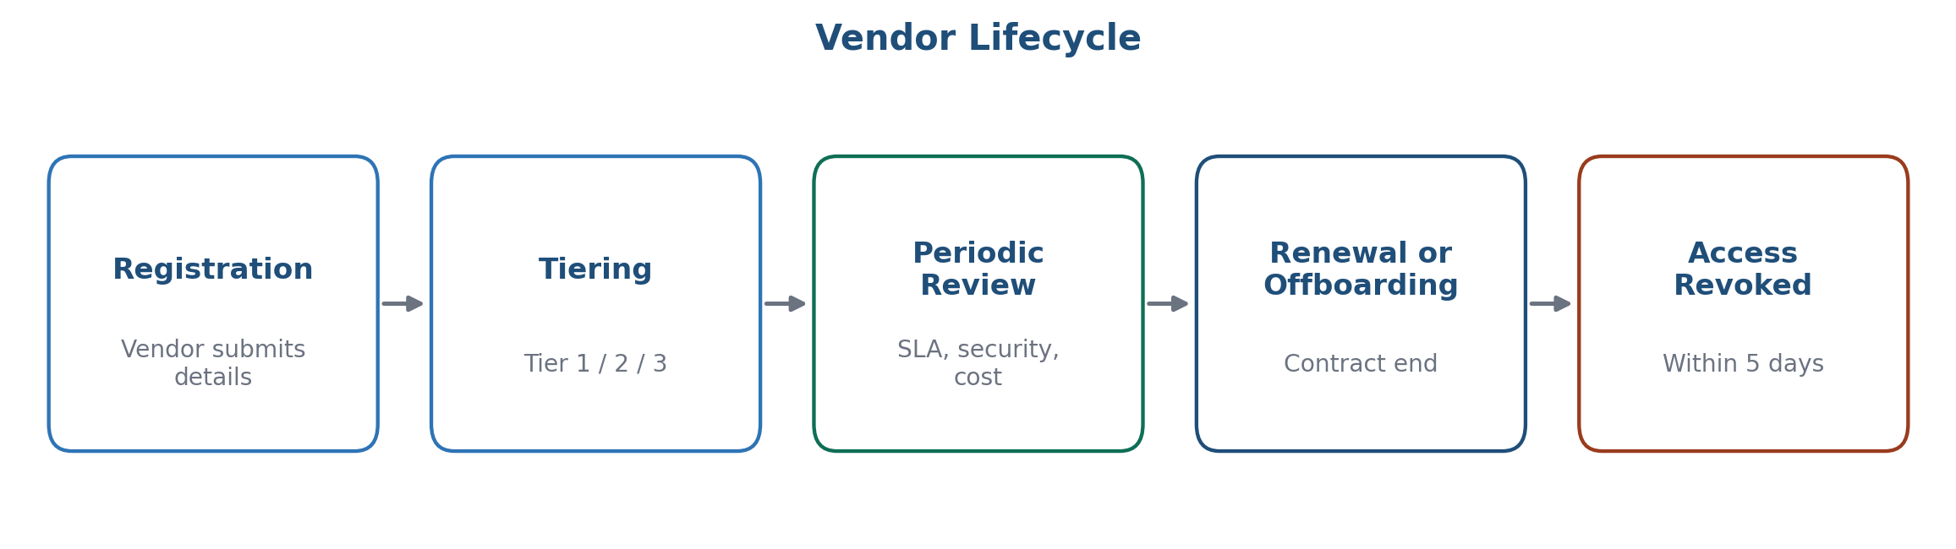
Figure 1: Vendor lifecycle from registration through offboarding

2. Vendor Review Checklist
Each review covers: service performance against SLA, security/compliance posture (for Tier 1/2), contract renewal terms, and cost trend.

3. Offboarding
When a vendor relationship ends, Operations must confirm data deletion/return within 30 days and revoke all associated system access within 5 business days of contract end date.

4. Escalation
Vendor service failures affecting Tier 1 vendors must be escalated to the Operations Director within 2 hours of detection.

5. Frequently Asked Questions

How is a vendor's tier determined at onboarding?
Operations assesses business impact of vendor failure during onboarding -- vendors supporting critical infrastructure or payroll-adjacent functions default to Tier 1, with the assignment reviewed at each subsequent review cycle.

Can a vendor's tier change over time?
Yes -- tier reassessment happens as part of the standard review cycle, or immediately if the scope of the vendor relationship changes materially.

6. Contact
vendor-management@company.com

