USECASE

**Use case:**Develop an application to perform Plotting Probabilities Using Matplotlib**.**

**Aim:**

To develop a Python application that plots probability distributions (such as Normal, Binomial, or Uniform) using **Matplotlib**, to visualize how probabilities vary across different outcomes.

**Procedure:**

1. **Import required libraries:**  
   Import numpy for numerical operations, matplotlib.pyplot for plotting, and scipy.stats for probability functions.
2. **Define the distribution parameters:**  
   For example, for a **Normal Distribution**, define mean (μ) and standard deviation (σ).
3. **Generate random variables:**  
   Use NumPy or SciPy to generate a range of x-values that represent possible outcomes.
4. **Compute probability density function (PDF):**  
   Calculate the corresponding probability values for each x using SciPy’s probability distribution functions.
5. **Plot the probability curve:**  
   Use Matplotlib to plot x (outcomes) vs. probability values (PDF or PMF).
6. **Customize the plot:**  
   Add title, labels, legend, and grid for clarity.
7. **Display the plot:**  
   Use plt.show() to visualize the probability distribution.

**Program**:

import numpy as np

import matplotlib.pyplot as plt

from scipy.stats import norm, binom

mean = 0

std_dev = 1

x = np.linspace(-4, 4, 1000)

pdf = norm.pdf(x, mean, std_dev)

plt.figure(figsize=(8, 5))

plt.plot(x, pdf, color='blue', label='Normal Distribution (μ=0, σ=1)')

plt.title("Probability Density Function - Normal Distribution")

plt.xlabel("Random Variable (x)")

plt.ylabel("Probability Density")

plt.legend()

plt.grid(True)

plt.show()

# Parameters

n = 10 # number of trials

p = 0.5 # probability of success

x_binom = np.arange(0, n+1)

pmf = binom.pmf(x_binom, n, p)

plt.figure(figsize=(8, 5))

plt.stem(x_binom, pmf, basefmt=" ", use_line_collection=True)

plt.title("Probability Mass Function - Binomial Distribution (n=10, p=0.5)")

plt.xlabel("Number of Successes")

plt.ylabel("Probability")

plt.grid(True)

plt.show()

**OUTPUT:**

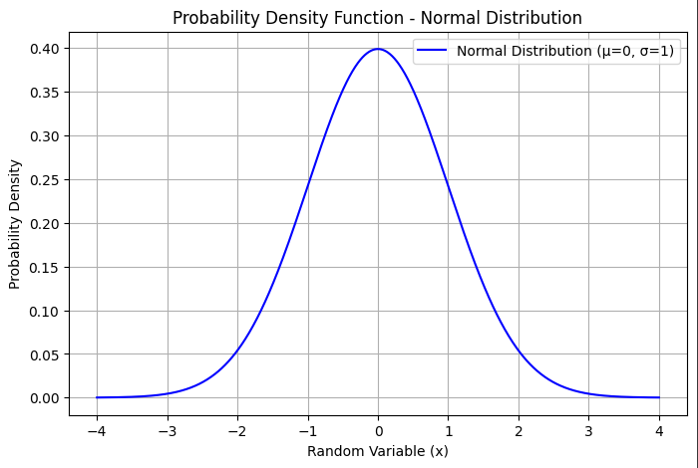

**Result:**

The application successfully plots probability distributions (Normal and Binomial) using **Matplotlib**, demonstrating how probabilities vary for continuous and discrete random variables.