**IDS 462 STATISTICAL SOFTWARAE FOR BUSINESS**

**HOMEWORK 1**

**TEAM MEMBERS**:

1. Harish Visweswaraiya
2. Balachandhar Chekka Narayanasame
3. Sriram Ravi
4. Vinodh Sankaran

**1. Create a temporary SAS dataset called “psales”**

**Code**

/* Question 1 */

DATA psales;

   infile '/folders/myfolders/SAS_HW1/Sales - All Categs_Pharm.csv' DLM=',' DSD MISSOVER FIRSTOBS=2;

   input prodid $

   category $

   date $

   sales $;

RUN;

**Output Data**

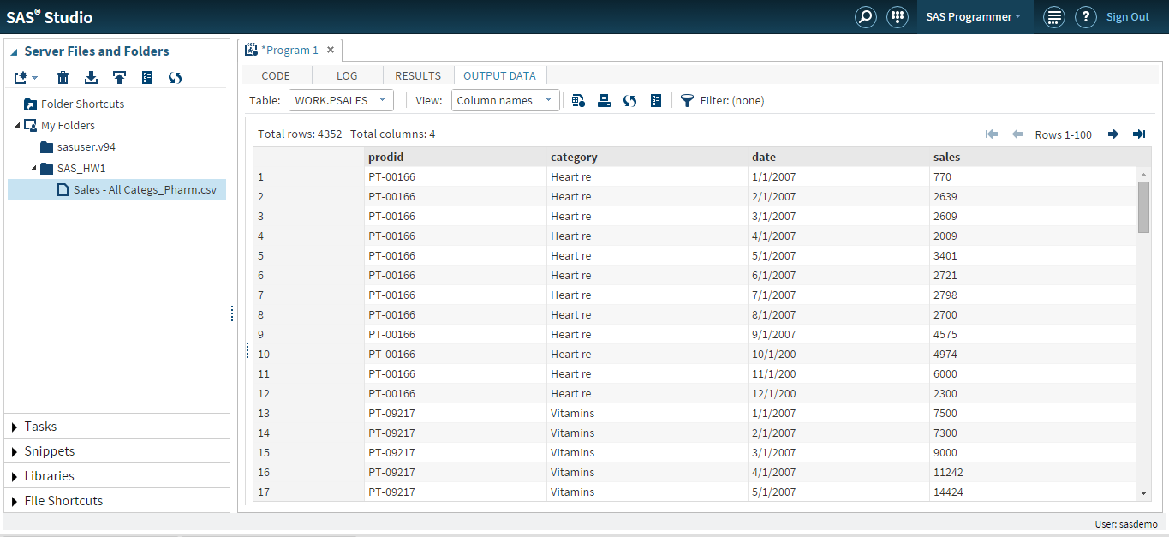

**2. Create a new variable, called adjSales (to indicate the adjusted sales for each date) using the following formula:**

* + 1. **1.25*sales + 10 * rand('UNIFORM'); * where rand('UNIFORM') produces a random variable from uniform distribution between 0 & 1;**

**Code**

/* Question 2 */

DATA psales_adj;

set psales;

adjSales = 1.25*sales+10*rand('UNIFORM');

RUN;

**Output Data**

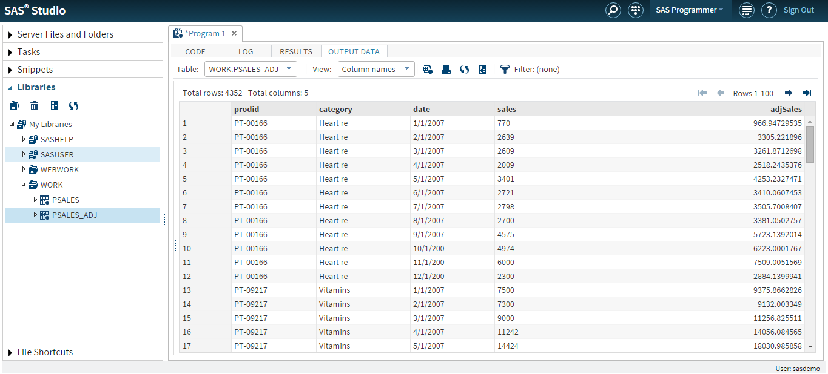

**3. Sort data by category and output the sorted data to a permanent dataset called as newSales (which should be used for the following steps)**

**Code**

/* Question 3 */

libname SAS_HW1'/folders/myfolders/SAS_HW1';

proc sort data=Work.psales_adj out=SAS_HW1.newsales; by category;

RUN;

**Output Data**

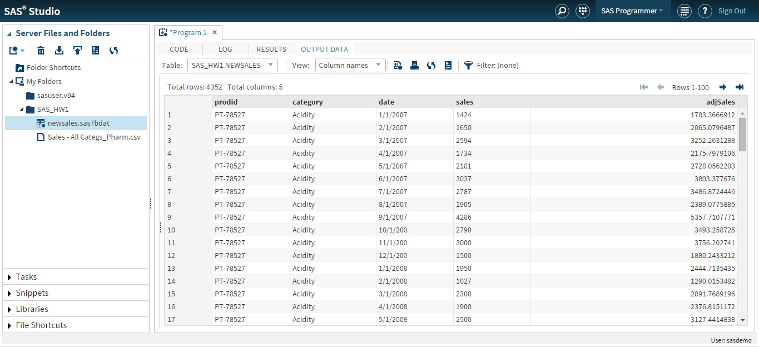

**4. Find average adjSales by category, output to a dataset called as aveSales with noprint option and print the results from aveSales**

**Code**

/* Question 4 */

proc means data=SAS_HW1.newsales noprint;

VAR ADJSALES;

BY CATEGORY;

output out=avesales mean=Average;

RUN;

proc print data=avesales;

RUN;

**Output Data**

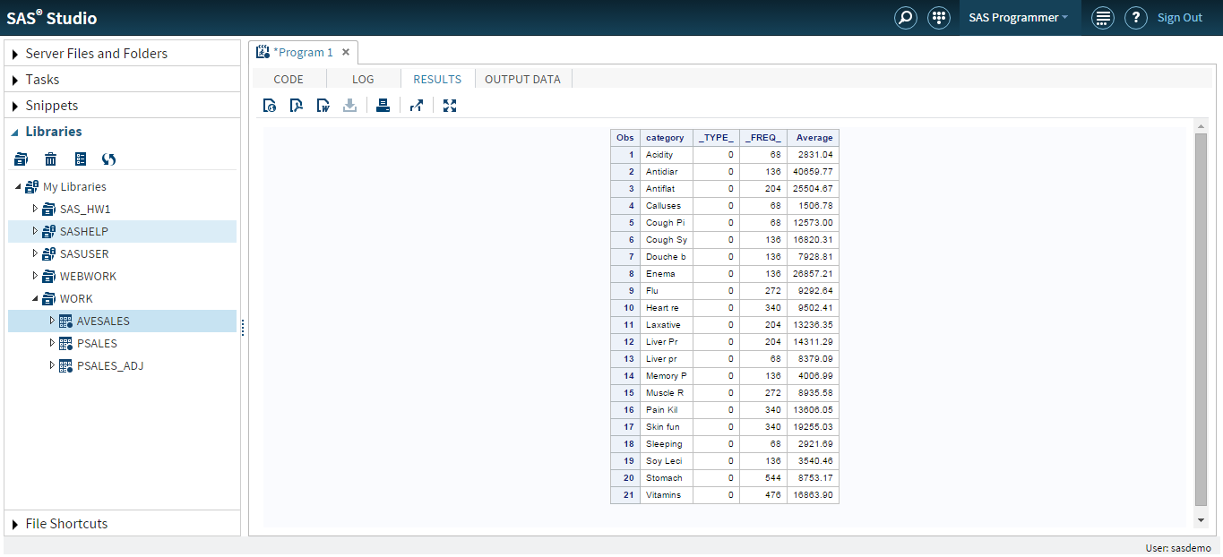

**5. Count how many observations there’s for each category, output and print the results.**

**Code**

/* Question 5 */

proc freq data=SAS_HW1.newsales;

tables category/out=countsales norow nocol nopercent nocum;

RUN;

**Output Data**

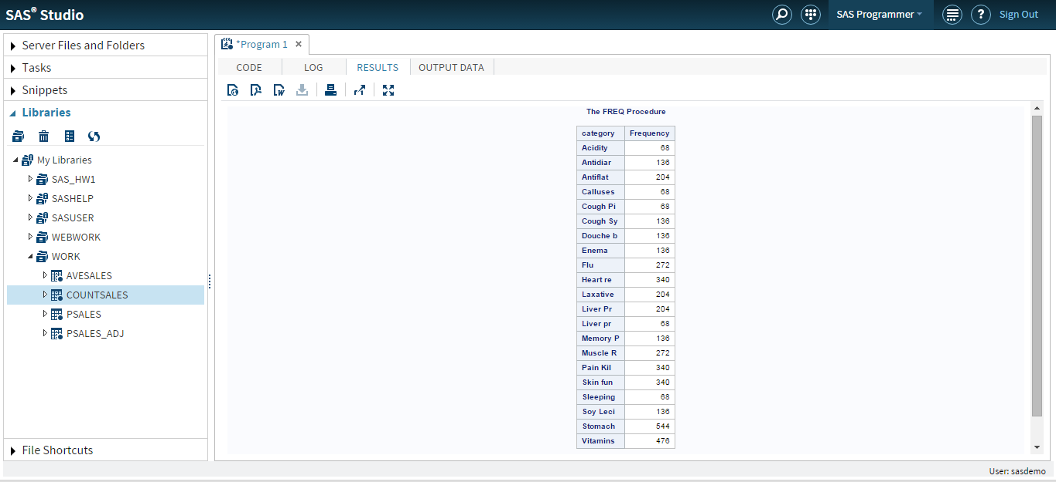

**6. Choose 1 category of your preference. Create a data set consisting of observations for that category only, name the dataset by an abbreviation of the category**

**Code**

/* Question 6 */

DATA Vit_category;

set SAS_HW1.newsales;

if category='Vitamins';

RUN;

**Output Data**

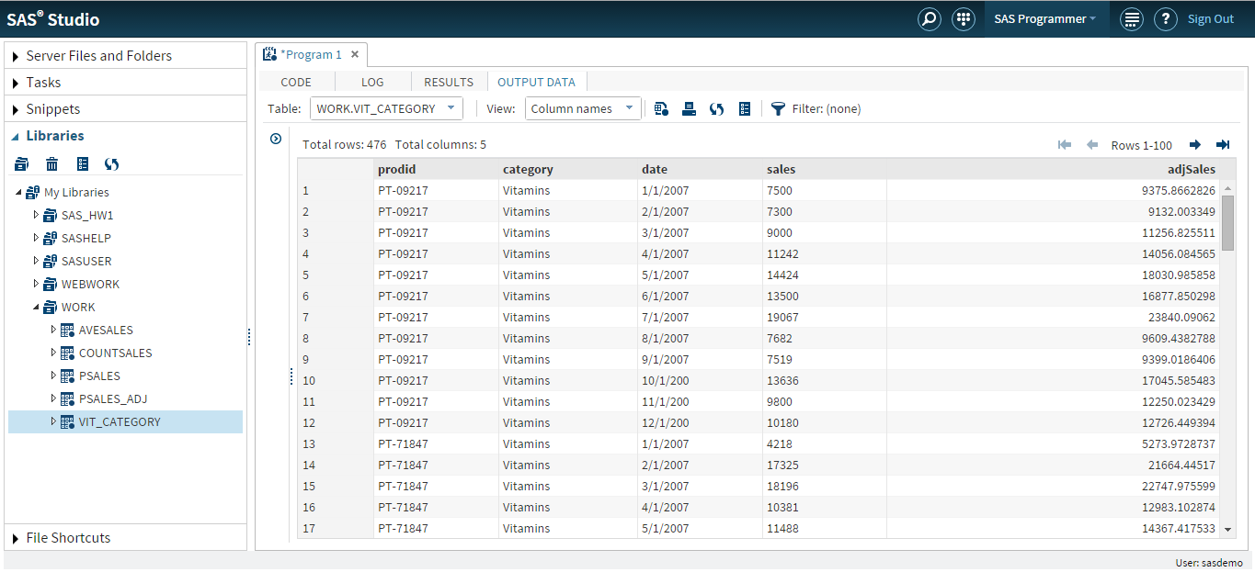

**7. Print 5 observations from the category dataset with a title indicating the category**

**Code**

/* Question 7 */

proc print data=Vit_Category(obs=5);

title "Vitamin category observations";

RUN;

**Output Data**

