**IDS 462 STATISTICAL SOFTWARE FOR BUSINESS**

**HOMEWORK 4**

**TEAM MEMBERS**:

1. Harish Visweswaraiya
2. Balachandhar Chekka Narayanasame
3. Sriram Ravi
4. Vinodh Sankaran

**Problem 1**

1. DATA step toconcatenate **sales** and **non-sales**

**Code**

libname SAS_HW4 '/folders/myfolders/SAS_HW4';

/* Problem 1(a) */

data work.allemployees (keep=Employee_ID First_Name Last_Name Job_Title Salary);

set SAS_HW4.sales SAS_HW4.nonsales(rename=(first=first_name last=last_name));

run;

**Output Data**

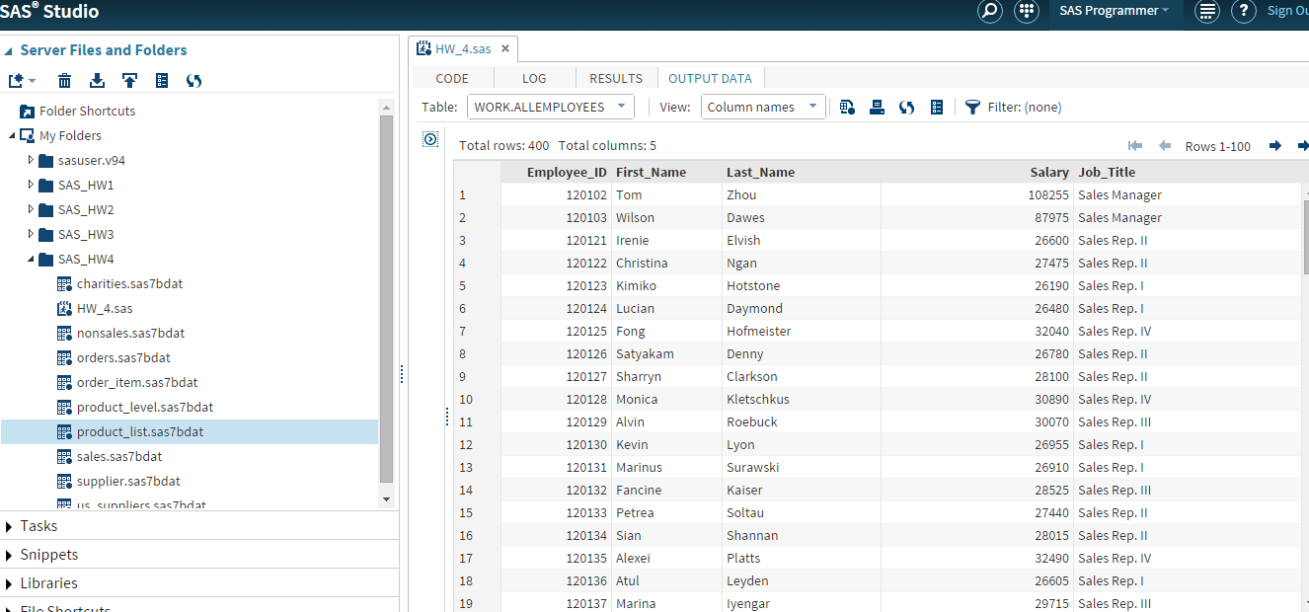

1. Print report with 10 observations

**Code**

/* Problem 1(b) */

proc print data=allemployees(obs=10);

title "Report with 10 sales and non sales employee details";

run;

**Output Data**

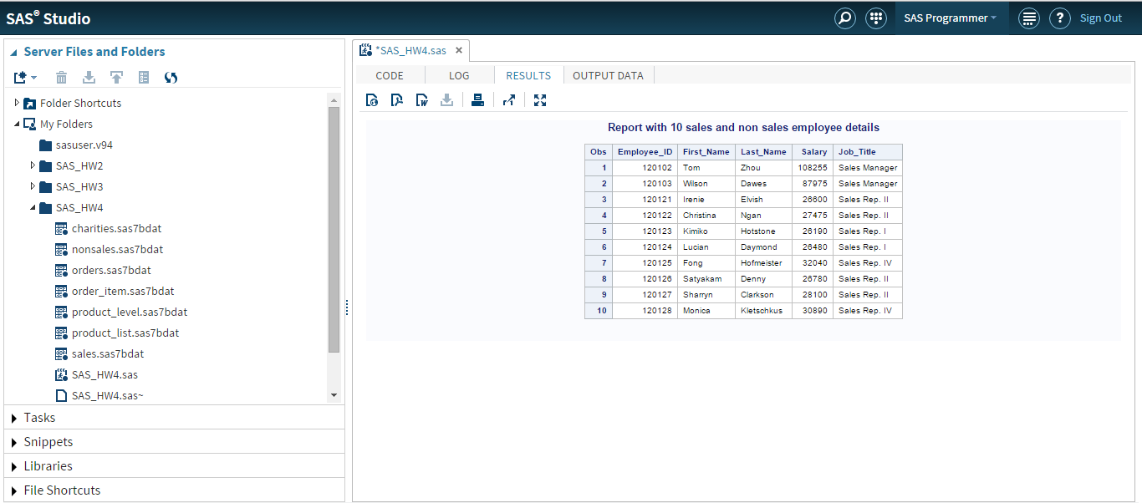

**Problem 2**

1. DATA step to concatenate **charities** and **us_suppliers**

**Code**

/* Problem 2(a) */

data contacts;

set SAS_HW4.charities SAS_HW4.us_suppliers;

run;

**Output Data**

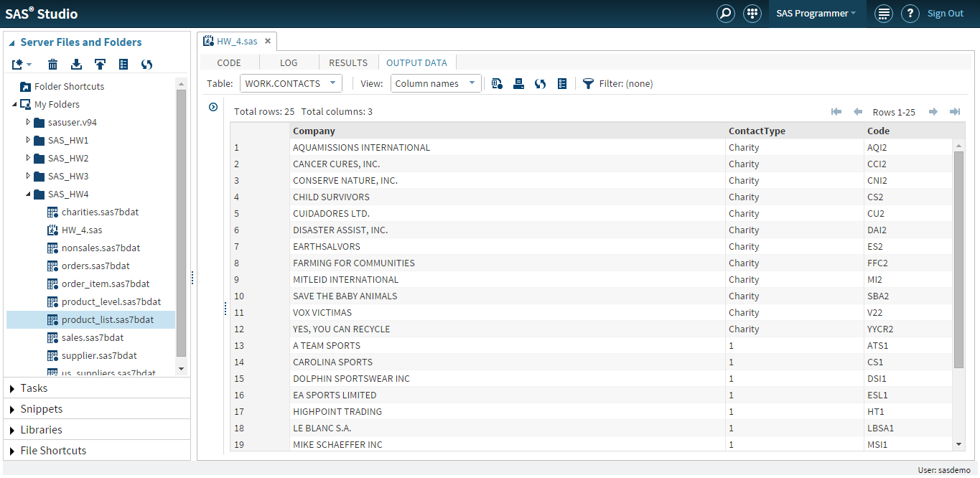

1. PROC CONTENTS step to examine **work.contacts**

**Code**

/*Program 2.(b)*/

/*The variable attributes are assigned from the first input data set (Charities)*/

proc contents data=contacts;

title "Examining the data set";

run;

**Comments**

The variables attributes are assigned in the order as same as the order of attributes from the first input data set **charities**

We could also note from the screenshot that the attribute length is dependent on the first variable given in the ‘Set’ statement.

**Output Data**

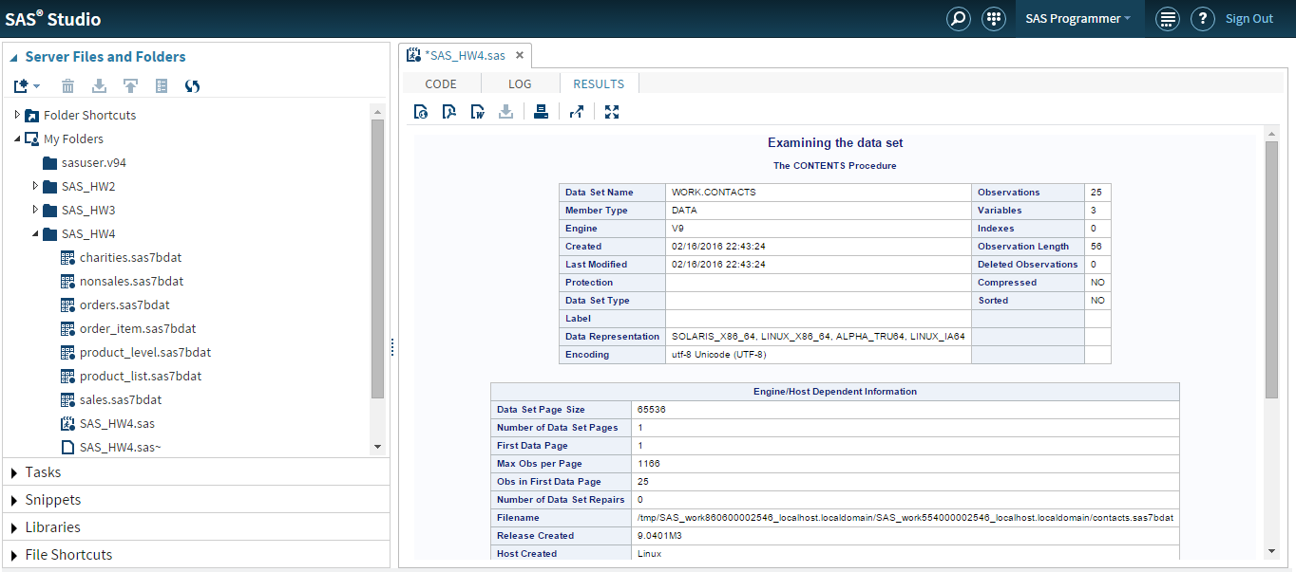

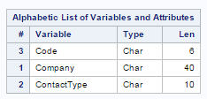

1. DATA step to concatenate **us_suppliers** and **charities**

**Code**

/* Problem 2(c) */

data contacts2;

set SAS_HW4.us_suppliers SAS_HW4.charities;

run;

**Output Data**

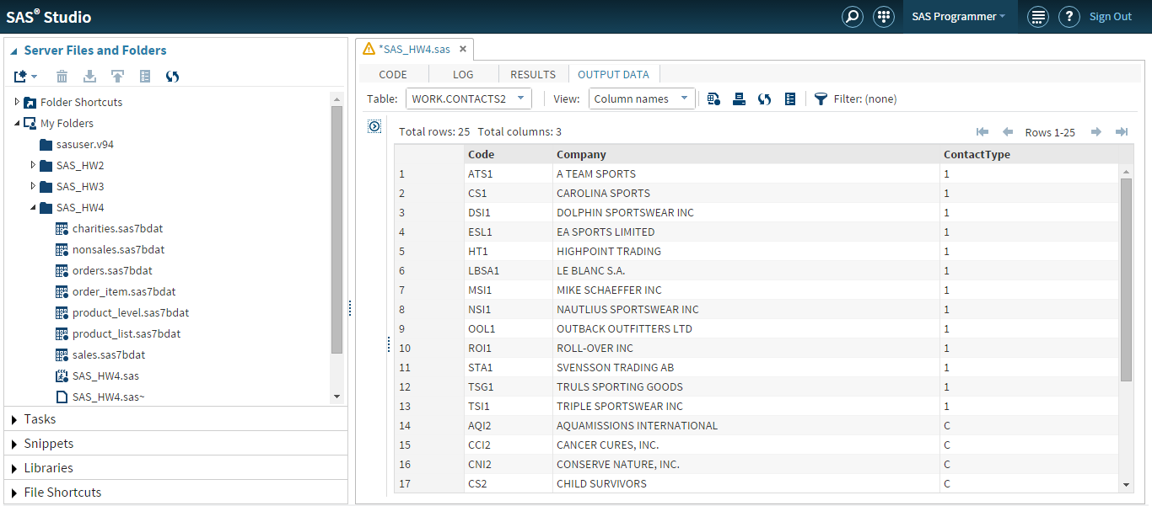

1. PROC CONTENTS step to examine **work.contacts2**

**Code**

/*Program 2.(d)*/

/*The variable attributes are assigned from the first input data set (us_suppliers)*/

proc contents data=contacts2;

title "Examining the data set";

run;

**Comments**

The variables attributes are assigned in the order as same as the order of attributes from the input data set **suppliers.**

As we had noted in 2(b), the attribute length depends on the first variable given in the ‘Set’ statement. Thus, the data gets truncated when length of the attribute from first variable is less than the second one. For example, ‘Contact Type’ data for ‘Charity’ is truncated as ‘C’.

**Output Data**

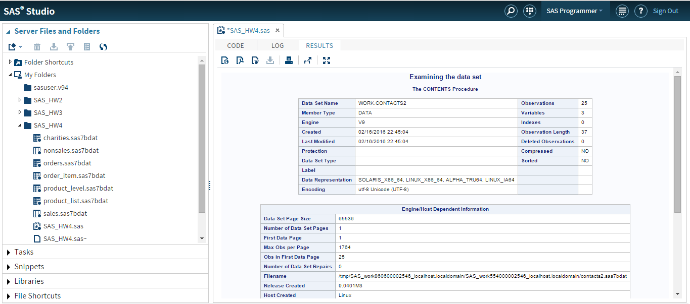

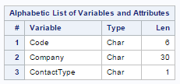

**Problem 3**

1. Data set – Merge order and order_times

**Code**

/* Problem 3(a) */

data work.allorders;

merge SAS_HW4.orders SAS_HW4.order_item;

by order_id;

run;

**Output Data**

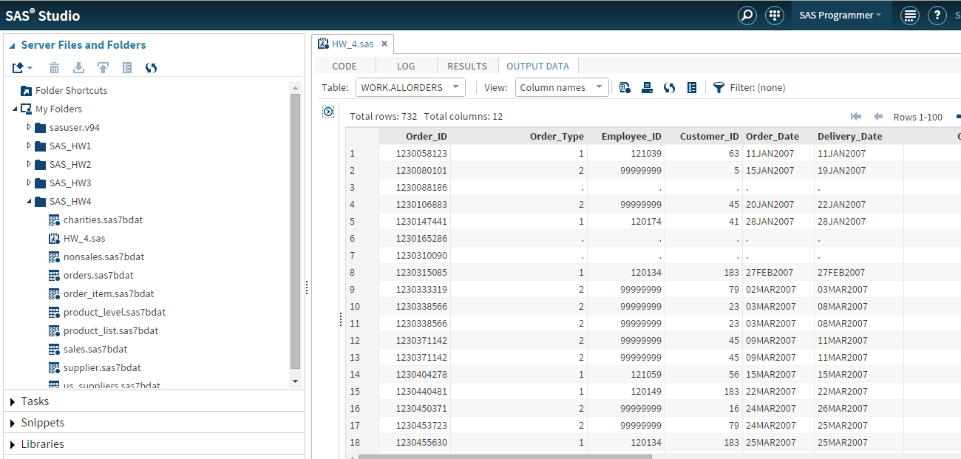

1. **Work.all_orders** Summary

The data set work.all_orders is created with 732 observations and 12 variables.

**Output Data**

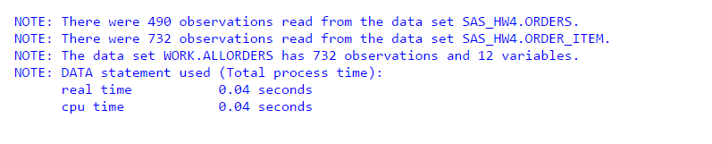

1. Subsetting the data set

**Code**

/* Problem 3(c) */

data allorders2 (keep=Order_ID Order_Item_Num Order_Type Order_Date Quantity Total_Retail_Price);

set allorders;

run;

**Output Data**

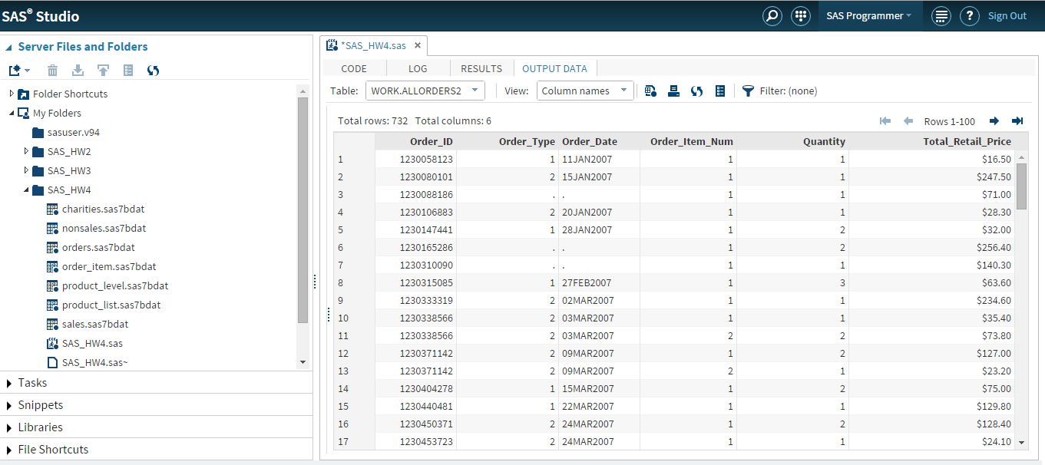

**Problem 4**

1. Sort Product_list by Product_level

**Code**

/* Problem 4(a) */

proc sort data = SAS_HW4.product_list out=product_list;

by product_level;

run;

**Output Data**

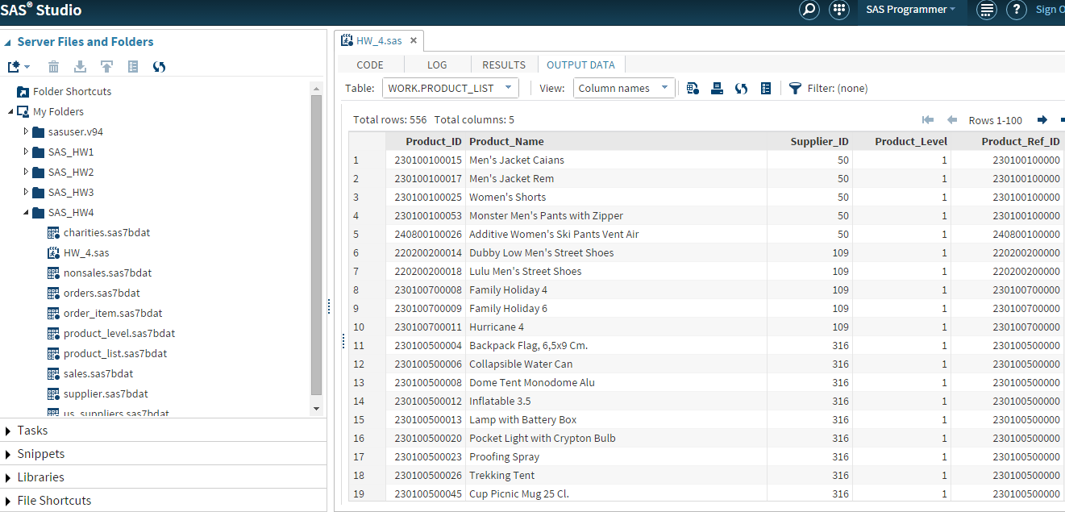

1. Merge Product_level with Product_list

**Code**

/* Problem 4(b) */

data listlevel(keep=Product_ID Product_Name Product_Level Product_Level_Name);

merge SAS_HW4.Product_Level product_list; by Product_Level;

run;

**Output Data**

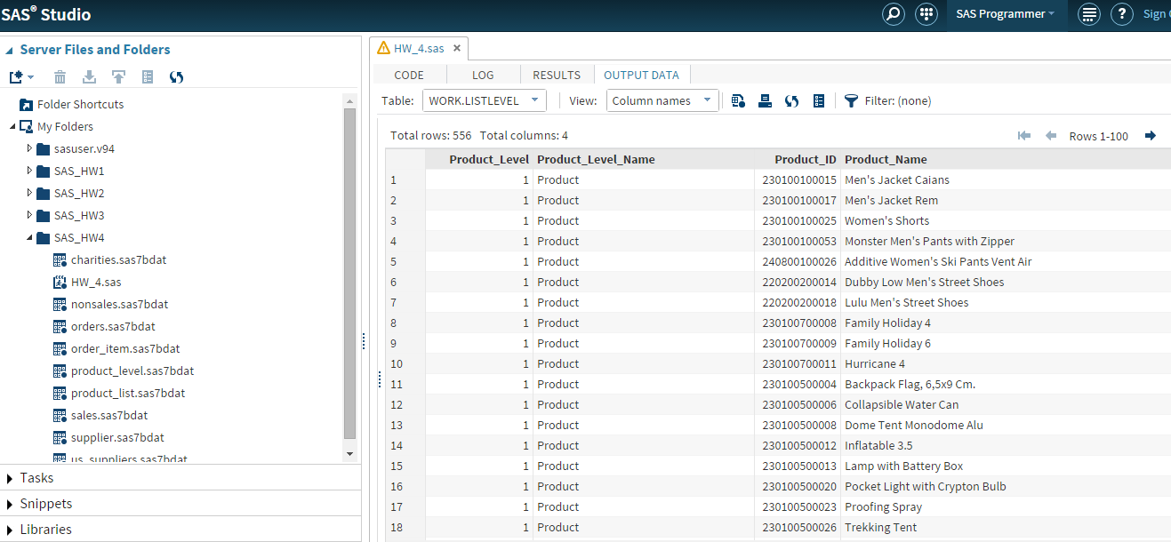

1. Print data set with product_level equal to 3

**Code**

/* Problem 4(c) */

proc print data = work.listlevel;

where product_level=3;

run;

**Output Data**

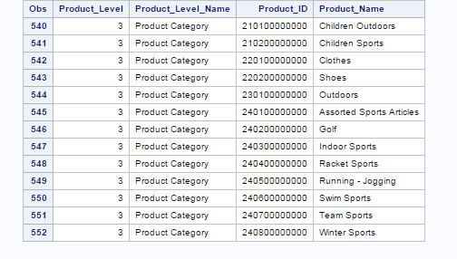

**Problem 5**

1. Merge **product_list** and **supplier** by **Supplier_ID**

**Code**

/* Problem 5(a) */

proc sort data=SAS_HW4.product_list; by supplier_id; run;

proc sort data=SAS_HW4.supplier; by supplier_id; run;

data work.prodsup;

merge SAS_HW4.product_list SAS_HW4.supplier;

by supplier_id;

**Output Data**

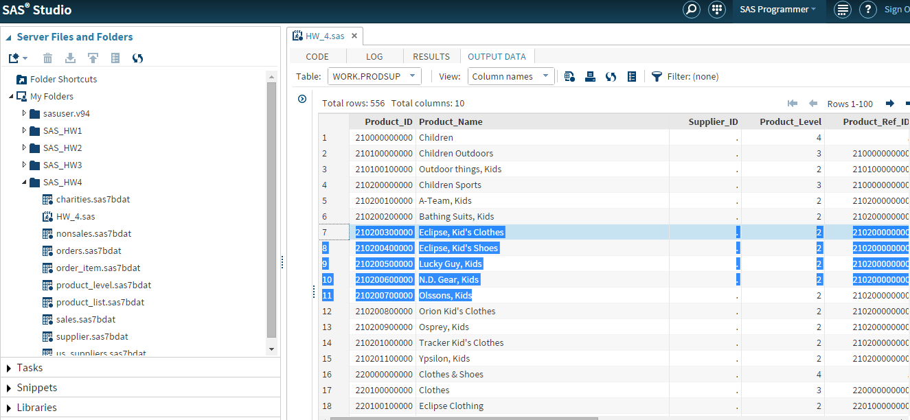

1. The data set was created with 556 observations and 10 columns

**Output Data**

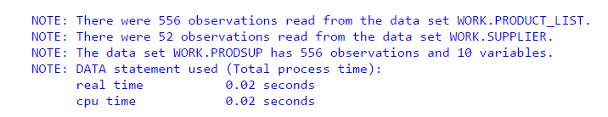

1. Data set with observations from only product_list not suppliers

**Code**

/* Problem 5(c) */

data prodsup;

merge SAS_HW4. product_list(in=product_list) supplier(in=supplier);

by supplier_id;

if product_list=1 and supplier=0;

run;

**Output Data**

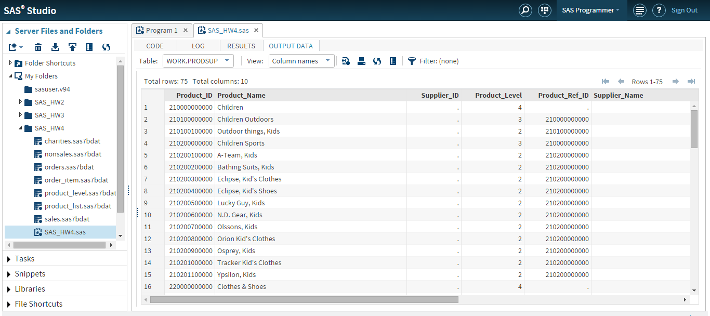

1. The data set was created with 75 observations and 10 columns

**Output**

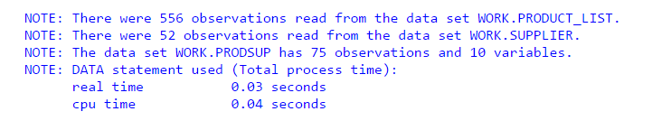

1. Report using **PROC PRINT**

**Code**

/*Program 5.(e)*/

proc print data=prodsup;

title "Product List Observation";

run;

**Output Data**

