**IDS 462 STATISTICAL SOFTWARE FOR BUSINESS**

**HOMEWORK 5**

**TEAM MEMBERS**:

1. Harish Visweswaraiya
2. Balachandhar Chekka Narayanasame
3. Sriram Ravi
4. Vinodh Sankaran

**Problem 1**

1. **Creating Multiple SAS Data Sets.**

**Code**

libname SAS_HW5 '/folders/myfolders/SAS_HW5';

/*Problem 1 Part(1)*/

data work.admin work.stock work.purchasing;

set SAS_HW5.employee_organization;

select (Department);

when ('Administration') output work.admin;

when ('Stock & Shipping') output work.stock;

when ('Purchasing') output work.purchasing;

otherwise;

end;

run;

**Output Data**

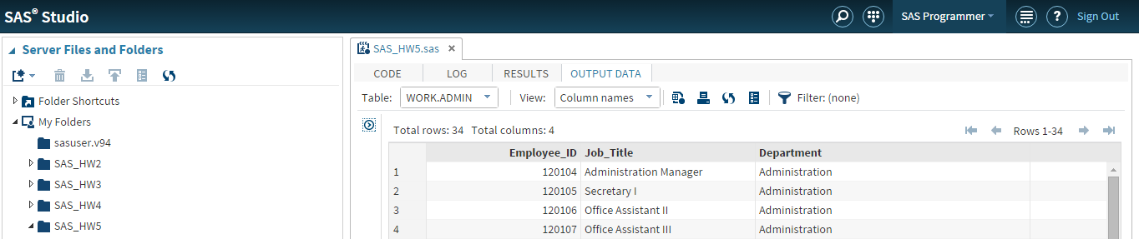

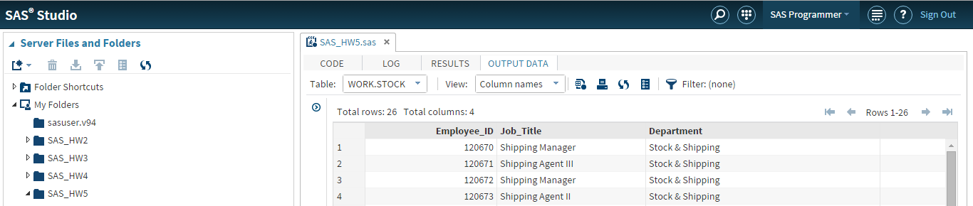

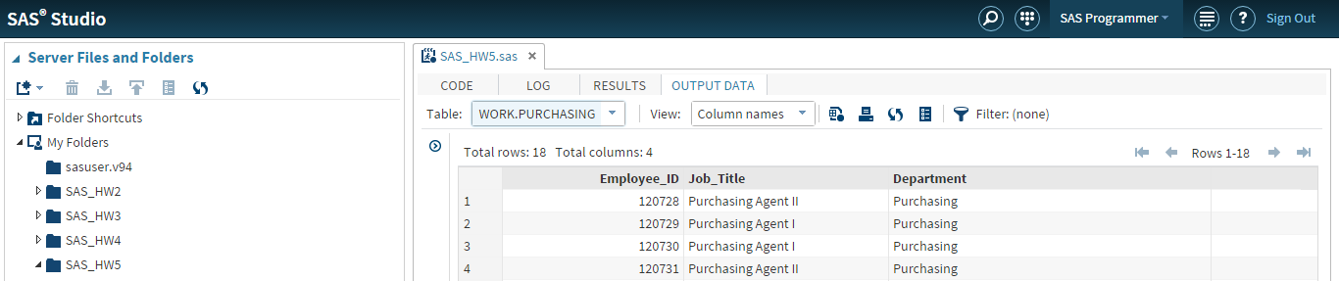

1. **Specifying Variables and Observations**

**Code**

/*Problem 1 Part(2)*/

data work.sales(keep=Employee_ID Job_Title Manager_ID) work.exec(keep=Employee_ID Job_Title);

set SAS_HW5.employee_organization;

select (Department);

when ('Sales') output work.sales;

when ('Executives') output work.exec;

otherwise;

end;

run;

proc print data=work.sales(obs=6);

title "Sales Department Employee Details";

run;

title;

proc print data=work.exec(firstobs=2 obs=3);

title "Executive Department Employee Details";

run;

title;

**Output Data**

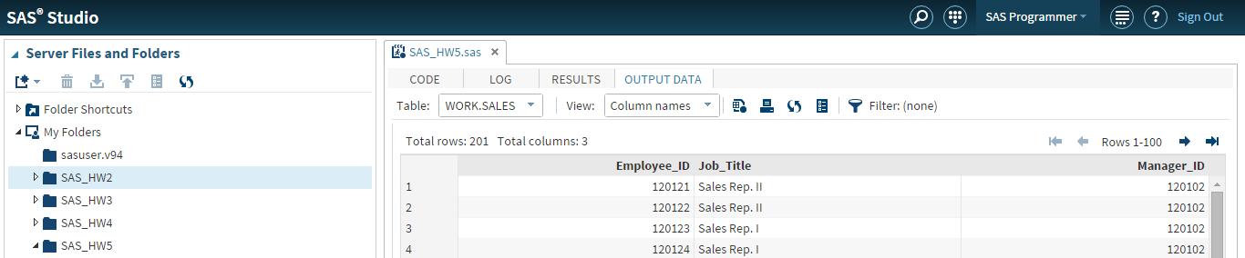

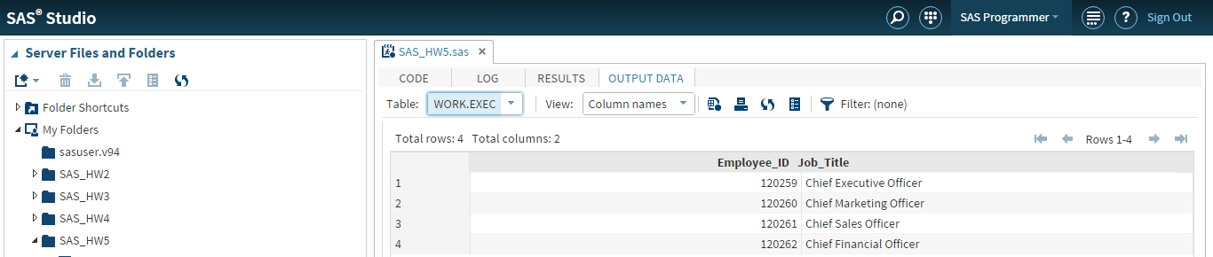

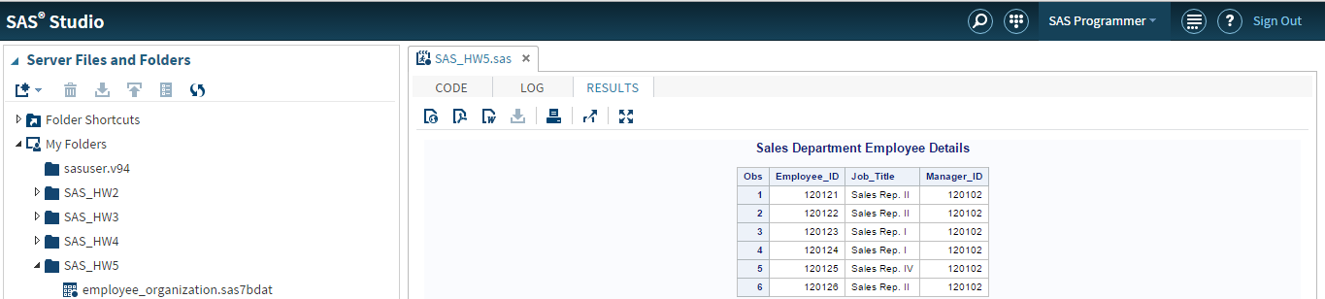

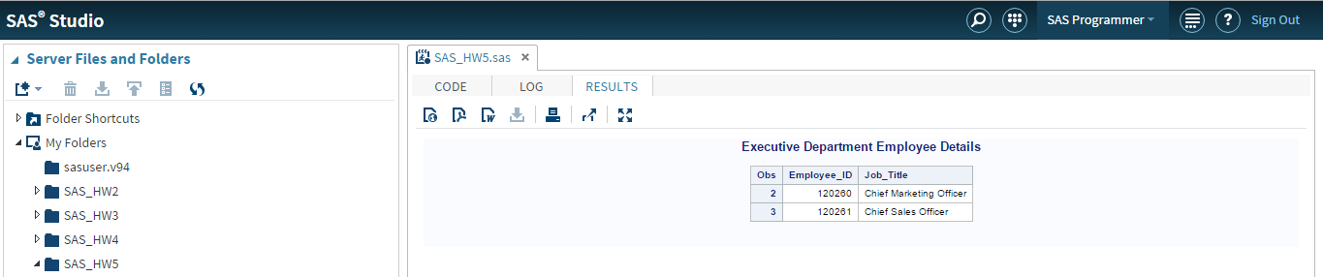

**Problem 2**

**Defining Ranges in User-Defined Formats.**

**Code**

/*Problem 2*/

proc format;

value $Gender 'F'='Female'

'M'='Male'

other='Invalid code';

run;

proc format;

value salrange 20000-<100000='Below $100,000'

100000-500000='$100,000 or more'

.='Missing salary'

other='Invalid salary';

run;

title1 'Salary and Gender Values';

title2 'for Non-Sales Employees';

proc print data=SAS_HW5.nonsales;

var Employee_ID Job_Title Salary Gender;

format Salary salrange. Gender $Gender.;

run;

**Output Data**

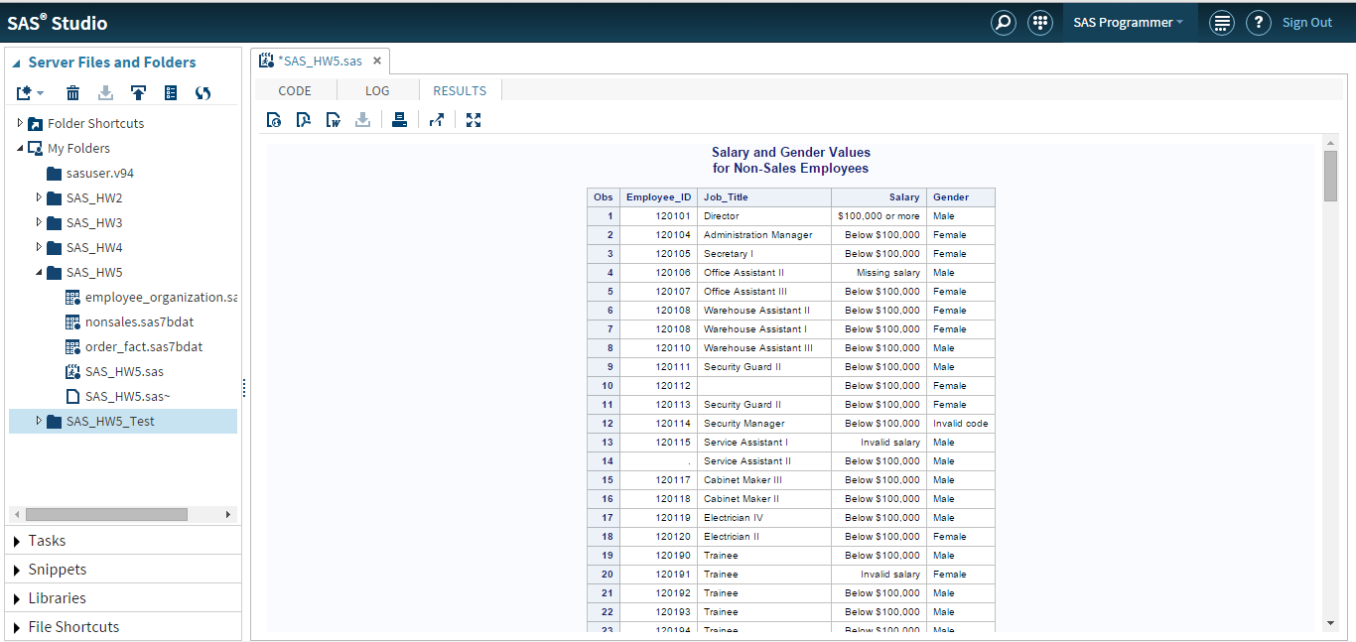

**Problem 3**

**Part 1**

1. **Creating Accumulating Totals with Conditional Logic**

**Code**

/*Problem 3*/

/*Part 1(a)*/

data work.typetotals;

set SAS_HW5.order_fact;

by order_date;

retain TotalRetail 0;

retain TotalCatalog 0;

retain TotalInternet 0;

where year(Order_Date) = 2009;

select (order_type);

when (1)

TotalRetail=TotalRetail+quantity;

when (2)

TotalCatalog=TotalCatalog+quantity;

when (3)

TotalInternet=TotalInternet+quantity;

otherwise;

end;

**Output Data**

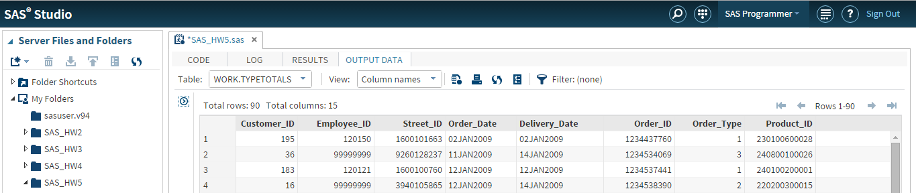

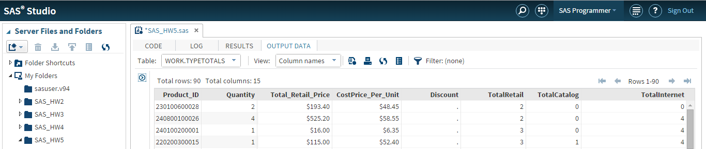

1. **Print cumulative orders for each channels**

**Code**

/*Part 1(b)*/

proc print data=work.typetotals;

title "Cumulative orders for each channels";

run;

**Output Data**

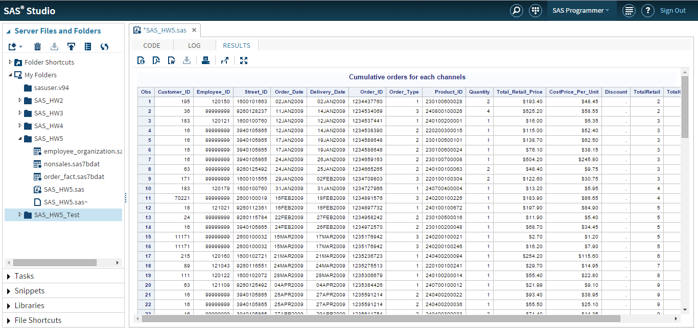

**Part 2 - Creating Accumulating Totals by Month**

**Code**

/*Problem 3*/

/*Part(2)*/

data work.order_fact_temp;

set SAS_HW5.order_fact;

month_ex=month(order_date);

run;

data work.order_fact(keep=order_date order_id total_retail_price monthsales);

set work.order_fact_temp;

by month_ex;

where year(order_date)=2011;

if first.month_ex then MonthSales=0;

MonthSales+total_retail_price;

run;

proc print data=work.order_fact;

format monthsales dollar10.2;

title "Accumulating Totals by Month in 2011";

run;

**Output Data**

