

|  |  |
| --- | --- |
| **IDS 462 STATISTICAL SOFTWARE FOR BUSINESS** | |
|  | **HOMEWORK 6** |
|  | **TEAM MEMBERS**: |
| 1. | Harish Visweswaraiya |
| 2. | Sriram Ravi |
| 3. | Vinodh Sankaran |
| 4. | Balachandhar Chekka Narayanasame |

Problem 1 - Monthly order data for the first half of the year is stored in the **orders_midyear** data set. This data set is updated monthly and can contain data for 1 to 12 months.

a) SAS code to create a Frequent Shopper Program (FSP)

Code

libname SAS_HW6 '/folders/myfolders/SAS_HW6';

/* Problem 1 */ /* Part A */

data fsp (keep = Customer_ID Months_Ordered Total_Order_Amount); set SAS_HW6.orders_midyear;

array Mon{*} Month1-Month12; Months_Ordered = 0;

do i=1 to dim(Mon);

Months_Ordered = N(of Mon[*]);

end;

if Months_ordered < 3 then delete;

else put "Customer is not qualified for loyalty program"; **Stop;

do i = 1 to dim(Mon);

Total_Order_Amount = Sum(of Mon{*});

end;

If Total_Order_amount < 1000.00 then delete; run;

Output Data

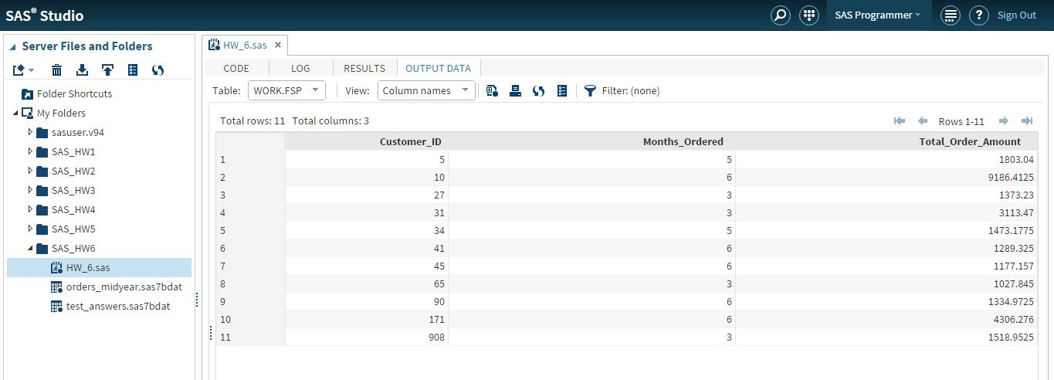

b) Print the resulting data set with an appropriate title and formats, and verify your results.

Code

/* Part B */

proc print data = fsp;

title "Customers who are eligible for Loyalty Program"; format Total_Order_Amount dollar14.2;

run; Output Data

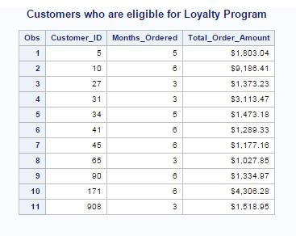

Problem 2 - The Public Safety Department at Orion Star wants all employees to be aware of the new policies and procedures regarding customer incidents in their retail stores.

**a)** Use the answer key 'A','C','C','B','E','E','D','B','B','A' and read test_answers and determine whether each personpassed or failed the test.

Code

/* Problem 2 */ /* Part A */

data passed failed; drop i;

set SAS_HW6.test_answers; Score = 0;

array response{*} Q1-Q10;

array answer_key{10} $ _temporary_ ('A','C','C','B','E','E','D','B','B','A'); do i=1 to dim(response);

If response[i] = answer_key[i] then score = score+1; end;

If score > 6 then output passed; Else output failed;

run;

Output Data

Work.passed data set:

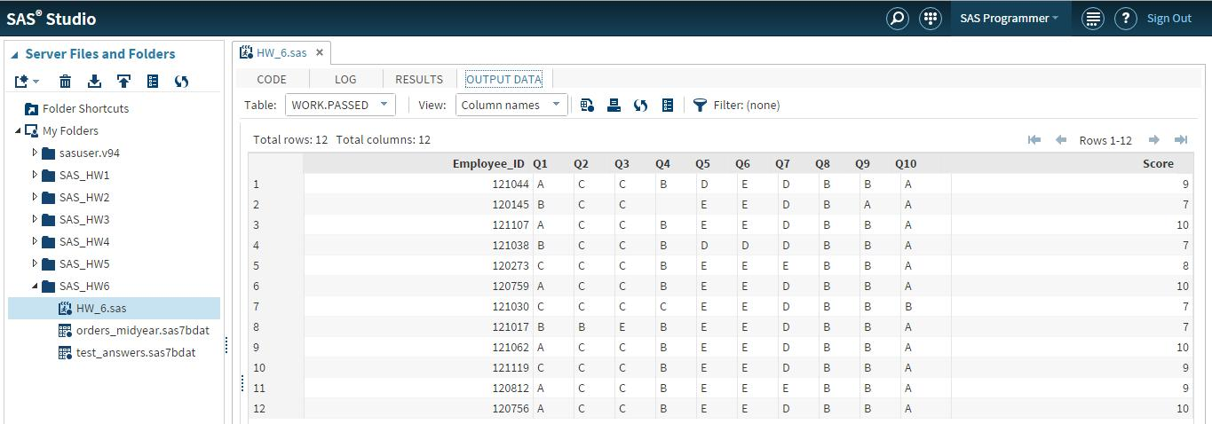

Work.failed data set:

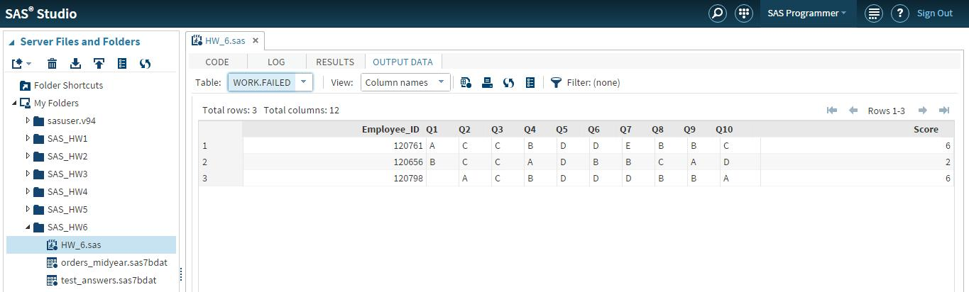

**b)** PROC Print the **passed** data set to verify that it contains 12 observations.

**Code**

/* Part B */

proc print data = passed;

title "Employees who passed the test"; run;

Output Data

