**IDS 462 STATISTICAL SOFTWARE FOR BUSINESS**

**HOMEWORK 8**

**TEAM MEMBERS**:

1. Harish Visweswaraiya
2. Sriram Ravi
3. Vinodh Sankaran
4. Balachandhar Chekka Narayanasame

**Problem 1 – Using SAS Date Constants**

Use the automatic macro variable **SYSDATE9** to return today’s date.

**Code**

libname SAS_HW8 '/folders/myfolders/SAS_HW8';

/* Problem 1 */

%put &sysdate9;

%let start_date='01JAN2007'd;

%let end_date="&sysdate9"d;

proc print data=SAS_HW8.employee_payroll;

format Birth_Date Employee_Hire_Date date9.;

where Employee_Hire_Date between &start_date and &end_date;

run;

**Output Data**

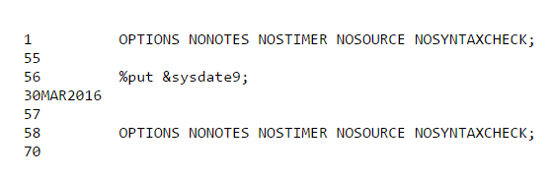

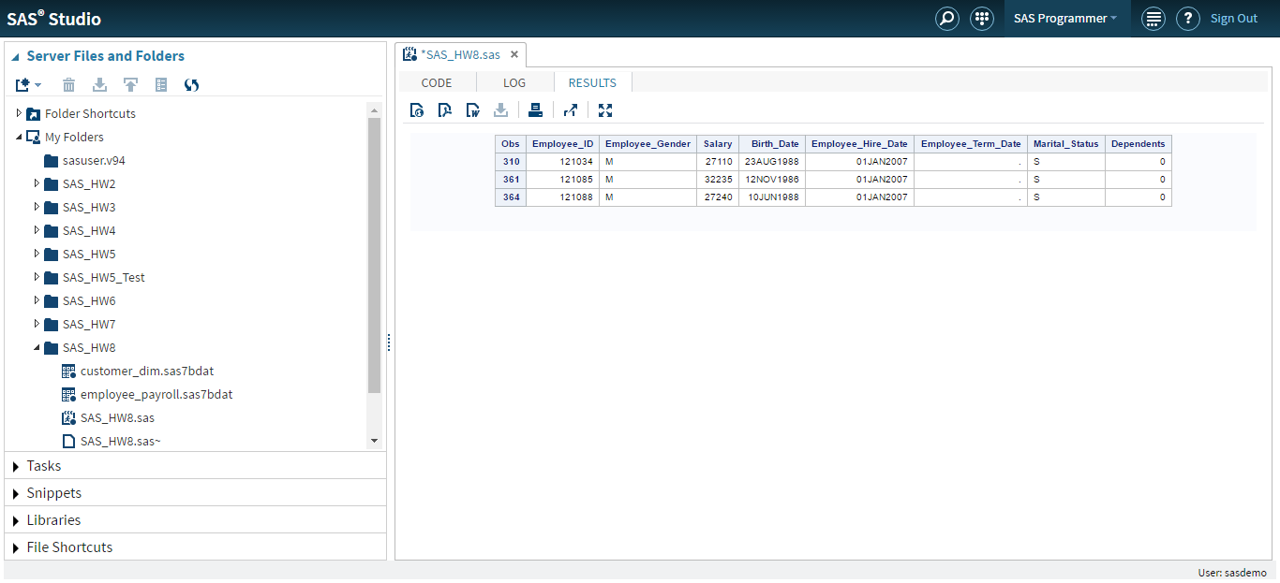

**Problem 2 - Macro Variable References with Multiple Delimiters**

1. The following program analyzes the **SAS_HW8.staff** data to find the employee with the most seniority within a job title. Submit the program and examine the output that it creates.

**Code**

/* Problem 2 */

/* Part A */

proc sort data=SAS_HW8.staff out=staffhires;

by Job_Title Emp_Hire_Date;

run;

data FirstHired;

set staffhires;

by Job_Title;

if First.Job_Title;

run;

proc print data=FirstHired;

id Job_Title;

var Employee_ID Emp_Hire_Date;

title "First Employee Hired within Each Job Title";

run;

**Output Data**

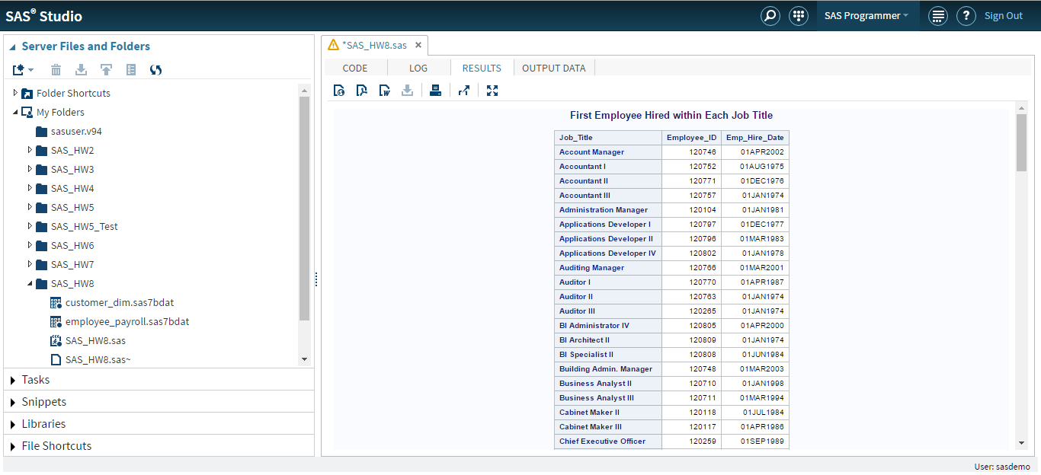

The above program returns the employees who were hired first under each job title.

1. Create a macro variable that acts as a toggle such that the program selects employees with either the most seniority or the least seniority within their job title. Make sure that the title reflects this difference.

**Toggle variable value set to “First” to get the list of employees with most seniority within their job title**

**Code**

/* Part B – Toggle variable set to First */

%let toggle_var=First;

proc sort data=SAS_HW8.staff out=staffhires;

by Job_Title Emp_Hire_Date;

run;

data &toggle_var.Hired;

set staffhires;

by Job_Title;

if &toggle_var..Job_Title;

run;

proc print data=&toggle_var.Hired;

id Job_Title;

var Employee_ID Emp_Hire_Date;

title "&toggle_var Employee Hired within Each Job Title";

run;

**Output Data**

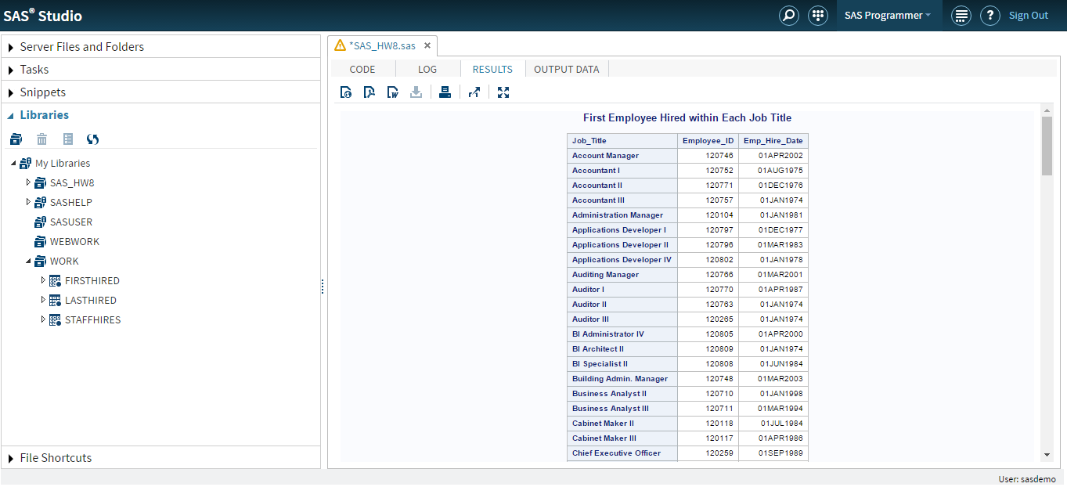

**Toggle variable value set to “Last” to get the list of employees with least seniority within their job title**

**Code**

/* Part B – Toggle variable set to Last */

%let toggle_var=Last;

proc sort data=SAS_HW8.staff out=staffhires;

by Job_Title Emp_Hire_Date;

run;

data &toggle_var.Hired;

set staffhires;

by Job_Title;

if &toggle_var..Job_Title;

run;

proc print data=&toggle_var.Hired;

id Job_Title;

var Employee_ID Emp_Hire_Date;

title "&toggle_var Employee Hired within Each Job Title";

run;

**Output Data**

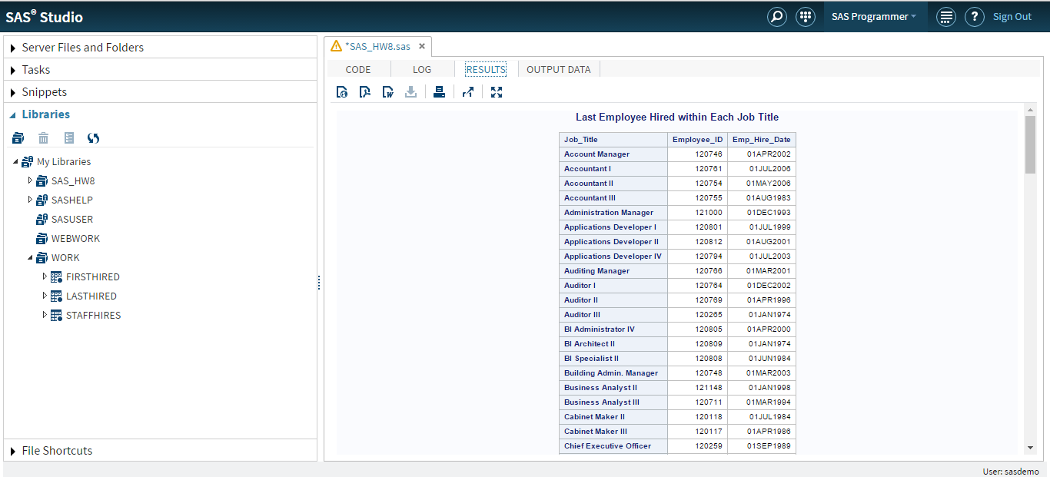

**Problem 3 - Calling a Macro from a TITLE Statement**

1. Define a macro that issues the current time of day with the TIMEAMPM. format. Name the macro **Currtime**. Submit the macro definition.

**Code**

/* Problem 3 */

/* Part A */

%macro Currtime;

%sysfunc(time(),timeampm.)

%mend Currtime;

1. Add a TITLE2 statement to the following program. Call the **Currtime** macro from the TITLE2 statement. Submit the program and examine the output.

**Code**

/* Problem 3 */

/* Part B */

proc print data=SAS_HW8.customer_dim(obs=10);

var Customer_Name Customer_Group;

title 'Customer List';

title2 "The Current time is %Currtime";

run;

**Output Data**

