

AIA (Singapore)

Functional Requirement Specification

CDB Group Data Download

Prepared by | Natesan Venu
Reviewed by | Elsa Tay, Ramanathan Rajasekar
Release No | 1.0
Date | 23rd Dec 2003

CONTENT
1 Version Control 3
2 Introduction 4
2.1 Purpose 4
2.2 Audience 4
2.3 Reference 4
3 User Requirements 5
3.1 Extraction 5
3.2 System Settings 5
3.3 Auto Run 5
3.4 Logs 5
3.5 Overview of Work Flow 6
4 Detailed Specifications 7
4.1 Settings 8
4.1.1 Setting Values 9
4.2 Download 10
4.3 Check 15
4.3.1 Additional Checks 15
4.4 Exit 15
4.5 Log File 15
5 System Requirements 16

Version Control
Document Information
Prepared by | Natesan Venu
Date Prepared | 23-Dec-2003
Reviewed by | Elsa Tay / Rajasekar Ramanathan

Version History
Date | Version | Author | Description of Changes
23-Dec-2003 | 1.0 | Natesan Venu | Creation of document

Introduction

Purpose
This document serves to provide a detailed specification on the User Requirements of CDB Group Data Download from Compass system.

Audience
The intended users of this document are:
- Group Dept. users and AIGMC who should check the contents of this document and verify that they are satisfied with the functional requirement. The document will also meant for user acceptance test.
- This document will serve as a guide for MIS to commence system development for this project.

Reference
- Customer Data Base.
- Group Compass system.

User Acceptance sign off

______________________ ______________________
Dept : Group Dept. Dept : AIGMC
Date : Date :
Name : Name :

User Requirements

Design and Develop a backend program to download the group information from COMPASS system to SYBASE system for Customer Database.

The Information downloaded from Compass system are

- Policy information
- Client Information
- Member Information

Extraction
The changes in above information required for Customer Data Base processing will be extracted and downloaded to Sybase system.

System Settings
Provide facility to enter system setting variables.
- Sybase Server details like ID, Password etc
- Compass Server details like ID, Password etc
- Email Server / address details.
- Mode of execution

Auto Run
The Group Data Download program can be scheduled in NT server. Giving the parameter “AUTO” while executing the program can do “Auto Run” mode of execution. (i.e. “Group_Download.exe AUTO”)

Logs
Log Files of execution will be sent to MIS support through email.

Overview of Work Flow
The Following Chart depicts the detailed work flow for the environment

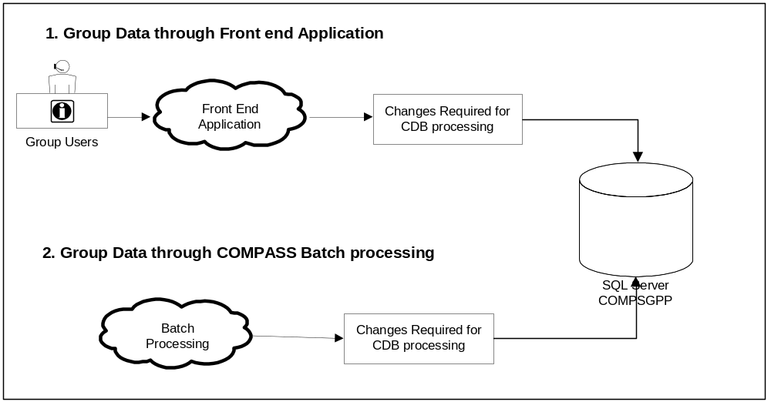

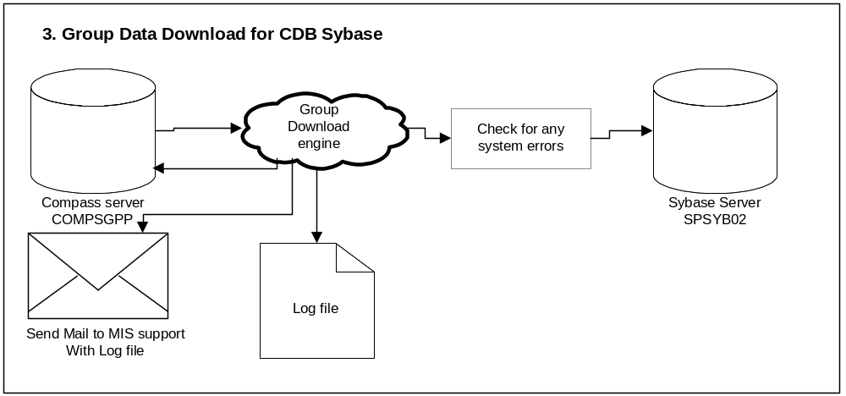

Detailed Specifications

The Group Download program has the following options

- Settings
- Download
- Check
- Exit
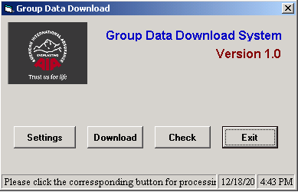
Figure 1.0

Settings

This option allows to do the initial setup for the Group Data download. Below is the sample screen for setting options.

When the “Settings” button is clicked, it prompts for password. For the first time password is blank and this password can be set in the Password option under “Super Admin” (Minimum 8 characters).

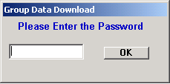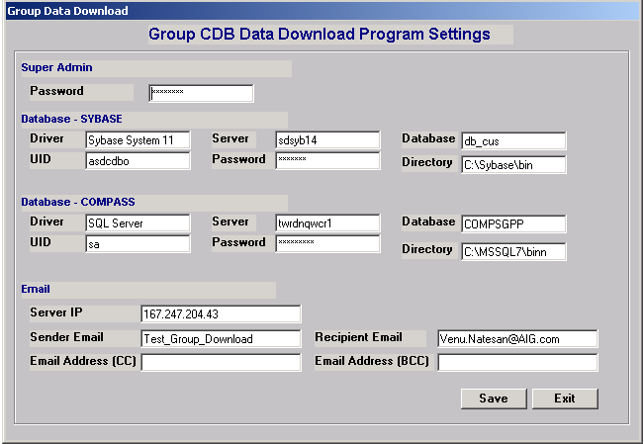Figure 2.0

Figure 3.0

Setting Values

Super Admin
Password – The Password for Setting options

Data Base – Sybase
Driver - Driver String Value used for connecting the Sybase server
Server – Sybase Server name
Database – Data Base name
UID – Sybase ID used to run the procedures / Query for Download
Password – Sybase Password
Directory – Sybase Client Directory

Data Base – SQL server
Driver - Driver String Value used for connecting the SQL server
Server – SQL Server name
Database – Data Base name
UID – SQL Server ID used to run the procedures / Query for Download
Password – SQL Server Password
Directory – SQL server Client Directory

Email
Server IP – Email Server IP Address Used to send the Log files to MIS support
Sender Email – Sender’s Email Address
Recipient Email – Email Address to receive the Log file (Separated By comma)
Email Address (CC) – Copy list of Email for sending the Log file (Separated By comma)
Email Address (BCC) – BCC list of Email for sending the Log file (Separated By comma)

Once the values for these settings are given and “Save” button is clicked, values are stored into Registry. Those passwords are encrypted before writing into registry.
To cancel all the changes done press “Cancel” button.

Download
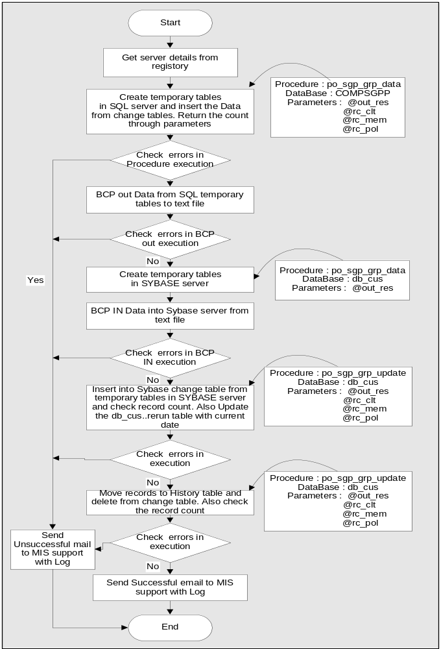The Download is the option to transfer CDB required Data from SQL server to Sybase server. Data transfer can be done in auto mode(Using “AUTO” parameter to the program). Also transfer of Data will also be done if the Download button is clicked. Below shows the process flow.
Figure 4.0
The Download process gets all the server details from registry for data download.
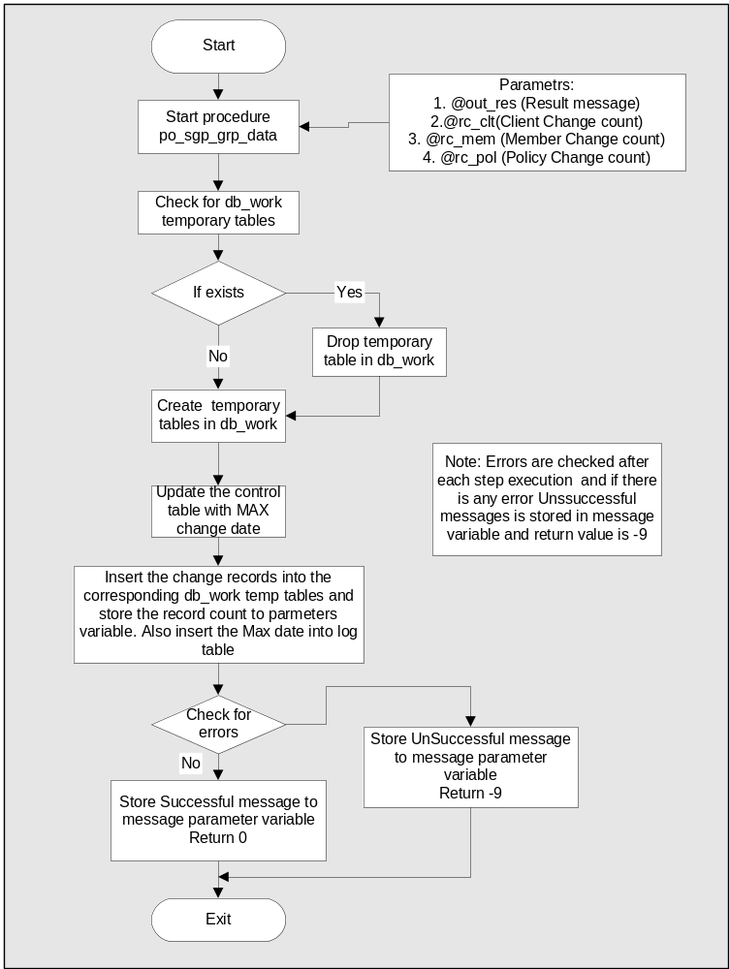First process is to create temporary tables in db_work of SQL server to insert the data from change tables. Also it logs the details into log table. The above process is done by executing stored procedure(“po_sgp_grp_data”). This stored procedure checks errors during execution and returns the results through output parameter. It also returns record count in output parameter.

The next process is to BCP out all the required data from SQL server temporary tables to text file. During this process the bcp log file will be checked for errors. Also the records count checked with the bcp count in the log files to make sure the data downloaded to text file is correct.
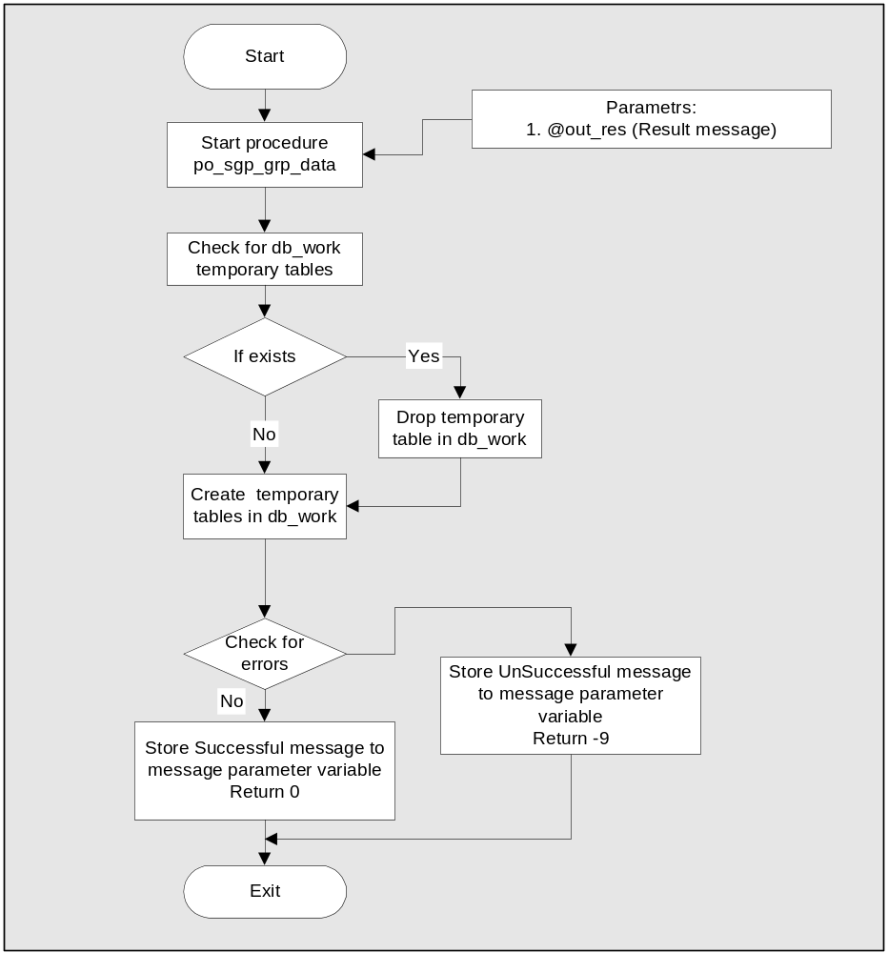 After the BCP out process is completed successfully, creation of temporary tables in Sybase server will be done through the stored procedure in db_cus database (“po_sgp_grp_data”). The result of execution is got through the output parameter.

Once the above processes are successful, BCP IN into Sybase server from text file will start. Errors and rowcount are checked in log file created by BCP.

When the Data is there in Sybase temporary tables, stored procedure in db_cus database is triggered to insert these data into db_group change tables. During the execution it will check for errors and insert record into the log table. Also it will update the db_cus..cust_rerun table.(This will be used for checking whether the Download process is running).
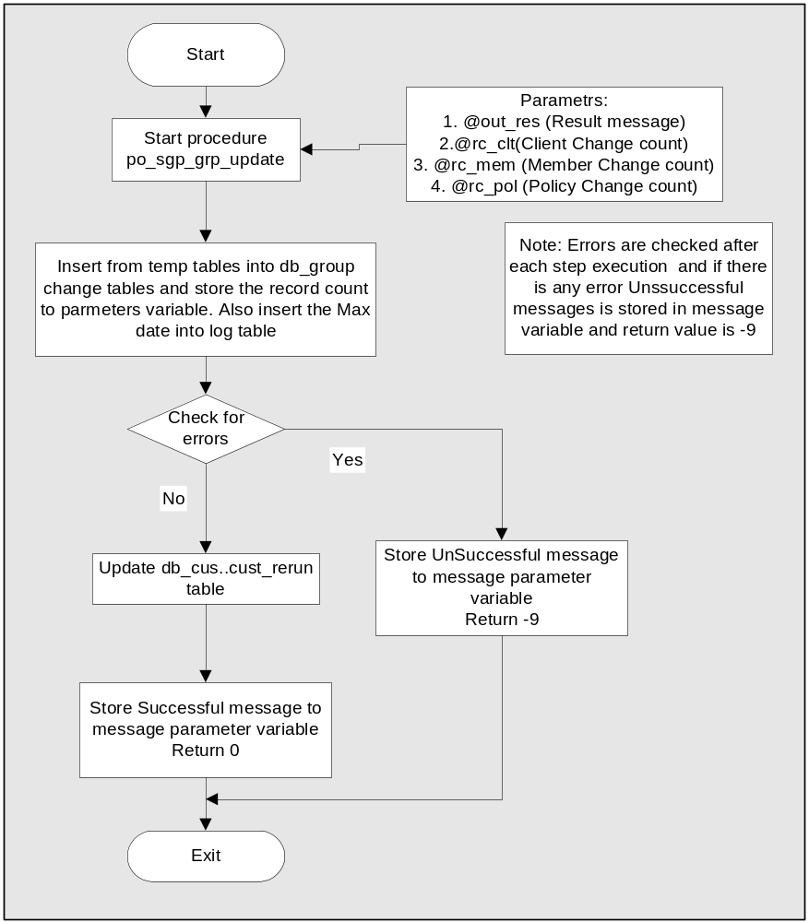

After the data comes to Sybase change table, SQL server change tables records will be checked and moved to history tables before it is deleted. While it gets deleted it updates the log table also. This process is carried out using the stored procedure(“po_sgp_grp_update”) in COMPSGPP database. The result of execution is returned through the output parameter. The record count is compared using the input parameter in this stored procedure to make sure record count matches in all stages.
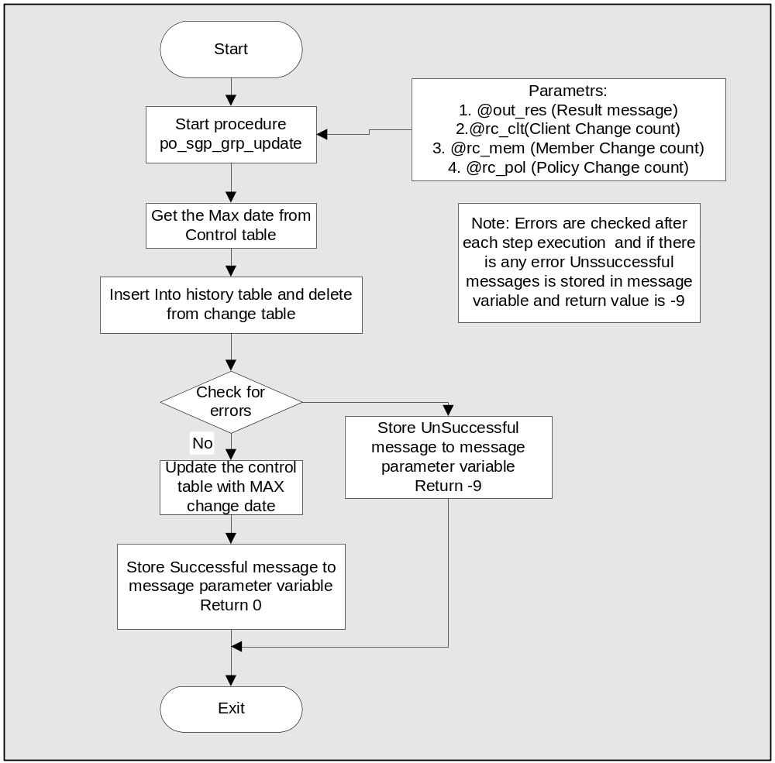

The final step is to send successful email to MIS support using mail ID given in settings. It also attach the log file in this email. If there is any failure in above process then Unsuccessful email will be triggered with the log file.
If the download is triggered in Auto mode, program comes automatically. If it is done manually, exit option has to be used to come out of execution.

Check

This option can be used whenever there is a need to check for last successful run. When this “Check” button is clicked program connects to sybase server and gets the date from db_cus..cust_rerun table. This date retrieved will be displayed in the output message box. Sample output message is shown below.
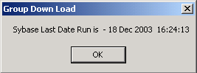Figure –5.0

Additional Checks
Additional checks will be done during the CDB Group batch Job processing to ensure the Group Data Download program is running. This will be done by comparing current date with the date in db_cus..cust_rerun table for this Group download. If the Date difference is more than 2 Days, in Group CDB processing log it will be highlighted as below.
++++++++++++++++++++++++++++++++++++++++++++++++++++++++
+ Group Download Date difference is more than 2 Days +
++++++++++++++++++++++++++++++++++++++++++++++++++++++++

Exit
This option is used exit the program

Log File
Attached is the Sample Log file that will be generated during program execution.
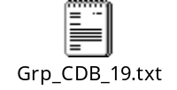 The log file name will be “Grp_CDB_” + Date of the month. This log file will be in log folder for one month before it gets over written. The log file will be attached to into the email triggered to Support persons after the end of program execution. Sample email content is as below.


System Requirements

- Disk Space
Data files = 30 MB * 3 = 90 MB
Log files = 30 KB * 30 = 900 KB
Temp Log files = 100 KB
Total Space = 90 MB + 900KB + 100KB = 91 MB

- Sybase Client
Sybase client to be installed in the Server
(If possible remove the Sybase Path from path setting)

