Ritha V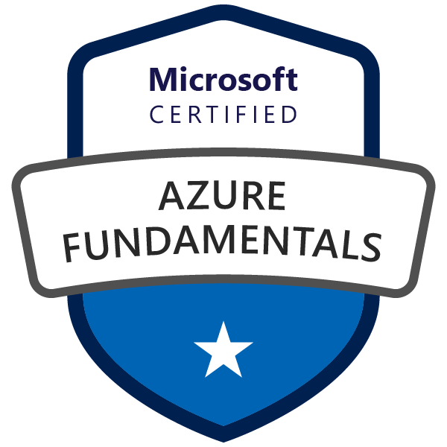
rithavalli@gmail.com/ +1 860-420-2238

I am an experienced software development engineer that combines innovative thinking, hard work and an adaptive personality with a passion to research and implement new ideas. I am flexible and versatile, and I contribute in any new environment with a strong desire to keep pace with the latest technologies.

Summary:
- Software development professional with 3 years of experience in Analysis, Design, Development, Maintenance and Implementation of enterprise web and client server applications using JAVA, J2EE and HTML.
- Experienced utilizing Java/J2EE technologies such as Core Java, Java Server Pages (JSP), Servlets, JDBC, Spring and Hibernate.
- Client-side Programming with HTML, JavaScript, and CSS.
- Knowledgeable in consuming and implementing Web Services using SOAP and REST.
- Experienced in building the applications using Maven and Gradle.
- Experienced implementing Design Patterns such as Singleton, MVC, and DAO.
- Experienced in developing web user interface using Spring MVC framework.
- Strong understanding of RDBMS concepts and working with relational databases like SQL Server and MySQL.
- Experienced in working with Web/Application servers such as Apache Tomcat, Oracle WebLogic.
- Working knowledge with versioning tools such as SVN, and Git.
- Experienced on Agile Methodologies and able to handle the multiple concurrent projects and manage delivery timelines.
- Hands on Experience on writing automation using scripting languages, such as Python and PowerShell.
- Working knowledge of build automated CI/CD Pipelines.
- Experience in writing Spark Applications in PySpark and Scala using Data frames and Data Sets.
- Worked on implementing AWS Dynamo DB, Lambda functions, AWS S3, CloudWatch logs, API Gateways, Amazon Lex, and AWS DevOps.
- Experience on Migrating SQL database to Azure data Lake, Azure Data Lake Analytics, Azure SQL Database, Data Bricks and Azure SQL Data Warehouse and Controlling and granting database access and Migrating On premise databases to Azure Data lake store using Azure Data factory.

Education:
- Master’s in computer science from University of Central Missouri (Missouri), USA. 3.9/4
- Bachelor’s in computer science from JNTU, India. 7.6/10

Technical Skills:

Languages : Java, AngularJS
J2EE Technologies : Servlets, JSP, Spring
Web Technologies : HTML, CSS, JavaScript
Databases : MySQL, SQL
Web/Application Servers : Apache Tomcat, Oracle WebLogic Server
Frameworks : Spring, Hibernate
Web Services : REST, SOAP
IDE’s : Eclipse, Visual Studio
Build Tools : Maven, and Gradle
Cloud : AWS, Azure

Experience:
University of Central Missouri Java developer Jan’20 to May’20

- Implemented major concepts of the application using Core Java, J2EE, Servlets, JSP, JDBC, MVC, Spring Framework, Hibernate, Java Beans, XML.
- Worked, implemented, and maintained an S architecture utilizing the Spring framework.
- Consumed REST services in the application using WADL's to get data from other services of the client.
- Used Maven for dependency management and build purposes and Jenkins for continuous builds and deployments on Red hot Jboss Application Server.
- Wrote unit test scripts using JUnit framework for testing functionalities in a Test-Driven Development (TDD) methodology.
- Used Spring Framework for Dependency injection and integrated with Hibernate.
- Implemented the web services using REST services.
- Architected the controllers and service layers for code maintenance and ease of understanding.
- Using Gradle to create dependency JARS and deploy the entire project onto the Jboss Server.
- Document the relationships among the SQL Servers and Databases.
- Used GitDesktop to run the application, Postman to test the API’s, GitHub for version control, and Rally for issue tracking.
Development Environment: Java, J2EE, Spring, Rest, Hibernate, Gradle, RedHotJboss Server, Junit, Postman, GitHub, Rally, Eclipse.

Capgemini/GE Full stack Engineer Nov’17 to July’19
Responsibilities:

- Involved all the stages of Software Development Life Cycle: application design, development, debugging and testing.
- Involved in working with agile methodology implementations like Daily scrum meetings, sprint planning's, resource planning, etc. to deliver quality code in 2-week sprints.
- Designed front end UI web pages using HTML, CSS, JavaScript, Bootstrap and Angular.
- Used CSS and Bootstrap for styling the HTML elements.
- Implemented Angular Controllers to maintain each view data.
- Implemented Angular Service calls using Angular Factory.
- Used Dependency Injection (DI) In order to develop code for obtaining bean references in spring framework using annotations.
- Used Spring Framework to integrate with Hibernate.
- Consumed API’s by using RESTful web services.
- Implemented a CI/CD pipeline with Docker, Jenkins (Team Foundation Plugin installed), Team Foundation Server (TFS), GitHub and Azure Container Service, whenever a new TFS/GitHub branch gets started, Jenkins, our Continuous Integration (CI) server, automatically attempts to build a new Docker container from it
- Used Maven to create dependency JARS and deploy the entire project onto the Apache Tomcat Server.
- Used GitBash to run the application, Postman to test the API’s, GitHub for version control, and JIRA for issue tracking.
Development Environment: Java, J2EE, HTML, CSS, JavaScript, Bootstrap, Angular, Spring (DI, MVC), Rest, Hibernate, Maven, Apache Tomcat Server, Junit, Postman, GitHub, JIRA, Eclipse

Eclinical Solutions Java UI developer Jan’17 to Sept’17
Responsibilities:

- Involved in gathering Requirements and Designing User Interface.
- Identified use cases and designed UML diagrams using Rational Rose.
- Involved in implementing presentation layer using JSP, HTML, CSS and JavaScript technologies
- Used Spring MVC framework for developing the Web user interface.
- Developed web applications that uses Model View Controller (MVC) architecture.
- Developed the application using J2EE modules like JDBC, and Servlets.
- Wrote SQL Queries for backend database interaction.
- Deployed the application using Apache Tomcat server.
- Worked together as a team to develop a well-documented project
- Used GitHub for version controlling.

Development Environment: Java, JSP, Servlet, Spring, Apache Tomcat server, MySQL, JavaScript, Eclipse, HTML, CSS, GitHub.

EDUCATION:
- Master’s in Computer Science from University of Central Missouri (UCM), MO, USA 3.9/4.0
- Bachelor’s in Information Technology from Andhra University, India 7.7/10.0

