Air-bed and breakfast(Airbnb) Report

## **INTRODUCTION**

#### Airbnb, the world leader in accommodations of the “sharing economy”, allows you to find places to stay directly from individuals in thousands of cities around the world.

#### It allows you to rent apartments (or even entire houses) from people all over the world, almost everywhere in fact.

## **Location Wise Room Availability**

#### From the Availability of room plots ,we can conclude that **Manhattan** has more number of room availability compared to other locations.

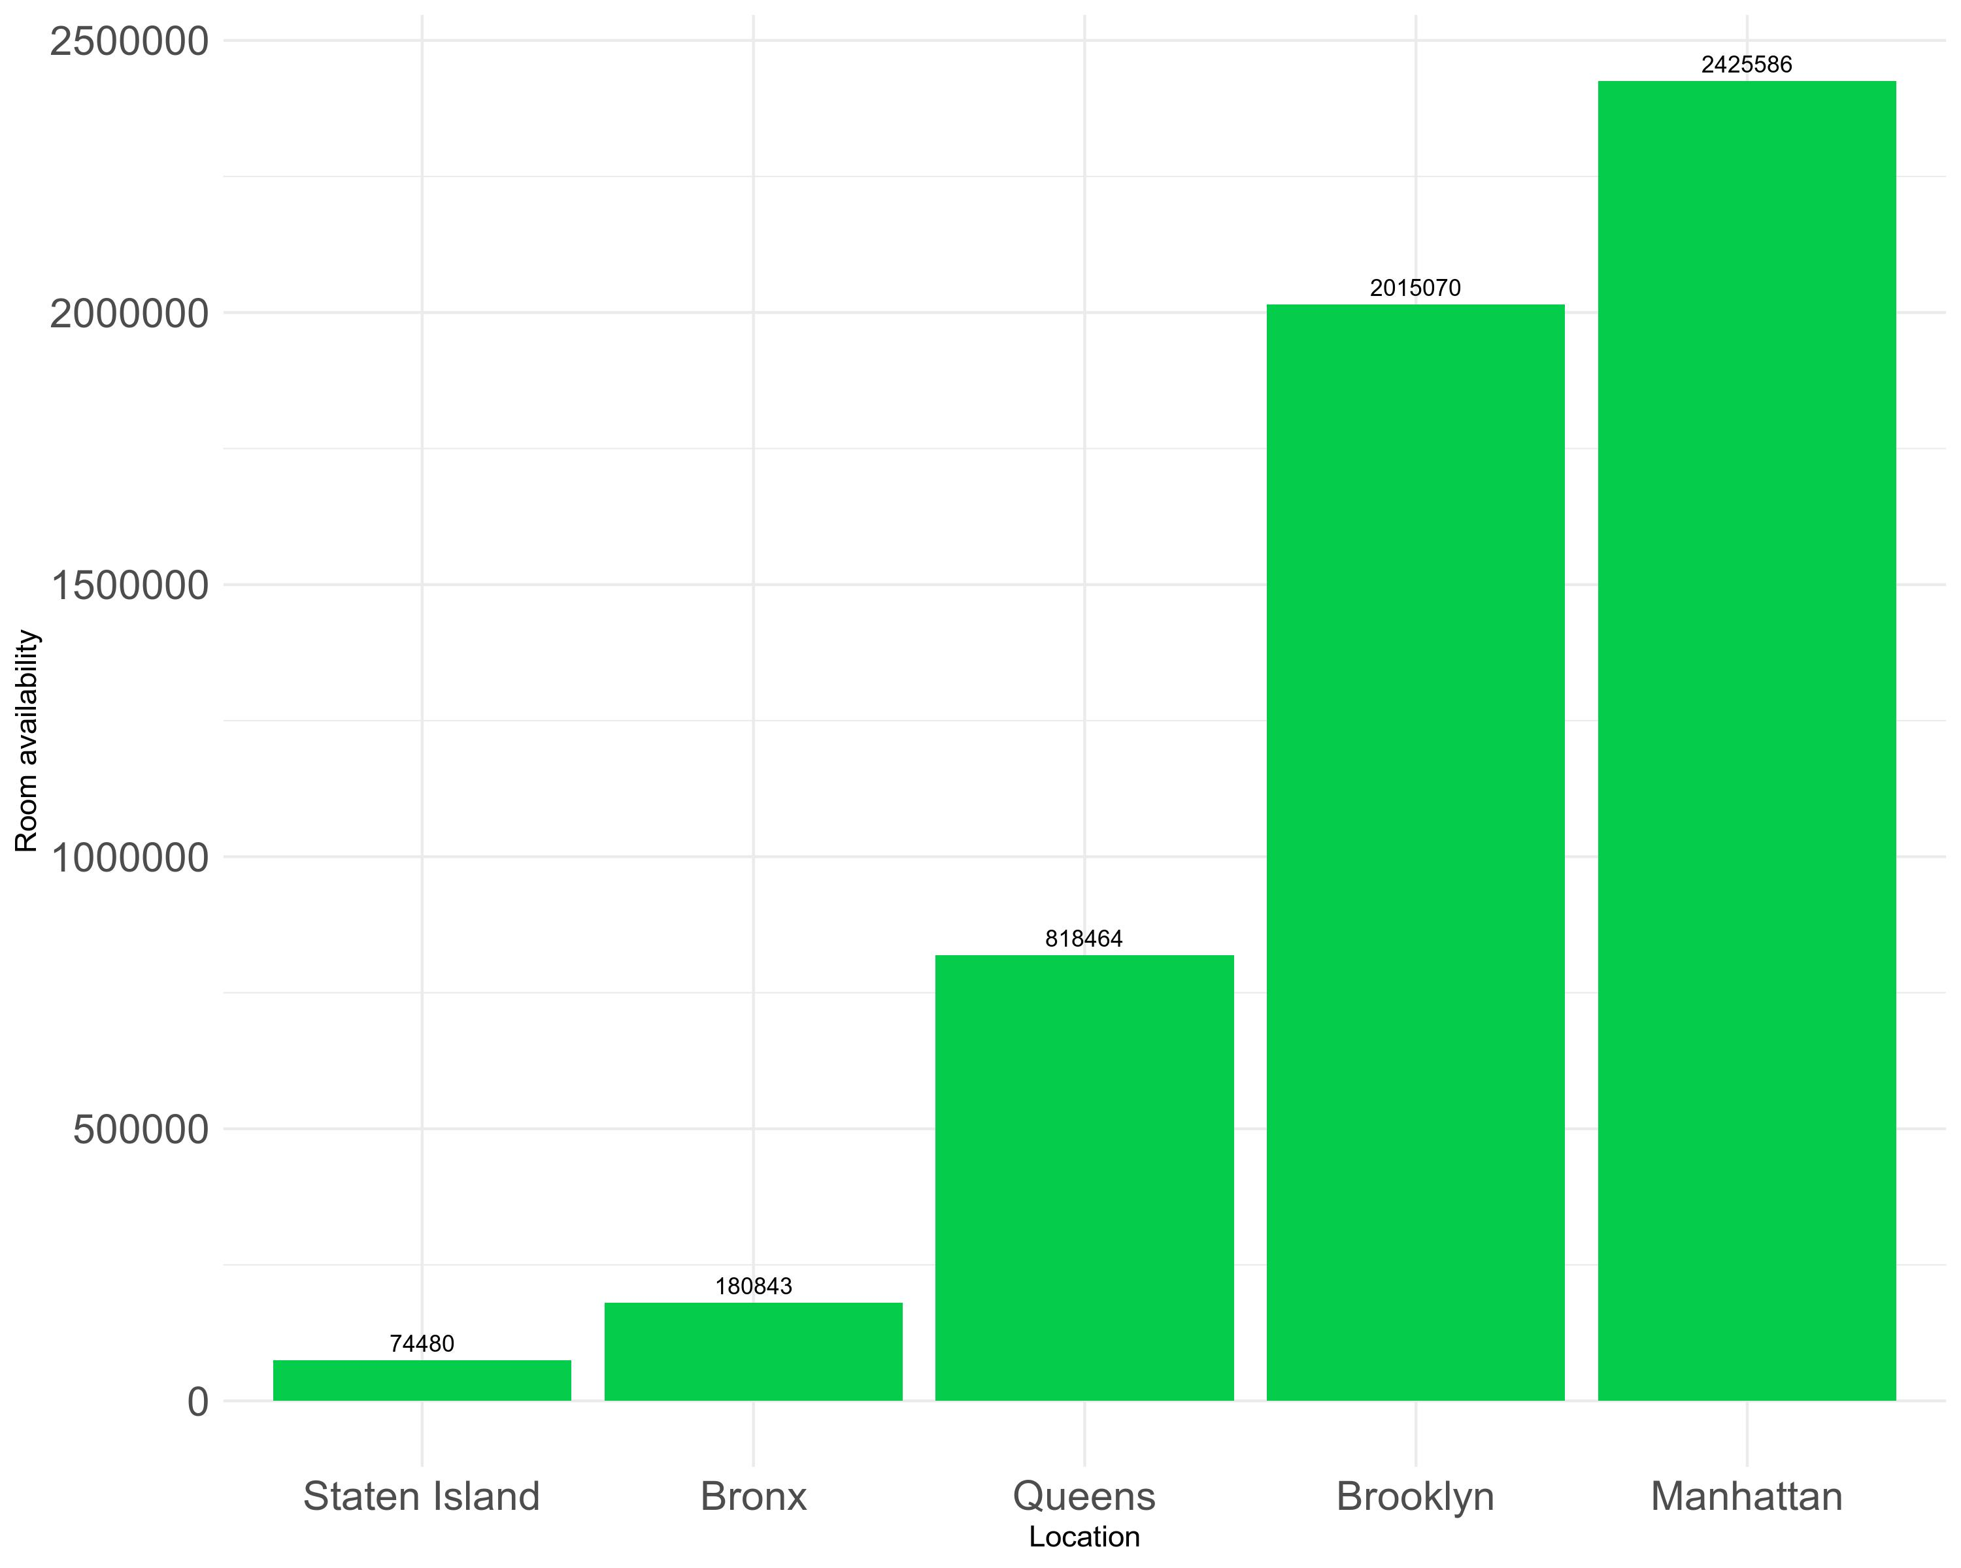

## **Average Price for Each Area**

#### The Plot Below shows the average price of each location , Here we can see more variation in average price of each location. Overall, it looks like **Manhattan** Location is slightly pricier than other locations.

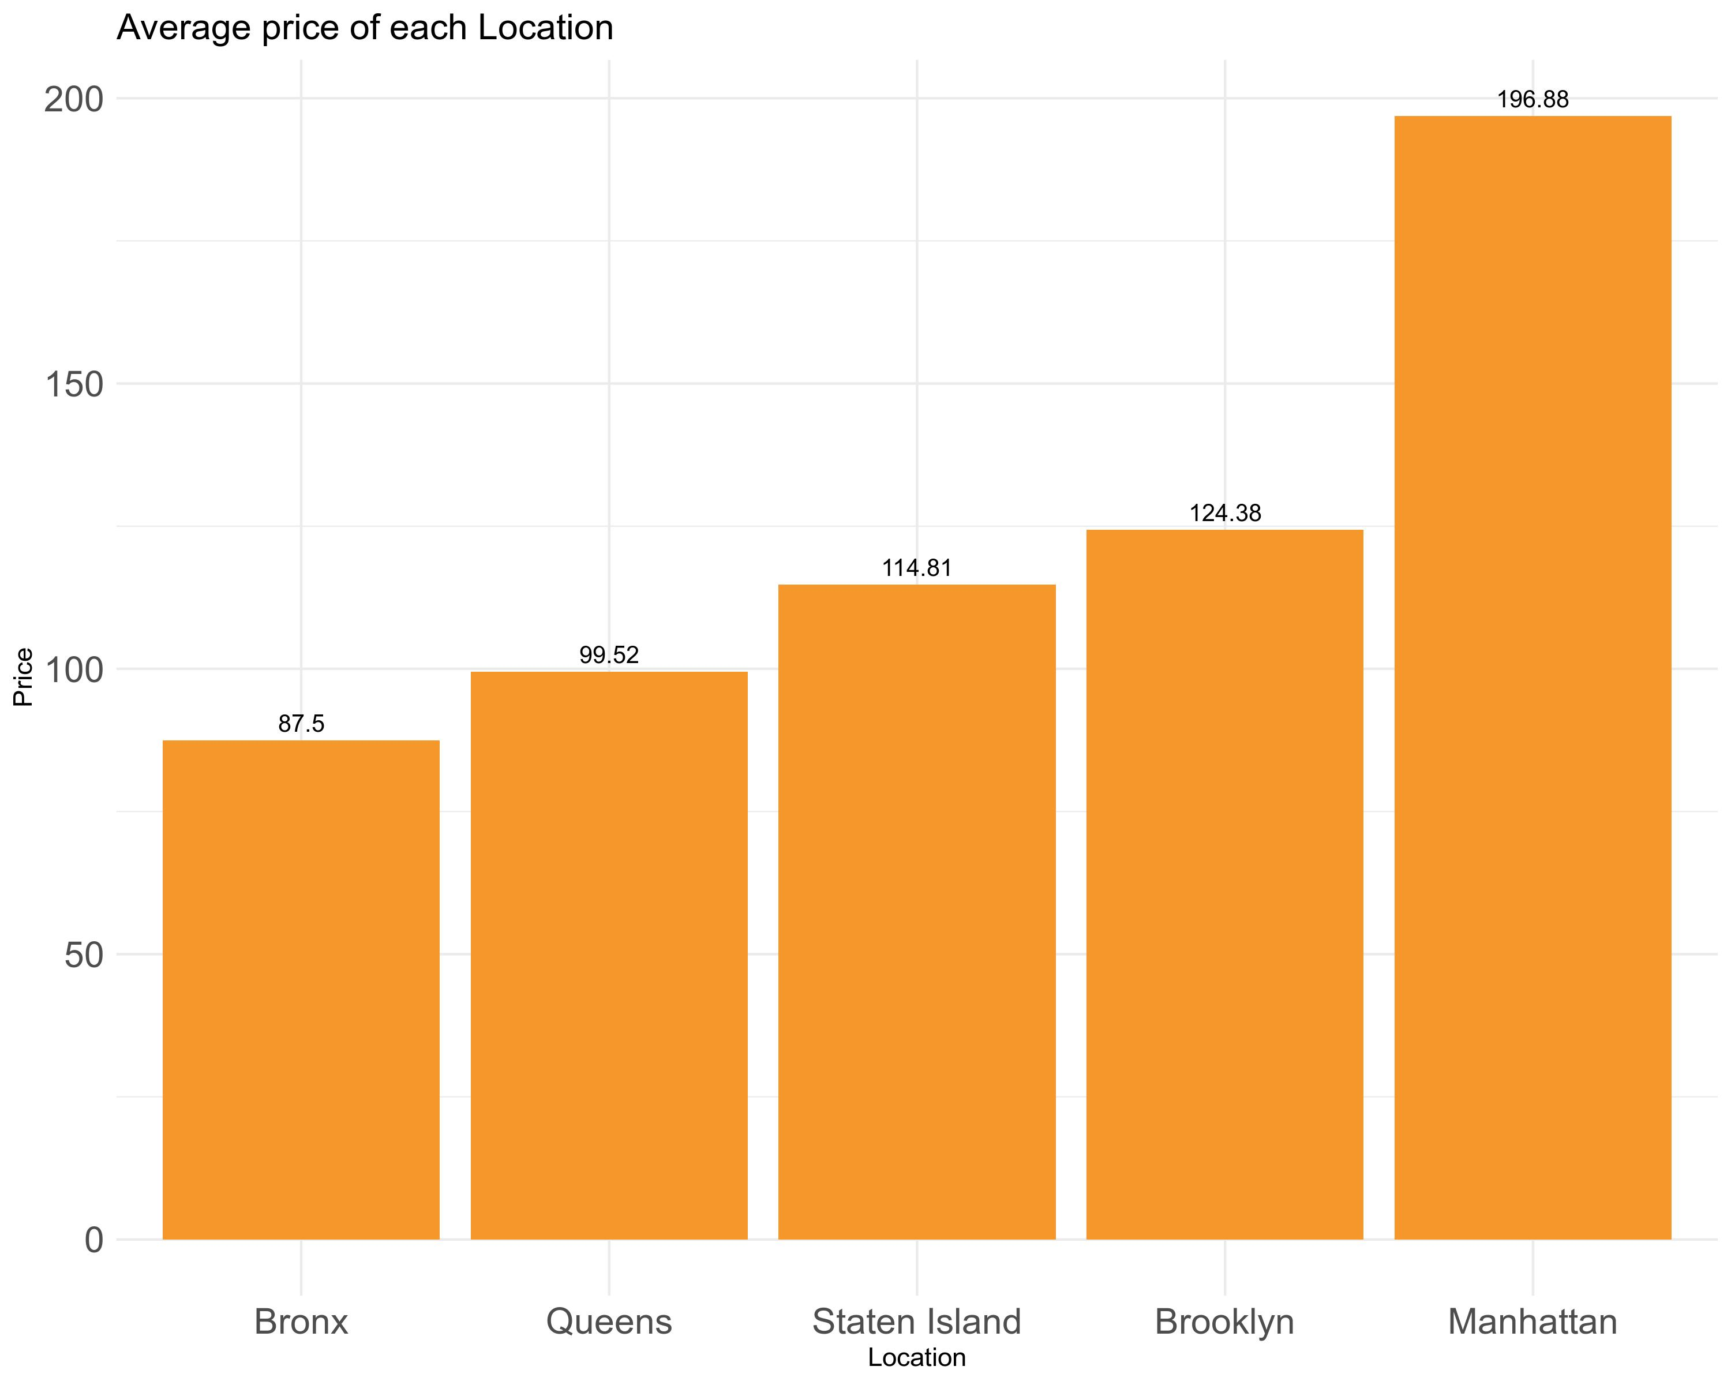

## **Ranking by Room Type**

#### Below is the chart that shows the distributions of Different room types of each location with respect to reviews.

#### Entire Room/Apartment type is highest in number, of all the other room types, and **Manhattan** has the highest Entire Room/Apartment type. People in Queens and Bronx prefer private room compared to Entire Room/Apartment type, this is so intuitive. We can also infer that shared room reviews are way less compared to other room types.

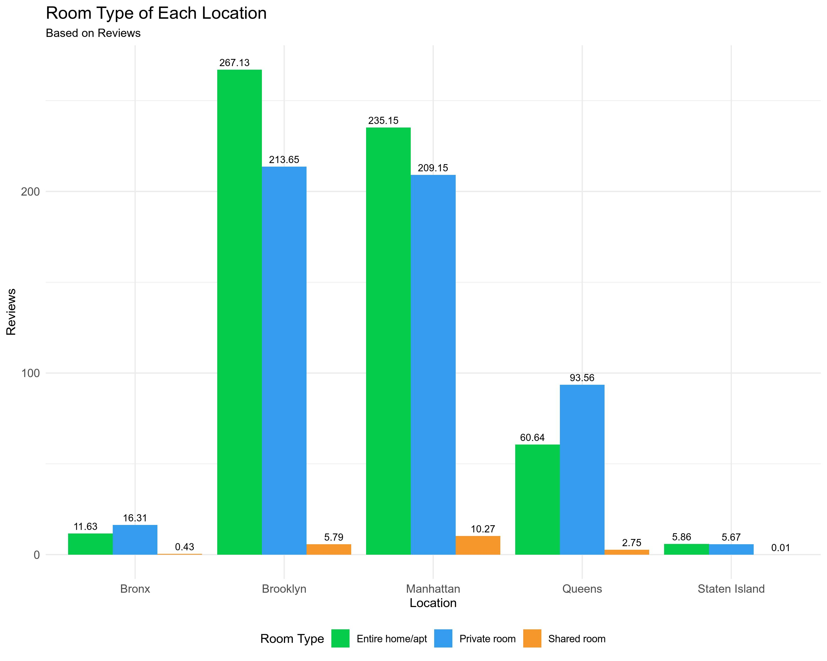

## **CORRELATION PLOT**

#### This correlation plot is representing the correlation matrix of the numeric variables in the dataset. We exclured 2 variables : “id” and “host_id” which are also determined as numeric variables but have no meaning in our analysis.

#### Through this correlation matrix, we found that the “availability_365” variable is most correlated with the variable “calculated_host_listings_count” (21%), and then with the variable “number_of_reviews” (17%). Howerver, the correlations are not very strong.

