**SECTION 0**

1. Create a directory ‘project_ dir’ & cd to ‘project _dir’

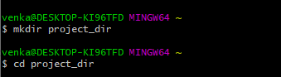

2.initialize git

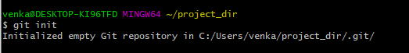

3.create a index file



4.check git status

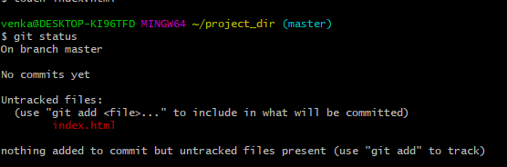

5.stage index.html



6.commit index.html

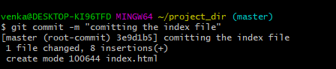

8.check git status

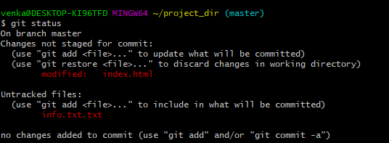

9.configure git



10.check git status

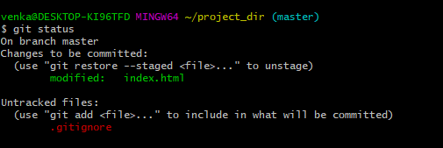

11.commit index.html

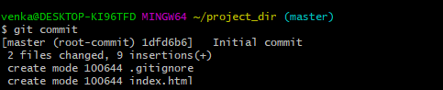

12.log all commit

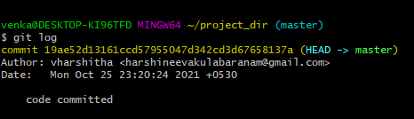

14.revert change

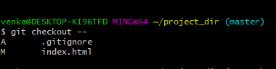

16.stage index.html



17.revert back



18.rename add as my add



19.commit index.html using my-add



20.revert last comment

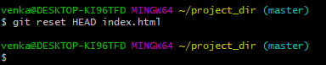

**SECTION 1**

**GIT BRANCHING**

22. Create an empty directory ‘Assignments’ &amp; cd to ‘Assignments’.

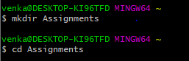

23. Create a file README.txt inside ‘Assignments’ & write few lines about the contents of ‘Assignments’ folder.



24. Commit README.txt file.

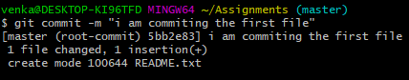

25. Now create a new branch ‘html -assignment’.

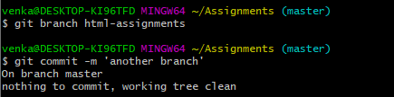

26. Switch to ‘html-assignments’ branch.

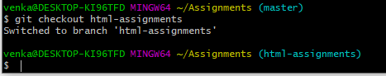

27. Copy all HTML assignments inside ‘Assignments’ folder.

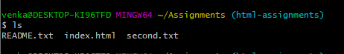

28. Commit HTML assignments into ‘html-assignments’ branch.

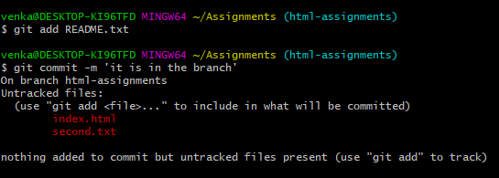

29. Make minor changes into few files belonging to ‘html-assignments’ branch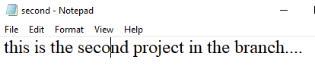

30. Commit those changed files.

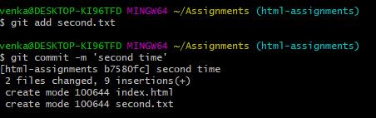

31. Switch to master branch.



32. Make minor changes into README.txt file commit those changes into master.

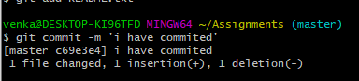

33. Again switch to ‘html-assignments’ branch.

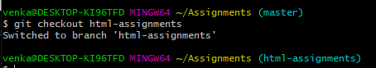

34. Make minor changes into few files belonging to ‘html-assignments’ branch.

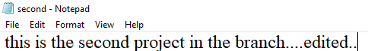

35. Commit those changes.

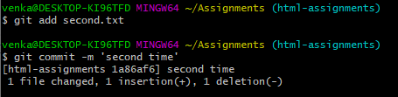

36. Switch to master.

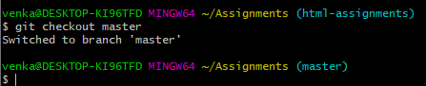

37. Merge ‘html-assignments’ branch into master. Confirm all html assignments are shown in master.

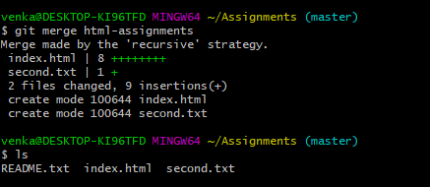

38. Finally delete the ‘html-assignments’ branch.



**SECTION 2:**

1. Create a new branch ‘css– assignments ’.



1. Switch to ‘css-assignments’ branch.

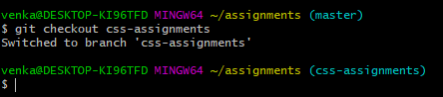

1. Copy all CSS assignments inside ‘Assignments’ folder.



1. Commit CSS assignments into ‘css-assignments’ branch.

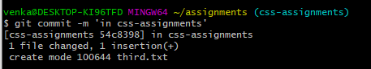

1. Make minor changes into README.txt file on line 1 belonging to ‘css-assignments’ branch.

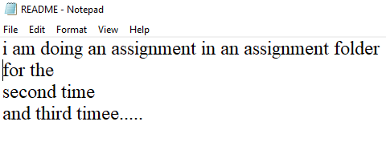

6. Commit those changed files.

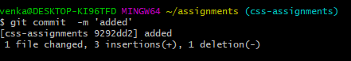

7.Switch to master branch.



8.Make minor changes into README.txt file on line 3 &commit those changes into master.

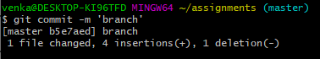

9. Again switch to ‘css-assignments’ branch.

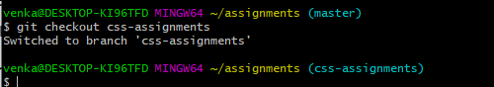

10. Make minor changes into few files belonging to ‘css-assignments’ branch.

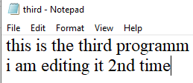

11. Commit those changes.

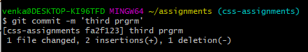

12. Switch to master.



13. Merge ‘css-assignments’ branch into master. Confirm all css assignments are shown in master.

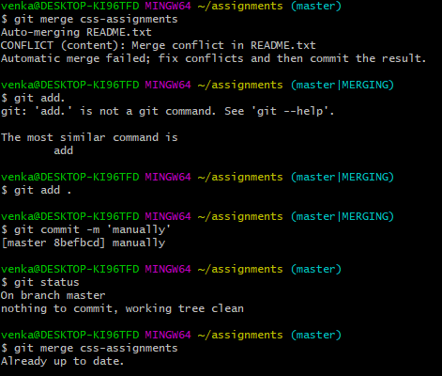

14. Finally delete the ‘css-assignments’ branch.



**SECTION 03:**

1. **Create a new branch ‘js-assignments’.**



1. **Switch to ‘js-assignments’ branch.**



**3. Copy all JavaScript assignments inside ‘Assignments’ folder.**

**4. Commit JavaScript assignments into ‘js-assignments’ branch.**

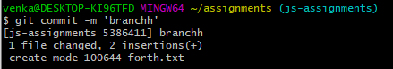

**5.Make minor changes into README.txt file on line 1 belonging to ‘js-assignments’ branch.**

**[**edited from the notepad………….**]**

**6. Commit those changed files.**

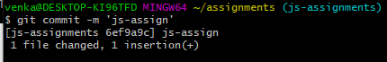

**7. Switch to master branch.**



**8.Make minor changes into README.txt file on line 1 & commit those changes into master.**

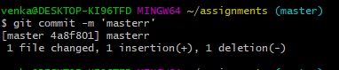

**9. Again switch to ‘js-assignments’ branch.**

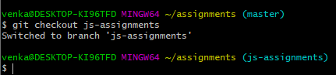

**10. Make minor changes into few files belonging to ‘js-assignments’ branch.**

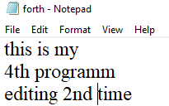

**11. Commit those changes.**

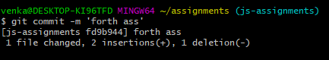

**12. Switch to master.**

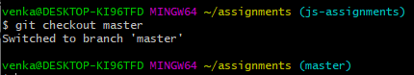

**13. Merge ‘js-assignments’ branch into master. Confirm all JavaScript assignments are shown in master.**

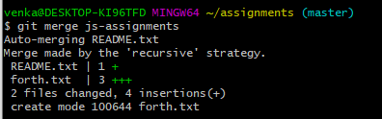

**14. Finally delete the ‘js-assignments’ branch.**

