
Continuing Education Programme (CEP) on “Advanced
Piezoelectric Materials and Devices”

Solid State Physics Laboratory (SSPL), DRDO, Delhi, September 17-19, 2025

Determination of electromechanical parameters of piezoelectric ceramics using vector impedance spectroscopy

Dr Anoop Kumar Shukla, Associate Professor, Department of Physics, Amity Institute of Applied Sciences,
Amity University Uttar Pradesh, Noida, G B Nagar. E Mail: akshukla@amity.edu


Contents

- Piezoelectric effect
- Vector – Impedance Characterization of a Piezoelectric Radial Mode Resonator
  - Evaluation of electromechanical parameters through equivalent circuit analysis
  - Evaluation of electromechanical parameters through direct measurement of series and parallel resonance frequencies
- Comparison of results obtained from two approaches
- Some ongoing work on lead-free materials materials in our group
- Few applications of piezoelectric materials


Piezoelectric Effect

- Discovered in 1880 by the brothers Pierre Curie and Jacques Curie
- There are certain materials which become polarized under mechanical stress
- A potential difference is created due to mechanical stress applied in certain directions
- Piezoelectric Effect: Pressure – Electricity
- Material must be non-centrosymmetric
- Quartz, Lithium Niobate, Barium Titanate, Lead Zirconate Titanate


Direct piezoelectric effect (Generator Action)

- Change in surface charge density due to applied mechanical
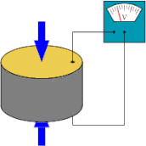
stress
- Contraction and elongation of material produce opposite charges on a particular face
- The developed polarization is directly proportional to the stress
- First order approximation
- 𝐷 = 𝑑𝑇, d is piezoelectric charge constant
- D is dielectric displacement (C/m2), T is applied stress (N/m2)
- d is charge constant (C/N)

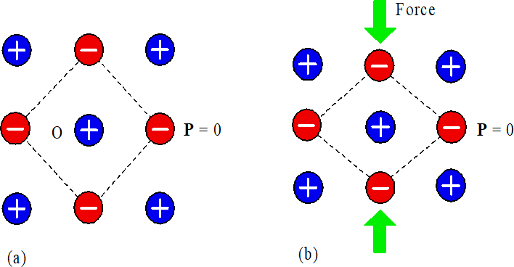
Mechanical to Electrical Energy Conversion

- Centrosymmetric crystals do not produce polarization under mechanical stress
- After compression or elongation, the center of symmetry does not change and hence P = 0
- Consider a non-centrosymmetric hexagonal unit cell
- F = 0, the centers of mass for positive and negative ions
coincide.
- F is applied in Y-direction centers of mass for positive and negative ions shift leading to a net dipole moment P along y.
- F is applied along X, which may not produce net dipole moment in X-direction

A

O

B

(a)

P = 0

y

A''

B''

x

P = 0
P

(c)

A'

B'

(b)
P










- The net dipole moment may be observed along Y-direction
Picture courtesy From Principles of Electronic Materials and Devices, Third Edition, S.O. Kasap (© McGraw-Hill, 2005)


Piezoelectric Coupling Coefficients

  - The piezoelectric materials convert the mechanical energy to electrical energy
  - Application of electric field produces mechanical strain in the piezoelectric
material
  - Piezoelectric materials are electromechanical transducers
  - The energy conversion in piezoelectric materials is characterized by
piezoelectric coupling factor (k)

  - 𝑘2 = 𝑒𝑙𝑒𝑐𝑡𝑟𝑖𝑐𝑎𝑙 𝑒𝑛𝑒𝑟𝑔𝑦 𝑐𝑜𝑛𝑣𝑒𝑟𝑡𝑒𝑑 𝑡𝑜 𝑚𝑒𝑐ℎ𝑎𝑛𝑖𝑐𝑎𝑙 𝑒𝑛𝑒𝑟𝑔𝑦 or
𝑖𝑛𝑝𝑢𝑡 𝑒𝑙𝑒𝑐𝑡𝑟𝑖𝑐𝑎𝑙 𝑒𝑛𝑒𝑟𝑔𝑦

  - 𝑘2 = 𝑚𝑒𝑐ℎ𝑎𝑛𝑖𝑐𝑎𝑙 𝑒𝑛𝑒𝑟𝑔𝑦 𝑐𝑜𝑛𝑣𝑒𝑟𝑡𝑒𝑑 𝑡𝑜 𝑒𝑙𝑒𝑐𝑡𝑟𝑖𝑐𝑎𝑙 𝑒𝑛𝑒𝑟𝑔𝑦
𝑖𝑛𝑝𝑢𝑡 𝑚𝑒𝑐ℎ𝑎𝑛𝑖𝑐𝑎𝑙 𝑒𝑛𝑒𝑟𝑔𝑦


Efficiency and charge constant
The efficiency of a piezoelectric material is defined as
𝜂 = 𝑂𝑢𝑡𝑝𝑢𝑡 𝑚𝑒𝑐ℎ𝑎𝑛𝑖𝑐𝑎𝑙 𝑒𝑛𝑒𝑟𝑔𝑦Τ𝐶𝑜𝑛𝑠𝑢𝑚𝑒𝑑 𝑒𝑙𝑒𝑐𝑡𝑟𝑖𝑐𝑎𝑙 𝑒𝑛𝑒𝑟𝑔𝑦
Or
𝜂 = 𝑂𝑢𝑡𝑝𝑢𝑡 𝑒𝑙𝑒𝑐𝑡𝑟𝑖𝑐𝑎𝑙 𝑒𝑛𝑒𝑟𝑔𝑦Τ𝐶𝑜𝑛𝑠𝑢𝑚𝑒𝑑 𝑚𝑒𝑐ℎ𝑎𝑛𝑖𝑐𝑎𝑙 𝑒𝑛𝑒𝑟𝑔𝑦

- Piezoelectric Charge Constant
- The magnitude of the strain S produced by electric field E
- 𝑑 = 𝑆Τ𝐸 = 𝐷Τ𝑇
- Unit is C/N or m/V
- Important figure of merit for actuator application


Piezoelectric voltage constant

    - The induced electric field E in the material is related to the applied stress T
    - Parameter relating E and T is known as piezoelectric
voltage constant (g)
    - The voltage constant is defined as 𝑔 = 𝑑
𝗌𝑜𝗌𝑟
    - The piezoelectric voltage constant is important figure of merit for electromechanical sensor applications and piezoelectric energy harvesting devices


Converse Piezoelectric Effect (Motor Action)

- A mechanical strain is observed under application of an

V=0
electric field
- Material exhibit expansion or contraction depending upon the direction of the electric field
- The strain is directly proportional to the applied field
- 𝑆 = 𝑑𝐸
- d is piezoelectric charge constant (m/V)

V≠0

- 𝑑 =
𝑆Τ𝐸 =
𝐷Τ𝑇same for both direct and converse effects


Piezoelectric constitutive equations

In piezoelectric effect, the elastic variables (T and S)are related to the electrical variable (D and E)
  - The constitutive equations for direct and converse piezoelectric effects can be expressed as
  - 𝑫 = 𝒅𝑻 + 𝜺^{𝑻}𝑬, here 𝜺^{𝑻}is the permittivity under constant stress (usually zero)
  - 𝑺 = 𝒔^{𝑬}𝑻 + 𝒅𝑬, here 𝒔^{𝑬}is the elastic compliance under constant electric field (usually zero)


Polarization and electric displacement tensors

- Piezoelectric effect is observed in anisotropic dielectrics
- Hence 𝑃 = 𝜒𝜀𝑜𝐸 and 𝐷 = 𝜀𝐸 should be replaced by tensors

𝑷𝟏 = 𝝌𝟏𝟏𝜺𝒐𝑬𝟏 + 𝝌𝟏𝟐𝜺𝒐𝑬𝟐 + 𝝌𝟏𝟑𝜺𝒐𝑬𝟑
𝑷𝟐 = 𝝌𝟐𝟏𝜺𝒐𝑬𝟏 + 𝝌𝟐𝟐𝜺𝒐𝑬𝟐 + 𝝌𝟐𝟑𝜺𝒐𝑬𝟑
𝑷𝟑 = 𝝌𝟑𝟏𝜺𝒐𝑬𝟏 + 𝝌𝟑𝟐𝜺𝒐𝑬𝟐 + 𝝌𝟑𝟑𝜺𝒐𝑬𝟑
𝑫𝟏 = 𝜺𝟏𝟏𝑬𝟏 + 𝜺𝟏𝟐𝑬𝟐 + 𝜺𝟏𝟑𝑬𝟑
𝑫𝟐 = 𝜺𝟐𝟏𝑬𝟏 + 𝜺𝟐𝟐𝑬𝟐 + 𝜺𝟐𝟑𝑬𝟑
𝑫𝟑 = 𝜺𝟑𝟏𝑬𝟏 + 𝜺𝟑𝟐𝑬𝟐 + 𝜺𝟑𝟑𝑬𝟑

- Since𝜒𝑖𝑗 = 𝜒𝑗𝑖 and 𝜀𝑖𝑗 = 𝜀𝑗𝑖
- Number of independent electrical coefficients are six


Piezoelectric Coefficient tensor

- Application of a mechanical stress T produces a strain S and
Z 3
electrical polarization P
6
5
2
Y
- Similarly application of an electric field E causes an electric polarization P and strain S
- 𝑃𝑖 = σ𝑗 𝑑𝑖𝑗𝑇𝑗, 𝑆𝑖𝑗 = σ𝑖 𝑑𝑖𝑗𝐸𝑖, (i = 1,2,3, j=1,2,3,4,5,6)
- A piezoelectric material can be described by a matrix of
electromechanical coefficient
- Piezoelectric coefficients, elastic constants, and permittivity are 1
all tensors X 4
- Permittivity- Second Rank, Piezoelectric Coefficient-Third Rank
and Elastic compliance-Fourth Rank tensors
- Axes notation, Cartesian System X-, Y- and Z- are 1, 2 and 3
- The shear effects are represented as 4, 5 and 6



Vector Impedance Characterization of a Piezoelectric Ceramic Resonator


Impedance/Admittance-Phase measurement

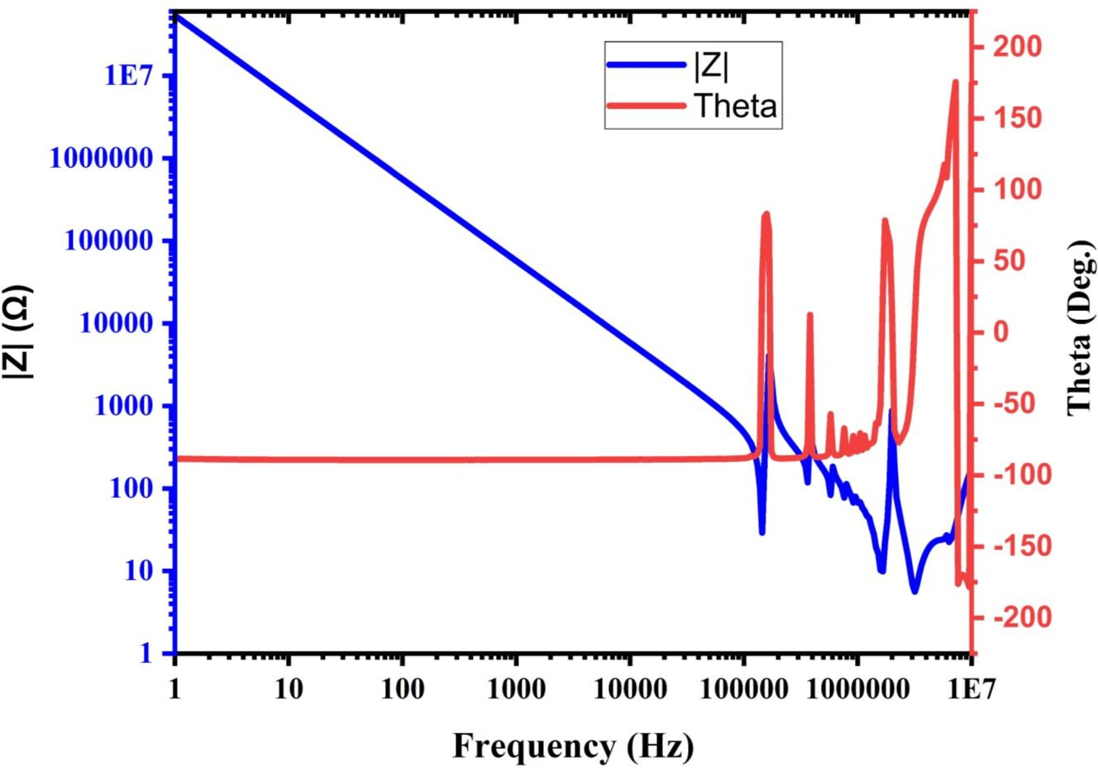
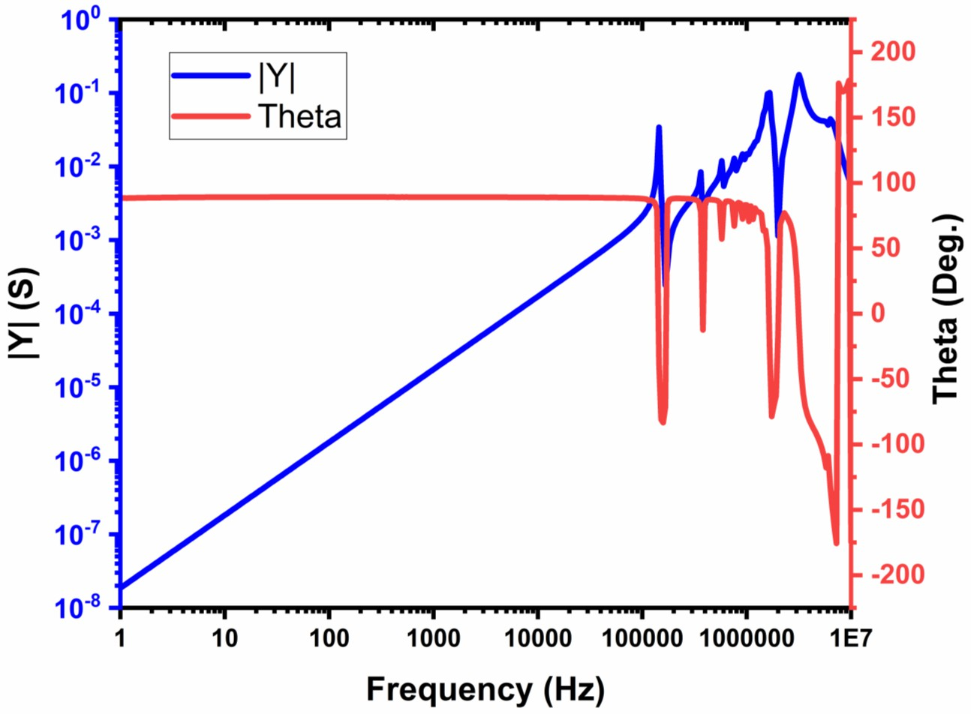
Material: Pb(Zr0.57, Ti0.43)O3 + 6 at % of lanthanum


Characteristic frequencies of a piezoelectric resonator

Frequencies fm & fn corresponds to minimum and maximum impedance
Frequencies at which reactance Xe = 0, are the resonant and anti-resonant frequencies fr & fa

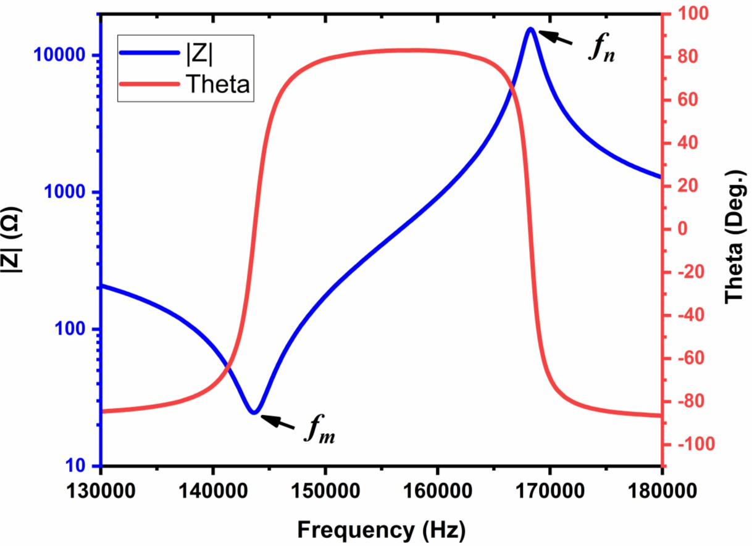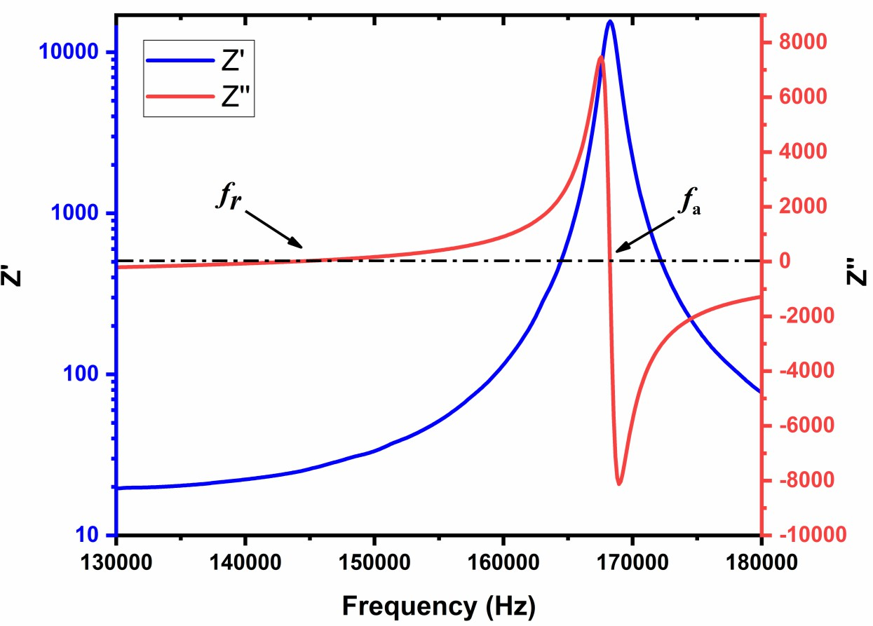



Evaluation of electromechanical parameters using equivalent circuit analysis


Equivalent circuit of a piezoelectric resonator




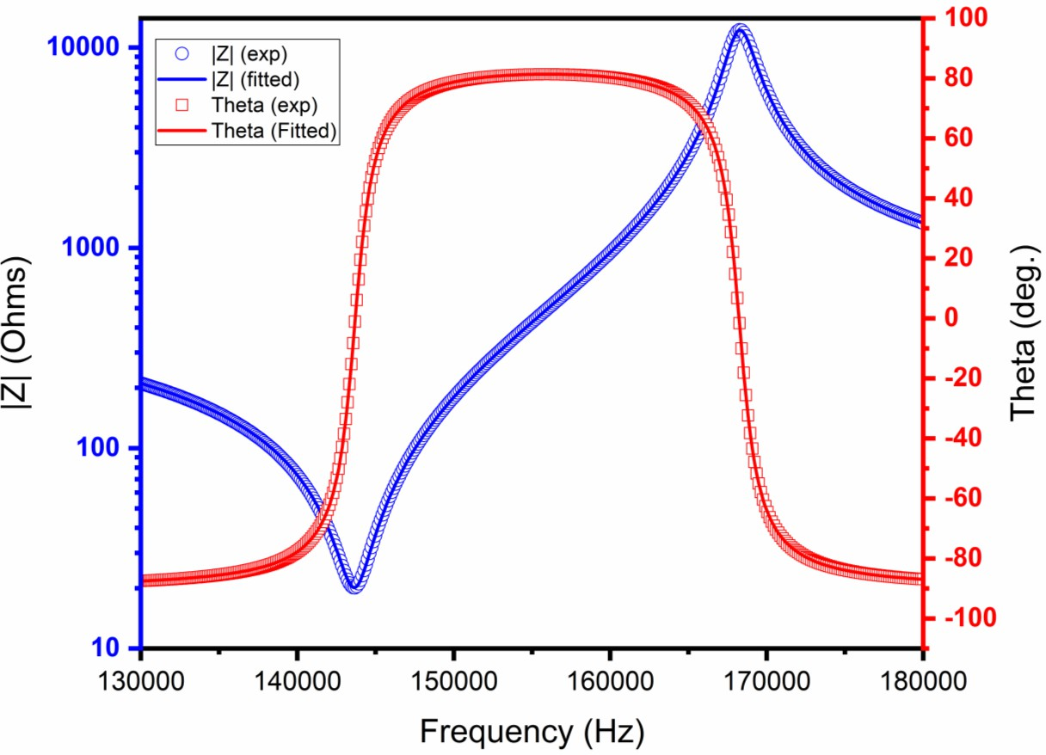
R
Cb

G = 1
R
L b
b

Ca

R – Motional resistance L – Motional inductance
Rb – Shunt resistance

Ca– Motional capacitance
Cb– Shunt capacitance


Simulated values of piezoelectric equivalent circuit parameters R, L, Ca, Cb and Rb
for fundamental radial mode and its overtone

x (at% of  La) | Rb infinite |  |  |  | Rb finite
 | R  (ohm) | L  (mH) | Ca  (pF) | Cb  (nF) | R  (ohm) | L  (mH) | Ca  (pF) | Cb  (nF) | Rb (ohm)
3.0 | 49.5  147.5  223.2 | 5.32  5.75  5.10 | 217.7  29.5  13.7 | 0.796  0.754  0.776 | 49.4  145.0  217.7 | 5.32  5.84  5.47 | 217.7  29.1  12.8 | 0.796  0.749  0.770 | ∞  37.2×10³  7.0×10³
5.0 | 24.5  77.0  120.6 | 2.48  2.49  2.22 | 490.1  72.4  33.6 | 1.389  1.293  1.326 | 24.5  74.4  118.3 | 2.48  2.55  2.37 | 490.1  70.73  31.4 | 1.389  1.277  1.309 | ∞  13.2×10³  4.4×10³
6.0 | 20.2  71.6  121.4 | 1.73  1.85  1.67 | 708.3  98.9  45.4 | 1.906  1.766  1.815 | 20.2  70.2  120.5 | 1.73  1.90  1.91 | 708.3  96.7  39.7 | 1.906  1.748  1.788 | ∞  11.6×10³  2.0×103
8.0 | 17.8  86.7  141.7 | 1.52  2.00  1.62 | 657.0  75.2  38.1 | 2.203  2.117  2.329 | 17.8  85.8  144.6 | 1.52  2.06  2.16 | 657.0  72.9  28.6 | 2.203  2.097  2.268 | ∞  7.4×10³  1.2×10³
10.1 | 57.9  166.0  281.8 | 4.68  4.54  3.15 | 277.6  42.8  25.1 | 2.006  1.999  2.071 | 57.9  162.0  275.7 | 4.68  5.09  5.22 | 277.6  38.2  15.1 | 2.006  1.971  2.055 | ∞  3.3×10³  1.3×10³
12.1 | 28.0  94.7  175.8 | 2.58  2.59  1.95 | 321.7  48.5  26.3 | 2.112  2.127  2.219 | 28.0  92.0  176.0 | 2.58  2.80  2.93 | 321.7  44.8  17.1 | 2.112  2.097  2.233 | ∞  2.9×10³  0.9×10³


Significance of equivalent circuit parameters

- R represents mechanical dissipation of the piezoelectric resonator.
- L represents mass transformed into electrical magnitude by piezoelectric effect.
- Ca represents elastic compliance transformed into electrical magnitude by piezoelectric effect.
- Cb is the capacitance in the absence of mechanical deformations at the concerned frequency of
resonance
- Rb is the loss associated with Cb
- In general, these parameters are independent of frequency
- This is true only for a narrow range of frequencies near the resonance frequency


Determination of electromechanical parameters according to IEEE std.

For Gb→0 the impedance of this circuit is given




Z =
ω
ωsQmR
jω r
1 + jQm
ωൗω
s
−
ωsൗω
1 + jQ
m
1 + r ൗ
r
ωൗ
ωp
−
ωpൗ
ω
Cb

= Z ∠θ
= Re + jXe

Capacitive ratio r = ^{Cb}ൗC
a
R

G = 1
R

M =
QmΤr
= 1Τ
L b
b

ωs = 2π fs =
1Τ L.Ca
ωsCbR
Ca
1 + 1Τr
ωp = 2π fp = ωs

(Proc. IRE 45, 354(1957))


Determination of electromechanical parameters according to IEEE std.

- The planar coupling coefficient KP can be determined

K2
J1 φ 1+ Δfൗfs
−φ 1+ Δfൗfs
J1 φ 1+ Δfൗfs
J0 φ 1+ Δfൗfs
1−σE
P
1−K2 =
1+σE
P
- Here ∆fps =fp-fs. J0 & J1 are the Bessel function of first kind and zero order and first order
- σE is the Poisson’s ratio

- φ is the lowest positive root of the equation
1 − σ^{E}
J1
= φJ0

- The roots of this equation are related the resonant frequencies of fundamental and overtones of
φ
φ
radial mode of the thin circular discs.
2 2
1 − σ^{E}
K
- The coupling coefficient K₃₁ can be determined as K = 0.5
31
P

(Proc. IRE 49, 1161(1961))


Determination of electromechanical parameters according to IEEE std.

  - The elastic compliance can be calculated from

1 4π²a²f ² 1 − σ^{E}2 ρ
s
E = φ2
s
11
  - Here ‘a’ is the radius of the disk and ‘ρ’ is the density of the material

  - The piezoelectric strain constant d31
= K31
1Τ2

  - Hydrostatic piezoelectric strain constant dh = d33 + 2d31
ε0ε^{T}
33 11
sE

  - Piezoelectric voltage constants g31 =
d31Τε0ε^{T} , g33 =
d33Τε0ε^{T}

  - Acoustical velocity V² = 1Τ
33
33
s
E
11 ρ

- Here 𝜀^{𝑇} is the dielectric constant and d
1 − σ^{E}2
33
31
is negative


Calculation of Poisson’s ratio

- Poisson’s ratio can be calculated from the ratio of resonance frequencies of fundamental and first overtone
- σ^{E} = −
sE
12 11
ൗs^{E}
1 − σ^{E}

J1

3
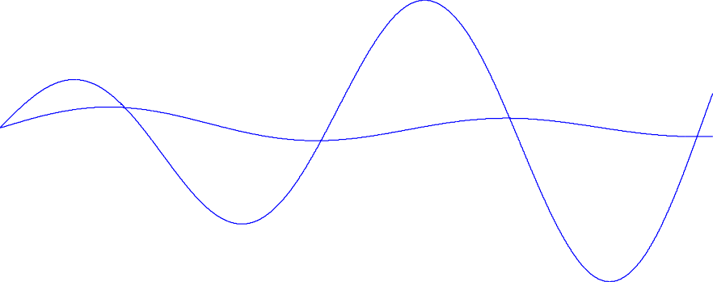
= φJ0
φ
φ

2

φiV

1 2
2 1Τ2 1

- ωφi =
1− 1Τ3 φ σ tൗ 1−σ 2a
i
E
E
2
1− 1Τ3 φ σ tΤ 1−σ 2a
0
E
E
2
a 1 − 3 γiφi
, Where γi=1 for all ϕ’s. 0

•

2
=
^{ω}si ^{ω}s0
φiΤφ0

2

-1
σEt
1−σE 2a

-2

-3
0 2 4 6 8 10 12



Evaluation of electromechanical parameters through
direct measurement of fs and fp


Direct measurement of fs, fp and calculation of electromechanical parameters


- At the series resonant frequency fs, real part of 𝜔 is maximum
𝑌 𝜔

- At parallel resonant frequency fp, the real part of ωZ
𝜔
is maximum

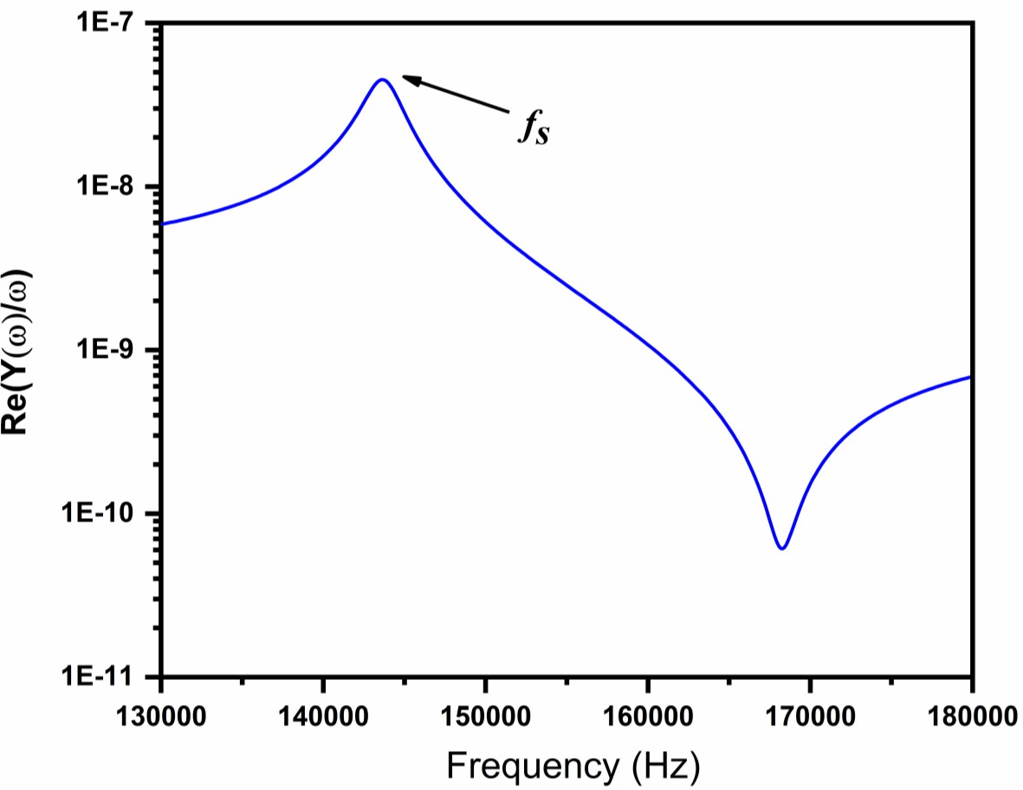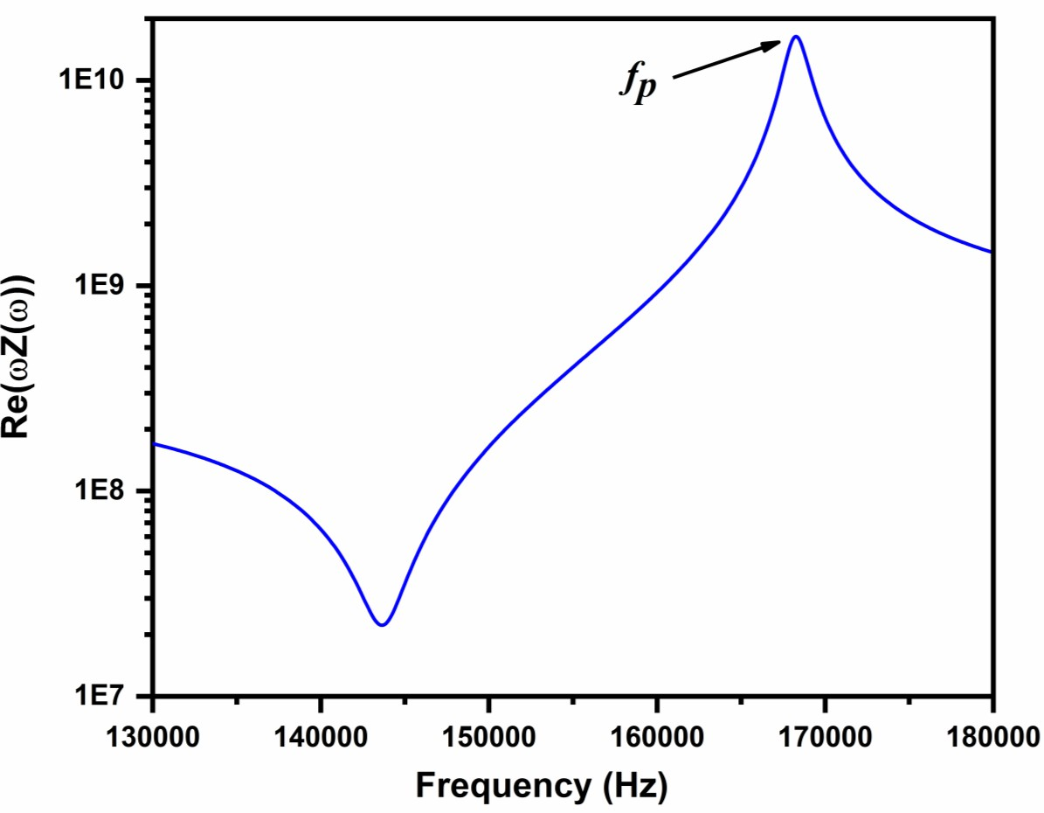
S. Sherrit, N. Gautheir, H. D. Wiederick and B. K. Mukherjee, Ferroelectrics. 119, 17 (1991).


Direct measurement of fs, fp and calculation of electromechanical parameters

- The admittance of radial resonator is given as

- 𝑌
−jω ε₀𝗌𝑝 πa2
=
𝜔
33

𝑡
− 1 , 𝐽
= xJ₀ 𝑥


𝐽1 𝑥
𝑥
, 𝑥 = ωa

- Once the 𝜎^{𝑝} and ωp are known 𝑘^{𝑝} can be determined from
2 𝑘𝑝 2
1−𝜎𝑝−𝐽 ωaൗ 𝑐𝑝
1Τ2
11
ൗ𝜌
𝑐𝑝
11
ൗ𝜌

- ² =
𝑘𝑝
1−𝜎𝑝−𝐽 𝜔 𝑎ൗ 𝑐𝑝
𝑝
11
1Τ2
ൗ𝜌
2

IEEE Standards on Piezoelectricity, 176 (1978).


Direct measurement of fs, fp and calculation of electromechanical parameters

- Knowing fs
and fp
of the fundamental and first harmonic 𝜎^{𝑝}and 𝑐^{𝑝} can be determined by the non-linear

least square polynomial fits of the equations
11
- 𝜂 = 𝑎0 + 𝑎1𝑟𝑠 + 𝑎2𝑟² + 𝑎3 3
𝑠
𝑟
𝑠


- 𝜎^{𝑝} = 𝑏0 + 𝑏1𝑟𝑠 + 𝑏
2
𝑠
0
𝑟² + 𝑏
𝑟³ + 𝑏
𝑟4



- The coefficients {an, bn} are taken from Table I of Sherrit et al. [7] and rs is defined as 𝑟𝑠 =
𝜌Τ𝑐^{𝑝}
11
3
𝑠
4
𝑠
1
𝑓𝑠
ൗ𝑓𝑠

- 𝜂 can be evaluated from 𝜂 = 2π f𝑠
0 𝑎
1Τ2


Direct measurement of fs, fp and calculation of electromechanical parameters

  - Poisson’s ratio 𝜎^{𝑝}, radial mode coupling coefficient 𝑘^{𝑝}, piezoelectric constant 𝑒^{𝑝} , dielectric constant 𝜀^{𝑝} and
31 33
and mechanical constants 𝑐^{𝑝} are defined as
11

  - 𝜎^{𝑝} =
−𝑠^{𝐸}
ൗ𝑠^{𝐸} , 𝜀^{𝑝}
2
= 𝜀′ − 31 , 𝑐^{𝑝}
𝑠𝐸
11 12
+𝑠𝐸
2d
𝐸
= 11 ,
𝑠𝐸
11
𝑠𝐸
12
𝑠

12 11
33
𝗌0
11 2− 2

  - 𝑒^{𝑝} = 𝑑31

,
𝑝 2
2 = 𝑒31 ,
𝑘𝑝

31 𝑠𝐸 +𝑠𝐸
𝗌0𝗌𝑝 𝑐𝑝

11 12
33 11

  - The planar coupling coefficient KP as defined earlier is related to radial mode coupling coefficient kp as

₂ = 1+𝜎𝑝
𝑘𝑝
2
𝐾2
1−𝐾2
𝑃
𝑃
,

IEEE Standards on Piezoelectricity, 176 (1978).


Comparison of results obtained from two approaches

- Pb(Zr
Ti )O
+ x at % of La,

0.57, 0.43 3
x (at% of La) | fs(kHz) |  | fp(kHz)
 | observed | calculated | observed | calculated
3.0 | 147.80  386.45  602.79 | 147.83  386.41  602.78 | 166.79  393.89  608.03 | 166.82  393.90  608.07
5.0 | 144.32  374.65  583.46 | 144.24  374.66  583.45 | 167.85  384.71  591.03 | 167.77  385.00  590.79
6.0 | 143.68  371.82  578.79 | 143.67  371.80  578.49 | 168.25  381.90  585.52 | 168.26  382.01  585.68
8.0 | 159.08  410.56  640.61 | 159.03  410.45  640.05 | 181.17  417.59  645.05 | 181.20  417.68  645.26
10.1 | 139.67  361.28  566.76 | 139.64  361.06  565.96 | 148.97  364.95  569.22 | 148.99  364.91  569.38
12.1 | 174.58  449.48  703.92 | 174.74  449.26  703.46 | 187.63  454.31  706.68 | 187.58  454.36  707.61

where x = 3, 5, 6, 8, 10 and 12

- Close agreement between two approaches, and either of the methods are valid for low loss piezoelectric materials
- For lossy piezoelectric materials, e.g. ceramic polymer composites one should consider the constants as complex parameters

Shukla et al(2004): Ferroelectrics, 308:1, 67-84


σfecεk11s33121311P
sεdK′Epp(pp0)

Comparison of results obtained from two approaches

Equivalent circuit analysis Direct measurement of fs and fp
x  (at% of  La) | 𝜎𝐄 | 𝐾𝑃 | 𝑠𝐸  11  ×10-12  m2/N | 𝑑31  ×10-12  C/N
3.0 | 0.31 | 0.52 | 14.1 | -100
5.0 | 0.32 | 0.58 | 15.9 | -157
6.0 | 0.34 | 0.59 | 16.7 | -197
8.0 | 0.33 | 0.54 | 14.7 | -182
10.1 | 0.33 | 0.39 | 18.3 | -129
12.1 | 0.35 | 0.41 | 12.5 | -115

x (at% of  La) | 𝜎𝑝 | 𝐾𝑃 | 𝑠𝐸  11  ×10-12  m2/N | 𝑑31  ×10-12  C/N
3.0 | 0.32 | 0.52 | 14.25 | -96
5.0 | 0.35 | 0.58 | 16.58 | -154
6.0 | 0.36 | 0.59 | 17.14 | -192
8.0 | 0.37 | 0.54 | 15.25 | -178
10.1 | 0.36 | 0.39 | 19.02 | -118
12.1 | 0.38 | 0.42 | 12.91 | -114


Development of doped barium zirconate titanate (BZT) based piezoelectric ceramics for acoustic emission sensor applications

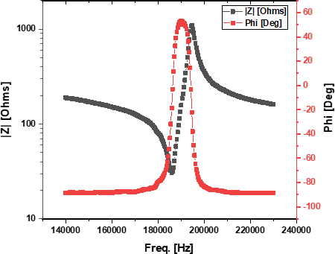
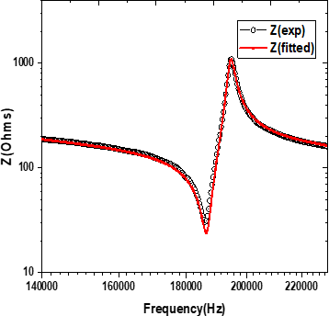


Developed for DMRL, Hyderabad, supplied ~400g powder and ~20 sintered discs with density >95%


Piezoelectric response of Cd-doped BCZT ceramics

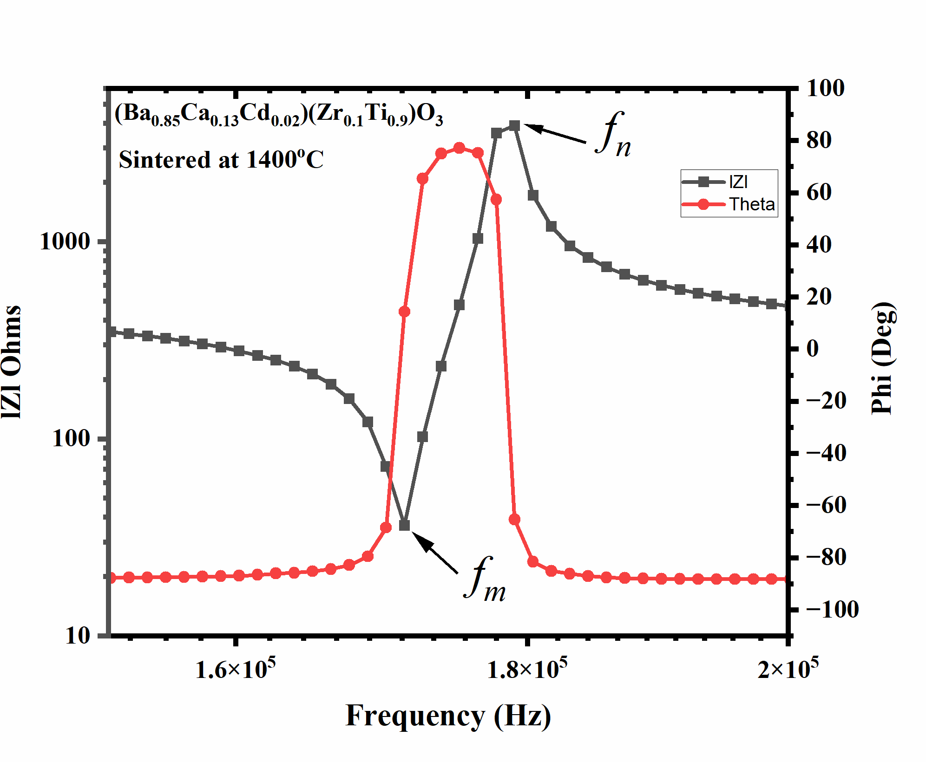
Sintering  temperature  (ºC) | Cd  content (x) | kp | kt | d33  (pC/N)
1400 | 0.00 | 0.32 | 0.30 | 311
 | 0.02 | 0.46 | 0.44 | 420
 | 0.04 | 0.19 | 0.18 | 178
 | 0.06 | 0.14 | 0.14 | 176
 | 0.00 | 0.40 | 0.39 | 404
1450 | 0.02 | 0.18 | 0.18 | 200
 | 0.04 | 0.16 | 0.16 | 165
 | 0.06 | 0.13 | 0.12 | 104
 | 0.00 | 0.46 | 0.44 | 500
1500 | 0.02 | 0.17 | 0.16 | 175
 | 0.04 | 0.16 | 0.16 | 135
 | 0.06 | 0.10 | 0.09 | 98

Salma et al. Ceramics International 51 (2025) 41251–41263



Applications of Piezoelectric Materials


Applications of Piezoelectric Materials

Generators
(millivolts to kilovolts)
Motors
(microns to millimeters)

- Hydrophones
- Microphones
- Gas igniters
- Accelerometer
- Power supplies
- Photoflash actuators
- Piezoelectric pens
- Impact fuses
- Composites
- Energy harvesting
- Actuators
- Loudspeakers
- Camera shutters
- Buzzers
- Ink jet printers
- Fish finders
- Micropositioners
- Valve controllers
- Pumps
- Video head positioner
- Ultrasonic motors
- Piezoelectric fans
- Relays


Applications contd.

Motor – Generator
(combination devices)

  - Sonar
  - Non – destructive testing (NDT)
  - Medical ultrasound
Resonant devices
(kilohertz to megahertz)
- Ultrasonic cleaners
- Ultrasonic welders
- Filters
- Transformers


Piezoelectric Gas Igniter
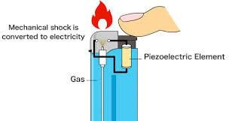
- A piezoelectric crystal is the heart of the gas igniter.
- When a strong force is applied on it by means of a spring loaded hammer it produces an electric spark.
- Requires no batteries or fuel


Piezoelectric Actuators

  - Displacement of up to several hundreds of microns with high
accuracy ( ± 0.01 µm)

  - High Response time on the order of 10 µs.

  - Generative force as large as 400 kg/cm2

  - Driving power an order of magnitude smaller than electromagnetic motors


In Space Structure and Military Vehicles Using P/E Actuators

Automation
Equipment
Optical Instrument.
Camera
Semi-conductive Chips

VIBRATION SUPPRESSORS

MOTORS

POSITIONER
ACTUATORS APPLICATION FIELDS


Piezoelectric Motor




SQUIGGLE* Linear Piezoelectric Motor
only 1.55x1.55x6 millimeters

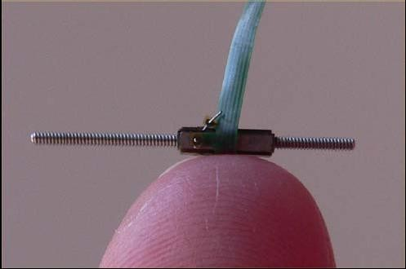
Uses less than
0.1 Watt to
produce 20 grams of force at 5 mm per second.

*Registered trademark of New Scale Technologies, Inc., USA


Auto focusing in camera installed cell phones

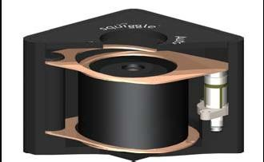
Flexure guide

Retracted Lens

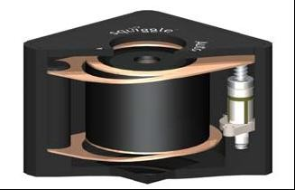
Motor

Extended Lens

Courtesy New Scale Technologies, Inc., USA


Piezoelectric Biosensors

- Blood, urine and saliva analysis
- HIV, Anthrex and Hepatitis detection
- Lab on a chip
- Work is in preliminary stage at international level


Schematic diagram of a piezoelectric biosensor

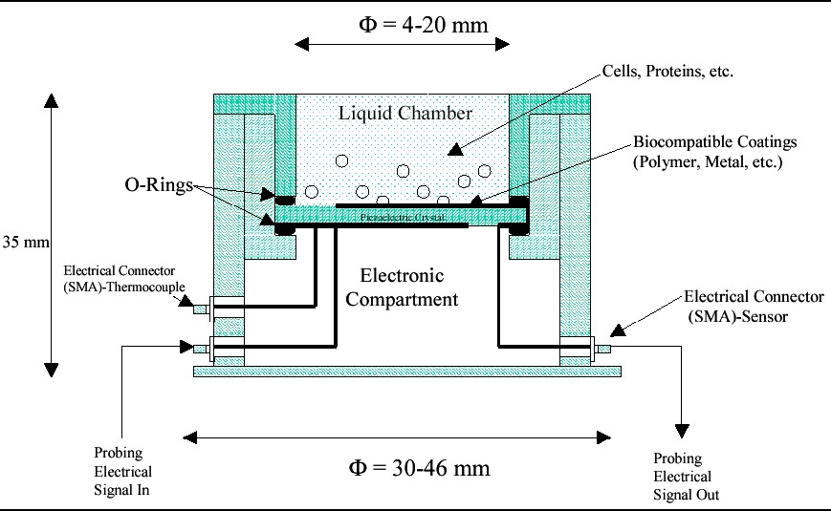
Piezoelectric crystal

Courtesy www.biomed.drexler.edu/technologyportfolio


Acoustic Emission Sensor

- Acoustic Emission (AE) can be defined as the vibration or stress waves generated during dynamic process in materials.
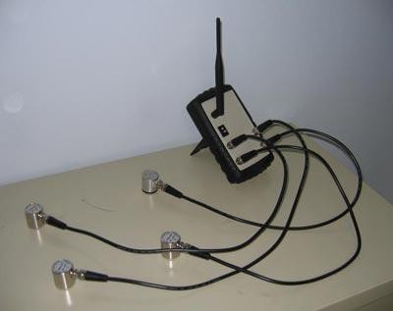
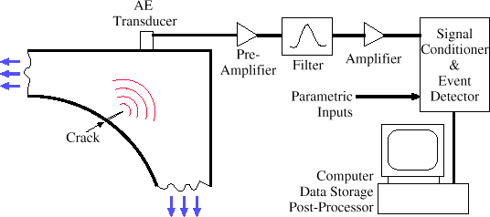
- AE monitoring system consists basically of a detector or pick-up to detect the material’s noise vibration and convert it to an equivalent electrical signal.


Ultrasound Imaging

- After X-rays, the ultrasound imaging is most extensively used technique in biomedical field.
- The ultrasound is a safe, real time, accurate, reliable, portable and cost effective imaging technique.
- It is used for characterizing the heart function, monitoring the growth of fetus in womb, locate cyst in liver / kidney, and assess carotid plaques and breast tumor
- Ultrasound imaging is less hazardous to soft tissues


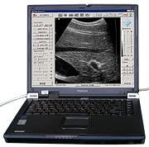

Ultrasound imaging

Receiver
Transmitter
Control

Acoustic matching layer
Acoustic lens
Coupling layer
Object
Transducer: PZT, PMN-PT, PZNT,PVDF
– TrFE etc
Scan Frame

A K Shukla, S L Srivastava, Smart Materials : Piezoelectrics, Nova Science Publisher, USA, 2012


Ultrasound Imaging

  - The ultrasound imaging uses pulse echo technique for imaging of the biological organs.
  - The piezoelectric materials generate and sense the acoustical signals and, therefore, suited for pulse echo measurements.
  - The piezoelectric transducer sends the ultrasonic pulse which senses the echoes also from the various obstacles in the path.


Energy Harvesting

- The search for environment friendly alternative energy sources is need of the day to overcome future energy problems.
- Extraction of energy from the external sources of environment (solar power, thermal energy, wind energy, salinity gradients, and kinetic energy), and storage for further utilization.


Piezoelectric Energy Harvesting
  - The vibrating strain energy is converted in the electrical energy using a piezoelectric system.
Capacitor
bank
Piezoelectric
device
Voltage sensing switch
Operating sensor/actuator, telemetry, MEMS etc
Strain
energy
  - This energy is stored using a rectifier into a capacitor bank up to a pre defined voltage.
  - Exceeding this voltage, the power is
transferred to the load.


Piezoelectric Energy Harvesting




Acknowledgements

- DDP, DST; ARDB, and ER&IPR, DRDO for grant of research projects
- Amity University for providing necessary facilities
- Late Dr. A R James, SC’G’, DMRL, Hyderabad for VIS measurement for ARDB, DRDO
project
- Prof. K Sreenivas, University of Delhi, and Dr. O P Thakur, SC’G’, SSPL, New Delhi for many
useful scientific discussions and support



THANK YOU

