|  |  |
| --- | --- |
|  | TutorialOn  Gaba, Vince Harley, D.  He, Zhiyang  Manuel, Lester, N. |

1. Table of Contents

A Objectives 1

B Scope and Features 2

B.1 Three Types of User 2

B.2 Real-Time Login and Logout 2

B.3 View Session Log 2

B.4 View Time Sheet 2

B.5 Add User 2

B.6 Email Students 2

B.7 Lists Logged-in Students 2

C Limitations 3

C.1 Real-Time Login and Logout 3

C.2 Email Students 3

D Class Diagram 4

D.1 {Name} Class Diagram 4

E User Manual 5

E.1 Peer Adviser Login 5

E.2 Advisee Login 7

E.3 Administrator Login 9

E.4 Administrator Panel 10

E.4.1 View Student Info 10

E.4.2 View Session Log via Date 12

E.5 Peer Adviser Signup 13

E.6 Advisee Signup 14

E.7 Administrator Signup 15

F Unit Test 17

F.1 User Class 17

F.2 Admin Class 17

F.3 Session Class 17

List of Figures

Figure F.1.a: {Name} Class Diagram 4

Figure G.1.a: Peer Adviser Login 5

Figure G.2.a: Advisee Login 7

Figure G.3.a: Administrator Login 9

Figure G.4.a: Peer Adviser Signup 14

Figure G.5.a: Advisee Registration 15

Figure G.6.a: Administrator Registration 16

Figure H.1.a: User Class 17

Figure H.2.a: Admin Class 17

Figure H.3.a: Session Class 17

# Objectives

To create a desktop application using Python

To implement three-tier architecture: Data Access Layer, Business Logic Layer, and User Interface

To use SQLite for storing data

# Scope and Features

## Three Types of User

TutorialOn users are identified as: Advisee, Peer Adviser, and Administrator – each having different user capabilities. Advisee and Peer Adviser are classified as Student users.

## Real-Time Login and Logout

TutorialOn utilizes real-time logging-in and logging-out of students.

## View Session Log

Administrators are capable of viewing session logs of Advisee users.

## View Time Sheet

Administrators are capable of viewing time sheets – the time-in and time-out of Peer Adviser users.

## Add User

Advisees with no data can register without Administrator permission. Only Administrators can add other users such as Peer Advisers and Administrators.

## Email Students

Students, either Advisees or Peer Advisers can be emailed by an Administrator through the application.

## Lists Logged-in Students

TutorialOn lists logged-in students.

# Limitations

## Real-Time Login and Logout

Logged-in student users that were not logged-out will have a null value in time-out when the application closes.

## Email Students

TutorialOn uses outlook.com server: 587 in emailing Student users, thus, email addresses not having MyMail as domain name system are not considered.

# Class Diagram

## TutorialOn Class Diagram

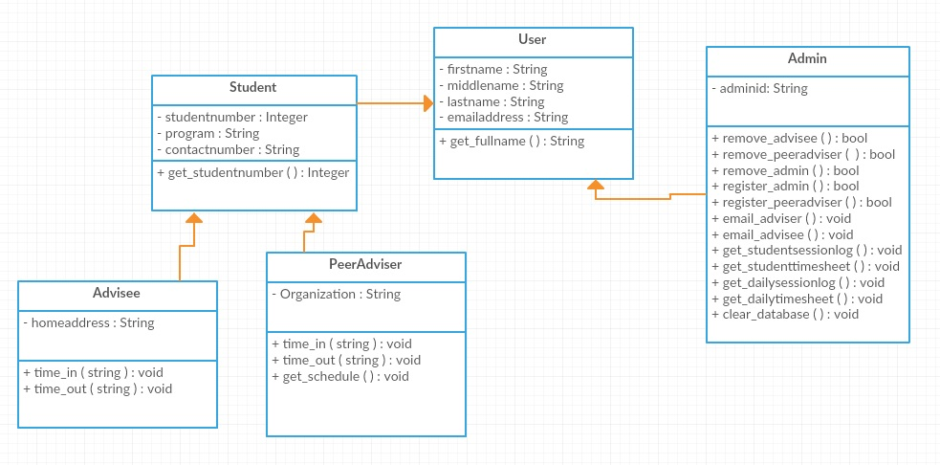

Figure .: Business Logic Layer Class Diagram

# User Manual

## Peer Adviser Login

Enter student number (10-digit).

Press Enter.

Click “Login”.

Enter password.

Click “Login”.

Click “OK”.

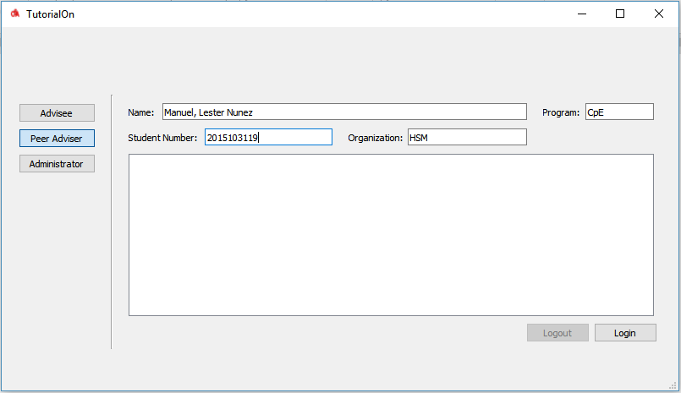

Figure .: Peer Adviser Login

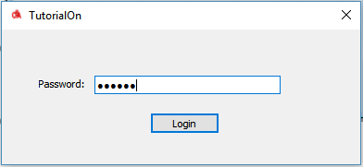

Figure .b: Peer Adviser Login Password Prompt

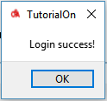

Figure .c: Peer Adviser Successful Login Prompt

## Advisee Login

Enter student number (10-digit).

Choose a field (Mathematics, Chemistry, Physics, or Professional Course)

Select a course code from the drop-down list.

If “Others” is selected, enter the course code.

Click the “…” button to choose a peer adviser from the logged in list.

Select a peer adviser.

Click “Select”.

Click “Login”.

Click “OK”.

Note: No advisee can login if there is no logged-in peer adviser.

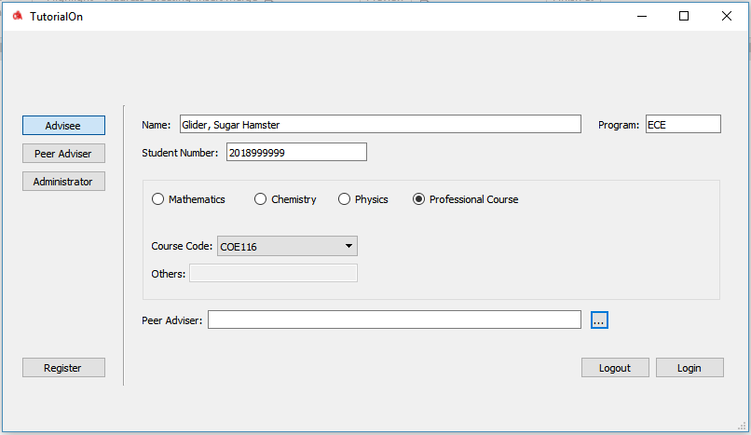

Figure .: Advisee Login

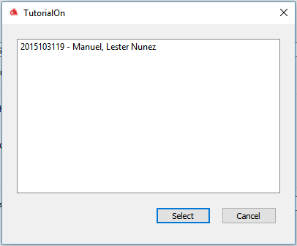

Figure 2.b: Logged-In Peer Advisers



Figure 2.c: Advisee Successful Login Prompt

## Administrator Login

Enter username.

Enter password.

Click “Login”.

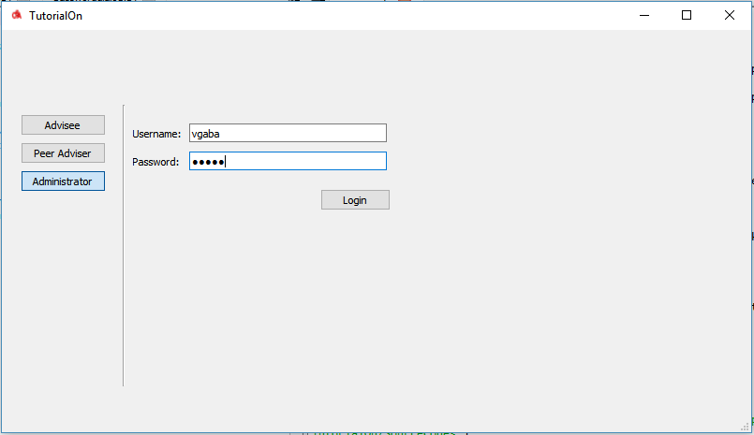

Figure .: Administrator Login



Figure 3.c: Administrator Successful Login Prompt

## Administrator Panel

### View Student Info

Choose between “Advisee” and “Peer Adviser”.

Enter 10-digit student number.

Click “Search”.

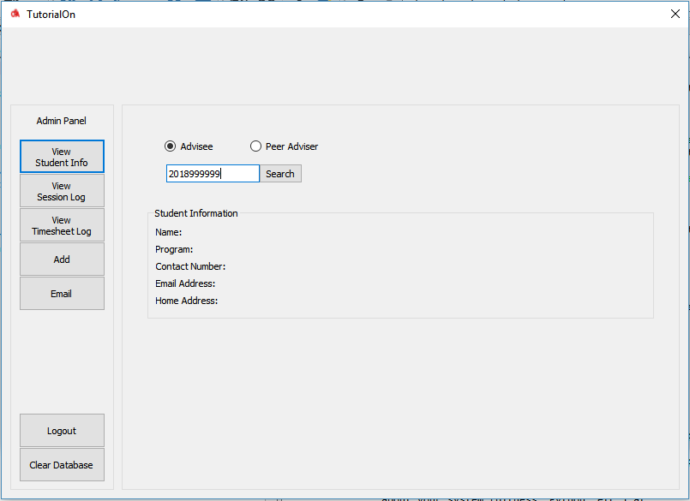

Figure 4.1.a: View Student Info Panel

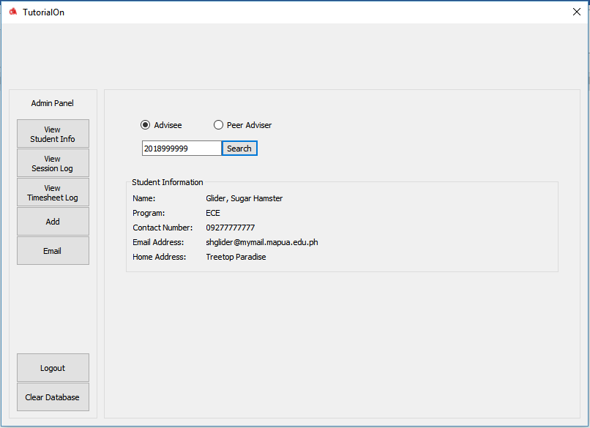

Figure 4.1.b: View Student Info Panel – Student Found

### View Session Log via Date

Select “Search by date”.

Set date.

Click “Search”.

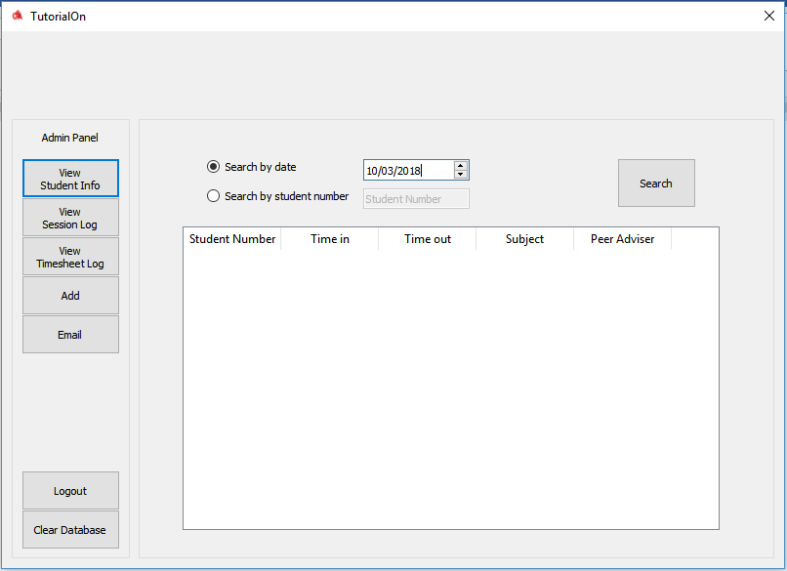

Figure 4.2.a: View Session Log Panel via Date

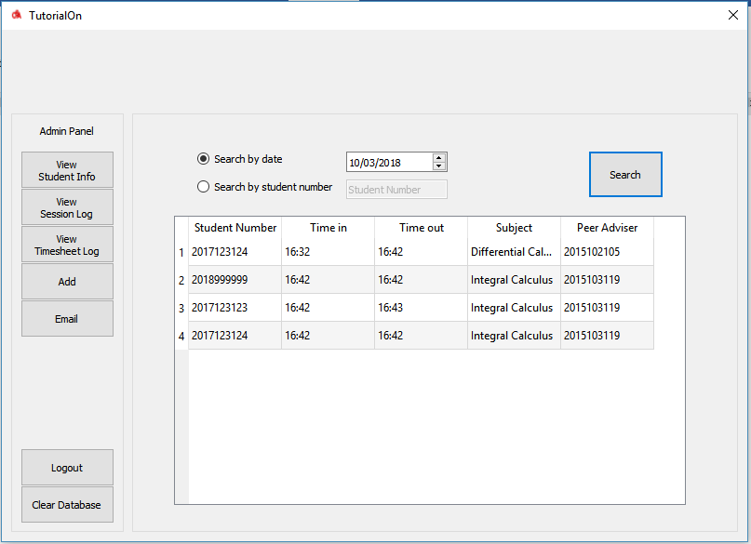

Figure 4.2.b: View Session Log Panel via Date– Student Found

## Peer Adviser Signup

Fill-up fields.

Click “Register”.

Note: Only administrators are capable of creating peer adviser’s account.

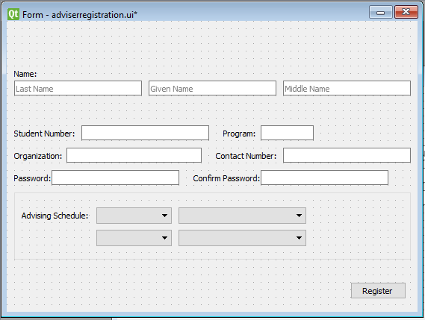

Figure : Peer Adviser Signup

## Advisee Signup

Fill-up fields.

Click “Register”.

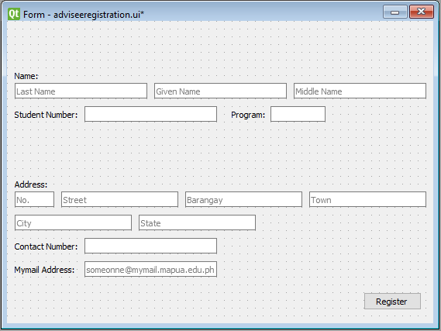

Figure : Advisee Registration

## Administrator Signup

Fill-up fields.

Click “Register”.

Note: Only administrators can create administrator account.

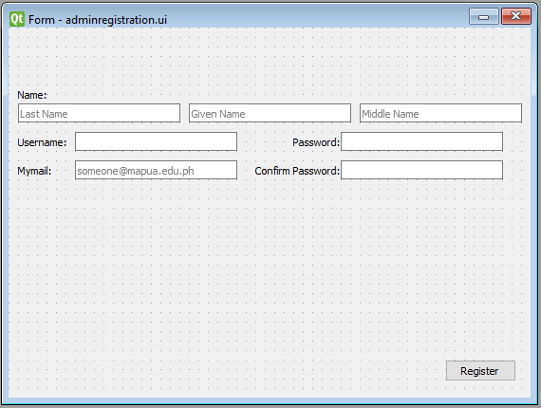

Figure : Administrator Registration

# Unit Test

## User Class

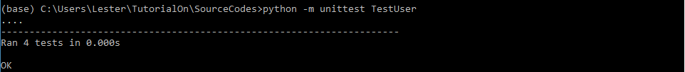

Figure : User Class

## Admin Class

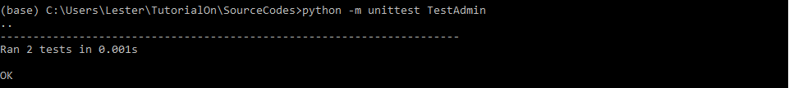 

Figure : Admin Class

## Session Class

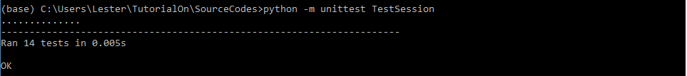

Figure : Session Class

