**Exploratory analysis**

**Vigilance Project**

**Table of Contents**

1. Justification
2. Definitions and concepts
   1. Global area
   2. Posterior area
   3. True Alpha
   4. Qualitative analysis
3. Data organization procedure
   1. Steps to follow having the **.txt exported from eLORETA**
   2. Content of the **Sleep.xlsx** file
   3. Content of the **Gp.xlsx** file
4. Run graphics interface
   1. Reactivity analysis in the **posterior** area
   2. Power analysis considering the **posterior** area
   3. Power analysis considering the **global** area
   4. Power analysis considering the **more relevant channel** (based relevance on reactivity or True Alpha)
   5. **Qualitative** analysis
   6. States of transition from vigilance to drowsiness
      1. Wakefulness
      2. Ripples
      3. Diffuse Theta
      4. Diffuse Theta + Vertex
      5. K complexes +-
      6. Diffuse Theta Before N1

**Information sources:**

* [**https://github.com/vhenaoi/Vigilance.git**](https://github.com/vhenaoi/Vigilance.git)
* [**https://photos.app.goo.gl/PU1hkKenDAAEwb3x5**](https://photos.app.goo.gl/PU1hkKenDAAEwb3x5)

1. **Justification**

This interface was developed as a support element during the exploratory analysis of the data from the vigilance project being developed by the Neuroscience Laboratory of Human Higher Functions at Sapienza Università di Roma under the direction of Professor Claudio Babiloni.

1. **Definitions and concepts**
   1. **Diagrama

      Descripción generada automáticamenteGlobal area:** Refers to the information that is extracted from the 19 channels considering the international standard 10-20. The channels are FP1, FP2, Fz, F7, F3, F4, F8, T7, C3, Cz, C4, T8, P7, P3, Pz, P4, P8, O1, O2 presented in *Figure 1*.

Figure 1. Global area

* 1. **Posterior area:** Refers to the information that is extracted from the 8 channels of the occipital and parietal zone in a 19-channel assembly considering the international standard 10-20. The channels are C3, Cz, C4, P3, Pz, P4, O1, O2 highlighted in blue in *Figure 2*.

Figure 2. Posterior area.

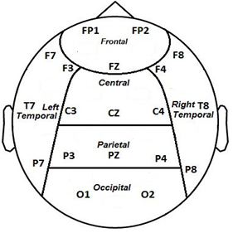

* 1. **True Alpha:** This term is used when the reactivity of a subject has the theoretically expected graphic behavior. In *Figure 3.a* a subject with True Alpha is presented and in *Figure 3.b* a subject that is not considered True Alpha.

Figure 3.a Figure 3.b

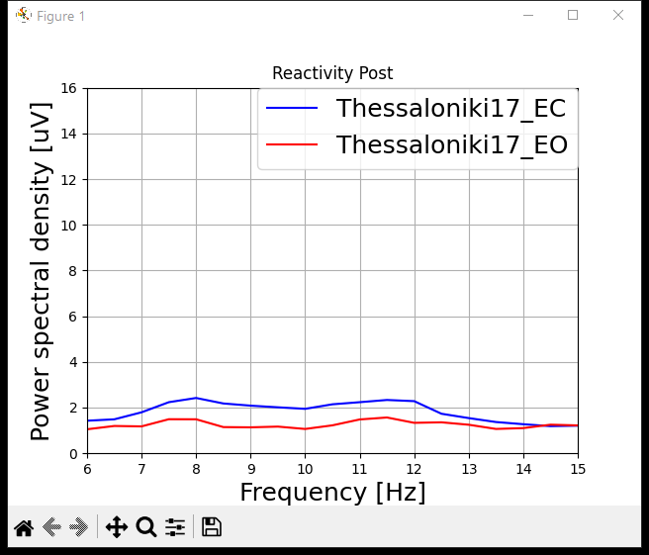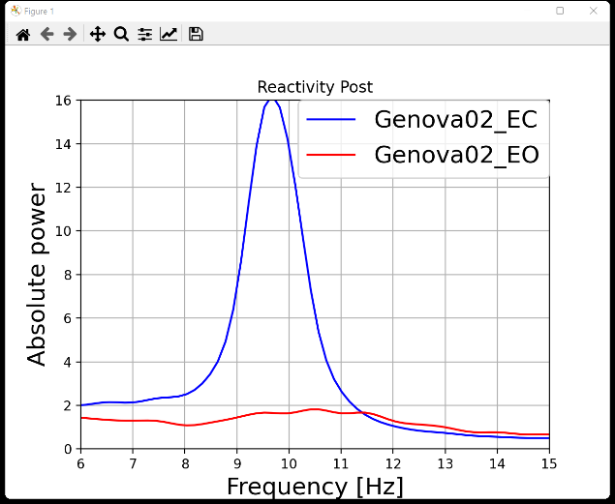

* 1. **Qualitative analysis:** Refers to the inspection and visual analysis of the electroencephalogram performed by an expert. During this analysis, 6 states are initially seen in *Figure 4*.

**A: Alert – D: Drowsiness – N1: transition phase to sleep – N2: Sleep – N3: deep sleep**

Figure 4. Qualitative

1. **Data organization procedure**
   1. Steps to follow having the **.txt exported from eLORETA**