BU Engineering – Research Tutorial



***RERAN***: Record and Replay for Android

RERAN is a tool that allows you to record and replay Android applications.

*To Use on Lab Computer:*

First, connect Android phone to computer via USB. Then, run the following commands.

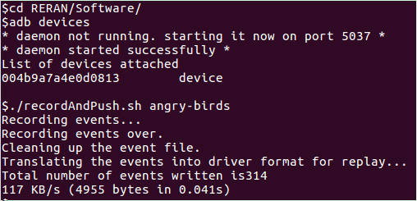

Immediately after running the recordAndPush.sh program, you can now go on your Android phone and run any application you would like to be recorded. The default setting in this program records for 40 seconds, but can be changed easily depending on your desired recording timeframe.

**TIP**: Be sure to end your recording at the same place where you began (i.e. home page).

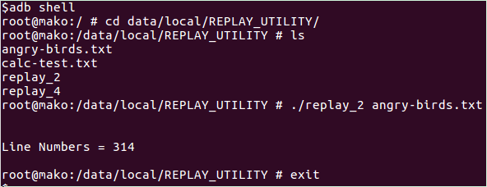

These commands bring you into the Android terminal, and allow you to replay the recording you just took. Make sure to have the Android on the same screen where you began the recording.

***Redexer***: