Q1

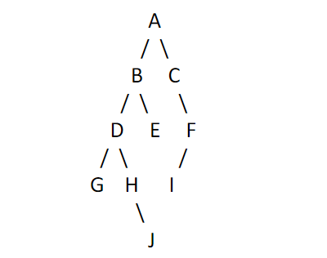

1. Height of the tree is the longest path from the root node to leaf node. Here the height is 4 assuming root is at 0.
2. The height of node B is 3.
3. The depth is the number of edges on the longest path to a leaf node. Here the depth is 3.
4. Post order: G J H D E B I F C A
5. In order: G D H J B E A C I F

Q2 The best data structure to implement a dictionary would be a Trie (26 char for every alphabet) data structure with string for its definition.



Q3 Because Queue class is an interface which employs linked list for its methods. Linked list is a collection object and therefore cannot be modified in the for loop as it will change the collection while iterating over it.

public static void removeEven(Queue<Integer> q) {

  Iterator<Integer> it = q.iterator();

  while (it.hasNext()) {

    Integer temp = it.next();

    if(temp % 2 == 0)

    {

      q.remove(temp);

      it = q.iterator();

    }

  }

}