Oocyst prev and intensity analysis
library(lme4)
library(MASS)
library(ggplot2)
library(emmeans)
library(tidyverse)
library(glmmTMB)
library(car)
library(devtools)
library(cowplot)
library(broom.mixed)
library(brglm2)
WARP <- read.csv("/Users/virginiahowick/Documents/allelic_replacement/Lah_TransmissionProject_Dataset_25Apr25/WARP/WARP_table_oocyst_4Aug25_normalised_2clones.csv")
HSP101 <- read.csv("/Users/virginiahowick/Documents/allelic_replacement/Oocyst_all_genes/HSP101_table_oocyst_normalised_19Mar25.csv")
Pfs47 <- read.csv("/Users/virginiahowick/Documents/allelic_replacement/Oocyst_all_genes/P47_table_oocyst_normalisedOocyst_19Mar25.csv")
CTRP <- read.csv("/Users/virginiahowick/Documents/allelic_replacement/Lah_TransmissionProject_Dataset_25Apr25/CTRP/CTRP_table_oocyst_normalised_20Mar25.csv")
Pfs25 <- read.csv("/Users/virginiahowick/Documents/allelic_replacement/Oocyst_all_genes/Pfs25_table_oocyst_17Mar25_normalised.csv")
WARP <- WARP[ , 1:9]
HSP101 <- HSP101[ , 1:9]
Pfs47 <- Pfs47[ , 1:9]
Pfs25 <- Pfs25[ , 1:9]
CTRP <- CTRP[ , 1:9]
WARP$gene <- rep("WARP", length(WARP$name))
HSP101$gene <- rep("HSP101", length(HSP101$name))
Pfs47$gene <- rep("Pfs47", length(Pfs47$name))
Pfs25$gene <- rep("Pfs25", length(Pfs25$name))
CTRP$gene <- rep("CTRP", length(CTRP$name))
CTRP <- subset(CTRP, background!="HB3")
CTRP <- subset(CTRP, clone!="bulk")
CTRP$RefAlt <- ifelse(CTRP$allele == "D", "Ref", "Alt")
HSP101$RefAlt <- ifelse(HSP101$allele == "R", "Ref", "Alt")
Pfs25$RefAlt <- ifelse(Pfs25$allele == "G", "Ref", "Alt")
Pfs47$RefAlt <- ifelse(Pfs47$allele == "S", "Ref", "Alt")
WARP$RefAlt <- ifelse(WARP$allele == "F", "Ref", "Alt")
alldata <- rbind(CTRP, HSP101, Pfs25, Pfs47, WARP)
write.csv(alldata, file="oocysts_20260416.csv")
Look at 3D7 prev in Kisumu as control and add to all data as a potential factor in the model
alldata <- alldata %>%
group_by(gene, rep) %>%
mutate(
prevalence_3D7 = {
use <- mosquito == "An_gam" & clone == "3D7" # change clone->background if needed
n_tot <- sum(use, na.rm = TRUE)
n_pos <- sum((oocysts > 0) & use, na.rm = TRUE)
ifelse(n_tot > 0, n_pos / n_tot, NA_real_)
}
) %>%
ungroup()
prev3d7 <- alldata %>%
group_by(gene, rep) %>%
mutate(
prevalence_3D7 = {
use <- mosquito == "An_gam" & clone == "3D7" # change clone->background if needed
n_tot <- sum(use, na.rm = TRUE)
n_pos <- sum((oocysts > 0) & use, na.rm = TRUE)
ifelse(n_tot > 0, n_pos / n_tot, NA_real_)
}
)
prev3d7$rep <- as.factor(prev3d7$rep)
prev_plotdat <- prev3d7 %>%
distinct(gene, rep, prevalence_3D7) %>%
filter(!is.na(prevalence_3D7))
genes <- c("HSP101","Pfs25","Pfs47","WARP","CTRP")
prev_plotdat <- prev_plotdat %>% filter(gene %in% genes)
ggplot(prev_plotdat, aes(x = factor(rep), y = prevalence_3D7, fill = gene)) +
geom_col(width = 0.75, color = "black", linewidth = 0.2) +
geom_text(aes(label = round(prevalence_3D7, 2)),
vjust = -0.4, size = 3) +
facet_grid(. ~ gene, scales = "free_x", space = "free_x", switch = "x") +
scale_y_continuous(limits = c(0, 1), expand = expansion(mult = c(0, 0.05))) +
labs(
x = "Replicate",
y = "3D7 prevalence (An. gam.)",
title = NULL
) +
theme_classic(base_size = 12) +
theme(
panel.spacing.x = unit(1, "lines"),
strip.background = element_blank(),
strip.placement = "outside",
strip.text = element_text(face = "bold"),
legend.position = "none",
axis.text.x = element_text(size = 9)
)
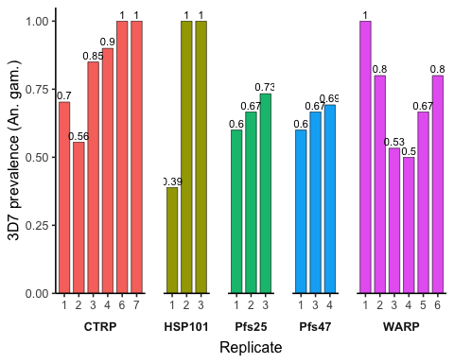
Subset data and set as factors
alldata <- subset(alldata, clone!="3D7")
alldata <- subset(alldata, clone!="HB3")
alldata$background[alldata$background == "3D25"] <- "3D7"
alldata$clone<-as.factor(alldata$clone)
alldata$allele<-as.factor(alldata$allele)
alldata$rep<-as.factor(alldata$rep)
alldata$mosquito<-as.factor(alldata$mosquito)
alldata$RefAlt <- factor(alldata$RefAlt, levels = c("Ref","Alt"), ordered = TRUE)
summary(alldata$oocysts)
## Min. 1st Qu. Median Mean 3rd Qu. Max.
## 0.000 0.000 0.000 1.251 1.000 71.000
var(alldata$oocysts)
## [1] 25.83415
alldata$oocyst_prev <- rep(0, length(alldata$name))
alldata[which(alldata$oocysts > 0), ]$oocyst_prev <- 1
alldata$mosq_allele <- interaction(alldata$mosquito,
alldata$allele,
sep = "_")
alldata$symp <- rep("symp", length(alldata$mosquito))
alldata[which(alldata$mosquito == "An_gam"), ]$symp <- "allo"
alldata$symp[alldata$mosquito == "An_alb" & !(alldata$gene %in% c("CTRP", "Pfs47")) ] <- "allo"
alldata[which(alldata$gene == "Pfs47" & alldata$mosquito != "An_alb"), ]$symp <- "allo"
Plot graph from raw data
#noctrp <- subset(alldata, alldata$gene !="CTRP")
#noctrp <- subset(noctrp, noctrp$mosquito!="An_alb")
# The genes you want to loop over
genes_to_plot <- c("CTRP", "HSP101", "Pfs25", "Pfs47", "WARP")
# Make plots for each gene
plots <- lapply(genes_to_plot, function(g) {
ggplot(data = filter(alldata, gene == g), aes(x = RefAlt, y = oocysts)) +
geom_violin(size = 0.4) +
geom_jitter(width = 0.2, height = 0.2, aes(color = RefAlt), size = 0.7, alpha = 0.7) +
scale_y_continuous(
limits = c(0, NA),
oob = scales::oob_squish_any,
expand = expansion(mult = c(0, .05))
) +
scale_x_discrete(
labels = c("Ref" = "Ref", "Alt" = "Alt")
) +
facet_grid(. ~ mosquito, labeller = labeller(
mosquito = c(
"An_gam" = "gambiae",
"An_steph" = "stephensi",
"An_mini" = "minimus",
"An_alb" = "albimanus"
)
)) +
theme_bw(base_size = 6) +
theme(
axis.line = element_line(colour = "black", size = 0.3, linetype = "solid"),
strip.background = element_rect(fill = "white", color = "black"),
strip.text = element_text(face = "italic", size = 3.5),
axis.text = element_text(size = 6),
axis.title.x = element_blank(),
axis.title.y = element_blank(),
legend.position = "none",
axis.ticks.length = unit(0.1, "cm")
) +
scale_colour_manual(values = c("#E31A1C","#6A3D9A"))
#ggtitle(g) # Add gene name as title
})
## Warning: Using `size` aesthetic for lines was deprecated in ggplot2 3.4.0.
## ℹ Please use `linewidth` instead.
## This warning is displayed once every 8 hours.
## Call `lifecycle::last_lifecycle_warnings()` to see where this warning was
## generated.
## Warning: The `size` argument of `element_line()` is deprecated as of ggplot2 3.4.0.
## ℹ Please use the `linewidth` argument instead.
## This warning is displayed once every 8 hours.
## Call `lifecycle::last_lifecycle_warnings()` to see where this warning was
## generated.
# Access a specific plot
plots[[1]]
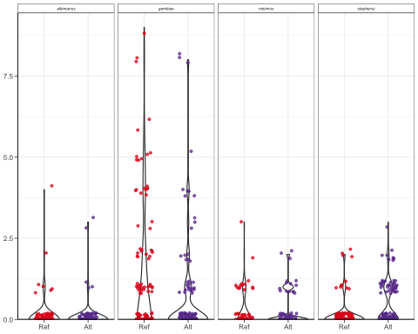
plots[[2]]
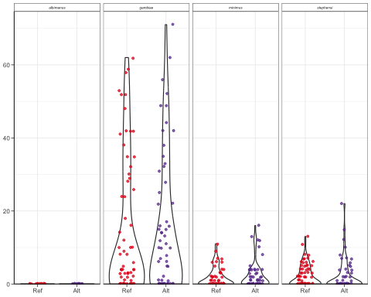
plots[[3]]
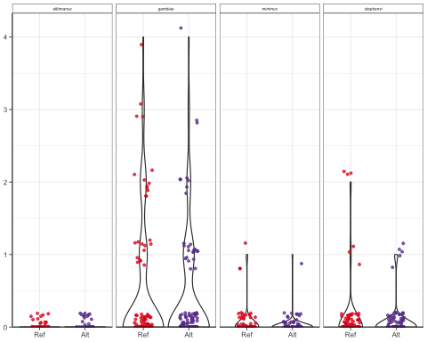
plots[[4]]
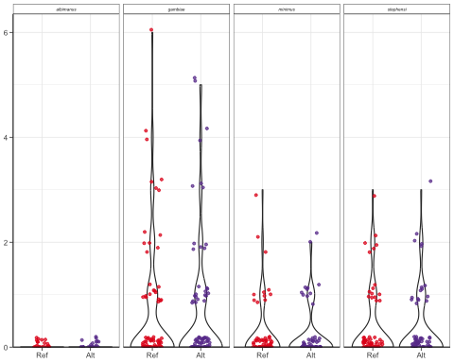
plots[[5]]
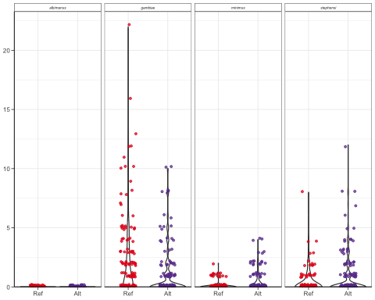
pdf("/Users/virginiahowick/Documents/allelic_replacement/plots/rawdataoocysts_20260416.pdf", width = 8, height = 1.6)
plot_grid(plotlist = plots, ncol = 5)
dev.off()
## quartz_off_screen
## 2
Calculate N and prop infected to place below raw data plots
prop_infected <- alldata %>%
group_by(mosquito, gene, RefAlt) %>%
summarise(
n_total = n(),
n_infected = sum(oocyst_prev, na.rm = TRUE),
prop_infected = mean(oocyst_prev, na.rm = TRUE),
.groups = "drop"
) %>%
mutate(
pct_infected = round(prop_infected * 100, 1) # one decimal place
)
prop_infected
## # A tibble: 40 × 7
## mosquito gene RefAlt n_total n_infected prop_infected pct_infected
## <fct> <chr> <ord> <int> <dbl> <dbl> <dbl>
## 1 An_alb CTRP Ref 80 7 0.0875 8.8
## 2 An_alb CTRP Alt 99 5 0.0505 5.1
## 3 An_alb HSP101 Ref 13 0 0 0
## 4 An_alb HSP101 Alt 15 0 0 0
## 5 An_alb Pfs25 Ref 29 0 0 0
## 6 An_alb Pfs25 Alt 31 0 0 0
## 7 An_alb Pfs47 Ref 25 0 0 0
## 8 An_alb Pfs47 Alt 25 0 0 0
## 9 An_alb WARP Ref 55 0 0 0
## 10 An_alb WARP Alt 57 0 0 0
## # ℹ 30 more rows
write.csv(prop_infected, file="/Users/virginiahowick/Documents/allelic_replacement/analysis/oocyst_prevs_20260416.csv")
Run oocyst prev model and calculate emmeans
# List of genes to loop over
genes <- c("CTRP", "HSP101", "Pfs25", "Pfs47", "WARP")
results <- lapply(genes, function(g) {
df <- subset(alldata, gene == g)
mod <- glm(
oocyst_prev ~ RefAlt * mosquito + rep,
family = binomial(link = "logit"),
data = df,
method = "brglmFit"
)
# Tidy summary (fixed effects only)
sum_df <- broom.mixed::tidy(mod, effects = "fixed") %>%
mutate(gene = g)
# ANOVA table
anova_tab <- Anova(mod, type = "III")
anova_df <- as.data.frame(anova_tab) %>%
rownames_to_column("term") %>%
mutate(gene = g)
# EMMeans + contrasts
emm_tab <- emmeans(mod, specs = pairwise ~ RefAlt | mosquito, type = "response")
emm_df <- as.data.frame(emm_tab$emmeans) %>%
mutate(gene = g)
contrast_df <- as.data.frame(emm_tab$contrasts) %>%
mutate(gene = g)
list(summary = sum_df, anova = anova_df, emm = emm_df, contrasts = contrast_df)
})
## Warning: The `tidy()` method for objects of class `brglmFit` is not maintained by the broom team, and is only supported through the `glm` tidier method. Please be cautious in interpreting and reporting broom output.
##
## This warning is displayed once per session.
# Combine across genes
summary_all <- bind_rows(lapply(results, `[[`, "summary"))
anova_all <- bind_rows(lapply(results, `[[`, "anova"))
emm_all <- bind_rows(lapply(results, `[[`, "emm"))
contrasts_all <- bind_rows(lapply(results, `[[`, "contrasts"))
# Export to CSV
write.csv(summary_all, "prev_summary_all_20260416.csv", row.names = FALSE)
write.csv(anova_all, "prev_anova_all_20260416.csv", row.names = FALSE)
write.csv(emm_all, "prev_emm_all_20260416.csv", row.names = FALSE)
write.csv(contrasts_all, "prev_contrasts_all_20260416.csv", row.names = FALSE)
summary_all
## # A tibble: 58 × 6
## term estimate std.error statistic p.value gene
## <chr> <dbl> <dbl> <dbl> <dbl> <chr>
## 1 (Intercept) -2.55 0.502 -5.08 3.82e- 7 CTRP
## 2 RefAlt.L -0.429 0.415 -1.03 3.02e- 1 CTRP
## 3 mosquitoAn_gam 2.04 0.326 6.26 3.74e-10 CTRP
## 4 mosquitoAn_mini 1.07 0.498 2.15 3.14e- 2 CTRP
## 5 mosquitoAn_steph 1.02 0.356 2.88 4.04e- 3 CTRP
## 6 rep2 -0.684 0.472 -1.45 1.47e- 1 CTRP
## 7 rep3 0.0268 0.451 0.0595 9.53e- 1 CTRP
## 8 rep4 0.209 0.432 0.484 6.29e- 1 CTRP
## 9 rep5 0.543 0.661 0.821 4.12e- 1 CTRP
## 10 rep6 0.543 0.436 1.25 2.13e- 1 CTRP
## # ℹ 48 more rows
anova_all
## term LR Chisq Df Pr(>Chisq) gene
## 1 RefAlt 1.04701037 1 3.061966e-01 CTRP
## 2 mosquito 58.77379788 3 1.074418e-12 CTRP
## 3 rep 18.01058431 6 6.205799e-03 CTRP
## 4 RefAlt:mosquito 39.68132215 3 1.244805e-08 CTRP
## 5 RefAlt -0.83739246 1 1.000000e+00 HSP101
## 6 mosquito 48.22946388 3 1.903011e-10 HSP101
## 7 rep 235.04626383 2 9.127510e-52 HSP101
## 8 RefAlt:mosquito 3.34077062 3 3.420083e-01 HSP101
## 9 RefAlt -0.97669440 1 1.000000e+00 Pfs25
## 10 mosquito 62.22785947 3 1.964005e-13 Pfs25
## 11 rep 3.14237032 2 2.077988e-01 Pfs25
## 12 RefAlt:mosquito -0.29756167 3 1.000000e+00 Pfs25
## 13 RefAlt -0.93041026 1 1.000000e+00 Pfs47
## 14 mosquito 22.83570993 3 4.369563e-05 Pfs47
## 15 rep -0.06527204 3 1.000000e+00 Pfs47
## 16 RefAlt:mosquito -0.92798942 3 1.000000e+00 Pfs47
## 17 RefAlt -0.98302701 1 1.000000e+00 WARP
## 18 mosquito 134.10008374 3 7.069595e-29 WARP
## 19 rep 75.48385078 5 7.372814e-15 WARP
## 20 RefAlt:mosquito 17.84161537 3 4.742014e-04 WARP
emm_all
## RefAlt mosquito prob SE df asymp.LCL asymp.UCL gene
## 1 Ref An_alb 0.103926031 0.038795846 Inf 0.0487598023 0.20786767 CTRP
## 2 Alt An_alb 0.059460743 0.026245879 Inf 0.0245795169 0.13689537 CTRP
## 3 Ref An_gam 0.535207196 0.062040344 Inf 0.4139284504 0.65246071 CTRP
## 4 Alt An_gam 0.274240170 0.050517789 Inf 0.1868382689 0.38325783 CTRP
## 5 Ref An_mini 0.193142620 0.057238518 Inf 0.1043685627 0.32963516 CTRP
## 6 Alt An_mini 0.207234160 0.059515919 Inf 0.1138801447 0.34713619 CTRP
## 7 Ref An_steph 0.099048115 0.030149330 Inf 0.0536551800 0.17571351 CTRP
## 8 Alt An_steph 0.341032872 0.051964063 Inf 0.2475175587 0.44880666 CTRP
## 9 Ref An_alb 0.015990789 0.025597975 Inf 0.0006696339 0.28269444 HSP101
## 10 Alt An_alb 0.011981807 0.018590049 Inf 0.0005582649 0.20841519 HSP101
## 11 Ref An_gam 0.671812295 0.092652264 Inf 0.4732156666 0.82346858 HSP101
## 12 Alt An_gam 0.577890906 0.102178627 Inf 0.3759279899 0.75678084 HSP101
## 13 Ref An_mini 0.247718201 0.069863692 Inf 0.1363896710 0.40708412 HSP101
## 14 Alt An_mini 0.400957440 0.097304224 Inf 0.2322796618 0.59689129 HSP101
## 15 Ref An_steph 0.514913436 0.099512442 Inf 0.3271317726 0.69857669 HSP101
## 16 Alt An_steph 0.342789714 0.093282179 Inf 0.1880950799 0.54007931 HSP101
## 17 Ref An_alb 0.018237073 0.025804294 Inf 0.0011007830 0.23845757 Pfs25
## 18 Alt An_alb 0.017043805 0.024105448 Inf 0.0010323700 0.22536157 Pfs25
## 19 Ref An_gam 0.292056496 0.049324247 Inf 0.2053830831 0.39703113 Pfs25
## 20 Alt An_gam 0.289860723 0.048103989 Inf 0.2052020137 0.39221094 Pfs25
## 21 Ref An_mini 0.057117402 0.029944046 Inf 0.0199652048 0.15263672 Pfs25
## 22 Alt An_mini 0.025297751 0.020498428 Inf 0.0050627594 0.11690563 Pfs25
## 23 Ref An_steph 0.087397749 0.032923947 Inf 0.0408991915 0.17700454 Pfs25
## 24 Alt An_steph 0.074521617 0.030727964 Inf 0.0325319111 0.16165272 Pfs25
## 25 Ref An_alb 0.028071825 0.034706558 Inf 0.0023813531 0.25897002 Pfs47
## 26 Alt An_alb 0.028071825 0.034706558 Inf 0.0023813531 0.25897002 Pfs47
## 27 Ref An_gam 0.344719818 0.110453376 Inf 0.1678834894 0.57835896 Pfs47
## 28 Alt An_gam 0.352557878 0.111323052 Inf 0.1731176244 0.58614753 Pfs47
## 29 Ref An_mini 0.194703567 0.084462263 Inf 0.0775914560 0.41000771 Pfs47
## 30 Alt An_mini 0.189150355 0.082487650 Inf 0.0751838063 0.40097081 Pfs47
## 31 Ref An_steph 0.250164895 0.096152002 Inf 0.1088655307 0.47674574 Pfs47
## 32 Alt An_steph 0.246427559 0.095131432 Inf 0.1069947333 0.47160526 Pfs47
## 33 Ref An_alb 0.006492316 0.009263298 Inf 0.0003913988 0.09833590 WARP
## 34 Alt An_alb 0.006448664 0.009197071 Inf 0.0003892685 0.09761822 WARP
## 35 Ref An_gam 0.516567155 0.044448303 Inf 0.4298266611 0.60232071 WARP
## 36 Alt An_gam 0.333775493 0.041839528 Inf 0.2573225036 0.42009473 WARP
## 37 Ref An_mini 0.086945030 0.022462584 Inf 0.0518527205 0.14222426 WARP
## 38 Alt An_mini 0.177931773 0.032085161 Inf 0.1234295559 0.24964623 WARP
## 39 Ref An_steph 0.175310653 0.034276646 Inf 0.1178322204 0.25279251 WARP
## 40 Alt An_steph 0.273190870 0.036253417 Inf 0.2081107779 0.34963696 WARP
contrasts_all
## contrast mosquito odds.ratio SE df null z.ratio p.value
## 1 Ref / Alt An_alb 1.8345395 1.07754348 Inf 1 1.033078e+00 3.015673e-01
## 2 Ref / Alt An_gam 3.0473645 0.87196815 Inf 1 3.894189e+00 9.852792e-05
## 3 Ref / Alt An_mini 0.9157247 0.38848352 Inf 1 -2.075248e-01 8.356000e-01
## 4 Ref / Alt An_steph 0.2124282 0.07743214 Inf 1 -4.249959e+00 2.138098e-05
## 5 Ref / Alt An_alb 1.3400263 3.00973071 Inf 1 1.303144e-01 8.963177e-01
## 6 Ref / Alt An_gam 1.4952179 0.87192783 Inf 1 6.898326e-01 4.902995e-01
## 7 Ref / Alt An_mini 0.4919679 0.24926379 Inf 1 -1.400016e+00 1.615084e-01
## 8 Ref / Alt An_steph 2.0351272 1.13015136 Inf 1 1.279542e+00 2.007061e-01
## 9 Ref / Alt An_alb 1.0713124 2.18095963 Inf 1 3.383683e-02 9.730073e-01
## 10 Ref / Alt An_gam 1.0107004 0.33676168 Inf 1 3.194375e-02 9.745169e-01
## 11 Ref / Alt An_mini 2.3340001 2.32757415 Inf 1 8.499236e-01 3.953676e-01
## 12 Ref / Alt An_steph 1.1893310 0.72084295 Inf 1 2.860806e-01 7.748164e-01
## 13 Ref / Alt An_alb 1.0000000 1.70483198 Inf 1 -1.908983e-16 1.000000e+00
## 14 Ref / Alt An_gam 0.9660726 0.32374674 Inf 1 -1.029981e-01 9.179645e-01
## 15 Ref / Alt An_mini 1.0364570 0.48023841 Inf 1 7.728173e-02 9.383994e-01
## 16 Ref / Alt An_steph 1.0202259 0.40850330 Inf 1 5.000949e-02 9.601148e-01
## 17 Ref / Alt An_alb 1.0068134 2.04111868 Inf 1 3.349407e-03 9.973276e-01
## 18 Ref / Alt An_gam 2.1328327 0.54787021 Inf 1 2.948721e+00 3.190921e-03
## 19 Ref / Alt An_mini 0.4399489 0.15349309 Inf 1 -2.353465e+00 1.859936e-02
## 20 Ref / Alt An_steph 0.5655514 0.16681501 Inf 1 -1.932310e+00 5.332125e-02
## gene
## 1 CTRP
## 2 CTRP
## 3 CTRP
## 4 CTRP
## 5 HSP101
## 6 HSP101
## 7 HSP101
## 8 HSP101
## 9 Pfs25
## 10 Pfs25
## 11 Pfs25
## 12 Pfs25
## 13 Pfs47
## 14 Pfs47
## 15 Pfs47
## 16 Pfs47
## 17 WARP
## 18 WARP
## 19 WARP
## 20 WARP
Now make the EMM prev plots
emm_all$symp <- rep("symp", length(emm_all$mosquito))
emm_all[which(emm_all$mosquito == "An_gam"), ]$symp <- "allo"
emm_all$symp[emm_all$mosquito == "An_alb" & !(emm_all$gene %in% c("CTRP", "Pfs47")) ] <- "allo"
emm_all[which(emm_all$gene == "Pfs47" & emm_all$mosquito != "An_alb"), ]$symp <- "allo"
emm_plots <- emm_all %>%
group_split(gene) %>%
setNames(unique(emm_all$gene)) %>%
lapply(function(df) {
ggplot(df, aes(x = RefAlt, y = prob, group = mosquito, color = mosquito, shape=symp)) +
geom_point(size = 1.3) +
geom_line(size = 0.55) +
geom_ribbon(
aes(ymin = prob - SE, ymax = prob + SE, fill = mosquito),
alpha = 0.3
) +
theme_classic(base_size = 6) +
scale_fill_manual(values = c(
"An_gam" = "#ECC671",
"An_mini" = "#7CB599",
"An_steph" = "#D5ABC6",
"An_alb" = "#1F78B4"
)) +
scale_colour_manual(values = c(
"An_gam" = "#ECC671",
"An_mini" = "#7CB599",
"An_steph" = "#D5ABC6",
"An_alb" = "#1F78B4"
)) +
scale_x_discrete(expand = expansion(mult = c(0.2, 0.2))) +
theme(
legend.position = "none",
axis.title.x = element_blank(),
axis.title.y = element_blank(),
axis.text = element_text(size = 6),
axis.ticks.length = unit(0.1, "cm")
)
#ggtitle(unique(df$gene)) # Add gene title
})
emm_plots[["CTRP"]]
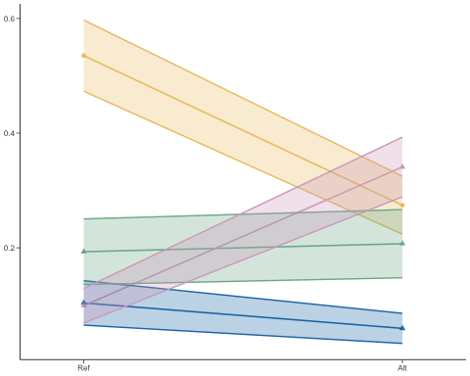
emm_plots[["HSP101"]]
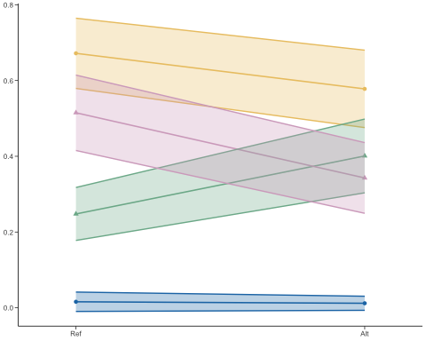
emm_plots[["Pfs25"]]
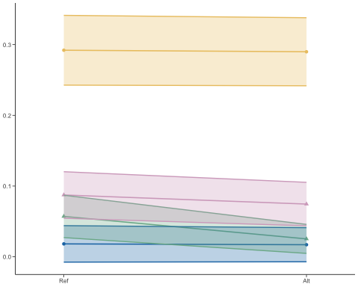
emm_plots[["Pfs47"]]
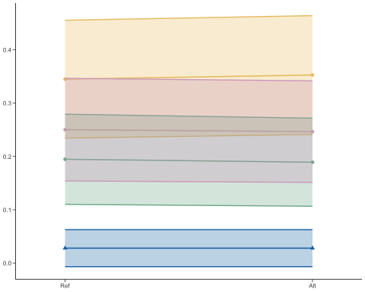
emm_plots[["WARP"]]
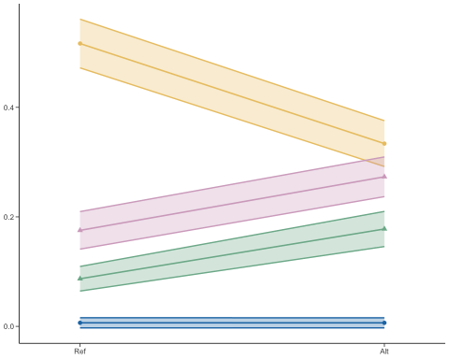
pdf("/Users/virginiahowick/Documents/allelic_replacement/plots/prev_oocysts_20260416.pdf", width = 8, height = 1.6)
plot_grid(plotlist = emm_plots, ncol = 5)
dev.off()
## quartz_off_screen
## 2
Now do stats and plots for Oocyst Intensity
oocysts_nozeros <- subset(alldata, alldata$oocysts > 0)
#Pfs25 <- subset(oocysts_nozeros, oocysts_nozeros$gene=="Pfs25")
genes <- c("CTRP", "HSP101", "Pfs25", "Pfs47", "WARP")
results <- lapply(genes, function(g) {
df <- subset(oocysts_nozeros, gene == g) # adjust if data frame has a different name
# Choose formula depending on gene
if (g %in% c("CTRP", "WARP")) {
form <- oocysts ~ RefAlt * mosquito + (1 | rep) + (1 | clone)
} else {
form <- oocysts ~ RefAlt * mosquito + (1 | rep)
}
# Fit model
mod <- glmmTMB(
form,
family = nbinom2,
data = df
)
# Tidy summary (fixed effects only)
sum_df <- broom.mixed::tidy(mod, effects = "fixed") %>%
mutate(gene = g)
# ANOVA table
anova_tab <- Anova(mod, type = "III")
anova_df <- as.data.frame(anova_tab) %>%
rownames_to_column("term") %>%
mutate(gene = g)
# EMMeans + contrasts
emm_tab <- emmeans(mod, specs = pairwise ~ RefAlt | mosquito, type = "response")
emm_df <- as.data.frame(emm_tab$emmeans) %>%
mutate(gene = g)
contrast_df <- as.data.frame(emm_tab$contrasts) %>%
mutate(gene = g)
list(summary = sum_df, anova = anova_df, emm = emm_df, contrasts = contrast_df)
})
## Warning in finalizeTMB(TMBStruc, obj, fit, h, data.tmb.old): Model convergence
## problem; non-positive-definite Hessian matrix. See vignette('troubleshooting')
## Warning in finalizeTMB(TMBStruc, obj, fit, h, data.tmb.old): Model convergence
## problem; non-positive-definite Hessian matrix. See vignette('troubleshooting')
# Combine across genes
summary_all <- bind_rows(lapply(results, `[[`, "summary"))
anova_all <- bind_rows(lapply(results, `[[`, "anova"))
emm_all <- bind_rows(lapply(results, `[[`, "emm"))
contrasts_all <- bind_rows(lapply(results, `[[`, "contrasts"))
# Export to CSV
write.csv(summary_all, "int_summary_all_20260416.csv", row.names = FALSE)
write.csv(anova_all, "int_anova_all_20260416.csv", row.names = FALSE)
write.csv(emm_all, "int_emm_all_20260416.csv", row.names = FALSE)
write.csv(contrasts_all, "int_contrasts_all_20260416.csv", row.names = FALSE)
summary_all
## # A tibble: 32 × 8
## effect component term estimate std.error statistic p.value gene
## <chr> <chr> <chr> <dbl> <dbl> <dbl> <dbl> <chr>
## 1 fixed cond (Intercept) 0.520 0.230 2.26 2.39e-2 CTRP
## 2 fixed cond RefAlt.L 0.0960 0.326 0.295 7.68e-1 CTRP
## 3 fixed cond mosquitoAn_gam 0.460 0.241 1.91 5.60e-2 CTRP
## 4 fixed cond mosquitoAn_mini -0.332 0.287 -1.15 2.49e-1 CTRP
## 5 fixed cond mosquitoAn_steph -0.274 0.274 -0.998 3.18e-1 CTRP
## 6 fixed cond RefAlt.L:mosquit… -0.169 0.340 -0.496 6.20e-1 CTRP
## 7 fixed cond RefAlt.L:mosquit… -0.104 0.406 -0.257 7.97e-1 CTRP
## 8 fixed cond RefAlt.L:mosquit… -0.186 0.388 -0.481 6.31e-1 CTRP
## 9 fixed cond (Intercept) 2.33 0.697 3.35 8.14e-4 HSP1…
## 10 fixed cond RefAlt.L 0.0212 0.117 0.182 8.56e-1 HSP1…
## # ℹ 22 more rows
anova_all
## term Chisq Df Pr(>Chisq) gene
## 1 (Intercept) 5.099908e+00 1 2.392712e-02 CTRP
## 2 RefAlt 8.699547e-02 1 7.680321e-01 CTRP
## 3 mosquito 3.399900e+01 3 1.982151e-07 CTRP
## 4 RefAlt:mosquito 3.116574e-01 3 9.578213e-01 CTRP
## 5 (Intercept) 1.120899e+01 1 8.140192e-04 HSP101
## 6 RefAlt 3.300416e-02 1 8.558413e-01 HSP101
## 7 mosquito 1.847384e+02 2 7.666130e-41 HSP101
## 8 RefAlt:mosquito 8.061587e-01 2 6.682591e-01 HSP101
## 9 (Intercept) 1.837142e+01 1 1.817640e-05 Pfs25
## 10 RefAlt 3.830601e-01 1 5.359701e-01 Pfs25
## 11 mosquito 1.372444e+00 2 5.034747e-01 Pfs25
## 12 RefAlt:mosquito 2.222531e-01 2 8.948255e-01 Pfs25
## 13 (Intercept) 4.548222e+01 1 1.540310e-11 Pfs47
## 14 RefAlt 8.645675e-03 1 9.259178e-01 Pfs47
## 15 mosquito 5.799030e+00 2 5.504991e-02 Pfs47
## 16 RefAlt:mosquito 8.534533e-02 2 9.582250e-01 Pfs47
## 17 (Intercept) 3.776285e+01 1 7.988891e-10 WARP
## 18 RefAlt 8.994691e+00 1 2.707651e-03 WARP
## 19 mosquito 3.667167e+01 2 1.088547e-08 WARP
## 20 RefAlt:mosquito 1.643632e+01 2 2.697115e-04 WARP
emm_all
## RefAlt mosquito response SE df asymp.LCL asymp.UCL gene
## 1 Ref An_alb 1.5714288 0.4845073 Inf 0.8587166 2.875673 CTRP
## 2 Alt An_alb 1.8000007 0.6155015 Inf 0.9208914 3.518333 CTRP
## 3 Ref An_gam 2.8035715 0.2326907 Inf 2.3826686 3.298828 CTRP
## 4 Alt An_gam 2.5294120 0.2826058 Inf 2.0319670 3.148636 CTRP
## 5 Ref An_mini 1.2142859 0.2996617 Inf 0.7486198 1.969612 CTRP
## 6 Alt An_mini 1.2000005 0.2877350 Inf 0.7500343 1.919914 CTRP
## 7 Ref An_steph 1.3636361 0.3590018 Inf 0.8139624 2.284508 CTRP
## 8 Alt An_steph 1.2000004 0.1661239 Inf 0.9148376 1.574051 CTRP
## 9 Ref An_gam 10.1484623 7.1137986 Inf 2.5688036 40.093095 HSP101
## 10 Alt An_gam 10.4575985 7.3418059 Inf 2.6414472 41.402063 HSP101
## 11 Ref An_mini 1.7514306 1.2596143 Inf 0.4277754 7.170839 HSP101
## 12 Alt An_mini 1.9752979 1.4096154 Inf 0.4877494 7.999604 HSP101
## 13 Ref An_steph 2.0442014 1.4524836 Inf 0.5078229 8.228773 HSP101
## 14 Alt An_steph 2.7164283 1.9491074 Inf 0.6656396 11.085552 HSP101
## 15 Ref An_gam 1.7199998 0.2622975 Inf 1.2756202 2.319185 Pfs25
## 16 Alt An_gam 1.4999999 0.2401922 Inf 1.0959478 2.053017 Pfs25
## 17 Ref An_mini 0.9999999 0.5773502 Inf 0.3225214 3.100569 Pfs25
## 18 Alt An_mini 0.9999999 0.9999999 Inf 0.1408635 7.099071 Pfs25
## 19 Ref An_steph 1.4999998 0.4999999 Inf 0.7804720 2.882870 Pfs25
## 20 Alt An_steph 0.9999999 0.4472135 Inf 0.4162278 2.402530 Pfs25
## 21 Ref An_gam 1.9615211 0.2746754 Inf 1.4907254 2.581002 Pfs47
## 22 Alt An_gam 1.9259046 0.2670735 Inf 1.4675570 2.527403 Pfs47
## 23 Ref An_mini 1.3636398 0.3520978 Inf 0.8220830 2.261953 Pfs47
## 24 Alt An_mini 1.1818214 0.3277843 Inf 0.6862252 2.035340 Pfs47
## 25 Ref An_steph 1.4374918 0.2997443 Inf 0.9552427 2.163202 Pfs47
## 26 Alt An_steph 1.3750058 0.2931603 Inf 0.9053630 2.088269 Pfs47
## 27 Ref An_gam 3.4044693 0.5882185 Inf 2.4264998 4.776597 WARP
## 28 Alt An_gam 2.3452237 0.4388393 Inf 1.6252010 3.384243 WARP
## 29 Ref An_mini 0.8556535 0.2700656 Inf 0.4609327 1.588395 WARP
## 30 Alt An_mini 1.5960395 0.3514016 Inf 1.0366538 2.457274 WARP
## 31 Ref An_steph 1.4475532 0.3308830 Inf 0.9248390 2.265703 WARP
## 32 Alt An_steph 2.1631084 0.4069308 Inf 1.4960550 3.127584 WARP
contrasts_all
## contrast mosquito ratio SE df null z.ratio p.value
## 1 Ref / Alt An_alb 0.8730157 0.4019566 Inf 1 -2.949499e-01 0.768032118
## 2 Ref / Alt An_gam 1.1083886 0.1542683 Inf 1 7.393690e-01 0.459682953
## 3 Ref / Alt An_mini 1.0119045 0.3481811 Inf 1 3.439321e-02 0.972563596
## 4 Ref / Alt An_steph 1.1363630 0.3380078 Inf 1 4.297667e-01 0.667365384
## 5 Ref / Alt An_gam 0.9704391 0.1602882 Inf 1 -1.816705e-01 0.855841347
## 6 Ref / Alt An_mini 0.8866666 0.2156969 Inf 1 -4.944616e-01 0.620980218
## 7 Ref / Alt An_steph 0.7525328 0.1719525 Inf 1 -1.244257e+00 0.213404896
## 8 Ref / Alt An_gam 1.1466666 0.2535582 Inf 1 6.189185e-01 0.535970079
## 9 Ref / Alt An_mini 1.0000000 1.1547005 Inf 1 -3.760428e-08 0.999999970
## 10 Ref / Alt An_steph 1.4999999 0.8366600 Inf 1 7.269352e-01 0.467265677
## 11 Ref / Alt An_gam 1.0184934 0.2007195 Inf 1 9.298212e-02 0.925917766
## 12 Ref / Alt An_mini 1.1538459 0.4372295 Inf 1 3.776416e-01 0.705696847
## 13 Ref / Alt An_steph 1.0454442 0.3117632 Inf 1 1.490280e-01 0.881531501
## 14 Ref / Alt An_gam 1.4516608 0.1804019 Inf 1 2.999115e+00 0.002707651
## 15 Ref / Alt An_mini 0.5361105 0.1684460 Inf 1 -1.984133e+00 0.047241016
## 16 Ref / Alt An_steph 0.6692005 0.1305568 Inf 1 -2.058865e+00 0.039507132
## gene
## 1 CTRP
## 2 CTRP
## 3 CTRP
## 4 CTRP
## 5 HSP101
## 6 HSP101
## 7 HSP101
## 8 Pfs25
## 9 Pfs25
## 10 Pfs25
## 11 Pfs47
## 12 Pfs47
## 13 Pfs47
## 14 WARP
## 15 WARP
## 16 WARP
Now make the EMM Intensity plots
emm_all$symp <- rep("symp", length(emm_all$mosquito))
emm_all[which(emm_all$mosquito == "An_gam"), ]$symp <- "allo"
emm_all[which(emm_all$gene == "Pfs47"), ]$symp <- "allo"
emm_plots <- emm_all %>%
group_split(gene) %>%
setNames(unique(emm_all$gene)) %>%
lapply(function(df) {
ggplot(df, aes(x = RefAlt, y = response, group = mosquito, color = mosquito, shape=symp)) +
geom_point(size = 1.3) +
geom_line(size = 0.55) +
geom_ribbon(
aes(ymin = response - SE, ymax = response + SE, fill = mosquito),
alpha = 0.3
) +
theme_classic(base_size = 6) +
scale_fill_manual(values = c(
"An_gam" = "#ECC671",
"An_mini" = "#7CB599",
"An_steph" = "#D5ABC6",
"An_alb" = "#1F78B4"
)) +
scale_colour_manual(values = c(
"An_gam" = "#ECC671",
"An_mini" = "#7CB599",
"An_steph" = "#D5ABC6",
"An_alb" = "#1F78B4"
)) +
scale_x_discrete(expand = expansion(mult = c(0.2, 0.2))) +
theme(
legend.position = "none",
axis.title.x = element_blank(),
axis.title.y = element_blank(),
axis.text = element_text(size = 6),
axis.ticks.length = unit(0.1, "cm")
)
#ggtitle(unique(df$gene)) # Add gene title
})
emm_plots[["CTRP"]]
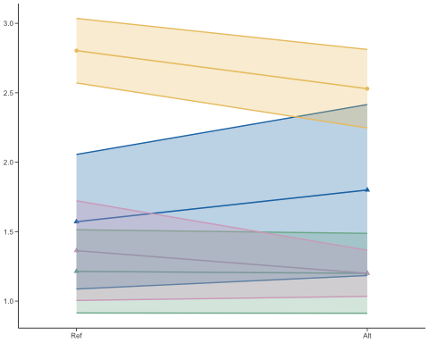
emm_plots[["HSP101"]]
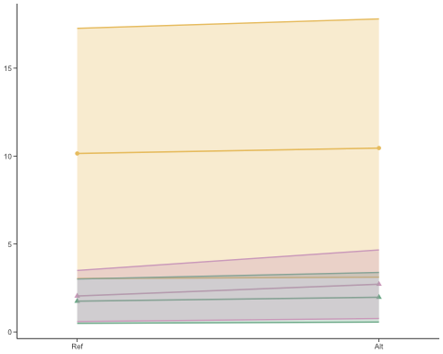
emm_plots[["Pfs25"]]
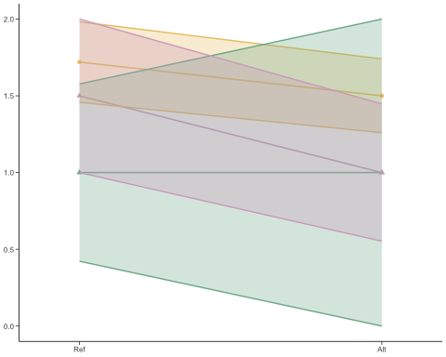
emm_plots[["Pfs47"]]
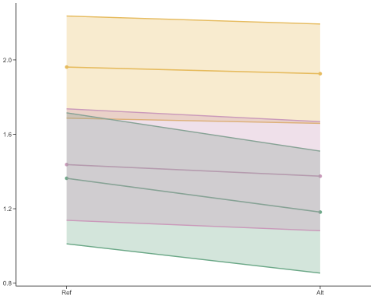
emm_plots[["WARP"]]
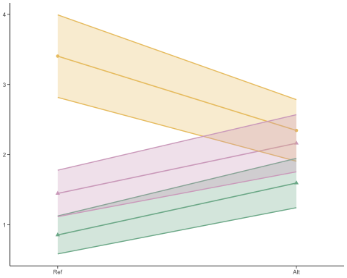
pdf("/Users/virginiahowick/Documents/allelic_replacement/plots/intensity_oocysts_20260416.pdf", width = 8, height = 1.6)
plot_grid(plotlist = emm_plots, ncol = 5)
dev.off()
## quartz_off_screen
## 2
session_info()
## ─ Session info ───────────────────────────────────────────────────────────────
## setting value
## version R version 4.5.1 (2025-06-13)
## os macOS Ventura 13.6.9
## system x86_64, darwin20
## ui X11
## language (EN)
## collate en_US.UTF-8
## ctype en_US.UTF-8
## tz Europe/London
## date 2026-04-16
## pandoc 3.4 @ /Applications/RStudio.app/Contents/Resources/app/quarto/bin/tools/x86_64/ (via rmarkdown)
## quarto 1.6.42 @ /Applications/RStudio.app/Contents/Resources/app/quarto/bin/quarto
##
## ─ Packages ───────────────────────────────────────────────────────────────────
## package * version date (UTC) lib source
## abind 1.4-8 2024-09-12 [1] CRAN (R 4.5.0)
## backports 1.5.0 2024-05-23 [1] CRAN (R 4.5.0)
## boot 1.3-31 2024-08-28 [1] CRAN (R 4.5.1)
## brglm2 * 1.0.0 2025-08-29 [1] CRAN (R 4.5.1)
## broom 1.0.8 2025-03-28 [1] CRAN (R 4.5.0)
## broom.mixed * 0.2.9.6 2024-10-15 [1] CRAN (R 4.5.0)
## cachem 1.1.0 2024-05-16 [1] CRAN (R 4.5.0)
## car * 3.1-3 2024-09-27 [1] CRAN (R 4.5.0)
## carData * 3.0-5 2022-01-06 [1] CRAN (R 4.5.0)
## cli 3.6.5 2025-04-23 [1] CRAN (R 4.5.0)
## coda 0.19-4.1 2024-01-31 [1] CRAN (R 4.5.0)
## codetools 0.2-20 2024-03-31 [1] CRAN (R 4.5.1)
## cowplot * 1.2.0 2025-07-07 [1] CRAN (R 4.5.1)
## crayon 1.5.3 2024-06-20 [1] CRAN (R 4.5.0)
## devtools * 2.4.5 2022-10-11 [1] CRAN (R 4.5.0)
## digest 0.6.37 2024-08-19 [1] CRAN (R 4.5.0)
## dplyr * 1.1.4 2023-11-17 [1] CRAN (R 4.5.0)
## ellipsis 0.3.2 2021-04-29 [1] CRAN (R 4.5.0)
## emmeans * 1.11.2-8 2025-08-27 [1] CRAN (R 4.5.1)
## enrichwith 0.4.0 2025-09-08 [1] CRAN (R 4.5.1)
## estimability 1.5.1 2024-05-12 [1] CRAN (R 4.5.0)
## evaluate 1.0.4 2025-06-18 [1] CRAN (R 4.5.0)
## farver 2.1.2 2024-05-13 [1] CRAN (R 4.5.0)
## fastmap 1.2.0 2024-05-15 [1] CRAN (R 4.5.0)
## forcats * 1.0.0 2023-01-29 [1] CRAN (R 4.5.0)
## Formula 1.2-5 2023-02-24 [1] CRAN (R 4.5.0)
## fs 1.6.6 2025-04-12 [1] CRAN (R 4.5.0)
## furrr 0.3.1 2022-08-15 [1] CRAN (R 4.5.0)
## future 1.58.0 2025-06-05 [1] CRAN (R 4.5.0)
## generics 0.1.4 2025-05-09 [1] CRAN (R 4.5.0)
## ggplot2 * 3.5.2 2025-04-09 [1] CRAN (R 4.5.0)
## glmmTMB * 1.1.12 2025-08-18 [1] CRAN (R 4.5.1)
## globals 0.18.0 2025-05-08 [1] CRAN (R 4.5.0)
## glue 1.8.0 2024-09-30 [1] CRAN (R 4.5.0)
## gtable 0.3.6 2024-10-25 [1] CRAN (R 4.5.0)
## hms 1.1.3 2023-03-21 [1] CRAN (R 4.5.0)
## htmltools 0.5.8.1 2024-04-04 [1] CRAN (R 4.5.0)
## htmlwidgets 1.6.4 2023-12-06 [1] CRAN (R 4.5.0)
## httpuv 1.6.16 2025-04-16 [1] CRAN (R 4.5.0)
## knitr 1.50 2025-03-16 [1] CRAN (R 4.5.0)
## labeling 0.4.3 2023-08-29 [1] CRAN (R 4.5.0)
## later 1.4.2 2025-04-08 [1] CRAN (R 4.5.0)
## lattice 0.22-7 2025-04-02 [1] CRAN (R 4.5.1)
## lifecycle 1.0.4 2023-11-07 [1] CRAN (R 4.5.0)
## listenv 0.9.1 2024-01-29 [1] CRAN (R 4.5.0)
## lme4 * 1.1-37 2025-03-26 [1] CRAN (R 4.5.0)
## lubridate * 1.9.4 2024-12-08 [1] CRAN (R 4.5.0)
## magrittr 2.0.3 2022-03-30 [1] CRAN (R 4.5.0)
## MASS * 7.3-65 2025-02-28 [1] CRAN (R 4.5.1)
## Matrix * 1.7-3 2025-03-11 [1] CRAN (R 4.5.1)
## memoise 2.0.1 2021-11-26 [1] CRAN (R 4.5.0)
## mgcv 1.9-3 2025-04-04 [1] CRAN (R 4.5.1)
## mime 0.13 2025-03-17 [1] CRAN (R 4.5.0)
## miniUI 0.1.2 2025-04-17 [1] CRAN (R 4.5.0)
## minqa 1.2.8 2024-08-17 [1] CRAN (R 4.5.0)
## mvtnorm 1.3-3 2025-01-10 [1] CRAN (R 4.5.0)
## nleqslv 3.3.5 2023-11-26 [1] CRAN (R 4.5.0)
## nlme 3.1-168 2025-03-31 [1] CRAN (R 4.5.1)
## nloptr 2.2.1 2025-03-17 [1] CRAN (R 4.5.0)
## nnet 7.3-20 2025-01-01 [1] CRAN (R 4.5.1)
## numDeriv 2016.8-1.1 2019-06-06 [1] CRAN (R 4.5.0)
## parallelly 1.45.0 2025-06-02 [1] CRAN (R 4.5.0)
## pillar 1.11.0 2025-07-04 [1] CRAN (R 4.5.1)
## pkgbuild 1.4.8 2025-05-26 [1] CRAN (R 4.5.0)
## pkgconfig 2.0.3 2019-09-22 [1] CRAN (R 4.5.0)
## pkgload 1.4.0 2024-06-28 [1] CRAN (R 4.5.0)
## profvis 0.4.0 2024-09-20 [1] CRAN (R 4.5.0)
## promises 1.3.3 2025-05-29 [1] CRAN (R 4.5.0)
## purrr * 1.1.0 2025-07-10 [1] CRAN (R 4.5.1)
## R6 2.6.1 2025-02-15 [1] CRAN (R 4.5.0)
## rbibutils 2.3 2024-10-04 [1] CRAN (R 4.5.0)
## RColorBrewer 1.1-3 2022-04-03 [1] CRAN (R 4.5.0)
## Rcpp 1.1.0 2025-07-02 [1] CRAN (R 4.5.1)
## Rdpack 2.6.4 2025-04-09 [1] CRAN (R 4.5.0)
## readr * 2.1.5 2024-01-10 [1] CRAN (R 4.5.0)
## reformulas 0.4.1 2025-04-30 [1] CRAN (R 4.5.0)
## remotes 2.5.0 2024-03-17 [1] CRAN (R 4.5.0)
## rlang 1.1.6 2025-04-11 [1] CRAN (R 4.5.0)
## rmarkdown 2.29 2024-11-04 [1] CRAN (R 4.5.0)
## rstudioapi 0.17.1 2024-10-22 [1] CRAN (R 4.5.0)
## sandwich 3.1-1 2024-09-15 [1] CRAN (R 4.5.0)
## scales 1.4.0 2025-04-24 [1] CRAN (R 4.5.0)
## sessioninfo 1.2.3 2025-02-05 [1] CRAN (R 4.5.0)
## shiny 1.11.1 2025-07-03 [1] CRAN (R 4.5.1)
## statmod 1.5.1 2025-10-09 [1] CRAN (R 4.5.1)
## stringi 1.8.7 2025-03-27 [1] CRAN (R 4.5.0)
## stringr * 1.5.1 2023-11-14 [1] CRAN (R 4.5.0)
## tibble * 3.3.0 2025-06-08 [1] CRAN (R 4.5.0)
## tidyr * 1.3.1 2024-01-24 [1] CRAN (R 4.5.0)
## tidyselect 1.2.1 2024-03-11 [1] CRAN (R 4.5.0)
## tidyverse * 2.0.0 2023-02-22 [1] CRAN (R 4.5.0)
## timechange 0.3.0 2024-01-18 [1] CRAN (R 4.5.0)
## TMB 1.9.17 2025-03-10 [1] CRAN (R 4.5.0)
## tzdb 0.5.0 2025-03-15 [1] CRAN (R 4.5.0)
## urlchecker 1.0.1 2021-11-30 [1] CRAN (R 4.5.0)
## usethis * 3.2.1 2025-09-06 [1] CRAN (R 4.5.1)
## utf8 1.2.6 2025-06-08 [1] CRAN (R 4.5.0)
## vctrs 0.6.5 2023-12-01 [1] CRAN (R 4.5.0)
## withr 3.0.2 2024-10-28 [1] CRAN (R 4.5.0)
## xfun 0.52 2025-04-02 [1] CRAN (R 4.5.0)
## xtable 1.8-4 2019-04-21 [1] CRAN (R 4.5.0)
## yaml 2.3.10 2024-07-26 [1] CRAN (R 4.5.0)
## zoo 1.8-14 2025-04-10 [1] CRAN (R 4.5.0)
##
## [1] /Library/Frameworks/R.framework/Versions/4.5-x86_64/Resources/library
## * ── Packages attached to the search path.
##
## ──────────────────────────────────────────────────────────────────────────────

