Analysis of oocyst size 17 Oct 2025
library(lme4)
library(MASS)
library(ggplot2)
library(emmeans)
library(tidyverse)
library(glmmTMB)
library(car)
library(devtools)
library(cowplot)
library(broom.mixed)
library(ggbeeswarm)
WARP <- read.csv("/Users/virginiahowick/Documents/allelic_replacement/OocystSize_Lah/WARP/WARP_oocystSize_28Jul25.csv")
HSP101 <- read.csv("/Users/virginiahowick/Documents/allelic_replacement/OocystSize_Lah/HSP101/HSP101_oocystSize_13Apr25.csv")
Pfs47 <- read.csv("/Users/virginiahowick/Documents/allelic_replacement/OocystSize_Lah/P47/P47_oocystSize_13Apr25.csv")
CTRP <- read.csv("/Users/virginiahowick/Documents/allelic_replacement/OocystSize_Lah/CTRP/CTRP_oocystSize_13Apr25.csv")
Pfs25 <- read.csv("/Users/virginiahowick/Documents/allelic_replacement/OocystSize_Lah/Pfs25/Pfs25_oocystSize_132Apr25.csv")
WARP$gene <- rep("WARP", length(WARP$name))
HSP101$gene <- rep("HSP101", length(HSP101$name))
Pfs47$gene <- rep("Pfs47", length(Pfs47$name))
Pfs25$gene <- rep("Pfs25", length(Pfs25$name))
CTRP$gene <- rep("CTRP", length(CTRP$name))
#CTRP <- subset(CTRP, background!="HB3")
#CTRP <- subset(CTRP, clone!="bulk")
CTRP$RefAlt <- ifelse(CTRP$allele == "D", "Ref", "Alt")
HSP101$RefAlt <- ifelse(HSP101$allele == "R", "Ref", "Alt")
Pfs25$RefAlt <- ifelse(Pfs25$allele == "G", "Ref", "Alt")
Pfs47$RefAlt <- ifelse(Pfs47$allele == "S", "Ref", "Alt")
WARP$RefAlt <- ifelse(WARP$allele == "F", "Ref", "Alt")
alldata <- rbind(CTRP, HSP101, Pfs25, Pfs47, WARP)
alldata$background <- sub("3D8", "3D7", alldata$background)
alldata$clone <- sub("E3", "E2", alldata$clone)
write.csv(alldata, file="/Users/virginiahowick/Documents/allelic_replacement/all_oocystsize_data_20260416.csv")
Subset data and set as factors
alldata <- subset(alldata, clone!="3D7")
alldata$clone <- as.factor(alldata$clone)
alldata$allele <- as.factor(alldata$allele)
alldata$rep <- as.factor(alldata$rep)
alldata$mosquito <- as.factor(alldata$mosquito)
alldata$RefAlt <- factor(alldata$RefAlt, levels = c("Ref","Alt"), ordered = TRUE)
alldata$midgut <- as.factor(alldata$midgut)
summary(alldata$oocystsize)
## Min. 1st Qu. Median Mean 3rd Qu. Max.
## 11.90 31.20 39.95 40.88 49.90 113.20
var(alldata$oocystsize)
## [1] 172.4574
#alldata <- subset(alldata, mosquito!="An_alb")
alldata$oocyst_prev <- rep(0, length(alldata$name))
alldata[which(alldata$oocysts > 0), ]$oocyst_prev <- 1
alldata$mosq_allele <- interaction(alldata$mosquito,
alldata$allele,
sep = "_")
Plot graph from raw data
# The genes you want to loop over
genes_to_plot <- c("CTRP", "HSP101", "Pfs25", "Pfs47", "WARP")
# Make plots for each gene
plots <- lapply(genes_to_plot, function(g) {
ggplot(filter(alldata, gene == g),
aes(x = RefAlt, y = oocystsize)) +
geom_violin(aes(colour = RefAlt), width = 0.6, size = 0.4) +
ggbeeswarm::geom_quasirandom(
aes(color = RefAlt),
groupOnX = TRUE, # swarm within each x group
dodge.width = 0.6, # keeps Ref/Alt separated
width = 0.25, # horizontal spread
alpha = 0.55, size = 0.75
) +
facet_grid(. ~ mosquito, labeller = labeller(
mosquito = c(An_gam = "gambiae", An_steph = "stephensi",
An_mini = "minimus", An_alb = "albimanus")
)) +
theme_bw(base_size = 6) +
theme(
axis.line = element_line(colour = "black", size = 0.3),
strip.background = element_rect(fill = "white", color = "black"),
strip.text = element_text(face = "italic", size = 6),
axis.text = element_text(size = 6),
axis.title.x = element_blank(),
axis.title.y = element_blank(),
legend.position = "none",
axis.ticks.length = unit(0.1, "cm")
) +
scale_fill_manual(values = c("#E31A1C", "#6A3D9A")) +
scale_color_manual(values = c("#E31A1C", "#6A3D9A")) +
ggtitle(g)
})
## Warning: Using `size` aesthetic for lines was deprecated in ggplot2 3.4.0.
## ℹ Please use `linewidth` instead.
## This warning is displayed once every 8 hours.
## Call `lifecycle::last_lifecycle_warnings()` to see where this warning was
## generated.
## Warning: The `size` argument of `element_line()` is deprecated as of ggplot2 3.4.0.
## ℹ Please use the `linewidth` argument instead.
## This warning is displayed once every 8 hours.
## Call `lifecycle::last_lifecycle_warnings()` to see where this warning was
## generated.
# Access a specific plot
plots[[1]]
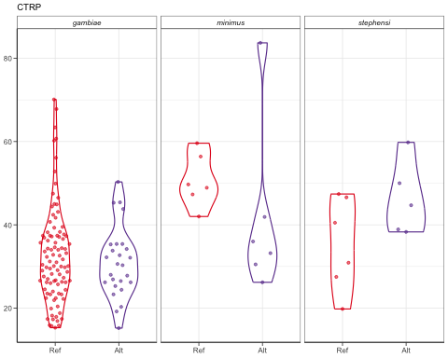
plots[[2]]
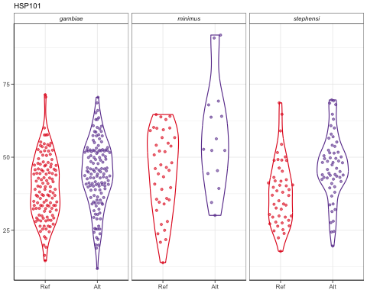
plots[[3]]
## Warning: Groups with fewer than two datapoints have been dropped.
## ℹ Set `drop = FALSE` to consider such groups for position adjustment purposes.
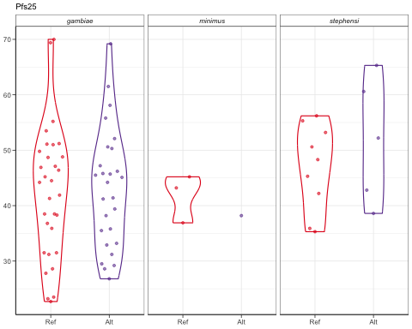
plots[[4]]
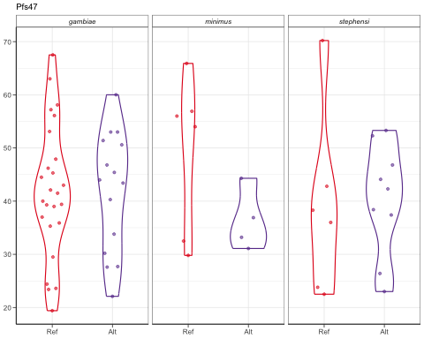
plots[[5]]
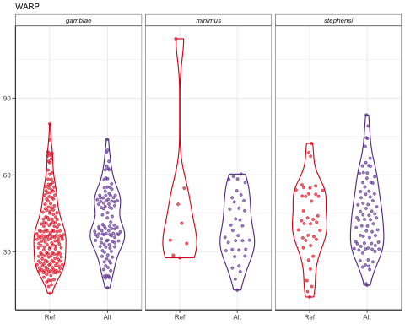
pdf("/Users/virginiahowick/Documents/allelic_replacement/plots/oocyst_size_20251017.pdf", width = 5, height = 5)
plot_grid(plotlist = plots, ncol = 2)
## Warning: Groups with fewer than two datapoints have been dropped.
## ℹ Set `drop = FALSE` to consider such groups for position adjustment purposes.
dev.off()
## quartz_off_screen
## 2
Just CTRP and WARP
# The genes you want to loop over
genes_to_plot <- c("CTRP", "WARP")
# Make plots for each gene
plots <- lapply(genes_to_plot, function(g) {
ggplot(filter(alldata, gene == g),
aes(x = RefAlt, y = oocystsize)) +
geom_violin(aes(colour = RefAlt), width = 0.6, size = 0.4) +
ggbeeswarm::geom_quasirandom(
aes(color = RefAlt),
groupOnX = TRUE, # swarm within each x group
dodge.width = 0.6, # keeps Ref/Alt separated
width = 0.25, # horizontal spread
alpha = 0.55, size = 0.75
) +
facet_grid(. ~ mosquito, labeller = labeller(
mosquito = c(An_gam = "gambiae", An_steph = "stephensi",
An_mini = "minimus", An_alb = "albimanus")
)) +
theme_bw(base_size = 6) +
theme(
axis.line = element_line(colour = "black", size = 0.3),
strip.background = element_rect(fill = "white", color = "black"),
strip.text = element_text(face = "italic", size = 6),
axis.text = element_text(size = 6),
axis.title.x = element_blank(),
axis.title.y = element_blank(),
legend.position = "none",
axis.ticks.length = unit(0.1, "cm")
) +
scale_fill_manual(values = c("#E31A1C", "#6A3D9A")) +
scale_color_manual(values = c("#E31A1C", "#6A3D9A"))
#ggtitle(g)
})
# Access a specific plot
plots[[1]]
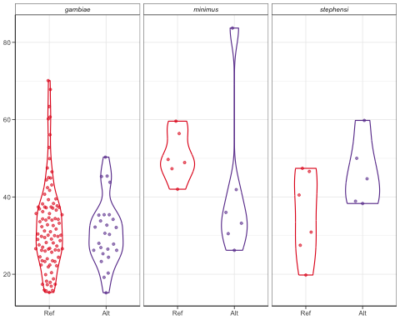
plots[[2]]
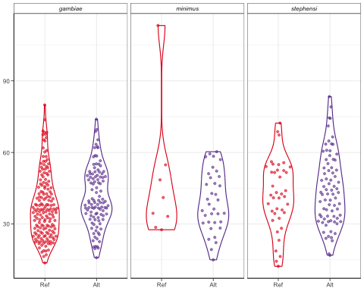
pdf("/Users/virginiahowick/Documents/allelic_replacement/plots/oocyst_size_20260326.pdf", width = 2.5, height = 3.5)
plot_grid(plotlist = plots, ncol = 1)
dev.off()
## quartz_off_screen
## 2
# The genes you want to loop over
genes_to_plot <- c("HSP101", "Pfs25", "Pfs47")
# Make plots for each gene
plots <- lapply(genes_to_plot, function(g) {
ggplot(filter(alldata, gene == g),
aes(x = RefAlt, y = oocystsize)) +
geom_violin(aes(colour = RefAlt), width = 0.6, size = 0.4) +
ggbeeswarm::geom_quasirandom(
aes(color = RefAlt),
groupOnX = TRUE, # swarm within each x group
dodge.width = 0.6, # keeps Ref/Alt separated
width = 0.25, # horizontal spread
alpha = 0.55, size = 0.75
) +
facet_grid(. ~ mosquito, labeller = labeller(
mosquito = c(An_gam = "gambiae", An_steph = "stephensi",
An_mini = "minimus", An_alb = "albimanus")
)) +
theme_bw(base_size = 6) +
theme(
axis.line = element_line(colour = "black", size = 0.3),
strip.background = element_rect(fill = "white", color = "black"),
strip.text = element_text(face = "italic", size = 6),
axis.text = element_text(size = 6),
axis.title.x = element_blank(),
axis.title.y = element_blank(),
legend.position = "none",
axis.ticks.length = unit(0.1, "cm")
) +
scale_fill_manual(values = c("#E31A1C", "#6A3D9A")) +
scale_color_manual(values = c("#E31A1C", "#6A3D9A")) +
ggtitle(g)
})
# Access a specific plot
plots[[1]]

plots[[2]]
## Warning: Groups with fewer than two datapoints have been dropped.
## ℹ Set `drop = FALSE` to consider such groups for position adjustment purposes.

plots[[3]]

pdf("/Users/virginiahowick/Documents/allelic_replacement/plots/oocyst_size_othergenes_20260326.pdf", width = 2.5, height = 6)
plot_grid(plotlist = plots, ncol = 1)
## Warning: Groups with fewer than two datapoints have been dropped.
## ℹ Set `drop = FALSE` to consider such groups for position adjustment purposes.
dev.off()
## quartz_off_screen
## 2
Run oocyst prev model and calculate emmeans
# List of genes to loop over
genes <- c("CTRP", "HSP101", "Pfs25", "Pfs47", "WARP")
results <- lapply(genes, function(g) {
df <- subset(alldata, gene == g)
# Choose model formula based on gene
if (g == "HSP101") {
form <- oocystsize ~ RefAlt * mosquito +
(1 | midgut)
} else if (g %in% c("CTRP", "Pfs25", "Pfs47", "WARP")) {
form <- oocystsize ~ rep + RefAlt * mosquito +
(1 | midgut)
}
# Fit the model
mod <- lmer(form, data = df)
# Tidy summary (fixed effects only)
sum_df <- broom.mixed::tidy(mod, effects = "fixed") %>%
mutate(gene = g)
# ANOVA table (Type III)
anova_tab <- Anova(mod, type = "III")
anova_df <- as.data.frame(anova_tab) %>%
rownames_to_column("term") %>%
mutate(gene = g)
# Estimated marginal means and pairwise contrasts
emm_tab <- emmeans(mod, specs = pairwise ~ RefAlt | mosquito)
emm_df <- as.data.frame(emm_tab$emmeans) %>%
mutate(gene = g)
contrast_df <- as.data.frame(emm_tab$contrasts) %>%
mutate(gene = g)
list(summary = sum_df,
anova = anova_df,
emm = emm_df,
contrasts = contrast_df)
})
# Combine across genes
summary_all <- bind_rows(lapply(results, `[[`, "summary"))
anova_all <- bind_rows(lapply(results, `[[`, "anova"))
emm_all <- bind_rows(lapply(results, `[[`, "emm"))
contrasts_all <- bind_rows(lapply(results, `[[`, "contrasts"))
# Export to CSV
#write.csv(summary_all, "/Users/virginiahowick/Documents/allelic_replacement/analysis/size_summary_all.csv", row.names = FALSE)
#write.csv(anova_all, "/Users/virginiahowick/Documents/allelic_replacement/analysis/size_anova_all.csv", row.names = FALSE)
#write.csv(emm_all, "/Users/virginiahowick/Documents/allelic_replacement/analysis/size_emm_all.csv", row.names = FALSE)
#write.csv(contrasts_all, "/Users/virginiahowick/Documents/allelic_replacement/analysis/size_contrasts_all.csv", row.names = FALSE)
summary_all
## # A tibble: 38 × 6
## effect term estimate std.error statistic gene
## <chr> <chr> <dbl> <dbl> <dbl> <chr>
## 1 fixed (Intercept) 30.8 2.07 14.9 CTRP
## 2 fixed rep2 2.29 3.87 0.591 CTRP
## 3 fixed RefAlt.L -1.31 2.56 -0.513 CTRP
## 4 fixed mosquitoAn_mini 16.7 4.26 3.92 CTRP
## 5 fixed mosquitoAn_steph 10.2 4.30 2.37 CTRP
## 6 fixed RefAlt.L:mosquitoAn_mini -5.11 5.85 -0.873 CTRP
## 7 fixed RefAlt.L:mosquitoAn_steph 10.5 5.91 1.78 CTRP
## 8 fixed (Intercept) 41.3 1.53 27.0 HSP101
## 9 fixed RefAlt.L 4.20 2.16 1.94 HSP101
## 10 fixed mosquitoAn_mini 10.2 2.69 3.79 HSP101
## # ℹ 28 more rows
anova_all
## term Chisq Df Pr(>Chisq) gene
## 1 (Intercept) 222.26737810 1 2.896155e-50 CTRP
## 2 rep 0.34967445 1 5.542975e-01 CTRP
## 3 RefAlt 0.26343102 1 6.077727e-01 CTRP
## 4 mosquito 17.59849460 2 1.508466e-04 CTRP
## 5 RefAlt:mosquito 4.66925253 2 9.684667e-02 CTRP
## 6 (Intercept) 729.20419707 1 1.334266e-160 HSP101
## 7 RefAlt 3.77427252 1 5.204653e-02 HSP101
## 8 mosquito 15.24635352 2 4.889860e-04 HSP101
## 9 RefAlt:mosquito 2.30302656 2 3.161580e-01 HSP101
## 10 (Intercept) 400.25648029 1 4.842863e-89 Pfs25
## 11 rep 0.92546191 1 3.360449e-01 Pfs25
## 12 RefAlt 0.04852023 1 8.256585e-01 Pfs25
## 13 mosquito 2.15623341 2 3.402357e-01 Pfs25
## 14 RefAlt:mosquito 0.30781698 2 8.573505e-01 Pfs25
## 15 (Intercept) 202.49673287 1 5.956695e-46 Pfs47
## 16 rep 0.70411530 2 7.032396e-01 Pfs47
## 17 RefAlt 0.11190241 1 7.379886e-01 Pfs47
## 18 mosquito 0.31270745 2 8.552566e-01 Pfs47
## 19 RefAlt:mosquito 2.11646510 2 3.470687e-01 Pfs47
## 20 (Intercept) 507.40680455 1 2.324998e-112 WARP
## 21 rep 43.23286192 4 9.258218e-09 WARP
## 22 RefAlt 0.01816990 1 8.927734e-01 WARP
## 23 mosquito 10.13089597 2 6.311083e-03 WARP
## 24 RefAlt:mosquito 3.10858046 2 2.113393e-01 WARP
emm_all
## RefAlt mosquito emmean SE df lower.CL upper.CL gene
## 1 Ref An_gam 32.87162 2.271798 39.26917 28.27748 37.46575 CTRP
## 2 Alt An_gam 31.01655 3.110997 50.24471 24.76868 37.26441 CTRP
## 3 Ref An_mini 53.17347 5.823483 57.69633 41.51519 64.83174 CTRP
## 4 Alt An_mini 44.09406 5.409630 65.08671 33.29056 54.89757 CTRP
## 5 Ref An_steph 35.62979 5.409630 65.08671 24.82629 46.43330 CTRP
## 6 Alt An_steph 48.61844 5.926082 63.79497 36.77899 60.45788 CTRP
## 7 Ref An_gam 38.28977 2.325139 21.77471 33.46483 43.11471 HSP101
## 8 Alt An_gam 44.22627 1.995003 25.64572 40.12273 48.32982 HSP101
## 9 Ref An_mini 44.58638 2.697227 43.92363 39.15021 50.02255 HSP101
## 10 Alt An_mini 58.33255 3.527387 94.87880 51.32969 65.33542 HSP101
## 11 Ref An_steph 39.33184 2.205517 61.55331 34.92244 43.74125 HSP101
## 12 Alt An_steph 45.99701 2.265631 44.66853 41.43286 50.56116 HSP101
## 13 Ref An_gam 45.24670 2.594527 41.49728 40.00886 50.48455 Pfs25
## 14 Alt An_gam 46.04697 2.544729 43.20818 40.91575 51.17819 Pfs25
## 15 Ref An_mini 42.26339 6.358802 46.30491 29.46606 55.06072 Pfs25
## 16 Alt An_mini 39.69017 11.086193 46.26047 17.37821 62.00213 Pfs25
## 17 Ref An_steph 47.98483 4.385776 42.41615 39.13655 56.83311 Pfs25
## 18 Alt An_steph 52.19803 4.919003 46.31394 42.29840 62.09766 Pfs25
## 19 Ref An_gam 41.92027 4.115790 33.75178 33.55371 50.28682 Pfs47
## 20 Alt An_gam 40.35499 4.948570 32.53085 30.28153 50.42845 Pfs47
## 21 Ref An_mini 51.47546 6.029785 35.69779 39.24289 63.70803 Pfs47
## 22 Alt An_mini 37.58003 7.479715 54.54723 22.58755 52.57251 Pfs47
## 23 Ref An_steph 41.54364 8.271023 38.71050 24.80992 58.27737 Pfs47
## 24 Alt An_steph 42.94647 8.005901 27.58189 26.53592 59.35703 Pfs47
## 25 Ref An_gam 36.41578 1.691750 103.13051 33.06065 39.77092 WARP
## 26 Alt An_gam 36.74781 2.043956 132.64176 32.70484 40.79077 WARP
## 27 Ref An_mini 47.38376 4.669309 300.00305 38.19502 56.57251 WARP
## 28 Alt An_mini 40.50880 2.662620 187.66162 35.25629 45.76132 WARP
## 29 Ref An_steph 39.75761 2.754221 160.20807 34.31835 45.19687 WARP
## 30 Alt An_steph 43.56837 1.921677 177.58008 39.77611 47.36063 WARP
contrasts_all
## contrast mosquito estimate SE df t.ratio p.value
## 1 Ref - Alt An_gam 1.8550706 3.624063 41.44419 0.5118760 0.611454745
## 2 Ref - Alt An_mini 9.0794039 7.460081 63.37182 1.2170650 0.228092522
## 3 Ref - Alt An_steph -12.9886430 7.540445 67.30991 -1.7225301 0.089565643
## 4 Ref - Alt An_gam -5.9364997 3.063709 23.30150 -1.9376841 0.064873649
## 5 Ref - Alt An_mini -13.7461780 4.440438 69.46437 -3.0956807 0.002830495
## 6 Ref - Alt An_steph -6.6651672 3.161865 51.92901 -2.1079859 0.039877127
## 7 Ref - Alt An_gam -0.8002650 3.634210 42.33236 -0.2202033 0.826771359
## 8 Ref - Alt An_mini 2.5732195 12.717604 46.30491 0.2023352 0.840541032
## 9 Ref - Alt An_steph -4.2132055 6.589230 44.53573 -0.6394078 0.525833117
## 10 Ref - Alt An_gam 1.5652711 4.715528 30.30041 0.3319397 0.742220041
## 11 Ref - Alt An_mini 13.8954328 8.664667 56.17460 1.6036891 0.114390974
## 12 Ref - Alt An_steph -1.4028311 7.380391 29.33999 -0.1900754 0.850559002
## 13 Ref - Alt An_gam -0.3320239 2.469074 102.02802 -0.1344730 0.893293437
## 14 Ref - Alt An_mini 6.8749619 5.244672 272.73913 1.3108468 0.191012199
## 15 Ref - Alt An_steph -3.8107630 3.150932 149.61766 -1.2094084 0.228413552
## gene
## 1 CTRP
## 2 CTRP
## 3 CTRP
## 4 HSP101
## 5 HSP101
## 6 HSP101
## 7 Pfs25
## 8 Pfs25
## 9 Pfs25
## 10 Pfs47
## 11 Pfs47
## 12 Pfs47
## 13 WARP
## 14 WARP
## 15 WARP
session_info()
## ─ Session info ───────────────────────────────────────────────────────────────
## setting value
## version R version 4.5.1 (2025-06-13)
## os macOS Ventura 13.6.9
## system x86_64, darwin20
## ui X11
## language (EN)
## collate en_US.UTF-8
## ctype en_US.UTF-8
## tz Europe/London
## date 2026-04-16
## pandoc 3.4 @ /Applications/RStudio.app/Contents/Resources/app/quarto/bin/tools/x86_64/ (via rmarkdown)
## quarto 1.6.42 @ /Applications/RStudio.app/Contents/Resources/app/quarto/bin/quarto
##
## ─ Packages ───────────────────────────────────────────────────────────────────
## package * version date (UTC) lib source
## abind 1.4-8 2024-09-12 [1] CRAN (R 4.5.0)
## backports 1.5.0 2024-05-23 [1] CRAN (R 4.5.0)
## beeswarm 0.4.0 2021-06-01 [1] CRAN (R 4.5.0)
## boot 1.3-31 2024-08-28 [1] CRAN (R 4.5.1)
## broom 1.0.8 2025-03-28 [1] CRAN (R 4.5.0)
## broom.mixed * 0.2.9.6 2024-10-15 [1] CRAN (R 4.5.0)
## cachem 1.1.0 2024-05-16 [1] CRAN (R 4.5.0)
## car * 3.1-3 2024-09-27 [1] CRAN (R 4.5.0)
## carData * 3.0-5 2022-01-06 [1] CRAN (R 4.5.0)
## cli 3.6.5 2025-04-23 [1] CRAN (R 4.5.0)
## coda 0.19-4.1 2024-01-31 [1] CRAN (R 4.5.0)
## codetools 0.2-20 2024-03-31 [1] CRAN (R 4.5.1)
## cowplot * 1.2.0 2025-07-07 [1] CRAN (R 4.5.1)
## crayon 1.5.3 2024-06-20 [1] CRAN (R 4.5.0)
## devtools * 2.4.5 2022-10-11 [1] CRAN (R 4.5.0)
## digest 0.6.37 2024-08-19 [1] CRAN (R 4.5.0)
## dplyr * 1.1.4 2023-11-17 [1] CRAN (R 4.5.0)
## ellipsis 0.3.2 2021-04-29 [1] CRAN (R 4.5.0)
## emmeans * 1.11.2-8 2025-08-27 [1] CRAN (R 4.5.1)
## estimability 1.5.1 2024-05-12 [1] CRAN (R 4.5.0)
## evaluate 1.0.4 2025-06-18 [1] CRAN (R 4.5.0)
## farver 2.1.2 2024-05-13 [1] CRAN (R 4.5.0)
## fastmap 1.2.0 2024-05-15 [1] CRAN (R 4.5.0)
## forcats * 1.0.0 2023-01-29 [1] CRAN (R 4.5.0)
## Formula 1.2-5 2023-02-24 [1] CRAN (R 4.5.0)
## fs 1.6.6 2025-04-12 [1] CRAN (R 4.5.0)
## furrr 0.3.1 2022-08-15 [1] CRAN (R 4.5.0)
## future 1.58.0 2025-06-05 [1] CRAN (R 4.5.0)
## generics 0.1.4 2025-05-09 [1] CRAN (R 4.5.0)
## ggbeeswarm * 0.7.2 2023-04-29 [1] CRAN (R 4.5.0)
## ggplot2 * 3.5.2 2025-04-09 [1] CRAN (R 4.5.0)
## glmmTMB * 1.1.12 2025-08-18 [1] CRAN (R 4.5.1)
## globals 0.18.0 2025-05-08 [1] CRAN (R 4.5.0)
## glue 1.8.0 2024-09-30 [1] CRAN (R 4.5.0)
## gtable 0.3.6 2024-10-25 [1] CRAN (R 4.5.0)
## hms 1.1.3 2023-03-21 [1] CRAN (R 4.5.0)
## htmltools 0.5.8.1 2024-04-04 [1] CRAN (R 4.5.0)
## htmlwidgets 1.6.4 2023-12-06 [1] CRAN (R 4.5.0)
## httpuv 1.6.16 2025-04-16 [1] CRAN (R 4.5.0)
## knitr 1.50 2025-03-16 [1] CRAN (R 4.5.0)
## labeling 0.4.3 2023-08-29 [1] CRAN (R 4.5.0)
## later 1.4.2 2025-04-08 [1] CRAN (R 4.5.0)
## lattice 0.22-7 2025-04-02 [1] CRAN (R 4.5.1)
## lifecycle 1.0.4 2023-11-07 [1] CRAN (R 4.5.0)
## listenv 0.9.1 2024-01-29 [1] CRAN (R 4.5.0)
## lme4 * 1.1-37 2025-03-26 [1] CRAN (R 4.5.0)
## lubridate * 1.9.4 2024-12-08 [1] CRAN (R 4.5.0)
## magrittr 2.0.3 2022-03-30 [1] CRAN (R 4.5.0)
## MASS * 7.3-65 2025-02-28 [1] CRAN (R 4.5.1)
## Matrix * 1.7-3 2025-03-11 [1] CRAN (R 4.5.1)
## memoise 2.0.1 2021-11-26 [1] CRAN (R 4.5.0)
## mgcv 1.9-3 2025-04-04 [1] CRAN (R 4.5.1)
## mime 0.13 2025-03-17 [1] CRAN (R 4.5.0)
## miniUI 0.1.2 2025-04-17 [1] CRAN (R 4.5.0)
## minqa 1.2.8 2024-08-17 [1] CRAN (R 4.5.0)
## mvtnorm 1.3-3 2025-01-10 [1] CRAN (R 4.5.0)
## nlme 3.1-168 2025-03-31 [1] CRAN (R 4.5.1)
## nloptr 2.2.1 2025-03-17 [1] CRAN (R 4.5.0)
## numDeriv 2016.8-1.1 2019-06-06 [1] CRAN (R 4.5.0)
## parallelly 1.45.0 2025-06-02 [1] CRAN (R 4.5.0)
## pbkrtest 0.5.5 2025-07-18 [1] CRAN (R 4.5.1)
## pillar 1.11.0 2025-07-04 [1] CRAN (R 4.5.1)
## pkgbuild 1.4.8 2025-05-26 [1] CRAN (R 4.5.0)
## pkgconfig 2.0.3 2019-09-22 [1] CRAN (R 4.5.0)
## pkgload 1.4.0 2024-06-28 [1] CRAN (R 4.5.0)
## profvis 0.4.0 2024-09-20 [1] CRAN (R 4.5.0)
## promises 1.3.3 2025-05-29 [1] CRAN (R 4.5.0)
## purrr * 1.1.0 2025-07-10 [1] CRAN (R 4.5.1)
## R6 2.6.1 2025-02-15 [1] CRAN (R 4.5.0)
## rbibutils 2.3 2024-10-04 [1] CRAN (R 4.5.0)
## RColorBrewer 1.1-3 2022-04-03 [1] CRAN (R 4.5.0)
## Rcpp 1.1.0 2025-07-02 [1] CRAN (R 4.5.1)
## Rdpack 2.6.4 2025-04-09 [1] CRAN (R 4.5.0)
## readr * 2.1.5 2024-01-10 [1] CRAN (R 4.5.0)
## reformulas 0.4.1 2025-04-30 [1] CRAN (R 4.5.0)
## remotes 2.5.0 2024-03-17 [1] CRAN (R 4.5.0)
## rlang 1.1.6 2025-04-11 [1] CRAN (R 4.5.0)
## rmarkdown 2.29 2024-11-04 [1] CRAN (R 4.5.0)
## rstudioapi 0.17.1 2024-10-22 [1] CRAN (R 4.5.0)
## sandwich 3.1-1 2024-09-15 [1] CRAN (R 4.5.0)
## scales 1.4.0 2025-04-24 [1] CRAN (R 4.5.0)
## sessioninfo 1.2.3 2025-02-05 [1] CRAN (R 4.5.0)
## shiny 1.11.1 2025-07-03 [1] CRAN (R 4.5.1)
## stringi 1.8.7 2025-03-27 [1] CRAN (R 4.5.0)
## stringr * 1.5.1 2023-11-14 [1] CRAN (R 4.5.0)
## tibble * 3.3.0 2025-06-08 [1] CRAN (R 4.5.0)
## tidyr * 1.3.1 2024-01-24 [1] CRAN (R 4.5.0)
## tidyselect 1.2.1 2024-03-11 [1] CRAN (R 4.5.0)
## tidyverse * 2.0.0 2023-02-22 [1] CRAN (R 4.5.0)
## timechange 0.3.0 2024-01-18 [1] CRAN (R 4.5.0)
## TMB 1.9.17 2025-03-10 [1] CRAN (R 4.5.0)
## tzdb 0.5.0 2025-03-15 [1] CRAN (R 4.5.0)
## urlchecker 1.0.1 2021-11-30 [1] CRAN (R 4.5.0)
## usethis * 3.2.1 2025-09-06 [1] CRAN (R 4.5.1)
## utf8 1.2.6 2025-06-08 [1] CRAN (R 4.5.0)
## vctrs 0.6.5 2023-12-01 [1] CRAN (R 4.5.0)
## vipor 0.4.7 2023-12-18 [1] CRAN (R 4.5.0)
## withr 3.0.2 2024-10-28 [1] CRAN (R 4.5.0)
## xfun 0.52 2025-04-02 [1] CRAN (R 4.5.0)
## xtable 1.8-4 2019-04-21 [1] CRAN (R 4.5.0)
## yaml 2.3.10 2024-07-26 [1] CRAN (R 4.5.0)
## zoo 1.8-14 2025-04-10 [1] CRAN (R 4.5.0)
##
## [1] /Library/Frameworks/R.framework/Versions/4.5-x86_64/Resources/library
## * ── Packages attached to the search path.
##
## ──────────────────────────────────────────────────────────────────────────────

