Looking at RSEM vsg analysis results

setwd("/Users/virginiahowick/Documents/Tryps/VSG")  
library(scater)

## Warning: package 'BiocGenerics' was built under R version 4.0.5

## Warning: package 'GenomeInfoDb' was built under R version 4.0.5

library(pheatmap)  
library(viridis)  
library(RColorBrewer)  
library(tidyverse)  
library(gplots)  
library(devtools)

tca <- readRDS("/Users/virginiahowick/Documents/Tryps/for_github/sc_data/howick_tryps_sce.rds")

counts <- read.csv("/Users/virginiahowick/Documents/Tryps/VSG/allgenes.alltotalgenes.results.csv", header=TRUE, row.names = 1)  
combovsg <- read.csv("/Users/virginiahowick/Documents/Tryps/VSG/blastpmvsg.outfmt6.csv", header=TRUE)  
plot(combovsg$length, combovsg$pident)

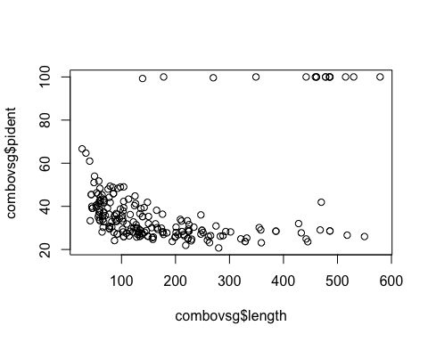

ggplot(combovsg, aes(x=length, y=pident)) + geom_point() + theme_bw()

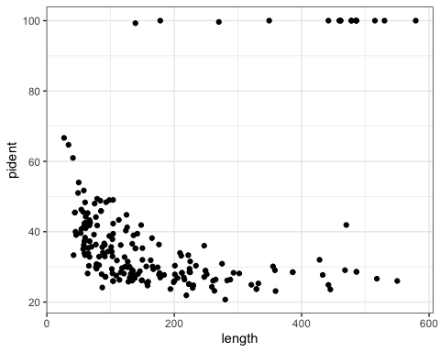

combovsg <- droplevels(subset(combovsg, pident > 90))  
#combovsg <- droplevels(subset(combovsg, length > 300))  
length(unique(combovsg$gene_id))

## [1] 13

#combovsg$for19 <- paste(combovsg$gene_id, combovsg$isoform, sep = "_")  
  
combovsgcounts <- counts[rownames(counts) %in% combovsg$gene_id, ]  
  
dim(combovsgcounts)

## [1] 13 676

#sample ids were different for RSEM and need to subset to cells of interest  
cd <- as.data.frame(colData(tca))  
  
subcd <- cd[cd$rsemname %in% colnames(combovsgcounts), ]  
  
subcombovsgcounts <- combovsgcounts[, colnames(combovsgcounts) %in% cd$rsemname]  
  
subcd <- subcd[match(colnames(subcombovsgcounts), subcd$rsemname), ]  
rownames(subcd) <- subcd$rsemname  
  
#Sum counts for VSG that are on top of eachother  
subcombovsgcounts <- aggregate(subcombovsgcounts, list(Group=replace(rownames(subcombovsgcounts),rownames(subcombovsgcounts) %in% c("TRINITY_DN13046_c0_g1","TRINITY_DN13046_c0_g2"), "TRINITY_DN13046_c0_g1g2")), sum)  
  
rownames(subcombovsgcounts) <- subcombovsgcounts$Group  
subcombovsgcounts <- subcombovsgcounts[ , 2:389]  
  
subcombovsgcounts <- aggregate(subcombovsgcounts, list(Group=replace(rownames(subcombovsgcounts),rownames(subcombovsgcounts) %in% c("TRINITY_DN143_c0_g1","TRINITY_DN143_c0_g2"), "TRINITY_DN143_c0_g1g2")), sum)  
  
rownames(subcombovsgcounts) <- subcombovsgcounts$Group  
subcombovsgcounts <- subcombovsgcounts[ , 2:389]

#make SCE with vsg counts  
vsg <- SingleCellExperiment(assays =   
 list(  
 counts = as.matrix(subcombovsgcounts),  
 logcounts = log2(as.matrix(subcombovsgcounts) + 1)  
), colData = subcd)  
  
#filter_genes <- apply(counts(mca[ , colData(mca)$use]), 1, function(x) length(x[x >= 1]) >= 2)  
  
CellQC <- perCellQCMetrics(vsg)  
FeatQC <- perFeatureQCMetrics(vsg)  
  
colData(vsg)$sumcomboVSG <- CellQC$sum  
colData(vsg)$detectedcomboVSG <- CellQC$detected  
  
counts <- as.data.frame(counts(vsg))  
  
#cells must have more than one read to count as expressing that VSG  
counts[counts == 1] <- 0  
  
colData(vsg)$sum_g1_VSG <- (as.data.frame(colSums(counts)))$`colSums(counts)`  
  
  
numcellsexp <- apply(counts, 1, function(x) length(x[x > 1]))  
numcellsexp

## TRINITY_DN1222_c0_g1 TRINITY_DN13046_c0_g1g2 TRINITY_DN13046_c1_g2   
## 32 14 16   
## TRINITY_DN143_c0_g1g2 TRINITY_DN16022_c0_g1 TRINITY_DN16709_c0_g1   
## 21 9 1   
## TRINITY_DN18105_c1_g1 TRINITY_DN21891_c0_g1 TRINITY_DN26789_c0_g1   
## 7 12 1   
## TRINITY_DN28824_c0_g1 TRINITY_DN9452_c0_g1   
## 1 9

#add number of VSG detected to coldata  
detected_g1_VSG <- apply(as.data.frame(t(counts)), 1, function(x) length(x[x > 1]))  
colData(vsg)$detected_g1_VSG <- (as.data.frame(detected_g1_VSG))$detected_g1_VSG  
  
#add sum of total vsg to coldata  
colData(vsg)$sumlogcountsVSG <- colSums(as.data.frame(logcounts(vsg)))  
colnames(FeatQC) <- c("comboVSGmean", "comboVSGdetected")  
rowData(vsg) <- cbind(rowData(vsg), FeatQC)  
  
  
mean(vsg$sumcomboVSG)

## [1] 2579.198

mean(vsg$detectedcomboVSG)

## [1] 0.5180412

mean(vsg$sum_g1_VSG)

## [1] 2579

mean(vsg$detected_g1_VSG)

## [1] 0.3170103

vsg <- vsg[, vsg$num_cells == "SC"]  
median(colData(vsg)$detected_g1_VSG)

## [1] 0

data <- as.data.frame(colData(vsg))  
  
tapply(data$sum_g1_VSG, data$spr_strain, mean)

## 1738 hybrid J10   
## 595.42392 18.77778 9604.92663

tapply(data$sum_g1_VSG, data$sc3_6_clusters, mean)

## 1 2 3 4 5 6   
## 1.634921e-02 1.615040e+04 1.325783e+02 0.000000e+00 3.330564e+02 2.777108e+01

tab <- as.data.frame(colData(vsg))  
ggplot(tab, aes(x=detectedcomboVSG, fill = strain)) + geom_histogram(bins = 20) + facet_grid(sc3_6_clusters~., scales="free")

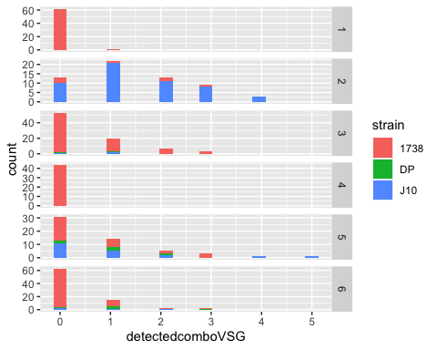

lc <- as.data.frame(logcounts(vsg))  
tlc <- as.data.frame(t(lc))  
tlc$cell <- rownames(tlc)  
  
tlc2 <- tlc %>% pivot_longer(cols = starts_with("TRINITY"), names_to = "gene_id", values_to = "logcounts")  
tlc2$cluster <- data[match(tlc2$cell, data[, 47]), 40]  
  
#ggplot(tlc2, aes(x=cell, y=logcounts, fill = gene_id)) + geom_bar(position="stack", stat="identity") + facet_grid(cluster~., scales="free")  
ggplot(tlc2, aes(x=cell, y=logcounts, fill = gene_id)) + geom_bar(position="stack", stat="identity") + facet_grid(cols = vars(cluster), scales="free")

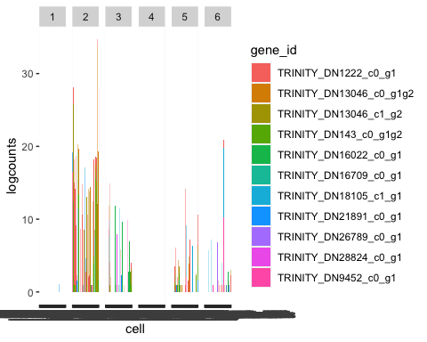

tlc2$detected_g1_VSG <- data[match(tlc2$cell, data[, 47]), 54]  
tlc3 <- tlc2[tlc2$detected_g1_VSG > 0, ]  
ggplot(tlc3, aes(x=cell, y=logcounts, fill = gene_id)) + geom_bar(position="stack", stat="identity") + facet_grid(cols = vars(cluster), scales="free", space="free")

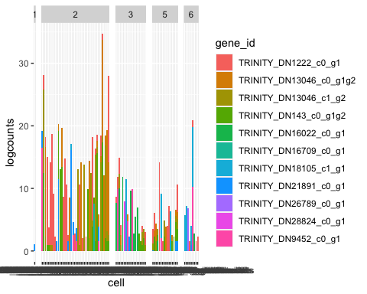

tlc3$cluster_name <- rep("C1", length(tlc3$cell))  
tlc3[which(tlc3$cluster==4), ]$cluster_name <- "C2"  
tlc3[which(tlc3$cluster==6), ]$cluster_name <- "C3"  
tlc3[which(tlc3$cluster==5), ]$cluster_name <- "C4"  
tlc3[which(tlc3$cluster==2), ]$cluster_name <- "C5"  
tlc3[which(tlc3$cluster==3), ]$cluster_name <- "C6"  
  
ggplot(tlc3, aes(x=cell, y=logcounts, fill = gene_id)) + geom_bar(position="stack", stat="identity") + facet_grid(cols = vars(cluster_name), scales="free", space="free") + geom_col(position = "dodge") + theme_bw() + theme(axis.text.x = element_blank())

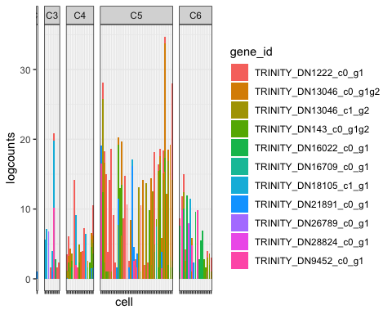

data <- as.data.frame(colData(vsg))  
data$cluster_name <- rep("C1", length(data$sample_id))  
data[which(data$sc3_6_clusters==4), ]$cluster_name <- "C2"  
data[which(data$sc3_6_clusters==6), ]$cluster_name <- "C3"  
data[which(data$sc3_6_clusters==5), ]$cluster_name <- "C4"  
data[which(data$sc3_6_clusters==2), ]$cluster_name <- "C5"  
data[which(data$sc3_6_clusters==3), ]$cluster_name <- "C6"  
  
  
pcentFun <- function(x) {  
 res <- x > 0  
 100 * (sum(res) / length(res))  
}  
  
with(data, tapply(data$detectedcomboVSG, cluster_name, pcentFun))

## C1 C2 C3 C4 C5 C6   
## 1.587302 0.000000 24.096386 43.636364 78.333333 36.144578

subdata <- data[data$detected_g1_VSG > 0, ]  
pcentFun <- function(x) {  
 res <- x >= 1  
 100 * (sum(res) / length(res))  
}  
with(data, tapply(data$detected_g1_VSG, data$cluster_name, pcentFun))

## C1 C2 C3 C4 C5 C6   
## 1.587302 0.000000 10.843373 29.090909 70.000000 22.891566

with(subdata, tapply(subdata$detected_g1_VSG, subdata$cluster_name, mean))

## C1 C3 C4 C5 C6   
## 1.000000 1.111111 1.500000 1.523810 1.263158

pcentFun <- function(x) {  
 res <- x >= 2  
 100 * (sum(res) / length(res))  
}  
with(subdata, tapply(subdata$detected_g1_VSG, subdata$cluster_name, pcentFun))

## C1 C3 C4 C5 C6   
## 0.00000 11.11111 37.50000 38.09524 21.05263

g1 <- subdata$rsemname  
  
tlc4 <- tlc3[tlc3$cell %in% g1, ]  
  
ggplot(tlc4, aes(x=cell, y=logcounts, fill = gene_id)) + geom_bar(position="stack", stat="identity", colour="black", size=0.2) + facet_grid(cols = vars(cluster_name), scales="free", space="free") + geom_col(position = "dodge") + theme_bw() + theme(axis.text.x = element_blank(), panel.grid.major = element_blank(), panel.grid.minor = element_blank())

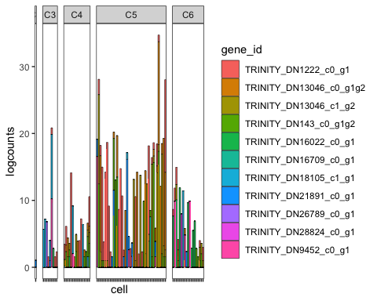

#######  
tlc4$spr_strain <- data[match(tlc4$cell, data[, 47]), 50]  
  
ggplot(tlc4, aes(x=cell, y=logcounts, fill = gene_id)) + geom_bar(position="stack", stat="identity", colour="black", size=0.2) + facet_grid(cols = vars(cluster_name, spr_strain), scales="free", space="free") + theme_classic() + theme(axis.text.x = element_blank(), panel.grid.major = element_blank(), panel.grid.minor = element_blank(), legend.position = "none")

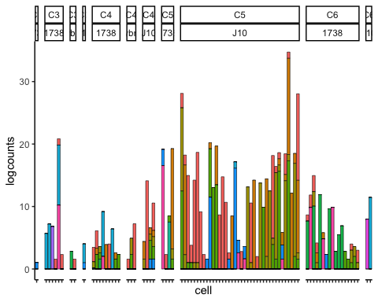

tlc5 <- tlc4[tlc4$logcounts > 1 , ]  
  
clustcol <- c("mediumseagreen", "gold2" , "mediumvioletred", "blue", "cyan3", "honeydew4", "darkmagenta","navy" , "dodgerblue", "salmon", "deepskyblue4", "purple", "thistle3")  
  
  
col2hex(c("mediumseagreen", "gold2" , "mediumvioletred", "blue", "cyan3", "honeydew4", "darkmagenta","navy" , "dodgerblue", "salmon", "deepskyblue4"))

## [1] "#3CB371" "#EEC900" "#C71585" "#0000FF" "#00CDCD" "#838B83" "#8B008B"  
## [8] "#000080" "#1E90FF" "#FA8072" "#00688B"

ggplot(tlc5, aes(x=cell, y=logcounts, fill = gene_id)) + geom_bar(position="stack", stat="identity", colour="black", size=0.2) + facet_grid(cols = vars(cluster_name, spr_strain), scales="free", space="free") + theme_classic() + theme(axis.text.x = element_blank(), panel.grid.major = element_blank(), panel.grid.minor = element_blank()) + scale_fill_manual(values=clustcol)

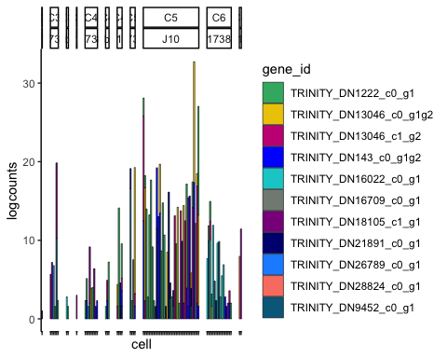

ggplot(tlc5, aes(x=cell, y=logcounts, fill = gene_id)) + geom_bar(position="stack", stat="identity", colour="black", size=0.2) + facet_grid(cols = vars(cluster_name, spr_strain), scales="free", space="free") + theme_classic() + theme(axis.text.x = element_blank(), panel.grid.major = element_blank(), panel.grid.minor = element_blank(), legend.position = "none") + scale_fill_manual(values=clustcol)

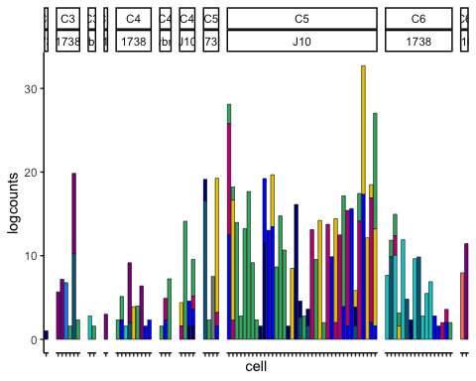

write.csv(as.data.frame(colData(tca)), file="/Users/virginiahowick/Documents/Tryps/for_github/vsgcoldata_forgithub.csv")  
write.csv(subcombovsgcounts, file="/Users/virginiahowick/Documents/Tryps/for_github/fig2_subcombovsgcounts_forgithub.csv")  
  
session_info()

## ─ Session info ───────────────────────────────────────────────────────────────  
## setting value   
## version R version 4.0.3 (2020-10-10)  
## os macOS Big Sur 10.16   
## system x86_64, darwin17.0   
## ui X11   
## language (EN)   
## collate en_GB.UTF-8   
## ctype en_GB.UTF-8   
## tz Europe/London   
## date 2022-01-11   
##   
## ─ Packages ───────────────────────────────────────────────────────────────────  
## package * version date lib source   
## assertthat 0.2.1 2019-03-21 [1] CRAN (R 4.0.2)  
## backports 1.2.1 2020-12-09 [1] CRAN (R 4.0.2)  
## beachmat 2.6.3 2020-12-12 [1] Bioconductor   
## beeswarm 0.2.3 2016-04-25 [1] CRAN (R 4.0.2)  
## Biobase * 2.50.0 2020-10-27 [1] Bioconductor   
## BiocGenerics * 0.36.1 2021-04-16 [1] Bioconductor   
## BiocNeighbors 1.8.2 2020-12-07 [1] Bioconductor   
## BiocParallel 1.24.1 2020-11-06 [1] Bioconductor   
## BiocSingular 1.6.0 2020-10-27 [1] Bioconductor   
## bitops 1.0-7 2021-04-24 [1] CRAN (R 4.0.2)  
## broom 0.7.4 2021-01-29 [1] CRAN (R 4.0.2)  
## callr 3.5.1 2020-10-13 [1] CRAN (R 4.0.2)  
## caTools 1.18.0 2020-01-17 [1] CRAN (R 4.0.2)  
## cellranger 1.1.0 2016-07-27 [1] CRAN (R 4.0.2)  
## cli 3.0.1 2021-07-17 [1] CRAN (R 4.0.2)  
## colorspace 2.0-2 2021-06-24 [1] CRAN (R 4.0.2)  
## crayon 1.4.1 2021-02-08 [1] CRAN (R 4.0.2)  
## DBI 1.1.0 2019-12-15 [1] CRAN (R 4.0.2)  
## dbplyr 2.1.0 2021-02-03 [1] CRAN (R 4.0.3)  
## DelayedArray 0.16.3 2021-03-24 [1] Bioconductor   
## DelayedMatrixStats 1.12.1 2020-11-24 [1] Bioconductor   
## desc 1.2.0 2018-05-01 [1] CRAN (R 4.0.2)  
## devtools * 2.3.2 2020-09-18 [1] CRAN (R 4.0.2)  
## digest 0.6.27 2020-10-24 [1] CRAN (R 4.0.2)  
## dplyr * 1.0.7 2021-06-18 [1] CRAN (R 4.0.2)  
## ellipsis 0.3.2 2021-04-29 [1] CRAN (R 4.0.2)  
## evaluate 0.14 2019-05-28 [1] CRAN (R 4.0.1)  
## fansi 0.5.0 2021-05-25 [1] CRAN (R 4.0.2)  
## farver 2.1.0 2021-02-28 [1] CRAN (R 4.0.2)  
## forcats * 0.5.1 2021-01-27 [1] CRAN (R 4.0.2)  
## fs 1.5.0 2020-07-31 [1] CRAN (R 4.0.2)  
## generics 0.1.0 2020-10-31 [1] CRAN (R 4.0.2)  
## GenomeInfoDb * 1.26.7 2021-04-08 [1] Bioconductor   
## GenomeInfoDbData 1.2.4 2020-12-11 [1] Bioconductor   
## GenomicRanges * 1.42.0 2020-10-27 [1] Bioconductor   
## ggbeeswarm 0.6.0 2017-08-07 [1] CRAN (R 4.0.2)  
## ggplot2 * 3.3.5 2021-06-25 [1] CRAN (R 4.0.2)  
## glue 1.4.2 2020-08-27 [1] CRAN (R 4.0.2)  
## gplots * 3.1.1 2020-11-28 [1] CRAN (R 4.0.2)  
## gridExtra 2.3 2017-09-09 [1] CRAN (R 4.0.2)  
## gtable 0.3.0 2019-03-25 [1] CRAN (R 4.0.2)  
## gtools 3.8.2 2020-03-31 [1] CRAN (R 4.0.2)  
## haven 2.3.1 2020-06-01 [1] CRAN (R 4.0.2)  
## hms 1.0.0 2021-01-13 [1] CRAN (R 4.0.2)  
## htmltools 0.5.0 2020-06-16 [1] CRAN (R 4.0.2)  
## httr 1.4.2 2020-07-20 [1] CRAN (R 4.0.2)  
## IRanges * 2.24.1 2020-12-12 [1] Bioconductor   
## irlba 2.3.3 2019-02-05 [1] CRAN (R 4.0.2)  
## jsonlite 1.7.2 2020-12-09 [1] CRAN (R 4.0.3)  
## KernSmooth 2.23-18 2020-10-29 [1] CRAN (R 4.0.2)  
## knitr 1.30 2020-09-22 [1] CRAN (R 4.0.2)  
## labeling 0.4.2 2020-10-20 [1] CRAN (R 4.0.2)  
## lattice 0.20-41 2020-04-02 [1] CRAN (R 4.0.3)  
## lifecycle 1.0.0 2021-02-15 [1] CRAN (R 4.0.2)  
## lubridate 1.7.9.2 2020-11-13 [1] CRAN (R 4.0.2)  
## magrittr 2.0.1 2020-11-17 [1] CRAN (R 4.0.2)  
## Matrix 1.2-18 2019-11-27 [1] CRAN (R 4.0.3)  
## MatrixGenerics * 1.2.1 2021-01-30 [1] Bioconductor   
## matrixStats * 0.60.0 2021-07-26 [1] CRAN (R 4.0.2)  
## memoise 1.1.0 2017-04-21 [1] CRAN (R 4.0.2)  
## modelr 0.1.8 2020-05-19 [1] CRAN (R 4.0.2)  
## munsell 0.5.0 2018-06-12 [1] CRAN (R 4.0.2)  
## pheatmap * 1.0.12 2019-01-04 [1] CRAN (R 4.0.2)  
## pillar 1.6.2 2021-07-29 [1] CRAN (R 4.0.2)  
## pkgbuild 1.1.0 2020-07-13 [1] CRAN (R 4.0.2)  
## pkgconfig 2.0.3 2019-09-22 [1] CRAN (R 4.0.2)  
## pkgload 1.1.0 2020-05-29 [1] CRAN (R 4.0.2)  
## prettyunits 1.1.1 2020-01-24 [1] CRAN (R 4.0.2)  
## processx 3.4.5 2020-11-30 [1] CRAN (R 4.0.2)  
## ps 1.5.0 2020-12-05 [1] CRAN (R 4.0.2)  
## purrr * 0.3.4 2020-04-17 [1] CRAN (R 4.0.2)  
## R6 2.5.0 2020-10-28 [1] CRAN (R 4.0.2)  
## RColorBrewer * 1.1-2 2014-12-07 [1] CRAN (R 4.0.2)  
## Rcpp 1.0.7 2021-07-07 [1] CRAN (R 4.0.2)  
## RCurl 1.98-1.3 2021-03-16 [1] CRAN (R 4.0.2)  
## readr * 1.4.0 2020-10-05 [1] CRAN (R 4.0.2)  
## readxl 1.3.1 2019-03-13 [1] CRAN (R 4.0.2)  
## remotes 2.2.0 2020-07-21 [1] CRAN (R 4.0.2)  
## reprex 1.0.0 2021-01-27 [1] CRAN (R 4.0.2)  
## rlang 0.4.11 2021-04-30 [1] CRAN (R 4.0.2)  
## rmarkdown 2.5 2020-10-21 [1] CRAN (R 4.0.3)  
## rprojroot 2.0.2 2020-11-15 [1] CRAN (R 4.0.2)  
## rstudioapi 0.13 2020-11-12 [1] CRAN (R 4.0.2)  
## rsvd 1.0.3 2020-02-17 [1] CRAN (R 4.0.2)  
## rvest 0.3.6 2020-07-25 [1] CRAN (R 4.0.2)  
## S4Vectors * 0.28.1 2020-12-09 [1] Bioconductor   
## scales 1.1.1 2020-05-11 [1] CRAN (R 4.0.2)  
## scater * 1.18.3 2020-11-08 [1] Bioconductor   
## scuttle 1.0.3 2020-11-23 [1] Bioconductor   
## sessioninfo 1.1.1 2018-11-05 [1] CRAN (R 4.0.2)  
## SingleCellExperiment * 1.12.0 2020-10-27 [1] Bioconductor   
## sparseMatrixStats 1.2.0 2020-10-27 [1] Bioconductor   
## stringi 1.7.3 2021-07-16 [1] CRAN (R 4.0.2)  
## stringr * 1.4.0 2019-02-10 [1] CRAN (R 4.0.2)  
## SummarizedExperiment * 1.20.0 2020-10-27 [1] Bioconductor   
## testthat 3.0.0 2020-10-31 [1] CRAN (R 4.0.2)  
## tibble * 3.1.3 2021-07-23 [1] CRAN (R 4.0.2)  
## tidyr * 1.1.2 2020-08-27 [1] CRAN (R 4.0.2)  
## tidyselect 1.1.1 2021-04-30 [1] CRAN (R 4.0.2)  
## tidyverse * 1.3.0 2019-11-21 [1] CRAN (R 4.0.2)  
## usethis * 2.0.0 2020-12-10 [1] CRAN (R 4.0.2)  
## utf8 1.2.2 2021-07-24 [1] CRAN (R 4.0.2)  
## vctrs 0.3.8 2021-04-29 [1] CRAN (R 4.0.2)  
## vipor 0.4.5 2017-03-22 [1] CRAN (R 4.0.2)  
## viridis * 0.5.1 2018-03-29 [1] CRAN (R 4.0.2)  
## viridisLite * 0.4.0 2021-04-13 [1] CRAN (R 4.0.2)  
## withr 2.4.2 2021-04-18 [1] CRAN (R 4.0.2)  
## xfun 0.19 2020-10-30 [1] CRAN (R 4.0.2)  
## xml2 1.3.2 2020-04-23 [1] CRAN (R 4.0.2)  
## XVector 0.30.0 2020-10-28 [1] Bioconductor   
## yaml 2.2.1 2020-02-01 [1] CRAN (R 4.0.2)  
## zlibbioc 1.36.0 2020-10-28 [1] Bioconductor   
##   
## [1] /Library/Frameworks/R.framework/Versions/4.0/Resources/library