The University of Massachusetts in Lowell

COMP4200 – Artificial Intelligence

Authors: Phong Vo (SID #01790283) – Giang Tran (SID #01670778)

Final Project Checkpoint

**The Ant’s Nest**

Overview: The project is processed and built using C# running on Visual Studio 2019.

Team members’ roles: Phong and Giang share the workload on the core classes (AStar.cs, MapManager.cs). Phong mainly works on C# and related frameworks classes (Form1.cs, Node.cs, NodeInfor.cs). Giang develops and approaches to the problem, integrates the A* algorithm to the project (Coordinate.cs, Cons.cs).

The A* algorithm is mainly built-in via C# functions in the project that are coded in classes MapManager.cs and AStar.cs. The A* algorithm causes the paths of the ant reduced wisely. For instance, the ant itself can pick the shortest way from its UML nest to the closest leaf. Once it has a leaf in hands, it can also choose the best route back to the nest.

The field-like map is created by function DrawMapBoard(). It is 10x10 size by default and also can be modified by those text boxes designed on the program interface. The quantities of leaves and bricks can also be changed regarding the purposes of the program users.

Project GUI: the GUI is developed based on the perception and the concepts which were introduced in the Final Project Proposal part. The GUI mainly includes a panel (contains the map), text boxes, labels, and animation that shows the heading direction of the ant in real-time.

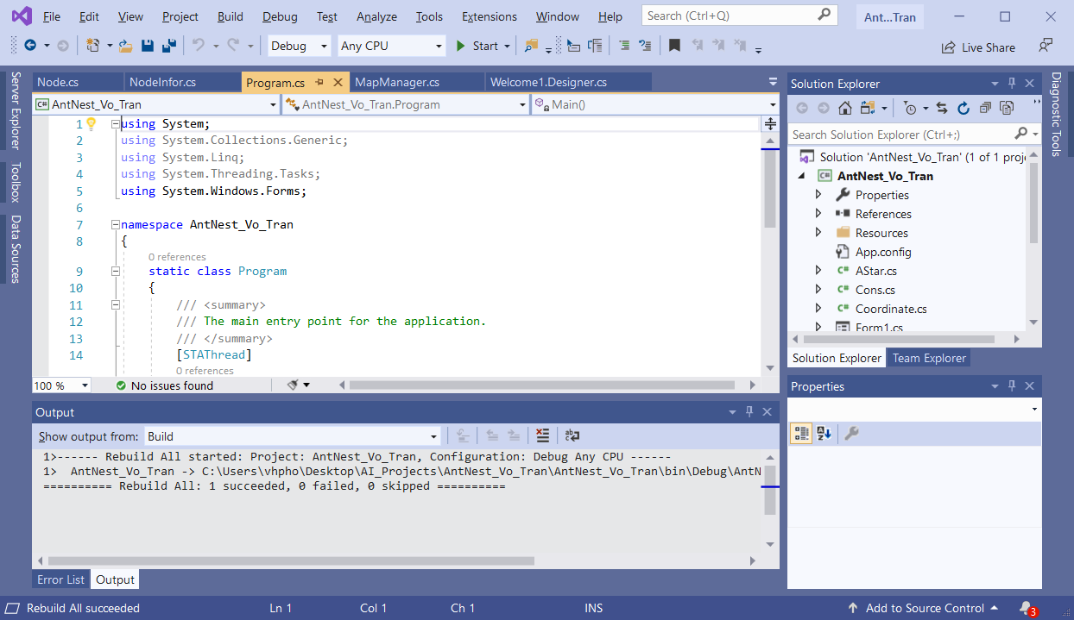

Fig. 1: The program is built successfully

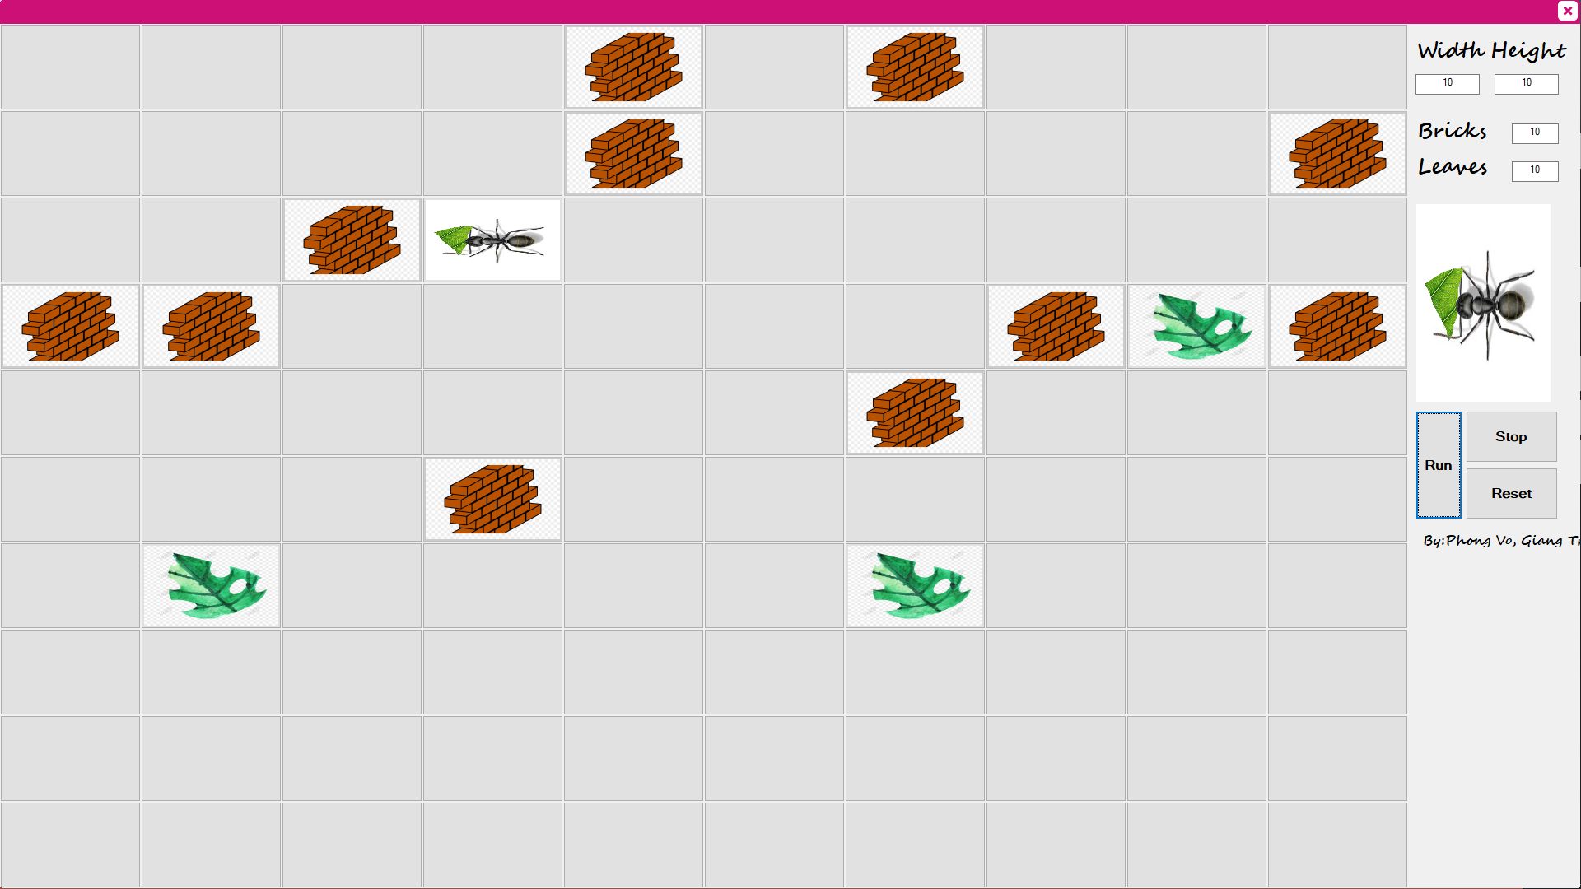

Fig. 2: The program’s GUI

The work that is left off is how to compare the A* algorithm that we built with the Interactive Deepening A* that we already learned in class. We are working on this and might finish by the end of the week.

Things that we have learned so far are reviewing the A* algorithm and its utilization might be integrated with the project. Compare to other agile programming languages, building this AI project with Visual C# may have more challenging and struggling. Our team has studied a lot more to get the project adapted and developed by Visual C# and Visual Studio 2019. Moreover, utilizing node and stack techniques in the project is an interesting challenge. In other words, linking all of the cells (stacks) to form the path is an appropriate method in this case. Our project is planned to finish by 10/12/2019.