Problem 1:

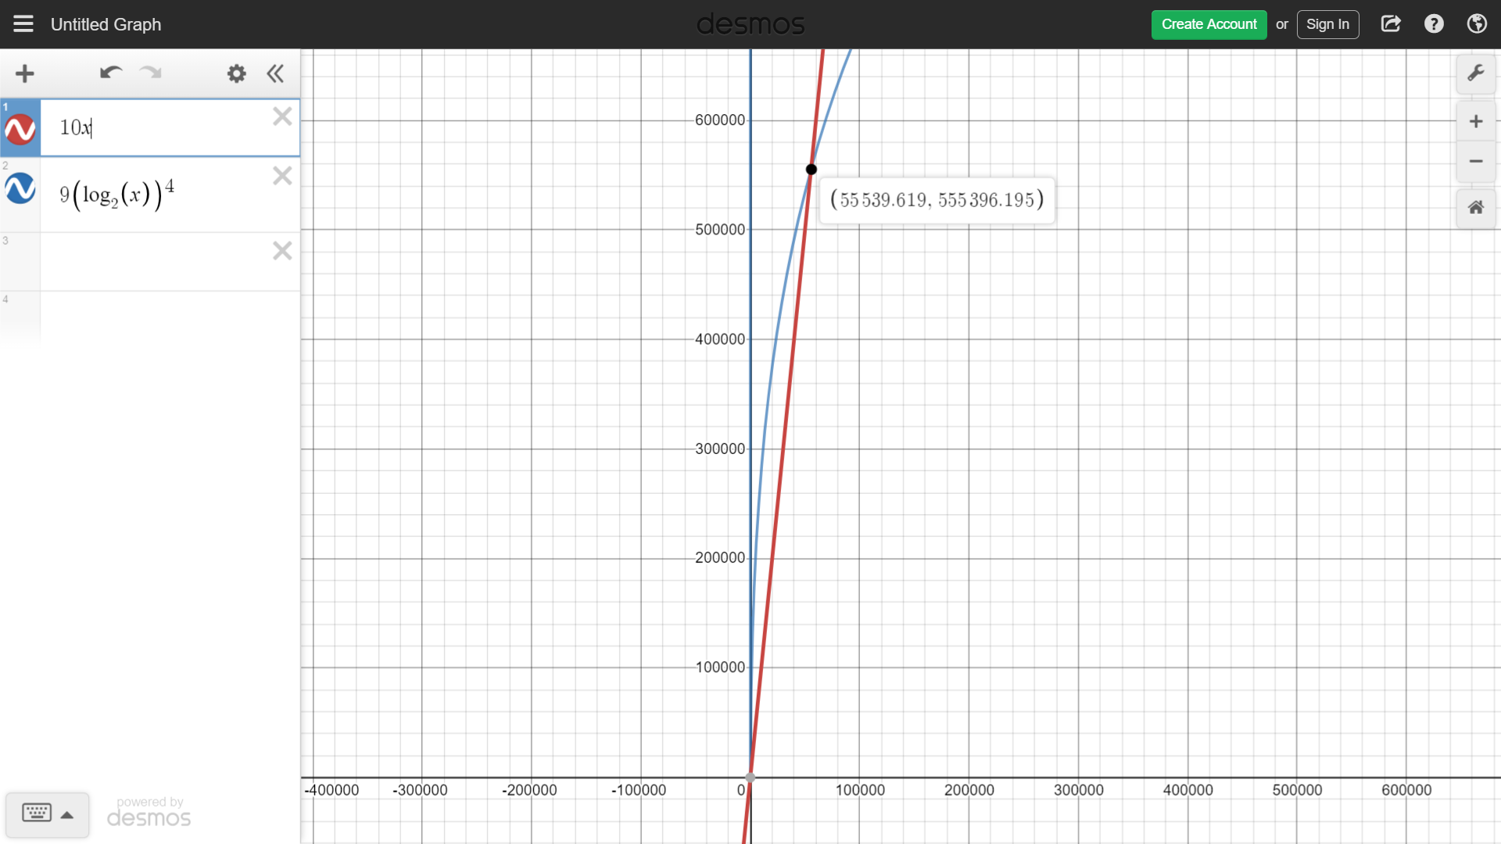

**Problem 5:**

b)

count_inversions(A, n)

|  |  |
| --- | --- |
| 1 | let temp[1..n] be a new Array |
| 2 | for i=1 to n |
| 3 | temp[i] = A[i] |
| 4 | return merge_sort(temp, 1, n) |

merge_sort(A, p, r)

|  |  |
| --- | --- |
| 1 | invNum = 0 |
| 2 | if (p<r) |
| 3 | q = $\left\lfloor \frac{p+r}{2}\right\rfloor$ |
| 4 | invNum = count_inversions(A, p, q) |
| 5 | invNum += count_inversions(A, p+1, r) |
| 6 | invNum += merge(A, p, q, r) |
| 7 | return invNum; |

merge(A, p, q, r)

|  |  |
| --- | --- |
| 1 | n1 = q-p+1 |
| 2 | n2 = r-q |
| 3 | let L[1..n1+1] and R[1..n2+1] be new arrays |
| 4 | for i=1 to n1 |
| 5 | L[i] = A[p+i-1] |
| 6 | for j = 1 to n2 |
| 7 | R[j] = A[q+j] |
|  |  |