|  |  |
| --- | --- |
| **DOKUMENTASI EKSTERNAL**  External Documentation |  |
| **[TUGAS MANDIRI / PROYEK ]**  **[*Assignment / Project*]** |
| **MATAKULIAH <XX999> – <SUBJECT NAME>**  ***Subject*** |
| SEMESTER [GANJIL/GENAP/PENDEK] 9999/9999 ***[Odd/Even/Compact] Semester Year 9999/9999*** |

## Judul Proyek

*[Assignment / Project]**Title*

* **TITLE**

## Abstrak [50 – 200 words]

*Abstract*

* **ABSTRACT [50 – 200 words]**

## Pendahuluan

*Introduction*

* **INTRODUCTION**

## Dokumentasi

*Report / Documentation*

* **REPORT / PRINT SCREEN & DESCRIPTION**

1. **Login**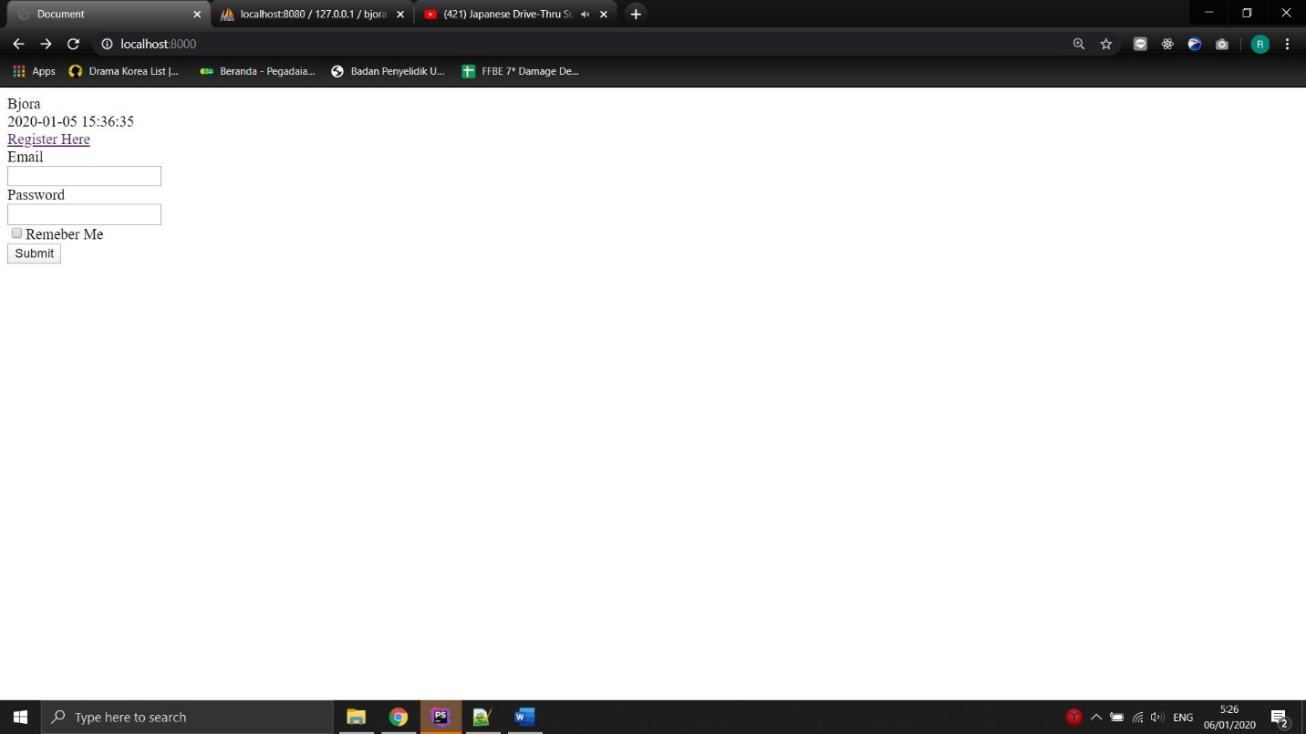
2. **Register**

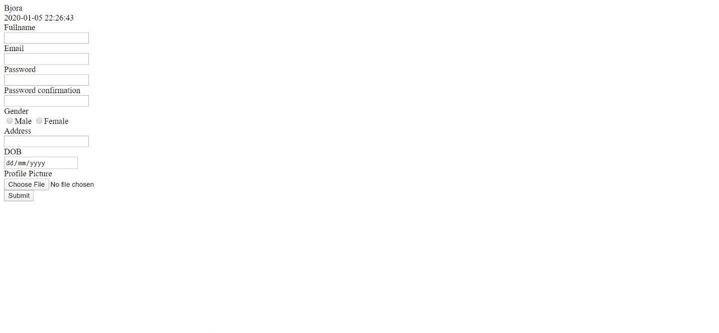

1. **Home**

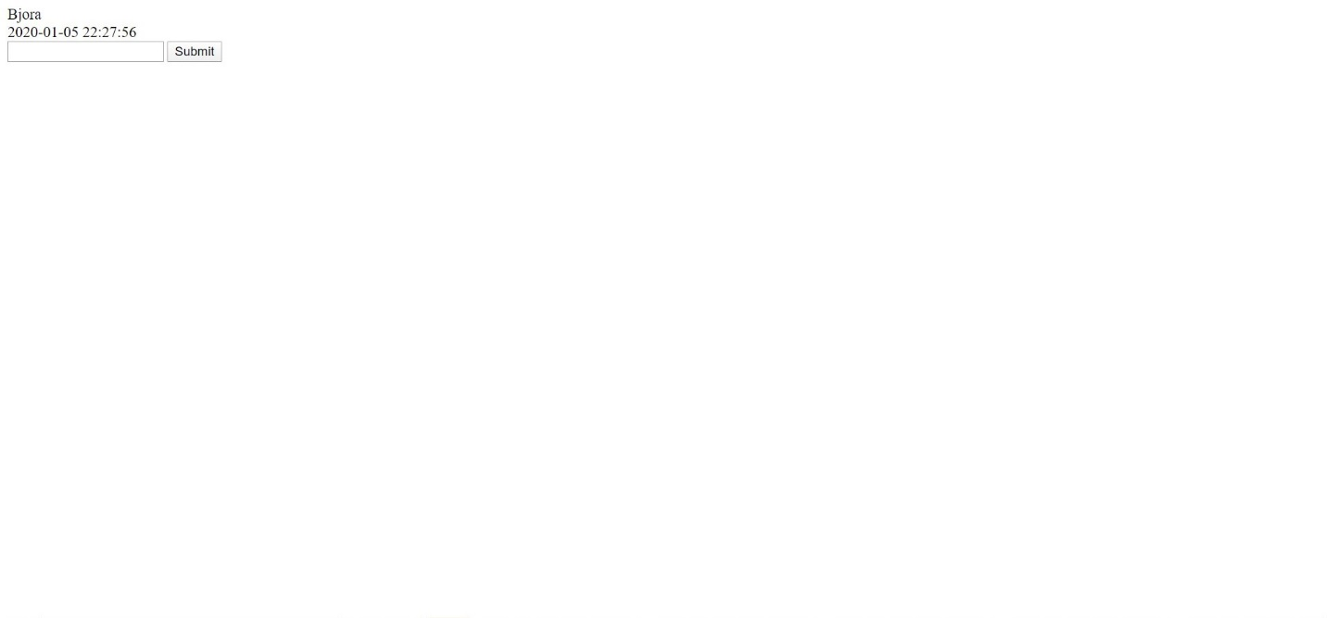

1. **addTopic**

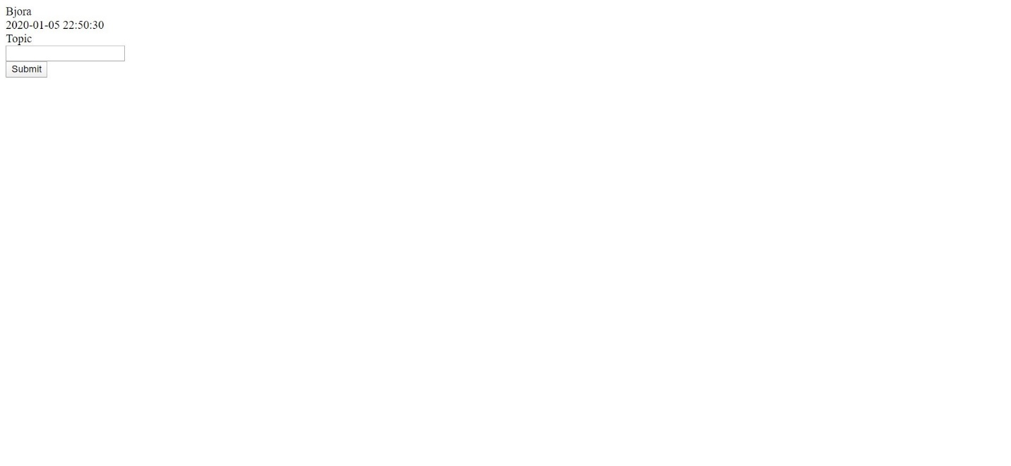

1. **masteruser**



1. **register**



1. **add question**

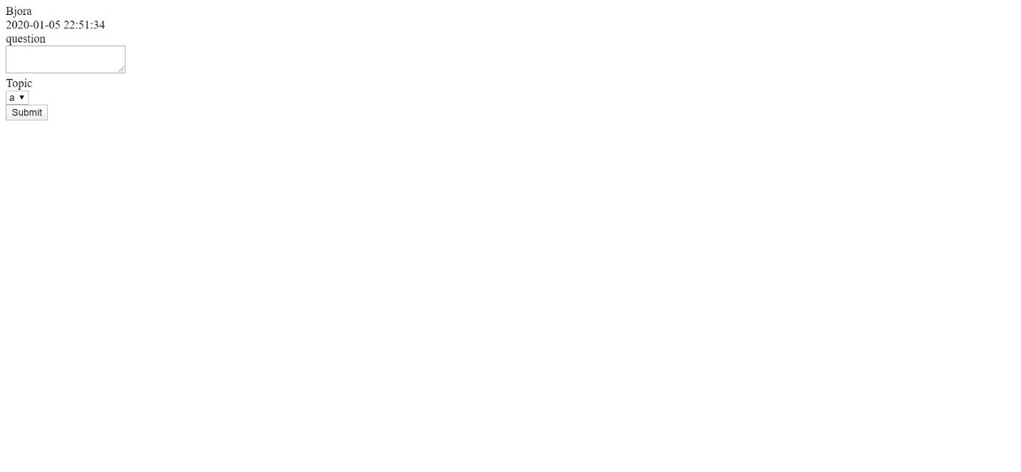

1. **unauthorized page**

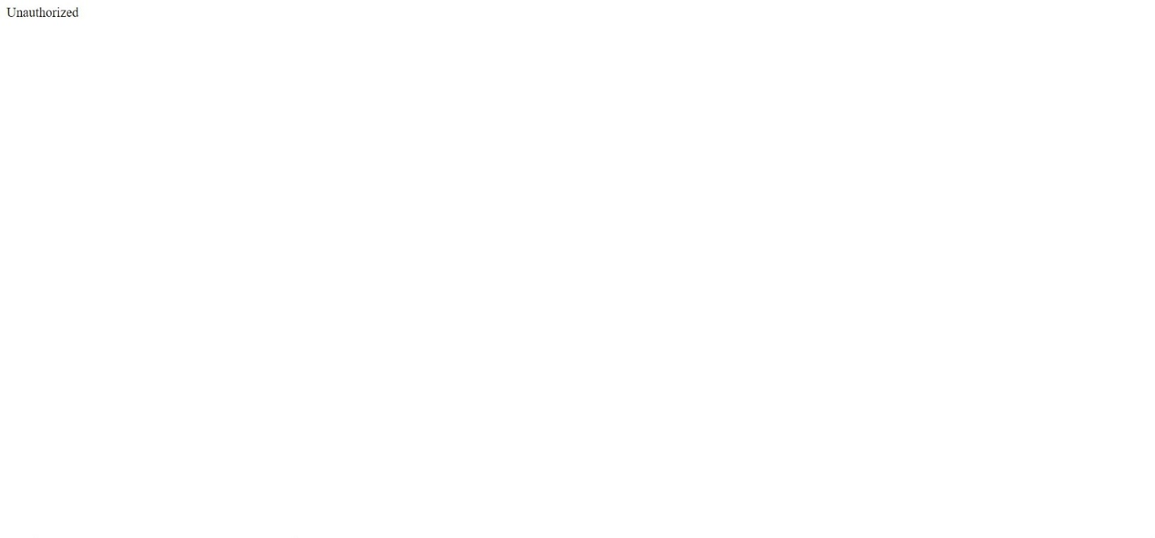

1. **login**



1. **add topic**



## Referensi

*References*

* **REFERENCES**
* **LINK**

Disiapkan Oleh,

*Prepared by,*

* **<NIM> - <1st Student Name>**
* **<NIM> - <2nd Student Name>**
* **<NIM> - <3rd Student Name>**
* **<NIM> - <4th Student Name>**