**Hand-Soldering SMD Practice Board Kit**

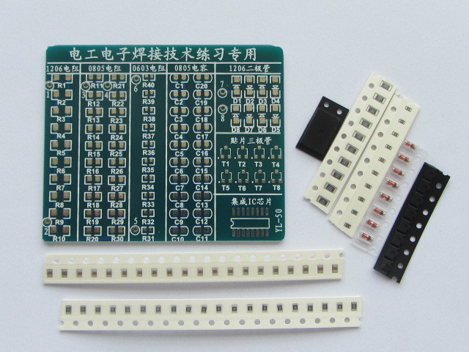-

**Components:**

1. PCB Board: 1 pcs (the board)
2. 1206 resistor: 10 pcs (black with silver writing – large)
3. 0805 resistor: 20 pcs (black with silver writing – medium)
4. 0603 resistor: 10 pcs (black with silver writing – small)
5. 0805 capacitor: 20 pcs (light brown with silver ends)
6. 1206 diode: 08 pcs (all clear package)
7. SOT23 triode: 08 pcs (all black package)
8. SO16 IC: 1 pcs (the chip!)

**Instructions:**

1. Try soldering few components of different types.
2. Use this kit for practice soldering and warm up.
3. When you finish a column, try the test points (e.g.1260 = 470k ohms)

**Useful Links:**

<https://www.youtube.com/watch?v=P_6XJR3D27Y> (Tom’s hand-soldering demo)  
<https://www.youtube.com/watch?v=3NN7UGWYmBY> (Hand-soldering with more flux)  
<https://www.youtube.com/watch?v=8JM4oCpWnjU&t=6s> (desoldering)  
<http://mightyohm.com/files/SMT_Soldering_Its_Easier_Than_You_Think_EN.pdf> (comic)