姓名：黄煜成 | 专业： 软件工程 | 班级：2015卓师 | 学号：2015118043
科目：Android |  | 实验日期：2017/10/18
实验题目：
【实验目的】1、理解 Activity 的生命周期（创建、启动、运行、暂停、恢复、销毁等），编程实现各生命周期的回调函数，理解各回调函数的触发场景。
2、实现多 Activity 的相互调用，使用显式 Intent 和隐式 Intent 启动 。其中隐式 Intent 使用自定义 Intent 的 action 。
【实验内容】
1.
MainActivity.java
package activitylifecycletest.example.com.activitylifecycletest;
import android.app.Dialog;
import android.content.Intent;
import android.os.StrictMode;
import android.support.v7.app.AppCompatActivity;
import android.os.Bundle;
import android.util.Log;
import android.view.View;
import android.widget.Button;
public class MainActivity extends AppCompatActivity {
public static final String TAG ="MainActivity";
@Override
protected void onCreate(Bundle savedInstanceState) {
super.onCreate(savedInstanceState);
setContentView(R.layout.activity_main);
Button startNormalActivity = (Button) findViewById(R.id.start_normal_activity);
Button startDialogActivity = (Button) findViewById(R.id.start_dialog_activity);
startNormalActivity.setOnClickListener(new View.OnClickListener() {
@Override
public void onClick(View v) {
Intent intent = new Intent(MainActivity.this,NormalActivity.class);
startActivity(intent);
}
});
startDialogActivity.setOnClickListener(new View.OnClickListener() {
@Override
public void onClick(View v) {
Intent intent = new Intent(MainActivity.this, DialogActivity.class);
startActivity(intent);
}
});
}
@Override
protected void onStart() {
super.onStart();
Log.d(TAG, "onStart");
}
@Override
protected void onPostResume() {
super.onPostResume();
Log.d(TAG, "onPostResume");
}
@Override
protected void onPause() {
super.onPause();
Log.d(TAG, "onPause");
}
@Override
protected void onStop() {
super.onStop();
Log.d(TAG, "onStop");
}
@Override
protected void onDestroy() {
super.onDestroy();
Log.d(TAG, "onDestroy");
}
@Override
protected void onRestart() {
super.onRestart();
Log.d(TAG, "onRestart");
}
}

运行时：点击start normalactivity
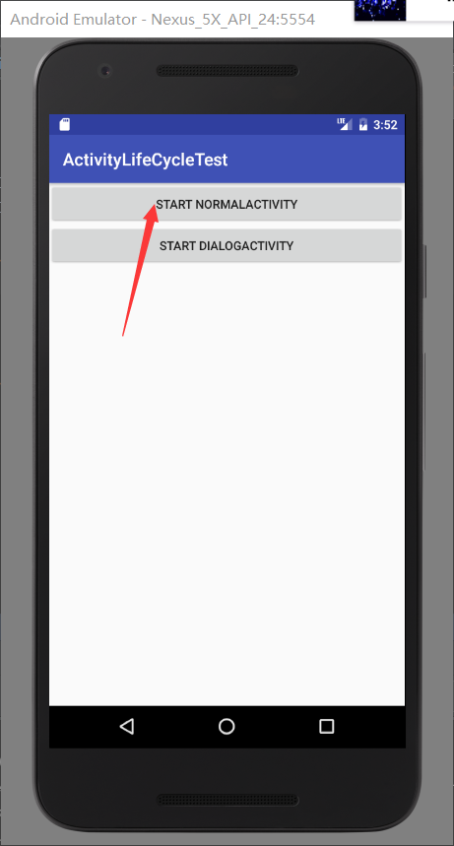

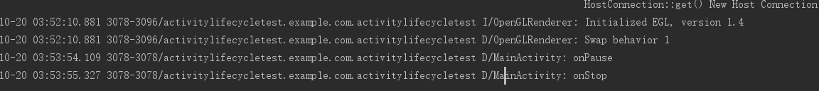
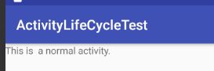

返回 back时
点击 start diglogactivity
返回 back时

2.
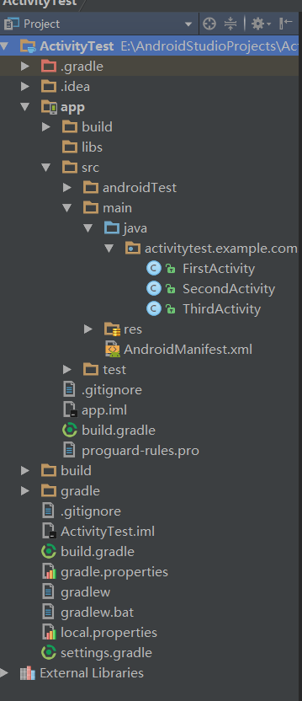

FirstActivity.java
package activitytest.example.com.activitytest;
import android.content.Intent;
import android.net.Uri;
import android.support.v7.app.AppCompatActivity;
import android.os.Bundle;
import android.util.Log;
import android.view.Menu;
import android.view.MenuItem;
import android.view.View;
import android.widget.Button;
import android.widget.Toast;
public class FirstActivity extends AppCompatActivity {
@Override
protected void onActivityResult(int requestCode, int resultCode, Intent data) {
switch (requestCode){
case 1:
if(resultCode == RESULT_OK){
String returnedData = data.getStringExtra("data_return");
Log.d("FirstActivity",returnedData);
}
break;
default:
}
}
@Override
public boolean onCreateOptionsMenu(Menu menu) {
getMenuInflater().inflate(R.menu.main, menu);
return true;
}
@Override
public boolean onOptionsItemSelected(MenuItem item) {
switch(item.getItemId()){
case R.id.add_item:
Toast.makeText(this,"You clicked Add",Toast.LENGTH_SHORT).show();
break;
case R.id.remove_item:
Toast.makeText(this,"You cilcked Remove",Toast.LENGTH_SHORT).show();
break;
case R.id.close_item:
finish();
default:
}
return true;
}
@Override
protected void onCreate(Bundle savedInstanceState) {
super.onCreate(savedInstanceState);
setContentView(R.layout.first_layout);
Button button_1 =(Button) findViewById(R.id.button_1);
button_1.setOnClickListener(new View.OnClickListener() {
@Override
public void onClick(View v) {
Intent intent = new Intent(FirstActivity.this,SecondActivity.class);
startActivityForResult(intent,1);
}
});
Button button_4 =(Button) findViewById(R.id.button_4);
button_4.setOnClickListener(new View.OnClickListener() {
@Override
public void onClick(View v) {
String data = "Hello SecondActivity";
Intent intent = new Intent(FirstActivity.this,SecondActivity.class);
intent.putExtra("extra_data",data);
// intent.setData(Uri.parse("tel:10086"));
startActivity(intent);
}
});
}
}

SecondActivity.java
package activitytest.example.com.activitytest;
import android.content.Intent;
import android.net.Uri;
import android.support.v7.app.AppCompatActivity;
import android.os.Bundle;
import android.util.Log;
import android.view.View;
import android.widget.Button;
public class SecondActivity extends AppCompatActivity {
@Override
public void onBackPressed() {
Intent intent = new Intent();
intent.putExtra("data_return","Hello FirstActivity_back");
setResult(RESULT_OK, intent);
finish();
}
@Override
protected void onCreate(Bundle savedInstanceState) {
super.onCreate(savedInstanceState);
setContentView(R.layout.second_layout);
// Intent intent1 = getIntent();
// String data = intent1.getStringExtra("extra_data");
// Log.d("SecondActivity",data);
Button button_2 =(Button) findViewById(R.id.button_2);
button_2.setOnClickListener(new View.OnClickListener() {
@Override
public void onClick(View v) {
Intent intent = new Intent();
intent.putExtra("data_return","Hello FirstActivity");
setResult(RESULT_OK,intent);
finish();
// intent.setData(Uri.parse("http://www.baidu.com"));
// Intent intent = new Intent(SecondActivity.this,ThirdActivity.class);
//startActivity(intent);
}
});
}
}

ThirdActivity.java
package activitytest.example.com.activitytest;
import android.content.Intent;
import android.net.Uri;
import android.support.v7.app.AppCompatActivity;
import android.os.Bundle;
import android.view.View;
import android.widget.Button;
public class ThirdActivity extends AppCompatActivity {
@Override
protected void onCreate(Bundle savedInstanceState) {
super.onCreate(savedInstanceState);
setContentView(R.layout.third_layout);
Button button_3 =(Button) findViewById(R.id.button_3);
button_3.setOnClickListener(new View.OnClickListener() {
@Override
public void onClick(View v) {
Intent intent = new Intent(Intent.ACTION_VIEW);
intent.setData(Uri.parse("http://www.baidu.com"));
startActivity(intent);
}
});
}
}

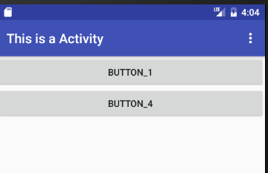
Button-1
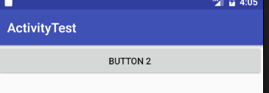
Button-2 隐式intent 返回firstactivity数据

Button-4 同理

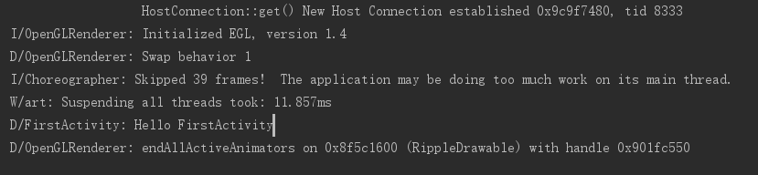
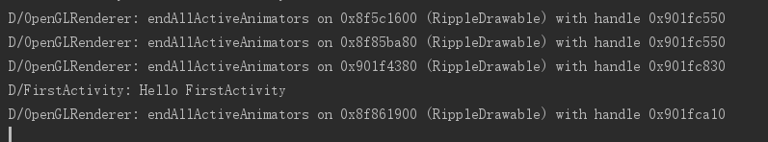

【实验结果】

【教师评语和成绩】

成绩： 指导教师： 日期：

