姓名：黄煜成 | 专业： 软件工程 | 班级：2015卓师 | 学号：2015118043
科目：Android |  | 实验日期：2018/1/14
实验题目：
【实验目的】1、熟悉 Widgets 和 各类 Layouts 。
2、订阅微信公众号 HenCoder ，阅读关于 ListView 的定制。
【实验内容】
- 创建项目：
ListViewTest
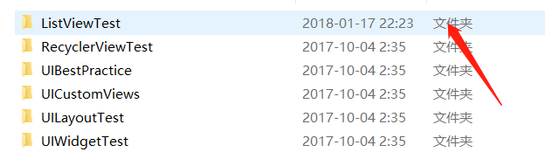
- 项目列表：
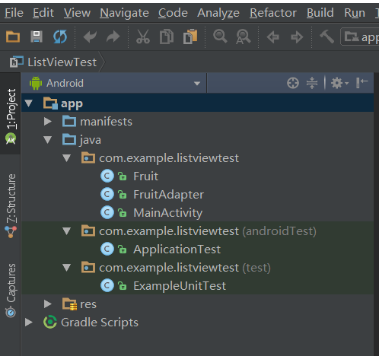
- 代码：
水果实体：Fruit.Java
package com.example.listviewtest;
public class Fruit {
private String name;
private int imageId;
public Fruit(String name, int imageId) {
this.name = name;
this.imageId = imageId;
}
public String getName() {
return name;
}
public int getImageId() {
return imageId;
}
}

FruitAdapter.java
package com.example.listviewtest;
import android.content.Context;
import android.view.LayoutInflater;
import android.view.View;
import android.view.ViewGroup;
import android.widget.ArrayAdapter;
import android.widget.ImageView;
import android.widget.TextView;
import java.util.List;
public class FruitAdapter extends ArrayAdapter<Fruit> {
private int resourceId;
public FruitAdapter(Context context, int textViewResourceId,
List<Fruit> objects) {
super(context, textViewResourceId, objects);
resourceId = textViewResourceId;
}
@Override
public View getView(int position, View convertView, ViewGroup parent) {
Fruit fruit = getItem(position); // 获取当前项的Fruit实例
View view;
ViewHolder viewHolder;
if (convertView == null) {
view = LayoutInflater.from(getContext()).inflate(resourceId, parent, false);
viewHolder = new ViewHolder();
viewHolder.fruitImage = (ImageView) view.findViewById (R.id.fruit_image);
viewHolder.fruitName = (TextView) view.findViewById (R.id.fruit_name);
view.setTag(viewHolder); // 将ViewHolder存储在View中
} else {
view = convertView;
viewHolder = (ViewHolder) view.getTag(); // 重新获取ViewHolder
}
viewHolder.fruitImage.setImageResource(fruit.getImageId());
viewHolder.fruitName.setText(fruit.getName());
return view;
}
class ViewHolder {
ImageView fruitImage;
TextView fruitName;
}
}

MainActivity.java
package com.example.listviewtest;
import android.support.v7.app.AppCompatActivity;
import android.os.Bundle;
import android.view.View;
import android.widget.AdapterView;
import android.widget.ArrayAdapter;
import android.widget.ListView;
import android.widget.Toast;
import java.util.ArrayList;
import java.util.List;
public class MainActivity extends AppCompatActivity {
private List<Fruit> fruitList = new ArrayList<Fruit>();
@Override
protected void onCreate(Bundle savedInstanceState) {
super.onCreate(savedInstanceState);
setContentView(R.layout.activity_main);
initFruits(); // 初始化水果数据
FruitAdapter adapter = new FruitAdapter(MainActivity.this, R.layout.fruit_item, fruitList);
ListView listView = (ListView) findViewById(R.id.list_view);
listView.setAdapter(adapter);
listView.setOnItemClickListener(new AdapterView.OnItemClickListener() {
@Override
public void onItemClick(AdapterView<?> parent, View view,
int position, long id) {
Fruit fruit = fruitList.get(position);
Toast.makeText(MainActivity.this, fruit.getName(), Toast.LENGTH_SHORT).show();
}
});
}
private void initFruits() {
for (int i = 0; i < 2; i++) {
Fruit apple = new Fruit("Apple", R.drawable.apple_pic);
fruitList.add(apple);
Fruit banana = new Fruit("Banana", R.drawable.banana_pic);
fruitList.add(banana);
Fruit orange = new Fruit("Orange", R.drawable.orange_pic);
fruitList.add(orange);
Fruit watermelon = new Fruit("Watermelon", R.drawable.watermelon_pic);
fruitList.add(watermelon);
Fruit pear = new Fruit("Pear", R.drawable.pear_pic);
fruitList.add(pear);
Fruit grape = new Fruit("Grape", R.drawable.grape_pic);
fruitList.add(grape);
Fruit pineapple = new Fruit("Pineapple", R.drawable.pineapple_pic);
fruitList.add(pineapple);
Fruit strawberry = new Fruit("Strawberry", R.drawable.strawberry_pic);
fruitList.add(strawberry);
Fruit cherry = new Fruit("Cherry", R.drawable.cherry_pic);
fruitList.add(cherry);
Fruit mango = new Fruit("Mango", R.drawable.mango_pic);
fruitList.add(mango);
}
}
}

布局：
Activity_main.xml
<?xml version="1.0" encoding="utf-8"?>
<LinearLayout xmlns:android="http://schemas.android.com/apk/res/android"
android:orientation="vertical"
android:layout_width="match_parent"
android:layout_height="match_parent">
<ListView
android:id="@+id/list_view"
android:layout_width="match_parent"
android:layout_height="match_parent" >
</ListView>
</LinearLayout>

Fruit_item.xml
<?xml version="1.0" encoding="utf-8"?>
<LinearLayout xmlns:android="http://schemas.android.com/apk/res/android"
android:orientation="horizontal"
android:layout_width="match_parent"
android:layout_height="match_parent">
<ImageView
android:id="@+id/fruit_image"
android:layout_width="wrap_content"
android:layout_height="wrap_content" />
<TextView
android:id="@+id/fruit_name"
android:layout_width="wrap_content"
android:layout_height="wrap_content"
android:layout_gravity="center_vertical"
android:layout_marginLeft="10dp" />
</LinearLayout>

水果图：
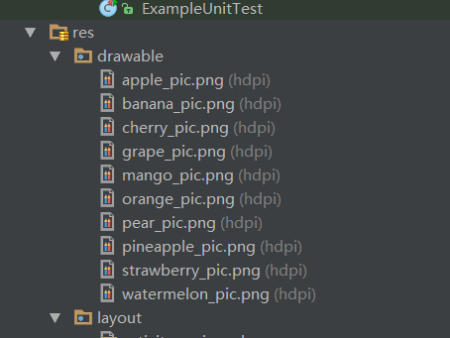
- 结果：
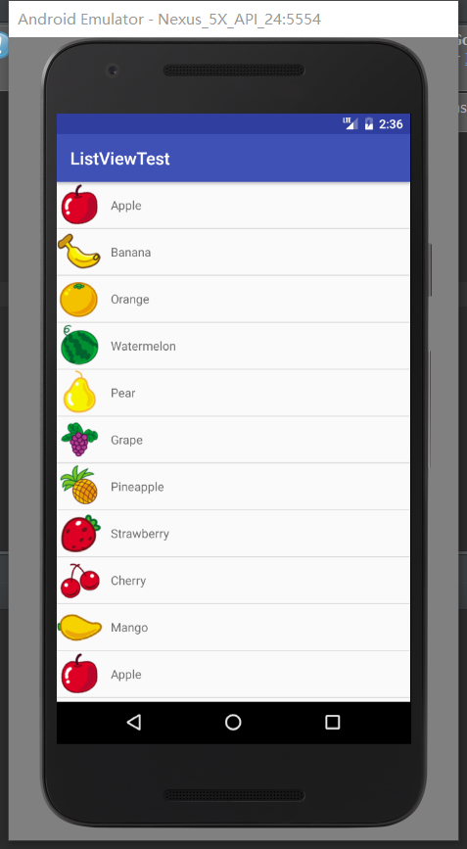

【实验结果】

【教师评语和成绩】

成绩： 指导教师： 日期：

