**CMSC203 Assignment 2 Implementation (Documentation)**

Class: CMSC203 CRN **40438**

 Program: Assignment # **2**

Instructor: **Grinberg**

 Summary of Description: (Give a brief description for each Program)

**The program consists of three classes: Patient, Procedure, and PatientDriverApp. The Patient class represents a patient and stores their personal information, while the Procedure class represents a medical procedure and holds details such as the name, date, practitioner, and charge. The PatientDriverApp class serves as the main driver program. It prompts the user for patient information, creates a Patient object, and displays the patient's details. It then enters a loop where the user can choose a procedure, which creates a corresponding Procedure object and displays its information. The loop continues until the user chooses to exit. Overall, the program offers a structured way to manage patient information and procedure details, making it suitable for medical offices or similar settings.**

 Due Date: **07/02/2023**

 Integrity Pledge: **I pledge that I have completed the programming assignment independently.**

**I have not copied the code from a student or any source.**

**Part1: Pseudo Code:** Here is a pseudo code for Assignment 2 program:

**Define a class named Patient.**

**Declare fields for first name, middle name, last name, address, city, state, ZIP code, phone number, emergency contact name, and emergency contact phone number.**

**Create a constructor that accepts arguments for each field and initializes the corresponding fields.**

**Create accessor methods for each field to retrieve their values.**

**Create mutator methods for each field to set their values.**

**Define a class named Procedure.**

**Declare fields for the procedure name, date, practitioner name, and procedure charges.**

**Create a constructor that accepts arguments for each field and initializes the corresponding fields.**

**Create accessor methods for each field to retrieve their values.**

**Create mutator methods for each field to set their values.**

**In the main program:**

**Create an instance of the Patient class, initialized with sample data using the constructor.**

**Create three instances of the Procedure class, initialized with the given data using the constructor.**

**Display the patient's information by calling the accessor methods of the Patient instance.**

**Display information about each of the three procedures by calling the accessor methods of the Procedure instances.**

**Calculate the total charges of the three procedures by summing up the charges of each Procedure instance.**

**Display the total charges.**

**Part2: Comprehensive Test Plan**

A good test plan should be comprehensive. This means you should have a few test cases that test when the input is in and out of range, division by 0, incorrect Data type, etc. (Provide valid and invalid input)

| Cases | Input | Expected Output | Actual Output | Did Test Pass? |
| --- | --- | --- | --- | --- |
| Case 1 | Patient name: Jenny Elaine Santori  Address: 123 Main Street  City: Rockville  State: MD  ZIP: 20877  Emergency Contact: Bill Santori 777-555-1212  Procedure: Physical Exam | Patient name: Jenny Elaine Santori  Address: 123 Main Street  City: Rockville  State: MD  ZIP: 20877  Emergency Contact: Bill Santori 777-555-1212  Procedure: Physical Exam  Procedure Date: 7/20/2023  Practitioner: Dr. Irvine  Procedure Charge: 250.0 | Procedure (1 - Physical Exam, 2 - X-ray, 3 - Blood Test, 0 - Exit): 1  Patient name: Jenny Elaine Santori  Address: 123 Main Street  City: Rockville  State: MD  ZIP: 20877  Emergency Contact: Bill Santori 777-555-1212  Procedure: Physical Exam  Procedure Date: 7/20/2023  Practitioner: Dr. Irvine  Procedure Charge: 250.0 | Yes |
| Case 2 | X-Ray | Procedure: X-ray  Procedure Date: 7/20/2023  Practitioner: Dr. Jamison  Procedure Charge: 500.0 | Procedure (1 - Physical Exam, 2 - X-ray, 3 - Blood Test, 0 - Exit): 2  Patient name: Jenny Elaine Santori  Address: 123 Main Street  City: Rockville  State: MD  ZIP: 20877  Emergency Contact: Bill Santori 777-555-1212  Procedure: X-ray  Procedure Date: 7/20/2023  Practitioner: Dr. Jamison  Procedure Charge: 500.0 | Yes(added patient information too). |
| Case 3 | Blood Test | Procedure: Blood Test  Procedure Date: 7/20/2023  Practitioner: Dr. Smith  Procedure Charge: 200.0 | Procedure (1 - Physical Exam, 2 - X-ray, 3 - Blood Test, 0 - Exit): 3  Patient name: Jenny Elaine Santori  Address: 123 Main Street  City: Rockville  State: MD  ZIP: 20877  Emergency Contact: Bill Santori 777-555-1212  Procedure: Blood Test  Procedure Date: 7/20/2023  Practitioner: Dr. Smith  Procedure Charge: 200.0 | Yes(with patient information too) |
| Case 4 | 0- Break | Student name: Vivek Hubbly  Student MC M#:M21174642  Due Date:07/03/2023 | Procedure (1 - Physical Exam, 2 - X-ray, 3 - Blood Test, 0 - Exit): 0  Student name: Vivek Hubbly  Student MC M#:M21174642  Due Date:07/03/2023 | Yes |

**Part3: Screenshots related to the Test Plan:**

**Case 1**

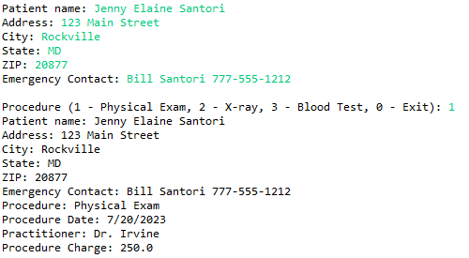

**Case 2**

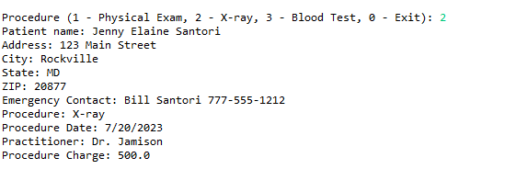

**Case 3**

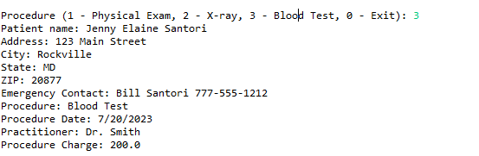

**Case 4**

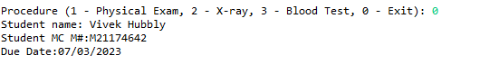

**Lessons Learned** <Provide answers to the questions listed above>**:**

Write about your Learning Experience, highlighting your lessons learned and learning experience from working on this project.

**This learning experience was enjoyable, as I had to learn how to format and call methods from other classes in order to write my code. I realized how important it was to use break; methods as well as using comparison objects in order to get an expected output.**

What have you learned?

**I learned the value of methods and separate classes.**

What did you struggle with?

**I struggled with calling methods in the main driver program.**

What would you do differently on your next project?

**Nothing, I found the way I did my project to be very good and effective.**

What parts of this assignment were you successful with, and what parts (if any) were you not successful with?

**I was successful with all parts of the assignment, specifically comparison objects to get a specific output.**

Provide any additional resources/links/videos you used to while working on this assignment/project.

N/A

**Check List:** <Provide answers to the column Y/N or N/A >**:**

| **#** |  | **Y/N** | **Comments** |
| --- | --- | --- | --- |
|  | **Assignment files:** |  |  |
|  | * FirstInitialLastName_ Assignment#_Moss.zip | **Yes or No** |  |
|  | * FirstInitialLastName_Assignment#.docx/.pdf | **Yes or No** |  |
|  | * Source java files | **Yes or No** |  |
|  | **Program compiles** | **Yes or No** |  |
|  | **Program runs with desired outputs related to a Test Plan** | **Yes or No** |  |
|  | **Documentation file:** |  |  |
|  | * Comprehensive Test Plan | **Yes or No** |  |
|  | * Screenshots related to the Test Plan | **Yes or No** |  |
|  | * Screenshots of your GitHub account with submitted Assignment# (if required) | **Yes or No or N/A** |  |
|  | * UML Diagram (if required) | **Yes or No or N/A** |  |
|  | * Algorithms/Pseudocode (if required) | **Yes or No or N/A** |  |
|  | * Flowchart (if required) | **Yes or No or N/A** |  |
|  | * Lessons Learned | **Yes or No** |  |
|  | * Checklist is completed and included in the Documentation | **Yes or No** |  |