**Introduction**

Parachuting involves working with gravity and air resistance for an enjoyable experience. This study delves into the intricacies of this interaction, aiming to precisely simulate the descent of parachuted objects despite the challenges posed by air resistance. This exploration is significant to the fields of aeronautics and sports, furthermore, shaping safety protocols for activities like skydiving, where a thorough understanding of parachute behavior is pivotal. Analyzing drag forces bridges theory to practicality, ensuring reliable models and safety standards.

**Methods**

In this simulation, we analyze the falling dynamics of a parachute-equipped object in the vertical dimension (y-dimension). The simulation focuses on gravitational acceleration (g=−9.81m/s²) and employs the drag equation to calculate the object's velocity (Vy) and position (y). The drag force, shaped by parachute features and air density, balances gravity, leading to a terminal velocity. The simulation ends when object's height (y) is non-positive, marking ground contact. Iterative calculations produce graphs showcasing gravity-air resistance dynamics over time. Parameters like parachute diameter (d), total mass (mtotal), initial height, and (y(1)) were meticulously chosen for accurate real-world simulation. To ensure as much accuracy as possible, research was done on parameter choices. For instance, the parachute's diameter is adjusted within a range of approximately 6.096 meters to 10.668 meters, aligning with research indicating typical parachute sizes in the range of 20 to 35 feet (How Much Does A Skydiving Parachute Weigh? – Extreme Sports News, 2022). The total mass (*m*total​) combines the body and parachute mass, with the latter set at 25 kg to account for gear weight (Kent, 2018). The average weight of a person was researched and averaged (*FastStats - Body Measurements*, n.d.). Additionally, the initial height (*y*(1)) is set at 1676.4 meters (5500 ft because on average the release of skydivers is around 10,000 feet (3048 m), while actual parachuting doesn’t occur until 5000 to 6000 ft (around 1600 m) (*How High Are Skydiving Jumps?*, 2019). Through specific adjustment of these parameters, the simulation seeks to ascertain a "reasonable" terminal velocity without compromising usability, comparing it to the max safe terminal velocity of 58 m/s (*Terminal Velocity Calculator*, n.d.). This iterative method explores viable combinations, balancing effectiveness and practicality in parachute design and real-world applications.

**Results**

Figures follow the same parameter in terms of mparachute = 25 kg, y(1) = 1676.4 Vy(1) = 0 m/s.

Figure 1. m_body = 70 kg, d = 6.095 m, terminal_Vy = -34.75 m/s

Figure 2. m_body = 70 kg, d = 8 m, terminal_Vy = -12.9 m/s

Figure 3. m_body = 135 kg, d = 6.095 m, terminal_Vy = -58.53 m/s

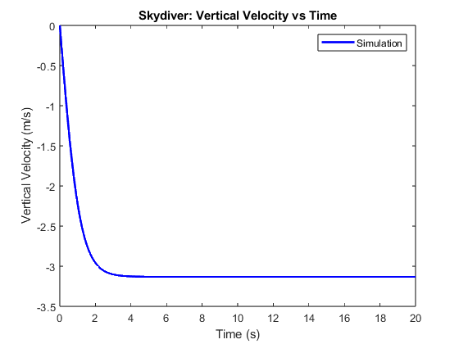

Figure 3

Figure 2

Figure 1

**Results**

Within the results, I plugged different initial values (mass and parachute diameter) into the simulation to address the design question. Figure 1 demonstrates a safe terminal velocity (“winning” result), Figure 3 with excessive speed for an unsafe landing, and Figure 2 depicts a very slow but impractically large parachute diameter. The graphs domain of the graph was cut down from 600 s to 20 s to show the curvature of the graph initially. All graphs depict a correct trajectory of a parachute; however, the time it takes for the parachute to reach an acceleration of 0 (steady Vy), is different. The time for the winning is between the largest time and the smallest time difference of the other figures. This makes sense since in my provided code, the deceleration is influenced by the diameter of the parachute through the drag coefficient (Cd) and the cross-sectional area (A) in the drag equation. A larger parachute diameter increases the cross-sectional area (A), which when combined with a constant drag coefficient (Cd), results in higher air resistance. This increased air resistance leads to a more significant deceleration effect, slowing down the falling object more rapidly, as Figure 2 depicts. For Figure 3, deceleration is much slower resulting in a faster descent to the ground in which it is too fast to be safe because its resulting terminal velocity is greater than a safe landing. Furthermore, Figure 3 provides evidence on how the mass of a person can affect the decent time and as seen from the graph, its deceleration time is much slower meaning a faster descent. This program addresses design questions by manipulating mass, density, area, and other parameters for safe landing. To enhance realism and account for wind effects, considering wind in both x and y directions impacts descent time and variability. Wind affects both horizontal and vertical motion, offering valuable insights. Integrating x-direction wind assesses crosswinds' impact, and altitude-dependent air density accounts for changing atmospheric conditions, enhancing simulation accuracy.

**References**

FastStats - Body Measurements. (n.d.). CDC. Retrieved October 4, 2023, from https://www.cdc.gov/nchs/fastats/body-measurements.htm

How High Are Skydiving Jumps? (2019, November 2). Skydive Orange. Retrieved October 4, 2023, from https://www.skydiveorange.com/2019/11/02/how-high-are-skydiving-jumps/

Kent, L. T. (2018, November 16). The Size of Skydiving Parachutes. SportsRec. Retrieved October 4, 2023, from https://www.sportsrec.com/7305468/the-size-of-skydiving-parachutes

Terminal Velocity Calculator. (n.d.). GoSkydive. Retrieved October 4, 2023, from https://www.goskydive.com/terminal-velocity-calculator/