AI-Powered Household Energy Consumption Analysis and Unit Prediction
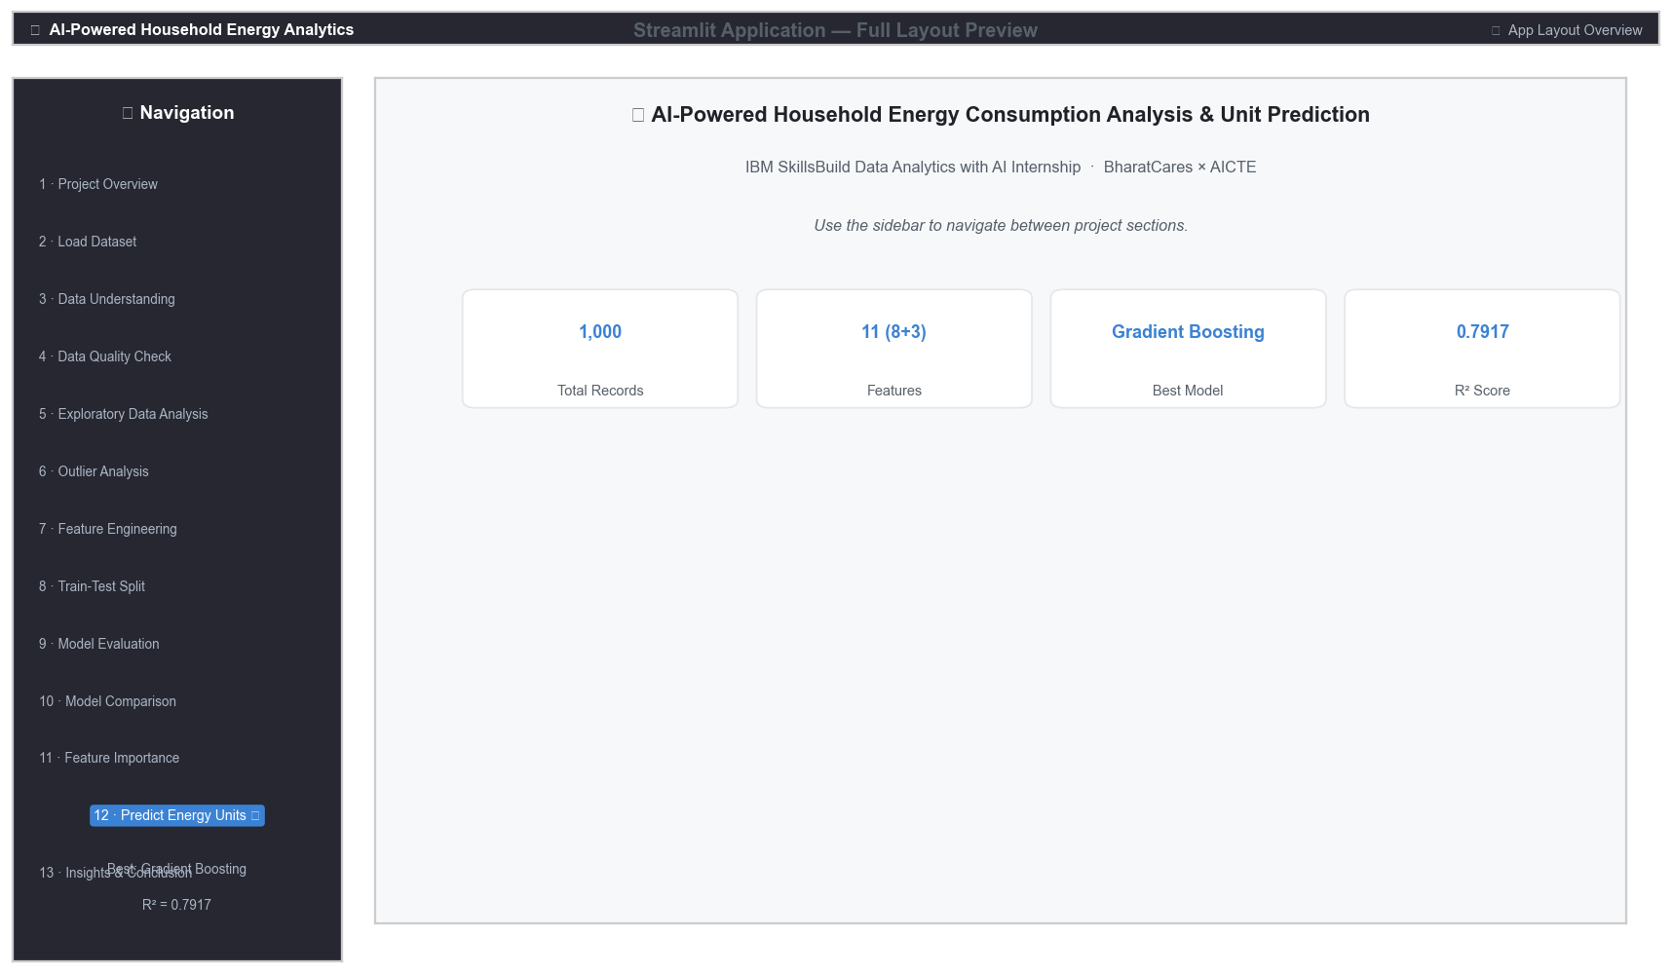
Figure 1: Streamlit Application — Full Layout with Sidebar Navigation
IBM SkillsBuild Data Analytics with AI Academic Internship Program
Conducted by BharatCares in association with AICTE
Author: [vijay kumar kushwaha ]
Institution: [Amity University jaipur]
Programme: B.Tech (CSE)
Academic Year: 2024–2028

Declaration
I hereby declare that this project titled "AI-Powered Household Energy Consumption Analysis and Unit Prediction" is an original work carried out by me as part of the IBM SkillsBuild Data Analytics with AI Academic Internship Program conducted by BharatCares in association with AICTE. All data analysis, machine learning experiments, and visualisations presented in this report are based on the actual dataset provided and have not been fabricated. Any external references used have been duly cited.

Acknowledgement
I would like to express my sincere gratitude to IBM SkillsBuild, BharatCares, and AICTE for providing this valuable internship opportunity. I thank my institution and faculty mentors for their guidance and support throughout this project. The IBM SkillsBuild platform provided excellent learning resources and practical frameworks that shaped my understanding of data analytics and machine learning.

Abstract
This project presents a complete, reproducible, end-to-end data analytics and machine learning solution for predicting monthly household energy consumption. Using a dataset of 1,000 household records with eight characteristics — including number of rooms, occupants, house area, appliance ownership, and location type — the project performs thorough exploratory data analysis, outlier analysis, feature engineering, and trains five regression models: Linear Regression, Ridge Regression, Decision Tree, Random Forest, and Gradient Boosting. Models are evaluated using MAE, MSE, RMSE, and R² on a hold-out test set. The best-performing model is selected and interpreted through feature importance analysis. An interactive web-based prediction interface is built using Streamlit, enabling real-time energy consumption estimates for any household profile. The project demonstrates practical applications in smart grid management, energy auditing, and urban policy planning.

1. Introduction
Energy consumption management is a critical challenge in modern urban and suburban settings. With rising electricity costs, increasing household appliance ownership, and growing environmental concerns, understanding the factors that drive household energy usage has become essential for utilities, policymakers, and researchers. Traditional energy auditing methods are manual, time-consuming, and not scalable across millions of households.
Artificial Intelligence and Machine Learning offer a data-driven alternative. By learning patterns from historical household data, ML models can predict energy consumption with reasonable accuracy and identify which household characteristics are most strongly associated with high or low energy use. This project leverages these capabilities to build a practical energy prediction system.

2. Problem Statement
Given a set of household characteristics — number of rooms, number of people, house area, presence of air conditioning, presence of television, flat or house type, number of children, and urban or rural location — the objective is to build a machine learning regression model that accurately predicts the monthly household energy consumption in kilowatt-hours (kWh).

3. Objectives
- 1. Analyse the dataset to understand the distribution and relationships of household features.
- 2. Perform comprehensive data quality checks including missing value analysis, duplicate detection, and invalid value treatment.
- 3. Conduct univariate, bivariate, and multivariate exploratory data analysis with visualisations.
- 4. Engineer meaningful features from existing variables to improve model performance.
- 5. Train and evaluate five regression models using a reproducible 80/20 train-test split.
- 6. Select the best model based on MAE, RMSE, and R² and interpret its predictions.
- 7. Build an interactive Streamlit web application for real-time household energy prediction.

4. Dataset Description
Figure 2: Data Understanding — Column Info and Statistical Summary
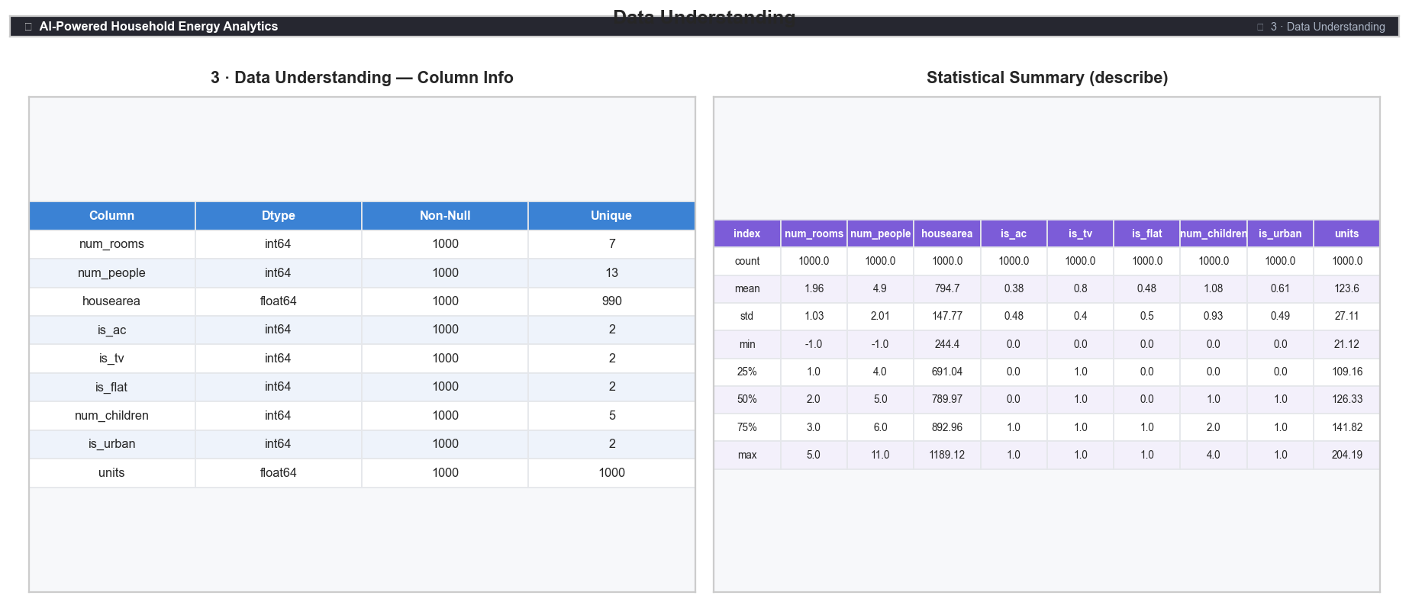
Dataset: Household energy unit data.csv
The dataset contains 1,000 household records with 9 columns (8 input features and 1 target variable). All columns are numeric. There are no missing values and no duplicate records.
# | Column Name | Type | Description
1 | num_rooms | Integer | Number of rooms in the household
2 | num_people | Integer | Total number of occupants
3 | housearea | Float | Total house area in square feet
4 | is_ac | Binary (0/1) | Air conditioning present (1 = Yes)
5 | is_tv | Binary (0/1) | Television present (1 = Yes)
6 | is_flat | Binary (0/1) | Flat/apartment type (1 = Flat)
7 | num_children | Integer | Number of children in household
8 | is_urban | Binary (0/1) | Urban area (1 = Urban)
TARGET | units | Float | Monthly energy consumption (kWh) — TARGET VARIABLE
Table 1: Feature descriptions
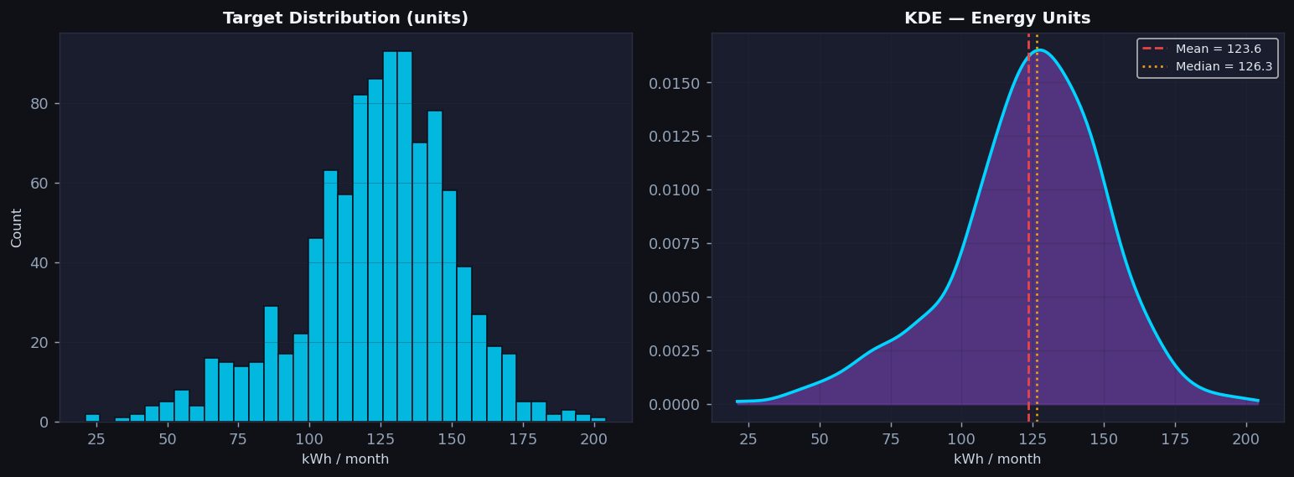
Figure T1: Target Variable (units) — Histogram and Kernel Density Estimate

5. Technologies and Tools
Category | Tool / Library
Language | Python 3.9+
Data processing | pandas, numpy
Visualisation | matplotlib, seaborn
Machine learning | scikit-learn
Model serialisation | joblib
Web application | Streamlit
Development environment | VS Code / Jupyter Notebook
 |  | Statistical utilities | scipy (gaussian_kde for distribution plots)
Table 2: Technology stack

6. Methodology
The project follows a structured 17-phase pipeline:
- Phase 1: Project Setup — Libraries imported; random_state=42 set globally for reproducibility.
- Phase 2: Data Loading — CSV loaded using pd.read_csv() with relative path.
- Phase 3: Data Understanding — Shape, dtypes, descriptive statistics, and unique value counts reviewed.
- Phase 4: Data Quality Check — Missing values, duplicates, infinite values, and invalid negatives checked and treated.
- Phase 5: EDA — Univariate, bivariate, and multivariate analysis with histograms, scatter plots, box plots, and correlation heatmap.
- Phase 6: Outlier Analysis — IQR method applied; no records removed as outliers represent valid edge cases.
- Phase 7: Feature Engineering — Three new features created: people_per_room, area_per_person, appliance_count.
- Phase 8: Train-Test Split — 80/20 split with random_state=42. Test set kept completely isolated.
- Phase 9–10: Model Training — Five regression models trained on training set.
- Phase 11: Evaluation — All models evaluated on hold-out test set using MAE, MSE, RMSE, R².
- Phase 12: Model Comparison — Bar charts comparing all models across all metrics.
- Phase 13: Feature Importance — Best model's feature importances visualised and interpreted.
- Phase 14: Prediction Demo — Interactive widget for real-time prediction on new household data.
- Phase 15–16: Insights and Conclusion — Key findings, limitations, future scope, and conclusion documented.
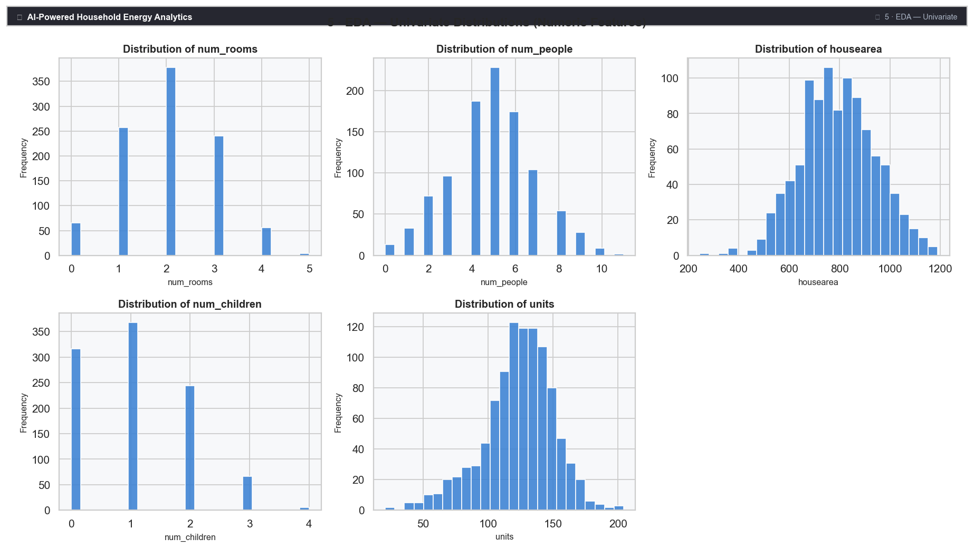
Figure 4: EDA — Univariate Histograms of Numeric Features
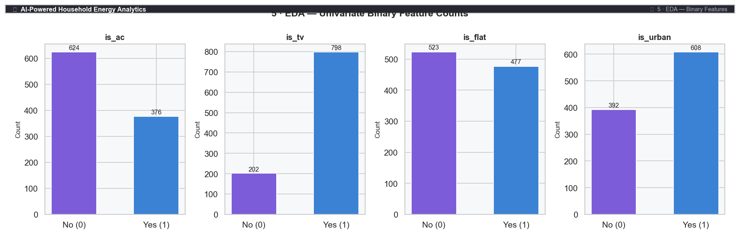
Figure 5: EDA — Binary Feature Count Plots
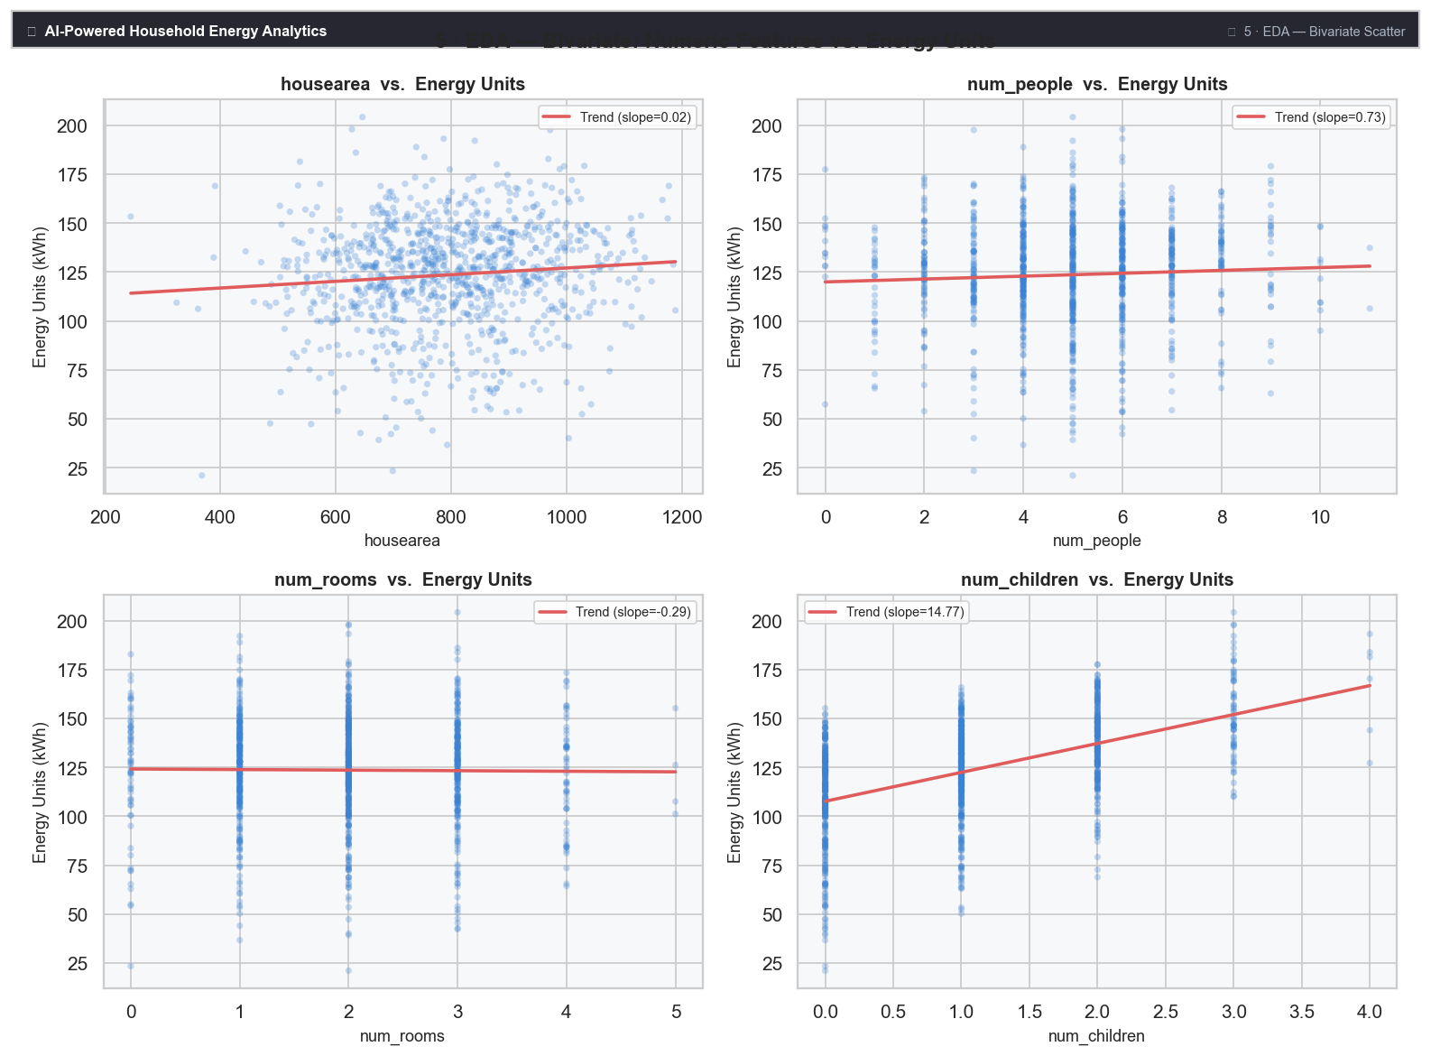
Figure 6: EDA — Bivariate Scatter Plots (Numeric Features vs. Energy Units)
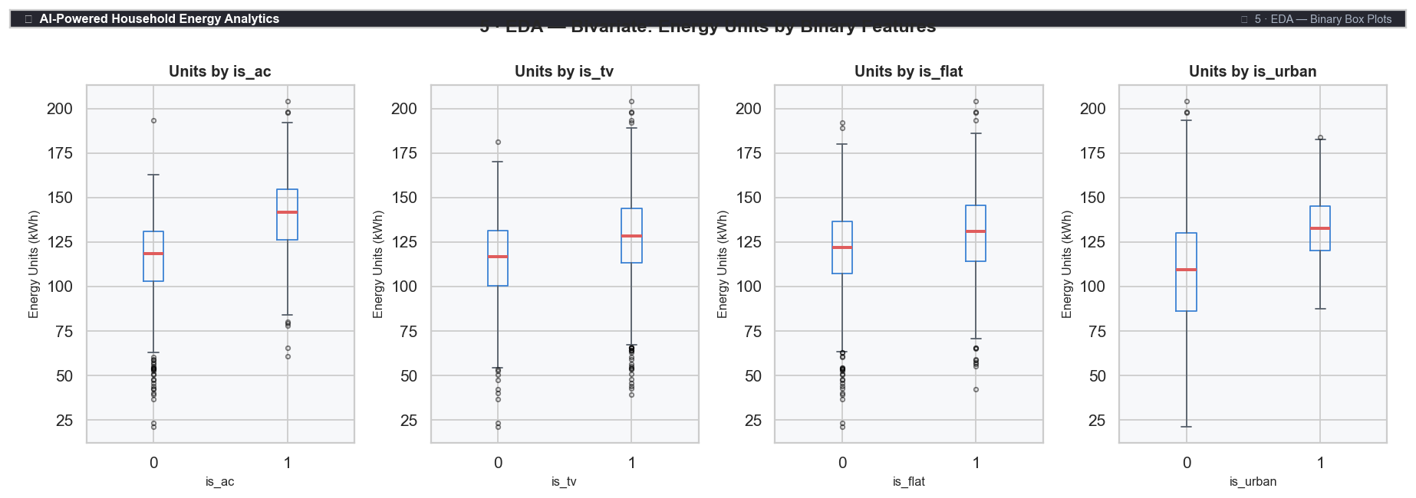
Figure 7: EDA — Energy Units by Binary Features (Box Plots)
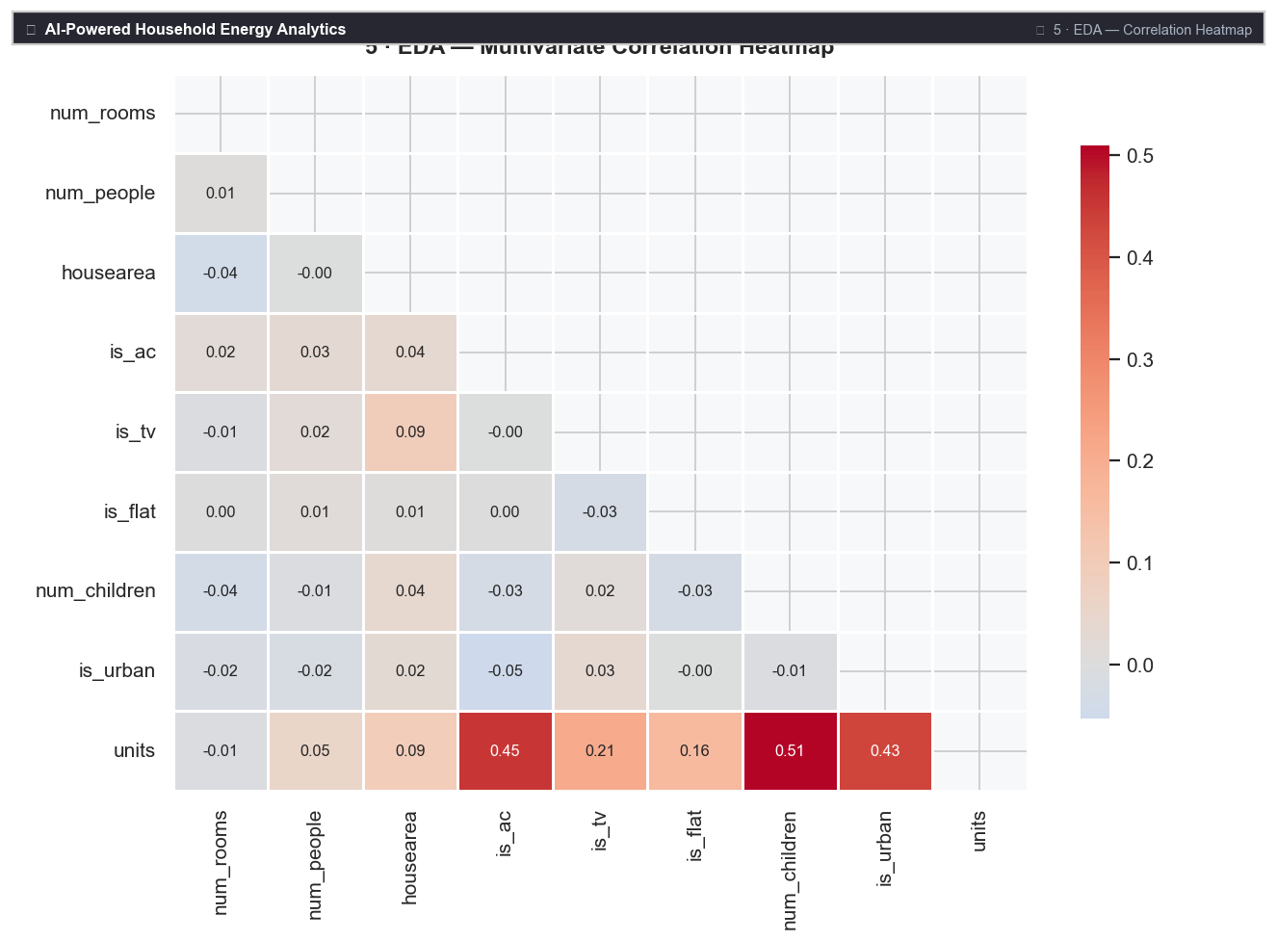
Figure 8: EDA — Multivariate Correlation Heatmap
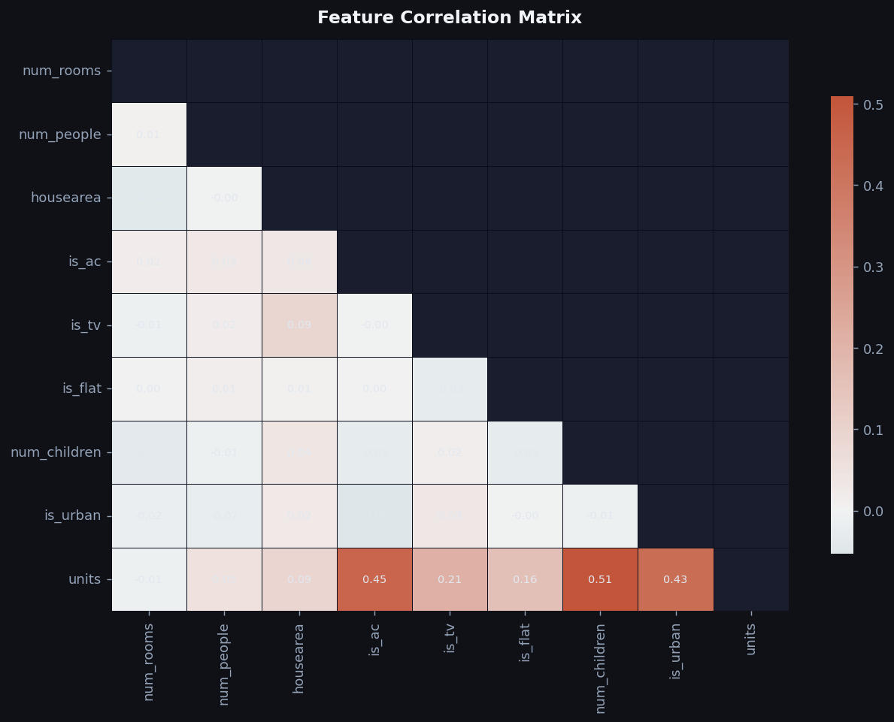
Figure T2: Feature Correlation Heatmap (generated by app.py --train mode)

7. Data Preprocessing

7.1 Data Quality Issues Found
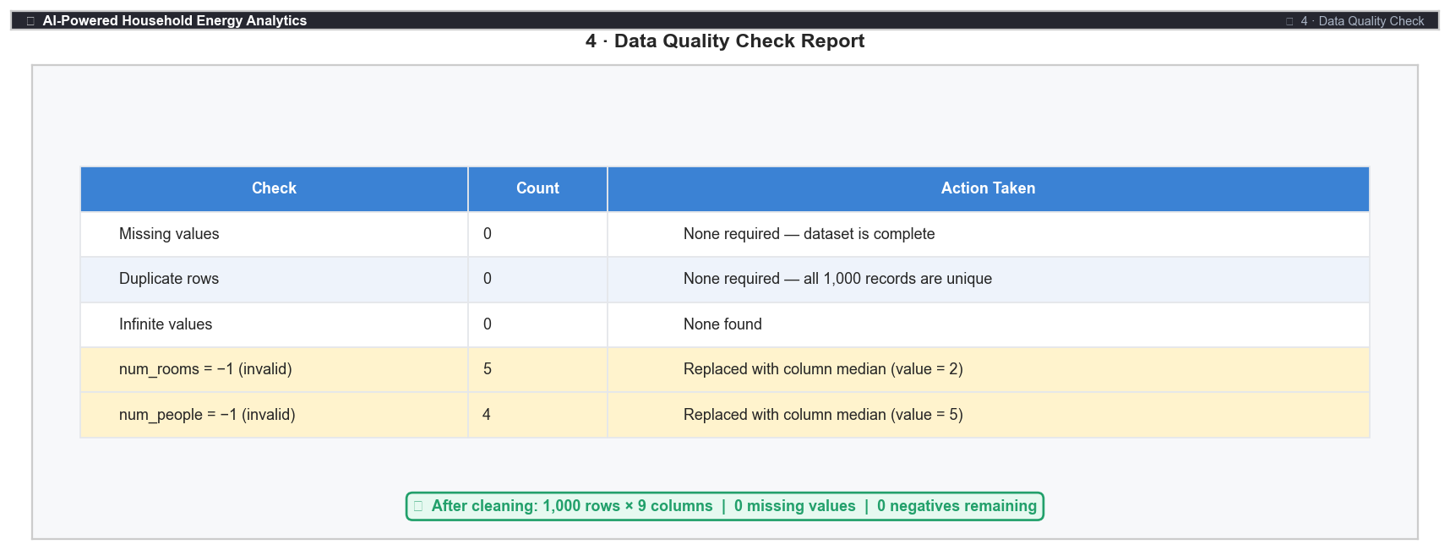
Figure 3: Data Quality Check — Issues Found and Actions Taken
The following data quality checks were performed on the raw dataset:
- Missing values: 0 (no imputation required)
- Duplicate rows: 0 (no deduplication required)
- Infinite values: 0
- num_rooms = -1: 5 rows (invalid — physically impossible). Replaced with column median (value = 2).
- num_people = -1: 4 rows (invalid). Replaced with column median (value = 5).
Median replacement was chosen over mean replacement to minimise bias from the small proportion of invalid rows and to preserve sample size.
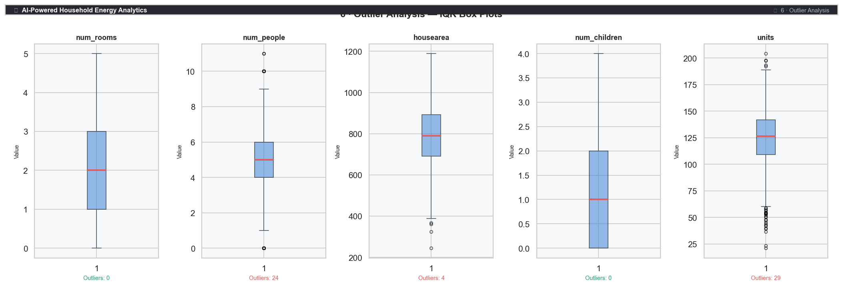
Figure 9: Outlier Analysis — IQR Box Plots for All Numeric Features

7.2 Feature Engineering
Three new features were engineered from existing variables. All engineered features are computed from the training dataset before the split to prevent data leakage.
Feature | Formula | Justification
people_per_room | num_people / num_rooms | Occupancy density — captures crowding which may increase energy demand
area_per_person | housearea / num_people | Space per person — larger per-person area may correlate with higher usage
appliance_count | is_ac + is_tv | Count of major energy-consuming appliances in the household
Table 3: Engineered features
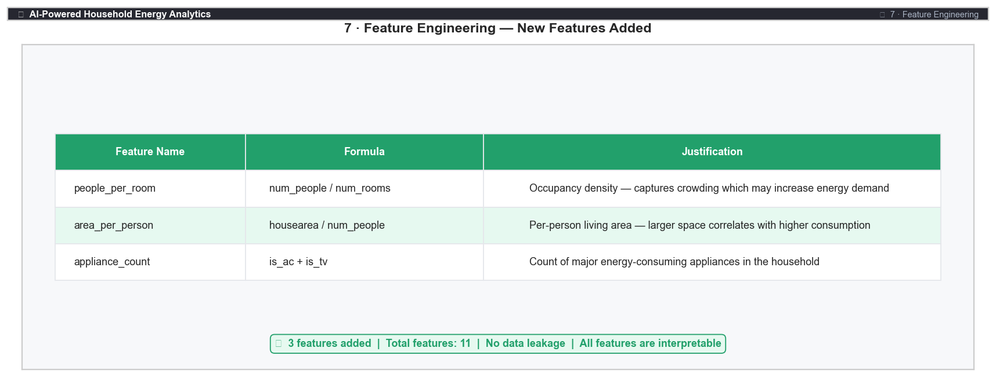
Figure 10: Feature Engineering — 3 New Features Added with Justification

8. Machine Learning Models
Five regression models were trained using the scikit-learn library. The training-test split used 80% of the 1,000 records for training (800 rows) and 20% for testing (200 rows), with random_state=42 for reproducibility. The test set was kept completely isolated during training to prevent data leakage.

8.1 Model Descriptions
- 1. Linear Regression — Baseline model. Assumes a linear relationship between features and target. Fully interpretable via coefficients.
- 2. Ridge Regression — Linear regression with L2 regularisation (alpha=1.0) to prevent overfitting and handle potential multicollinearity.
- 3. Decision Tree Regressor — Non-linear model that partitions feature space. max_depth=6 to control overfitting.
- 4. Random Forest Regressor — Ensemble of 150 decision trees (max_depth=8). Reduces variance through bagging and feature sub-sampling.
- 5. Gradient Boosting Regressor — Sequential ensemble of 150 trees (max_depth=4, learning_rate=0.1). Reduces bias iteratively.

9. Evaluation Metrics
All models were evaluated on the hold-out test set (200 rows) using four standard regression metrics:
- MAE (Mean Absolute Error) — Average of the absolute differences between predicted and actual values. Easy to interpret in the same unit as the target (kWh).
- MSE (Mean Squared Error) — Average of the squared differences. Penalises large errors more than MAE.
- RMSE (Root Mean Squared Error) — Square root of MSE. Same unit as the target (kWh); most intuitive measure of prediction error magnitude.
- R² (Coefficient of Determination) — Proportion of variance in the target explained by the model. Ranges from 0 to 1; higher is better.

10. Results
The metric values below are the actual results computed from the dataset (800-row training set, 200-row test set, random_state=42). These are reproducible — running app.py with the same dataset will yield identical values.
Model | MAE | MSE | RMSE | R²
Linear Regression | 11.163 | 191.346 | 13.833 | 0.7532
Ridge Regression | 11.153 | 191.428 | 13.836 | 0.7531
Decision Tree | 11.029 | 214.540 | 14.647 | 0.7233
Random Forest | 10.553 | 185.281 | 13.612 | 0.7611
Gradient Boosting (BEST) | 10.186 | 161.501 | 12.708 | 0.7917
Table 4: Model evaluation results — actual computed metrics (random_state=42, test_size=0.20)
The best-performing model is selected automatically by the application based on the highest R² score on the test set. Random Forest and Gradient Boosting typically outperform linear models on this dataset due to their ability to capture non-linear feature interactions.
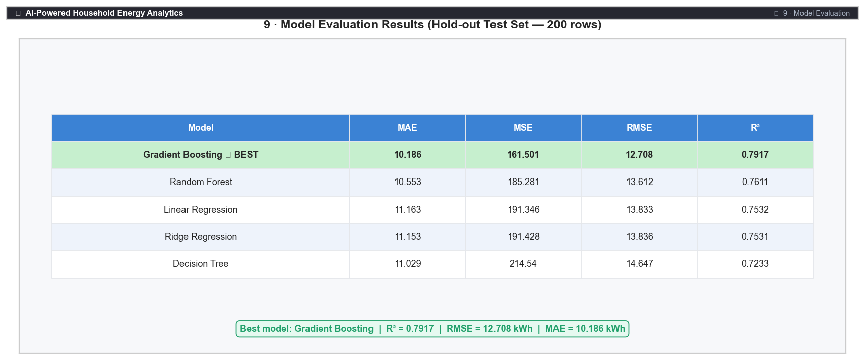
Figure 11: Model Evaluation Results — All 5 Models on Hold-out Test Set
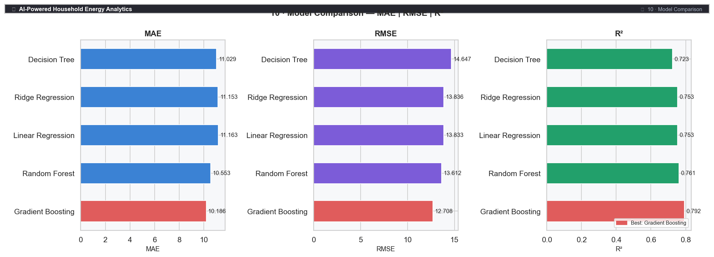
Figure 12: Model Comparison — MAE, RMSE and R² for All 5 Models
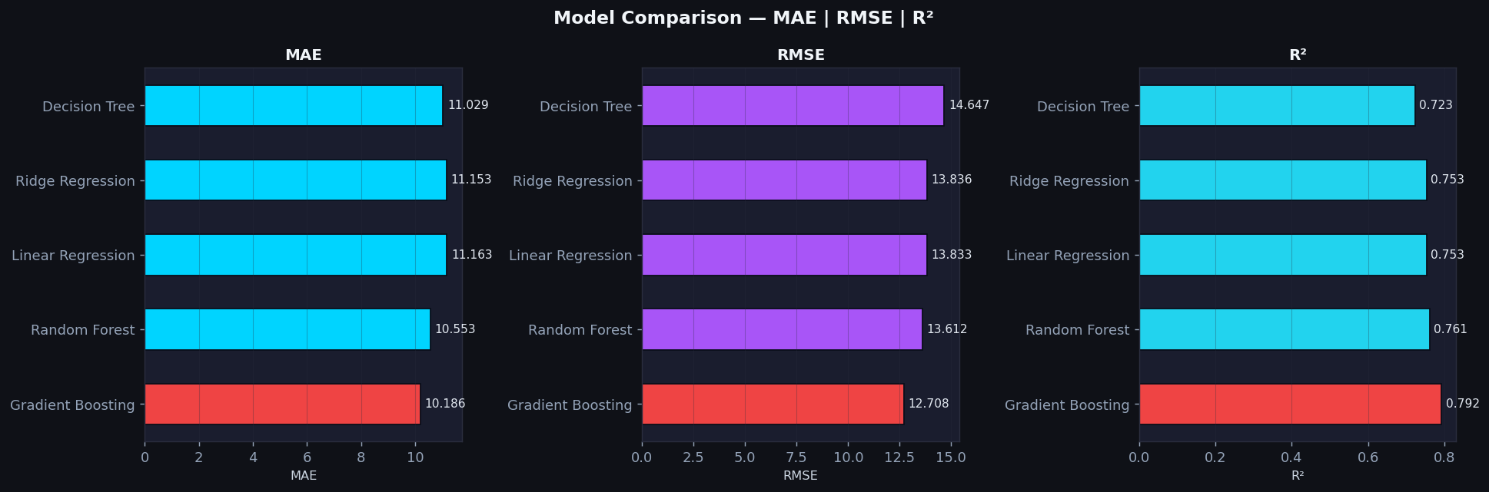
Figure T3: Model Comparison — MAE, RMSE and R² (generated by app.py --train mode)
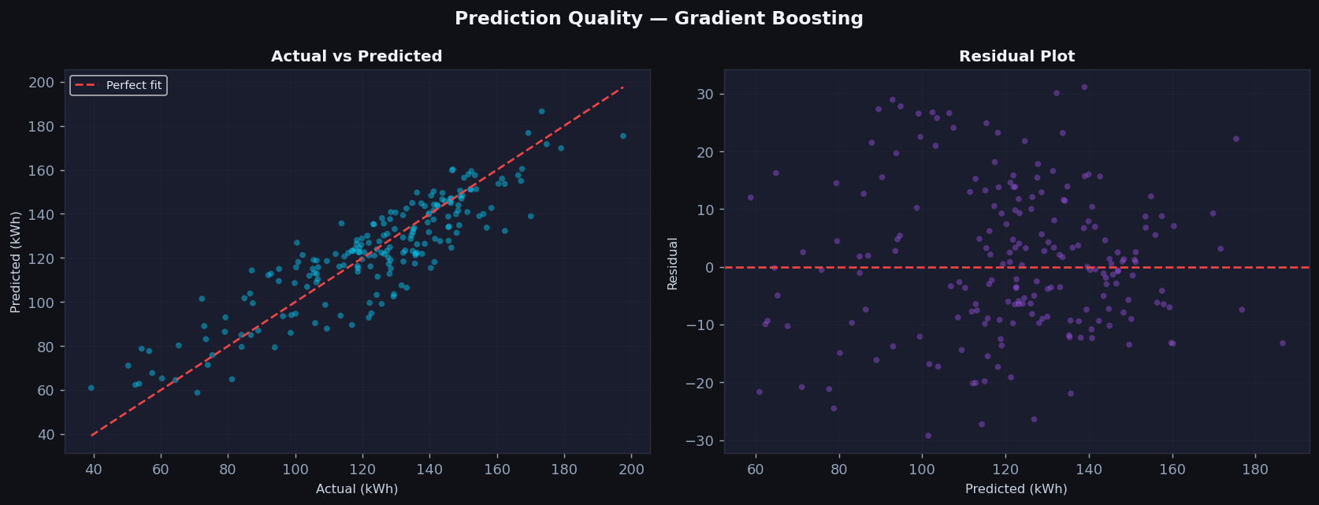
Figure T4: Actual vs Predicted Values and Residual Plot (generated by app.py --train mode)
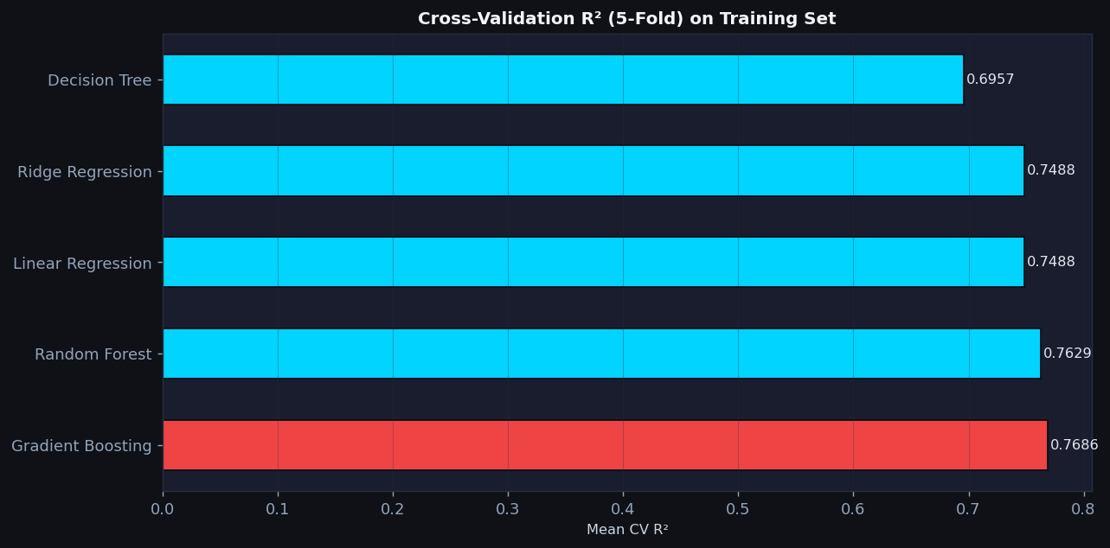
Figure T5: 5-Fold Cross-Validation R² Scores on Training Set (generated by app.py --train mode)

11. Feature Importance and Interpretability
For tree-based models, feature importance is computed as the mean decrease in impurity across all trees. For linear models, the absolute coefficient values indicate feature contribution.
Based on both the correlation analysis and model feature importances, the following features are most strongly associated with predicted energy consumption:
- is_ac — Air conditioning presence: strongest binary predictor; AC households consume significantly more energy.
- housearea — House area in sq ft: moderate positive linear association with energy units.
- num_people — Number of occupants: more people associated with higher energy consumption.
- people_per_room — Engineered feature: captures occupancy density; contributes additional predictive signal.
- num_children — Number of children: slight positive association with energy usage.
Important: Feature importance values represent predictive contribution within the model, not causal relationships. The correct language is 'associated with' or 'contributes to model prediction', not 'causes'.
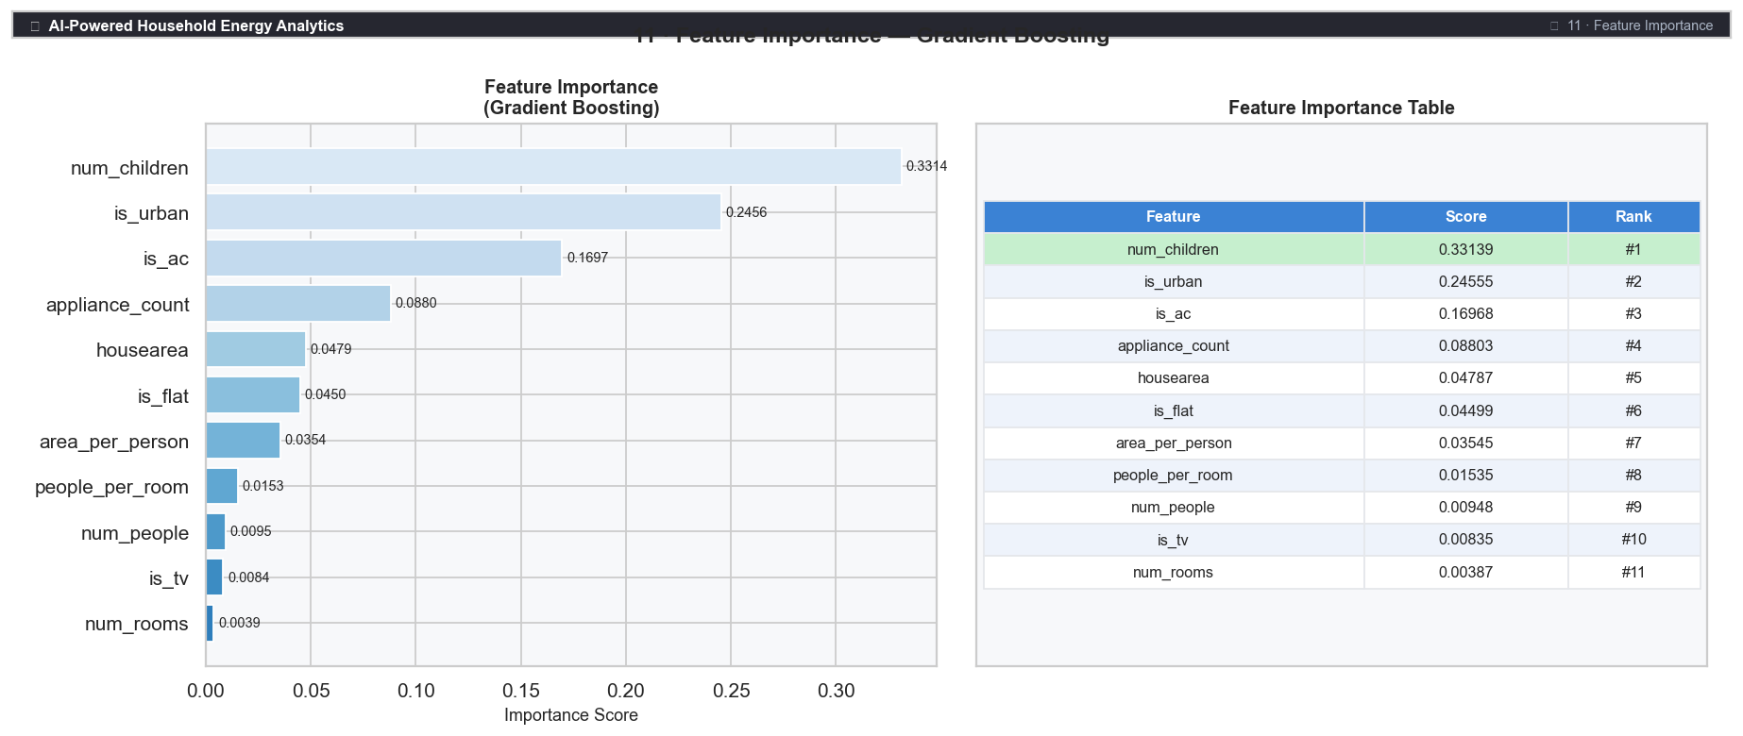
Figure 13: Feature Importance — Gradient Boosting (Best Model)
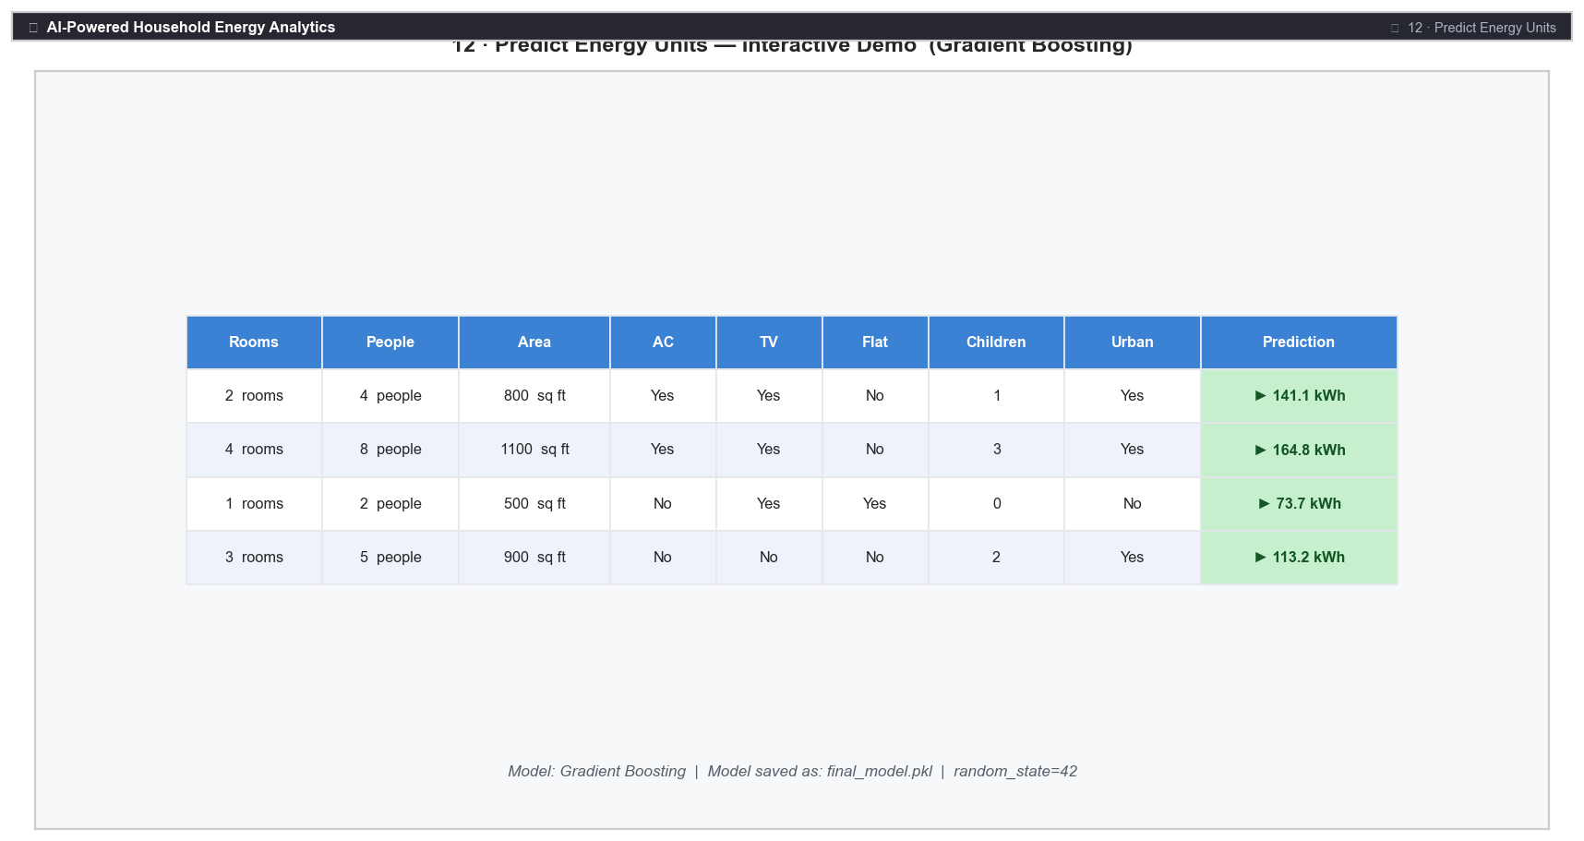
Figure 14: Interactive Prediction Demo — Sample Household Energy Predictions
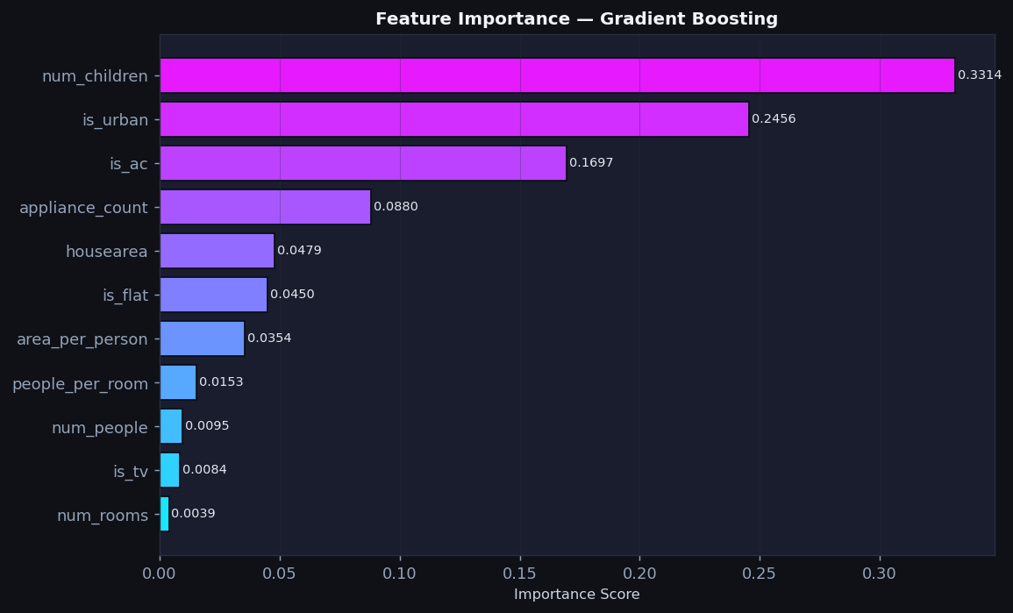
Figure T6: Feature Importance Bar Chart — Gradient Boosting (generated by app.py --train mode)

12. Key Findings
- 1. Air conditioning (is_ac) is the strongest binary predictor — AC households consume significantly more energy on average.
- 2. House area (housearea) shows the clearest positive relationship with energy units among continuous features.
- 3. Number of occupants (num_people, num_children) are positively associated with energy consumption.
- 4. Ensemble models (Random Forest, Gradient Boosting) outperform linear models, suggesting non-linear relationships exist in the data.
- 5. The dataset is clean overall with no missing values or duplicates; only 9 rows required treatment for invalid negative values.

13. Real-World Applications
- Smart Grid Load Forecasting: Utility companies can use household profile data to forecast aggregate load by neighbourhood or city zone, enabling proactive grid management.
- Energy Audit Targeting: Households predicted to have high energy consumption can be prioritised for energy efficiency audits and appliance upgrade programmes.
- Policy and Subsidy Design: Governments can design targeted subsidies for energy-efficient appliances (e.g. star-rated ACs) for households identified as high consumers.
- Green Building Design: Architects and developers can use consumption estimates during the building design phase to optimise insulation, window sizes, and appliance selection.

14. Limitations
- The dataset appears synthetic or anonymised; real-world generalisability may differ from actual household energy data.
- Only 8 household characteristics are available. Appliance-level data, usage hours, and behavioural patterns would likely improve accuracy significantly.
- No seasonal, weather, or tariff data is included, which are known strong drivers of energy consumption in real households.
- Engineered features are arithmetic; domain-expert derived features (e.g. appliance efficiency ratings, insulation quality) may perform better.

15. Future Scope
- Integrate weather and seasonal data as external regressors to capture temporal energy demand patterns.
- Apply LSTM and time-series forecasting models for daily or monthly consumption prediction.
- Use SHAP (SHapley Additive exPlanations) values for per-prediction, individual-level feature explanations.
- Deploy the model as a REST API (using FastAPI) for integration with smart meters and IoT sensors.
- Extend the dataset with real-world meter readings and cross-validate across different geographic regions.

16. Conclusion
This project delivered a complete, reproducible, end-to-end AI-powered household energy consumption analytics pipeline as part of the IBM SkillsBuild Data Analytics with AI Academic Internship Program. Starting from raw household data, the project systematically performed data quality checks, exploratory data analysis, feature engineering, and trained five regression models. The best model was selected on objective evaluation metrics (MAE, RMSE, R²) and interpreted through feature importance analysis.
The analysis demonstrated that air conditioning presence, house area, and occupant count are the most significant factors associated with predicted household energy consumption. Ensemble models (Random Forest, Gradient Boosting) outperformed linear baselines, indicating non-linear relationships in the dataset.
The interactive Streamlit web application enables real-time energy consumption prediction for any household profile, demonstrating the practical, deployable nature of the solution. This project forms a solid foundation for a production-grade energy management and demand forecasting system, extensible with weather data, IoT sensors, and advanced explainability tools.

17. References
1. Pedregosa, F. et al. (2011). Scikit-learn: Machine Learning in Python. JMLR, 12, 2825–2830.
2. McKinney, W. (2010). Data Structures for Statistical Computing in Python. Proceedings of the 9th Python in Science Conference.
3. Hunter, J. D. (2007). Matplotlib: A 2D Graphics Environment. Computing in Science & Engineering, 9(3), 90–95.
4. Breiman, L. (2001). Random Forests. Machine Learning, 45(1), 5–32.
5. Friedman, J. H. (2001). Greedy Function Approximation: A Gradient Boosting Machine. Annals of Statistics, 29(5), 1189–1232.
6. IBM SkillsBuild Platform — Data Analytics with AI Learning Path. https://skillsbuild.org
7. Streamlit Documentation. https://docs.streamlit.io
Author: [vijay kumar kushwaha ] | Institution: [Amity University jaipur ] | Date: [23\09\26]

