Backend Report

Newman report:
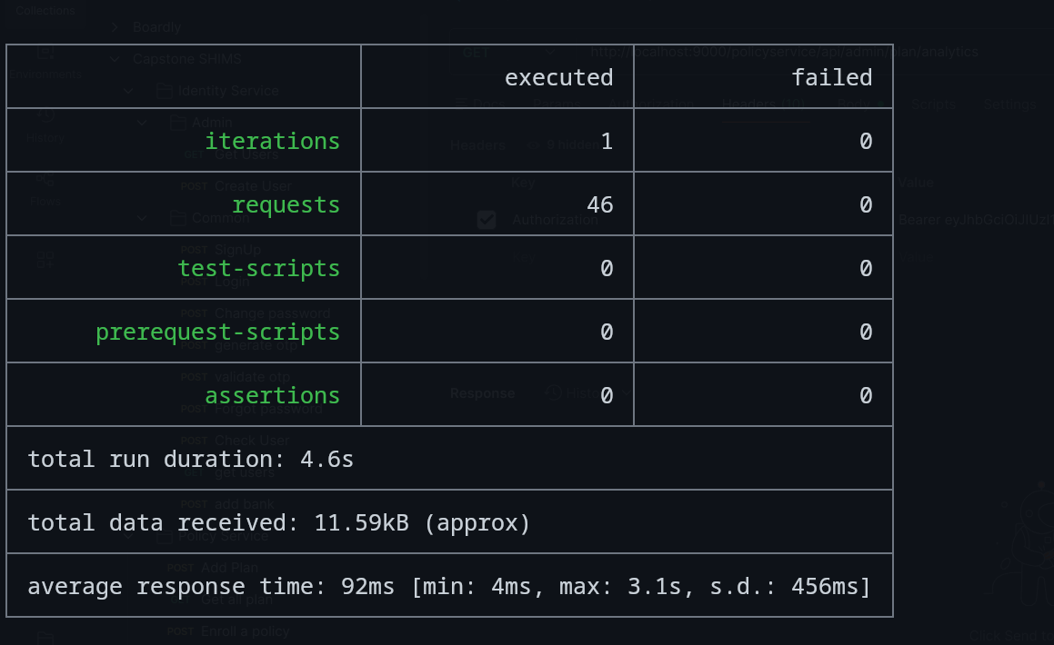
(Note: full detailed test report can be found in newman folder in root directory)
SonarQube Analysis:

Billing Service:

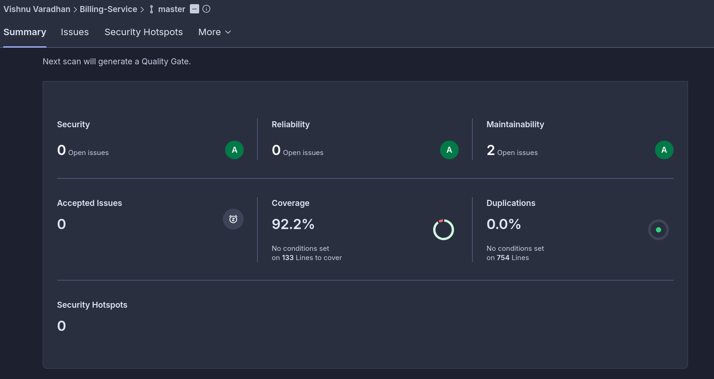
Link = https://sonarcloud.io/summary/overall?id=vi2hnu-1_shims-billing-service&branch=master

Claims Service:
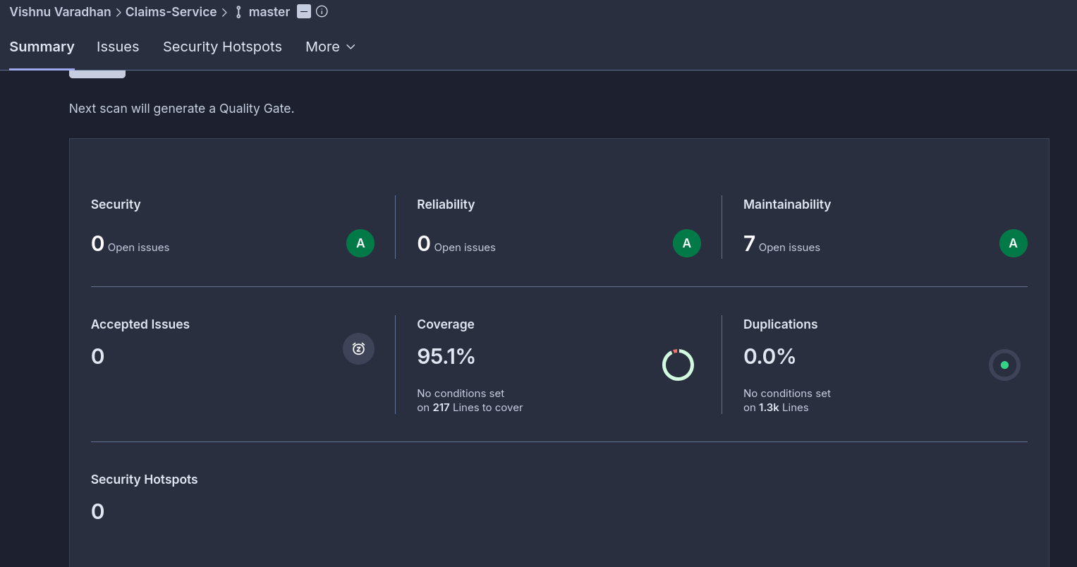
link = https://sonarcloud.io/summary/overall?id=vi2hnu-1_shims-claims-service&branch=master

EmailService
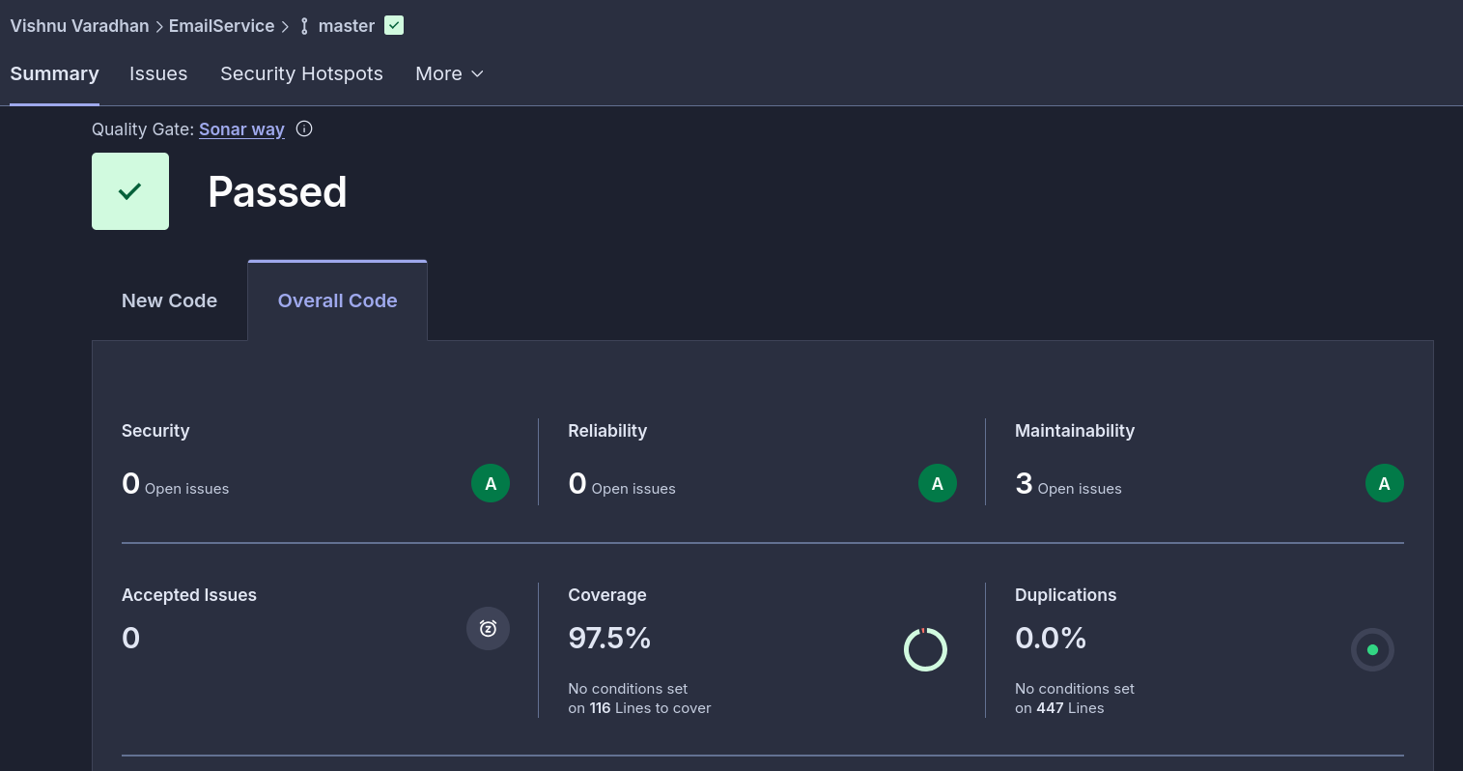
Link = https://sonarcloud.io/summary/overall?id=vi2hnu-1_shims-email-service&branch=master

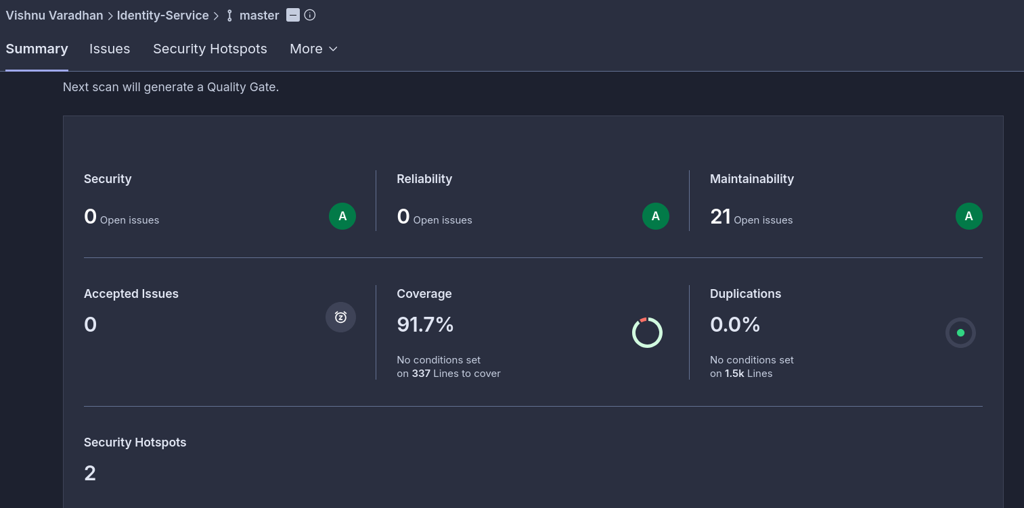
Link =https://sonarcloud.io/summary/overall?id=vi2hnu-1_shims-identity-service&branch=master
Policy-Service:
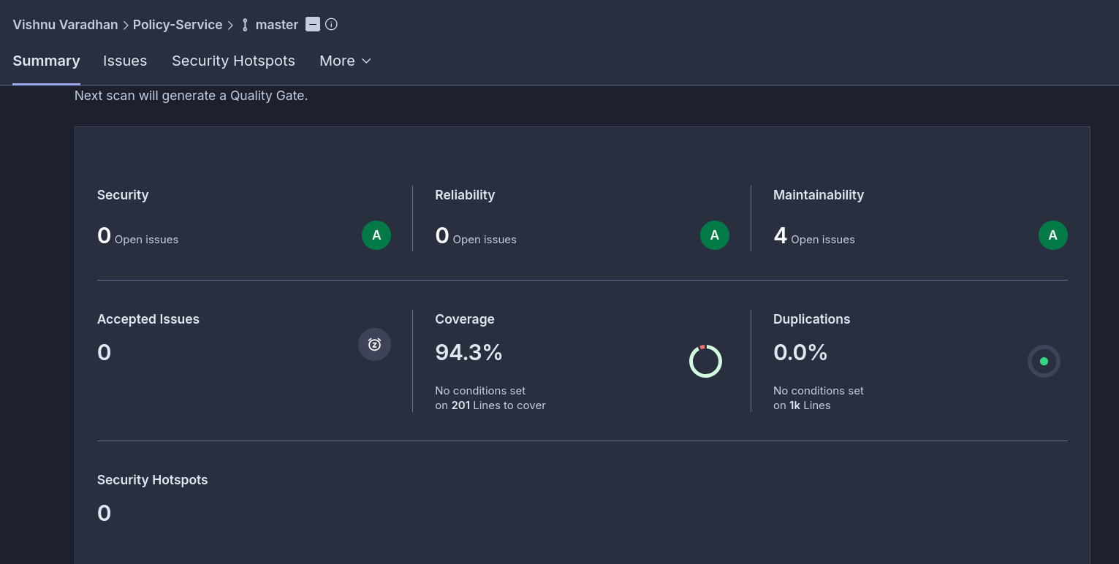
Link = https://sonarcloud.io/summary/overall?id=vi2hnu-1_shims-policy-service&branch=master

Provider Service:
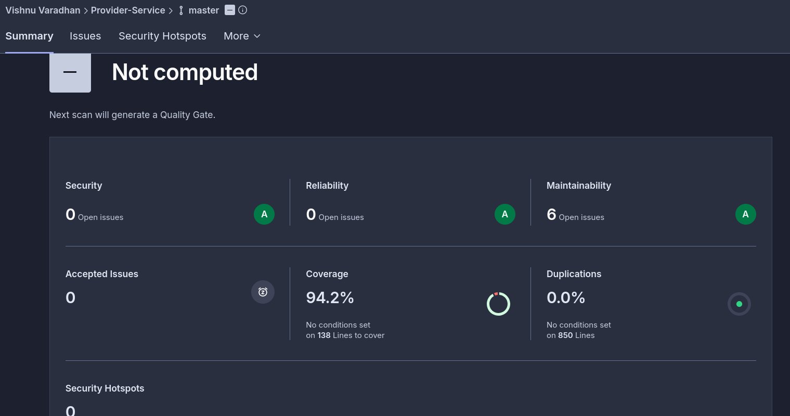
Jacoco Report:
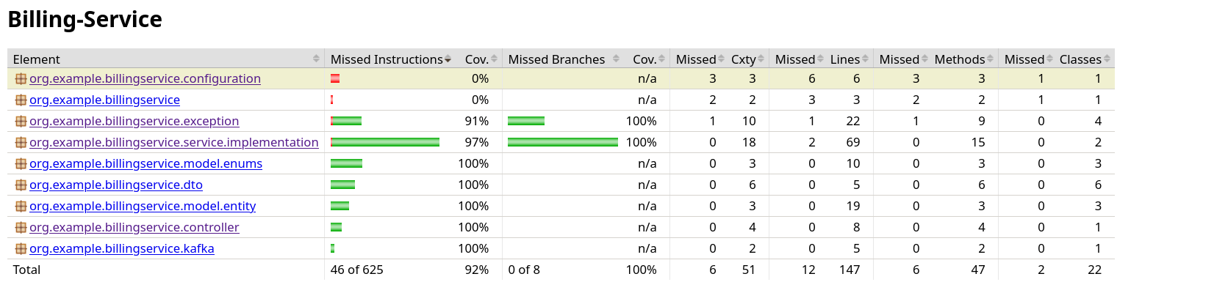
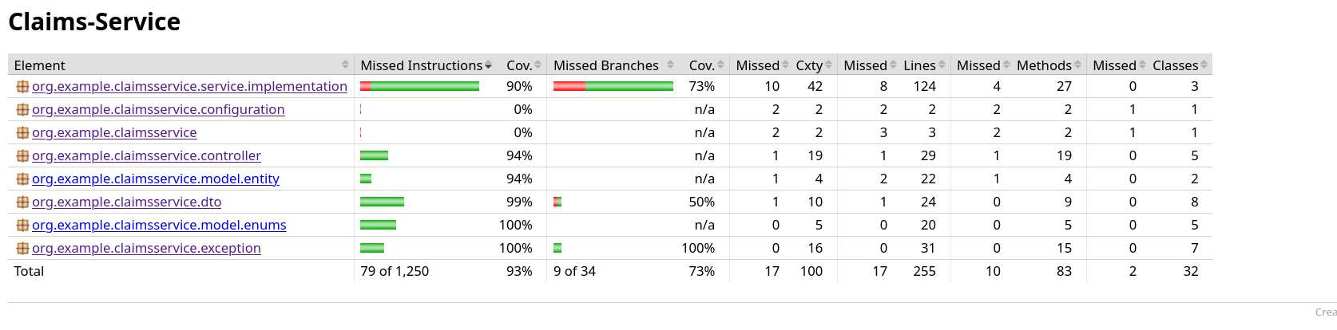
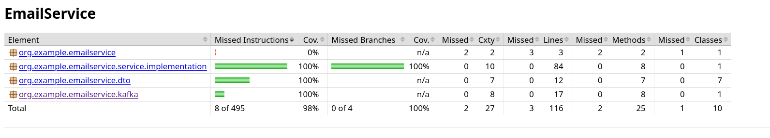
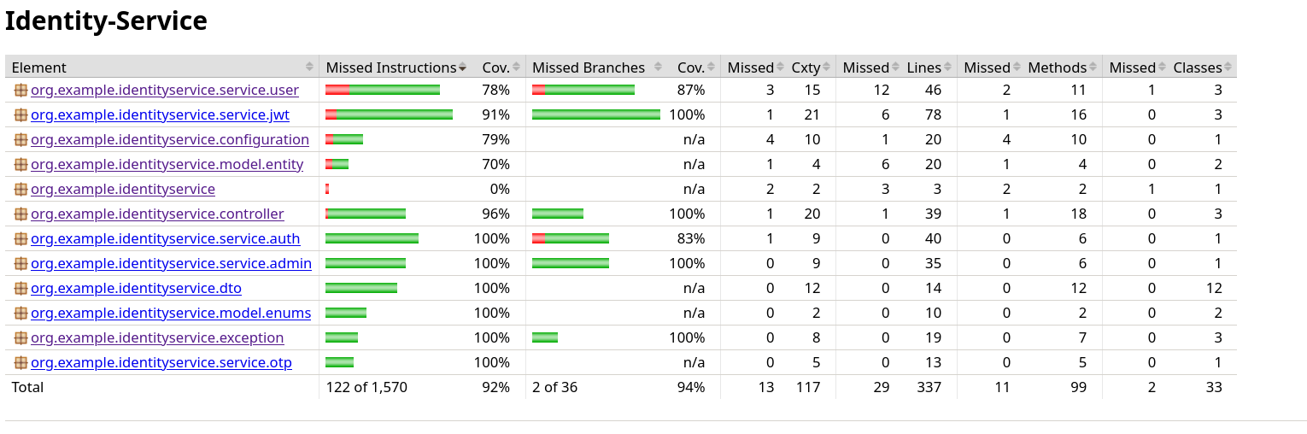
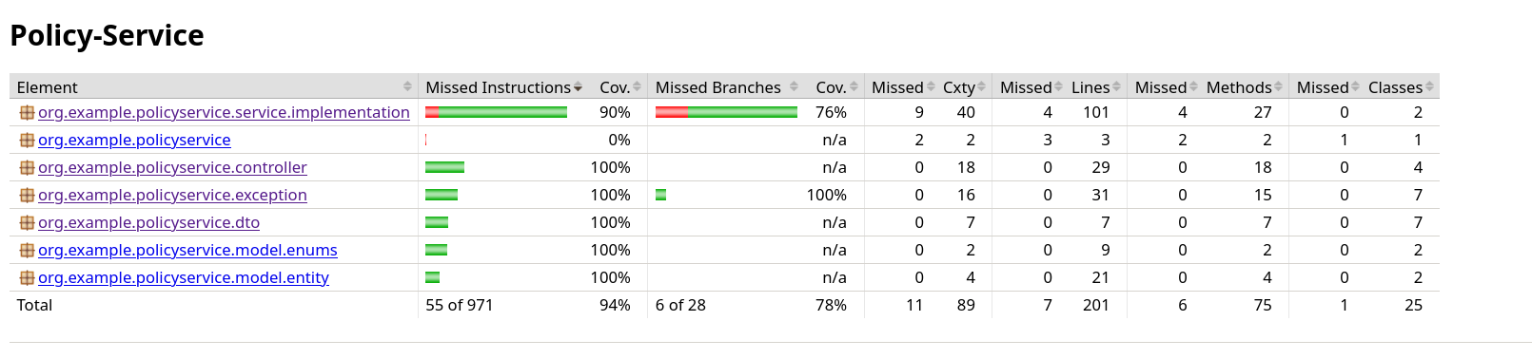

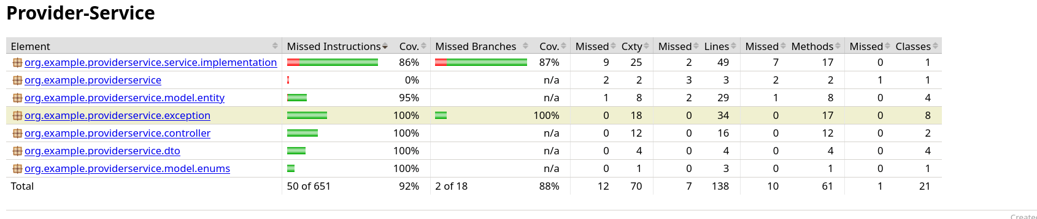
Jmeter:

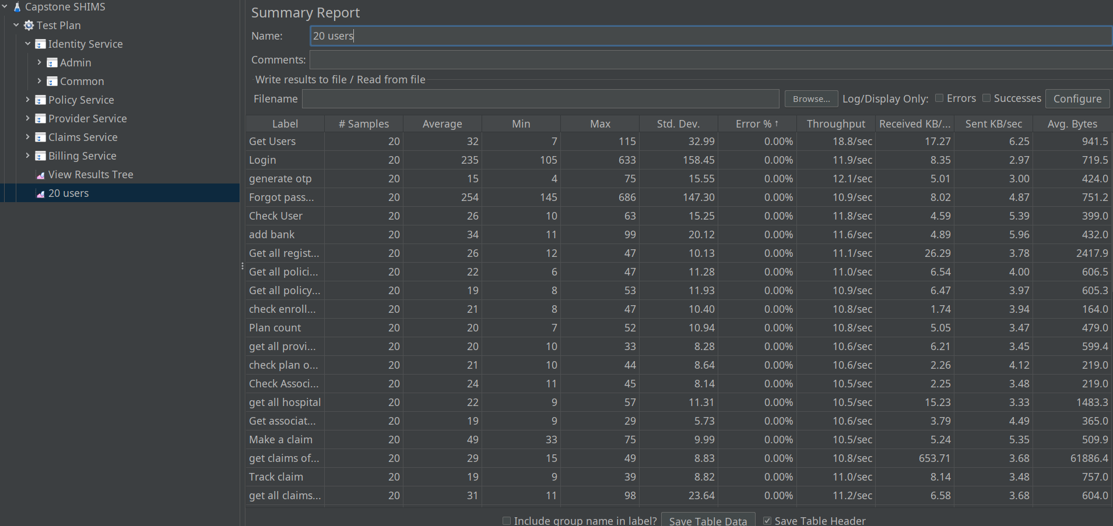
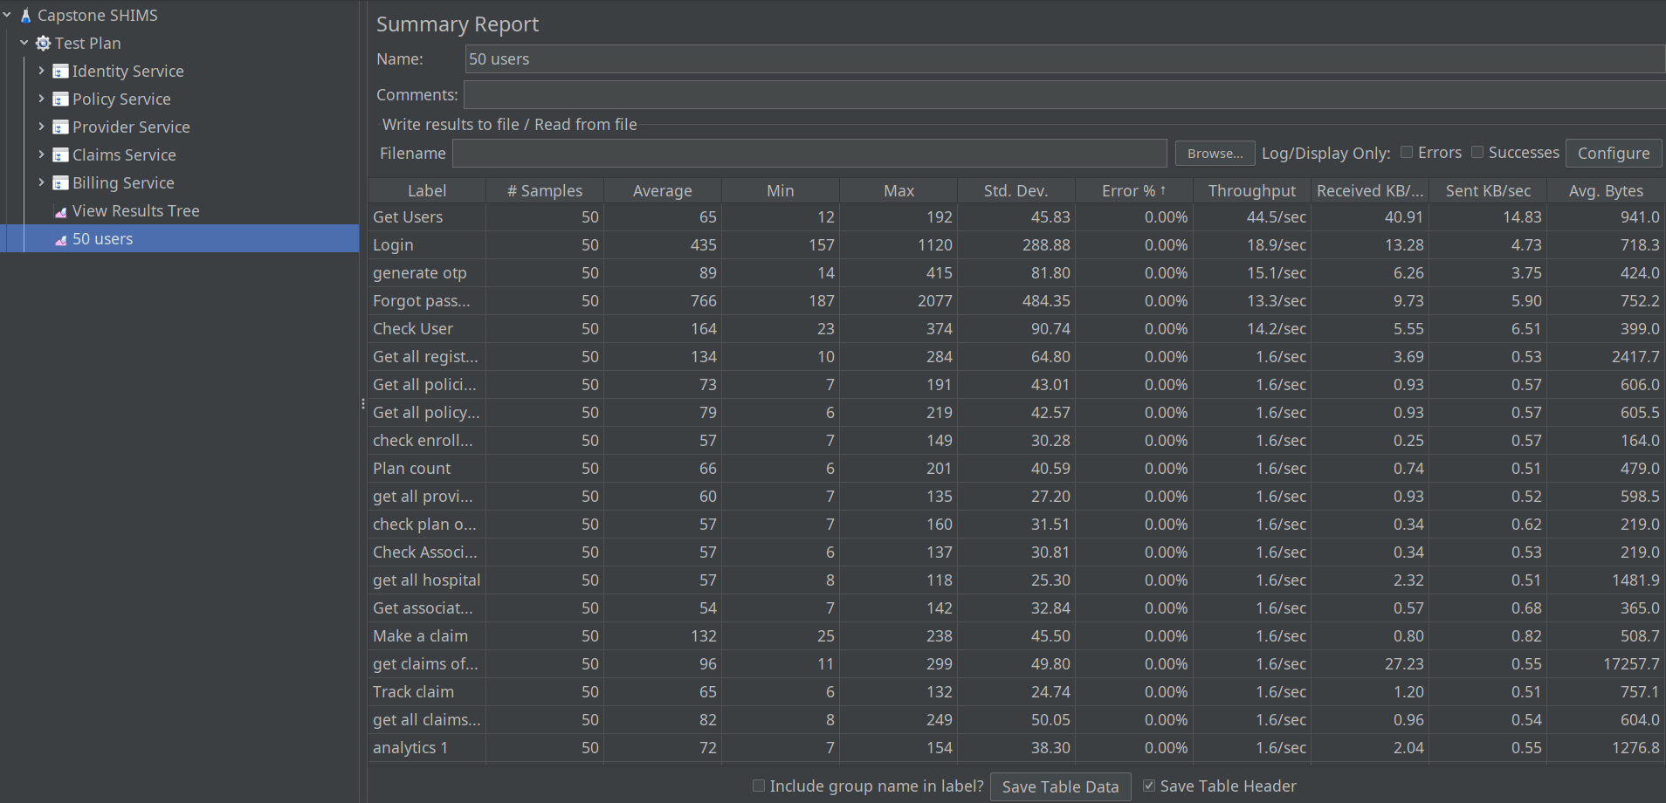
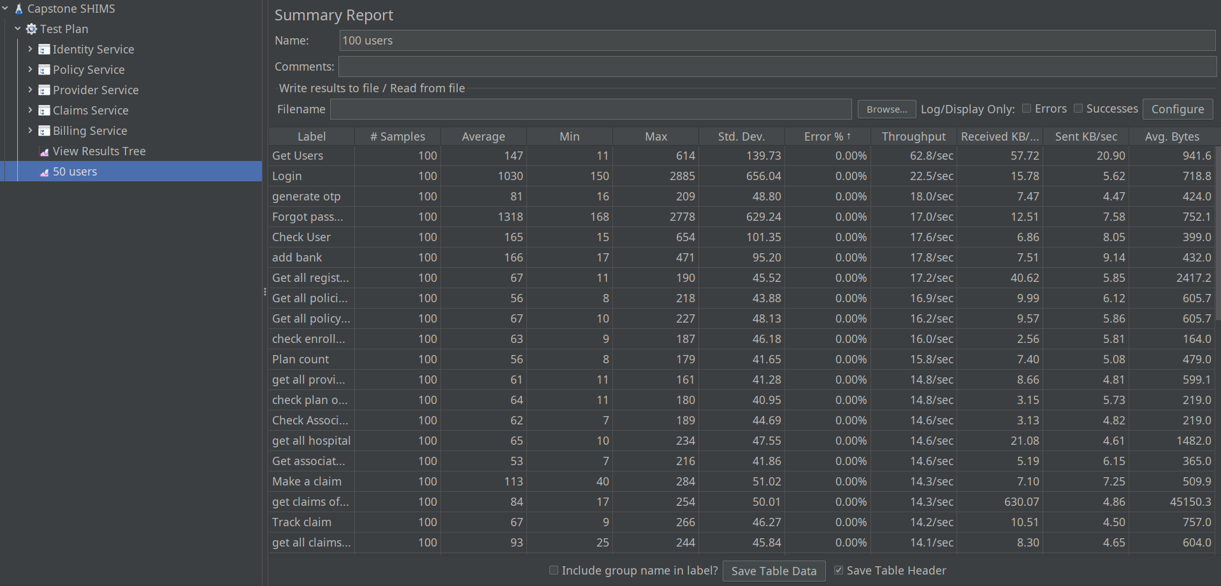
(Note: test script can be found in root folder)
Jenkins: (note: pipeline script can be found in root folder)
