Assignment 4

Newman Report:
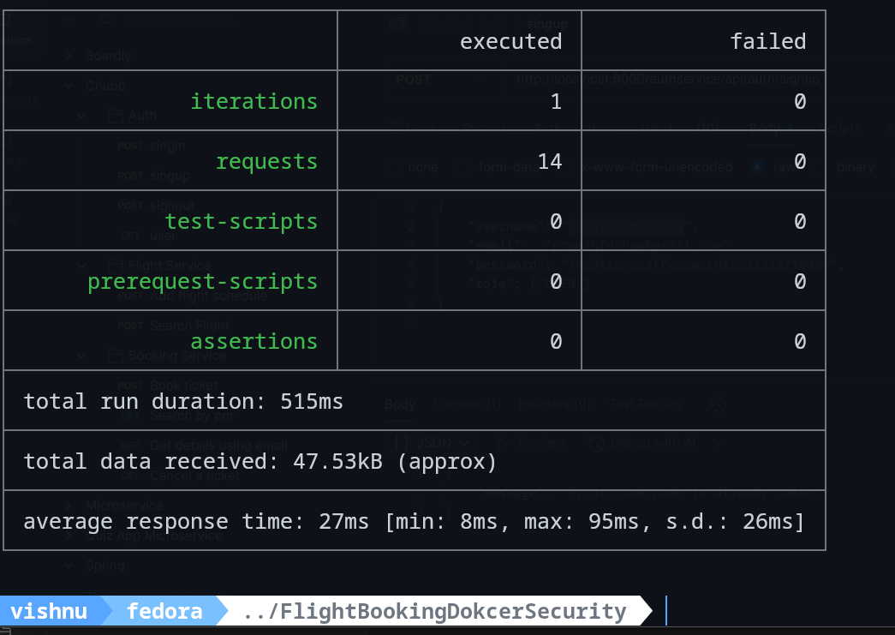

Jmeter Report: (Test plan and full report available on jmeter folder)

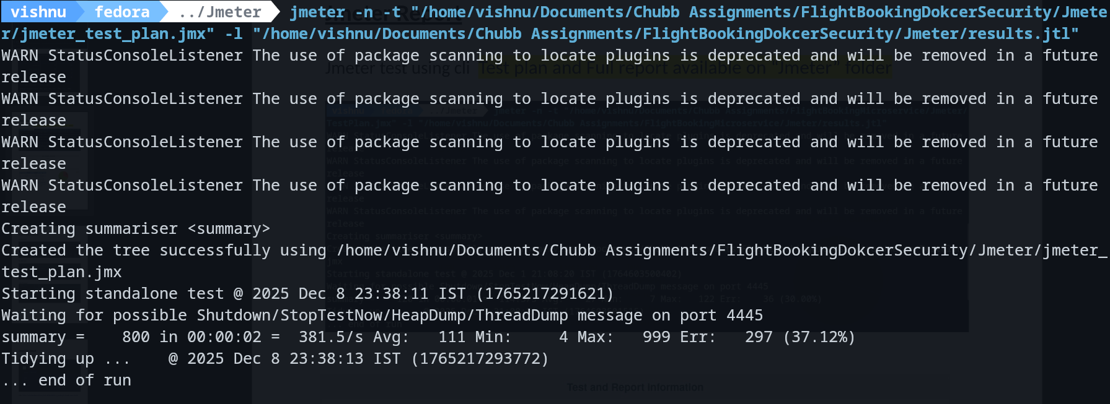
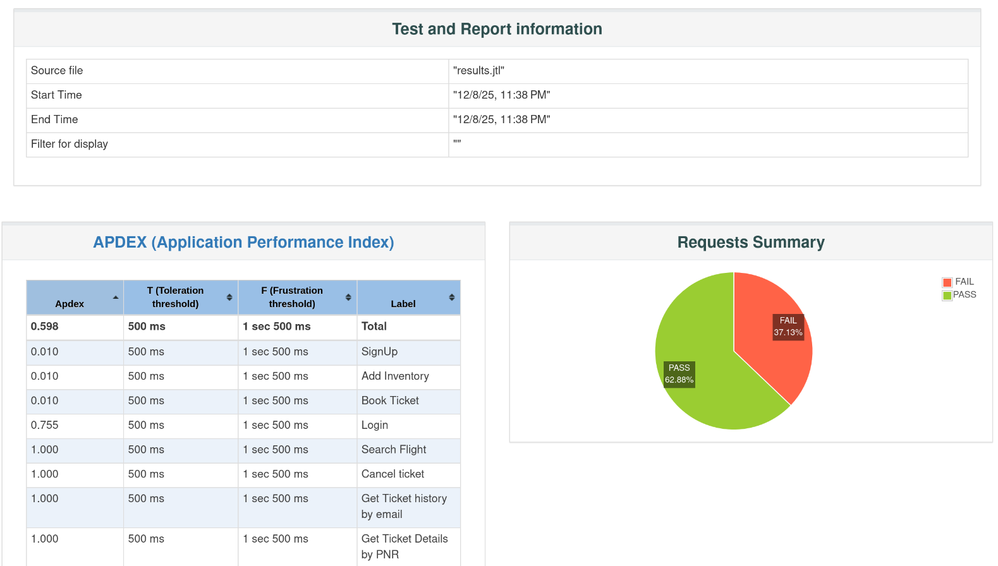
(note: failure in test is due to submission of siginin request for same email, booking same seats and adding same schedule multiple times)

20 Threads

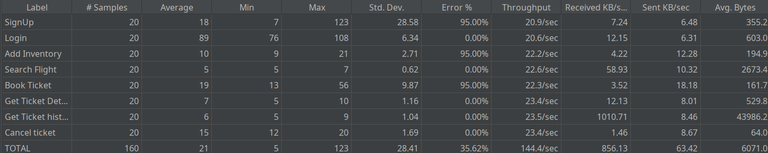
50 Threads

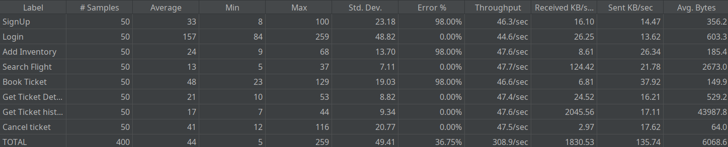
100 Threads
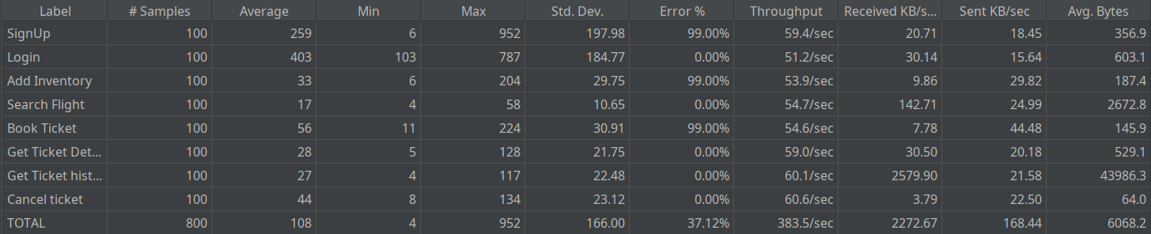
SonarQube Report:

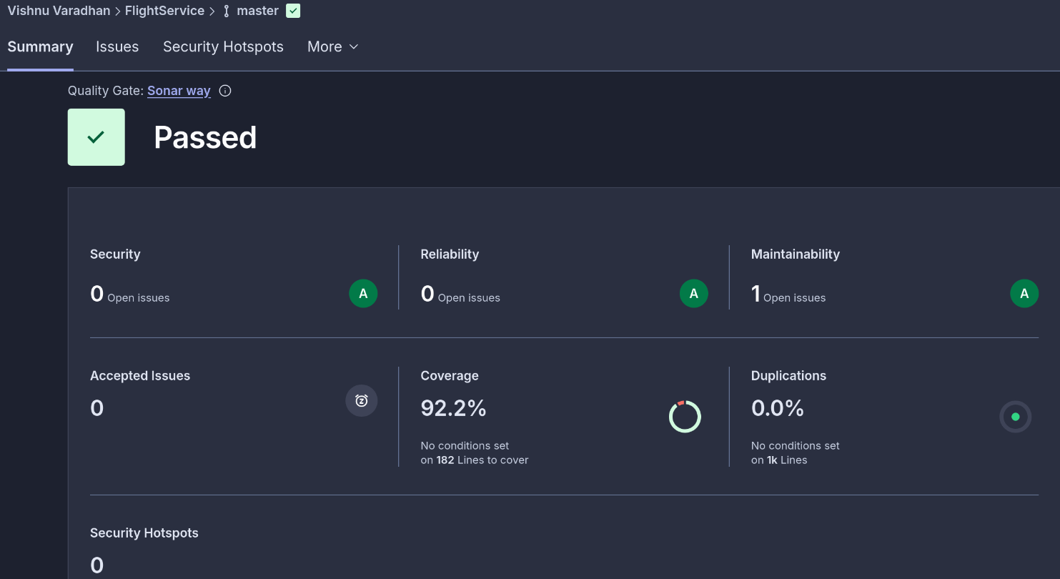
FlightService:
link =
https://sonarcloud.io/summary/overall?id=vi2hnu-1_flightservicedocker&branch=master

BookingService:
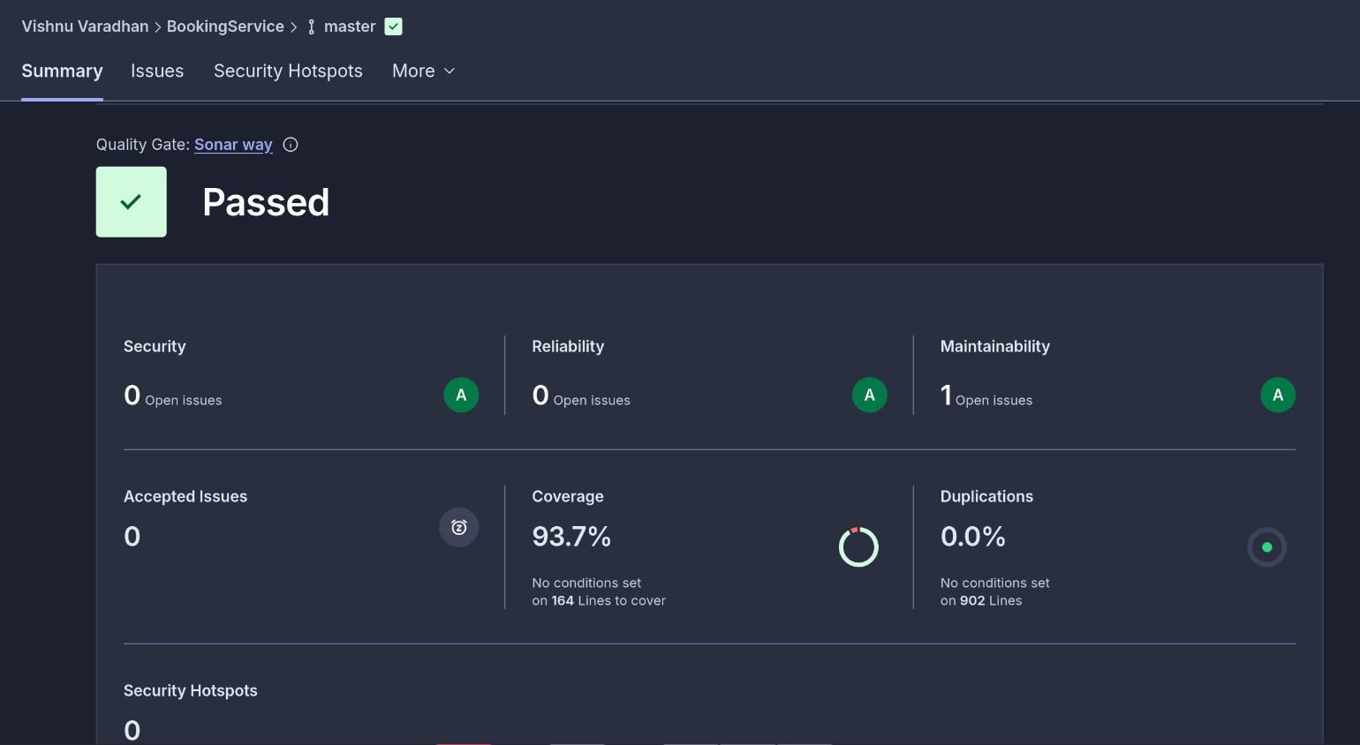
link:
https://sonarcloud.io/summary/overall?id=vi2hnu-1_bookingservicedocker&branch=master

Email Service:

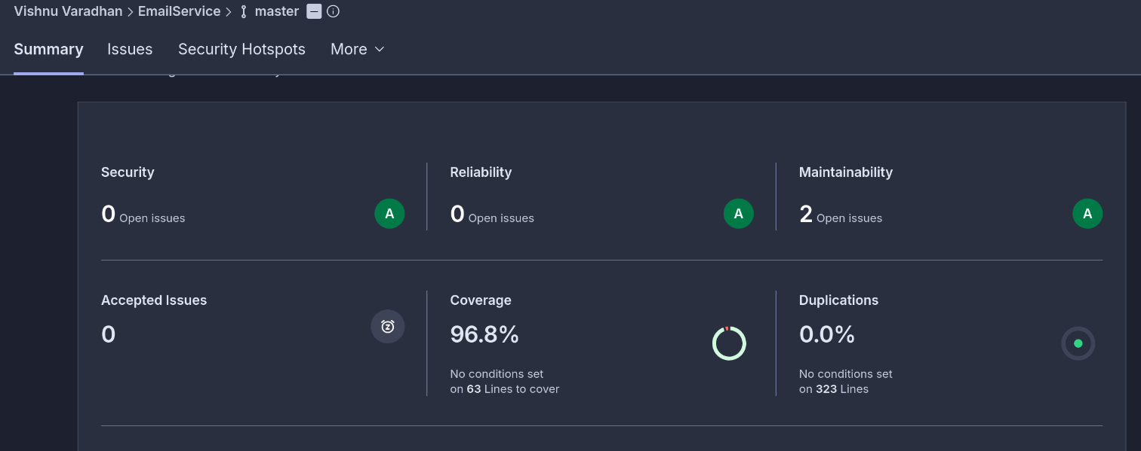
Link:
https://sonarcloud.io/summary/overall?id=vi2hnu-1_emailservicedocker&branch=master
AuthService:

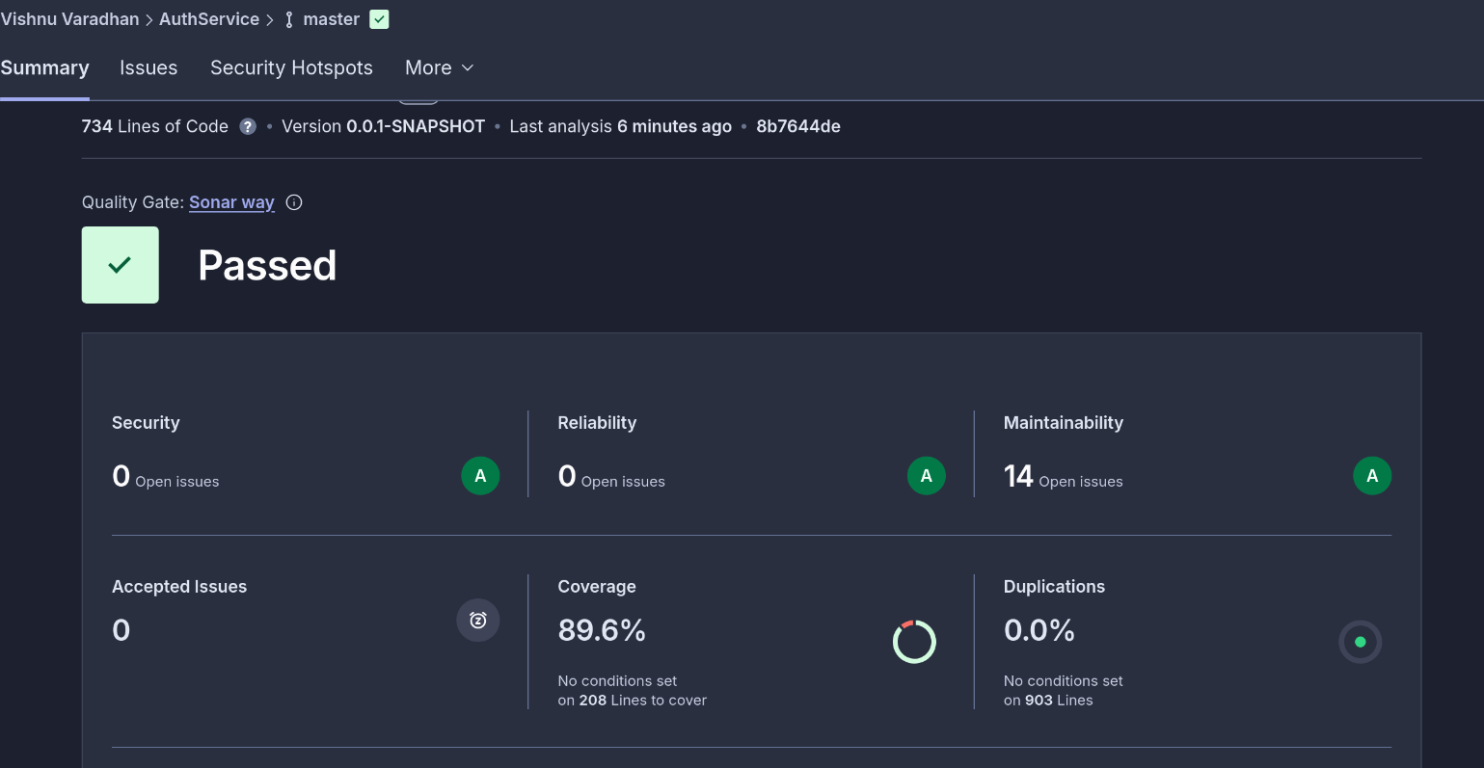
Link: https://sonarcloud.io/summary/overall?id=vi2hnu-1_authservice&branch=master

Jacoco report:

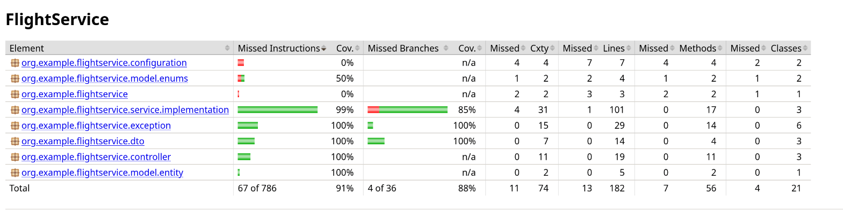
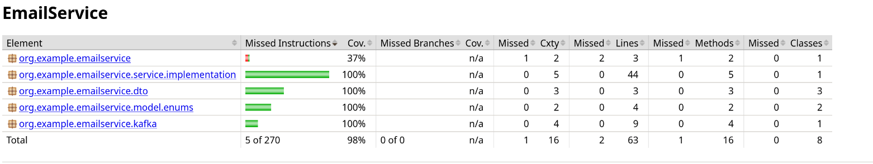
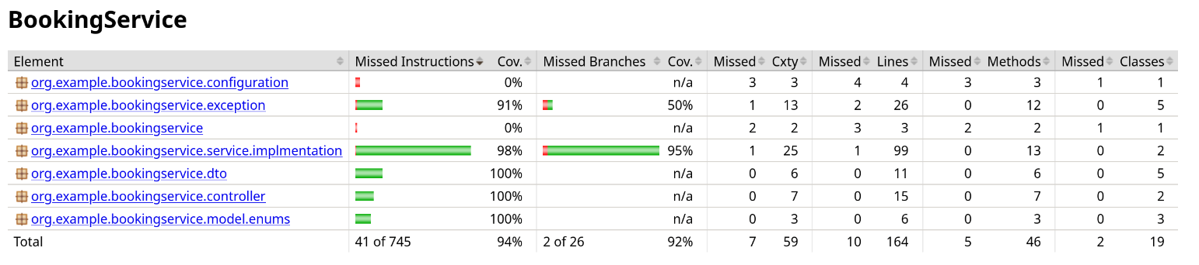
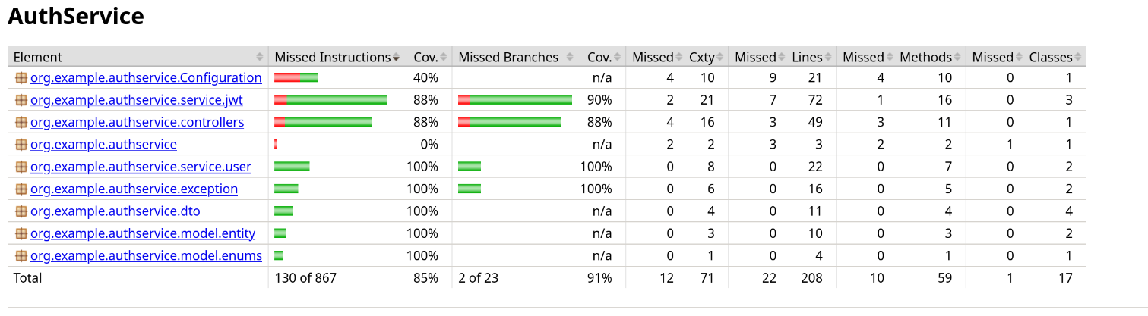
Eureka:
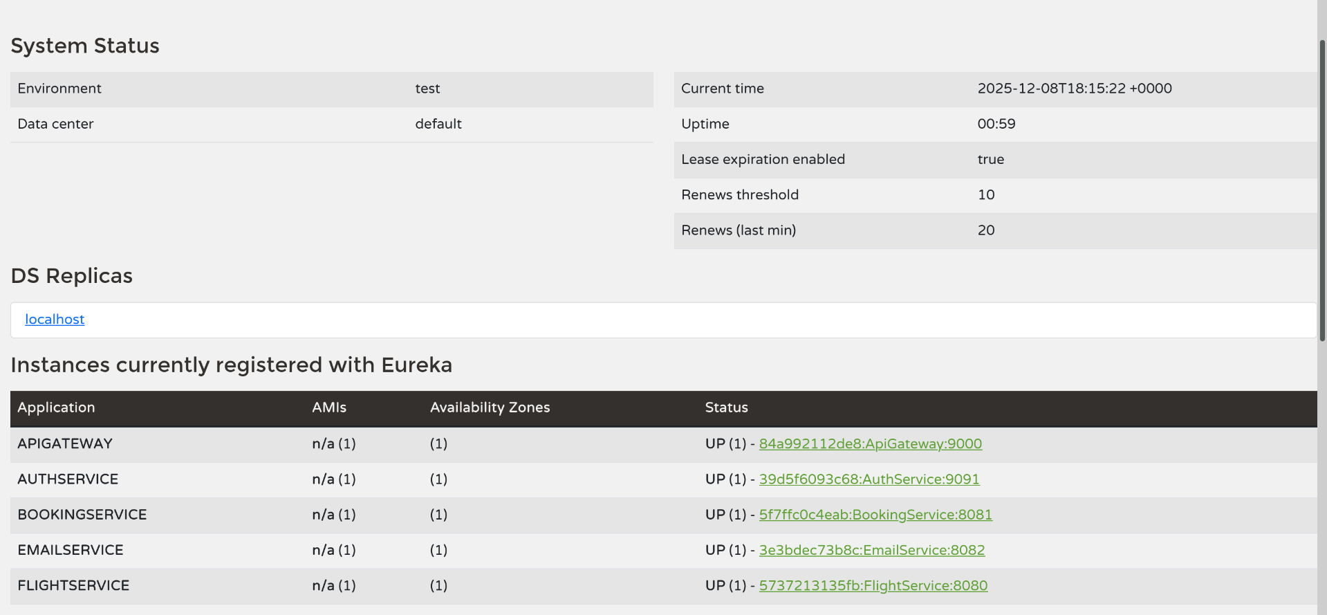
Docker:
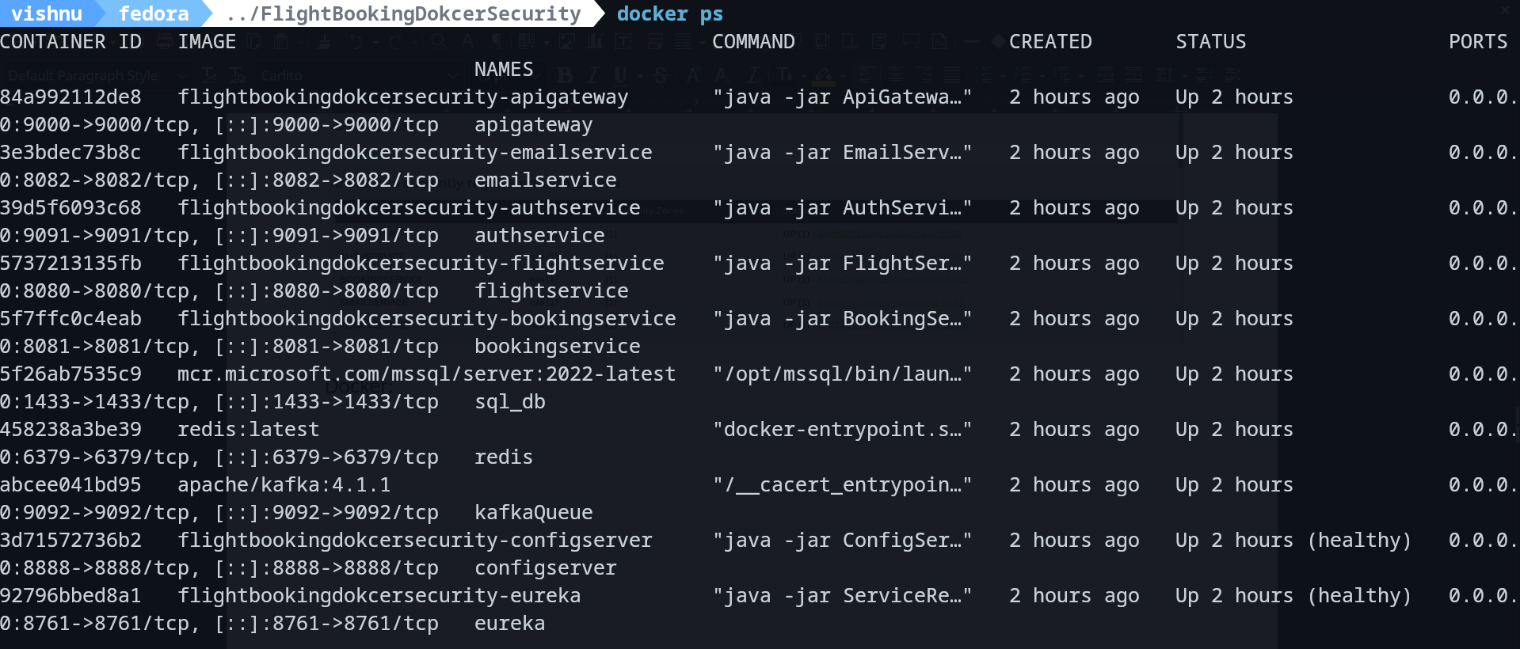
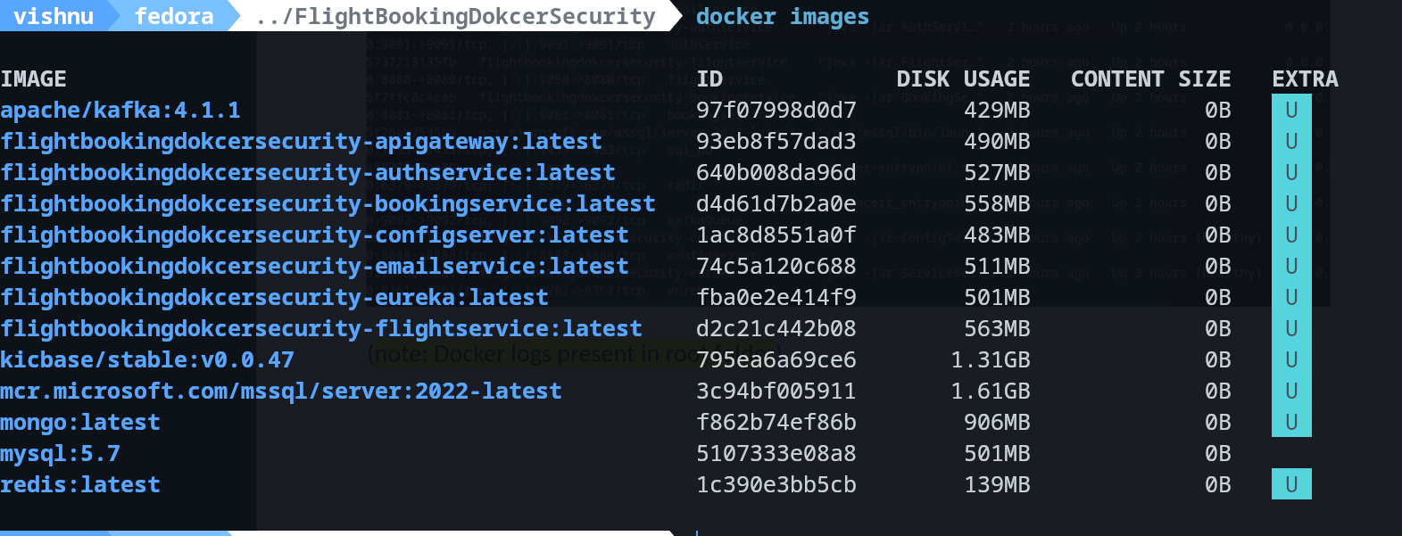

Logs:
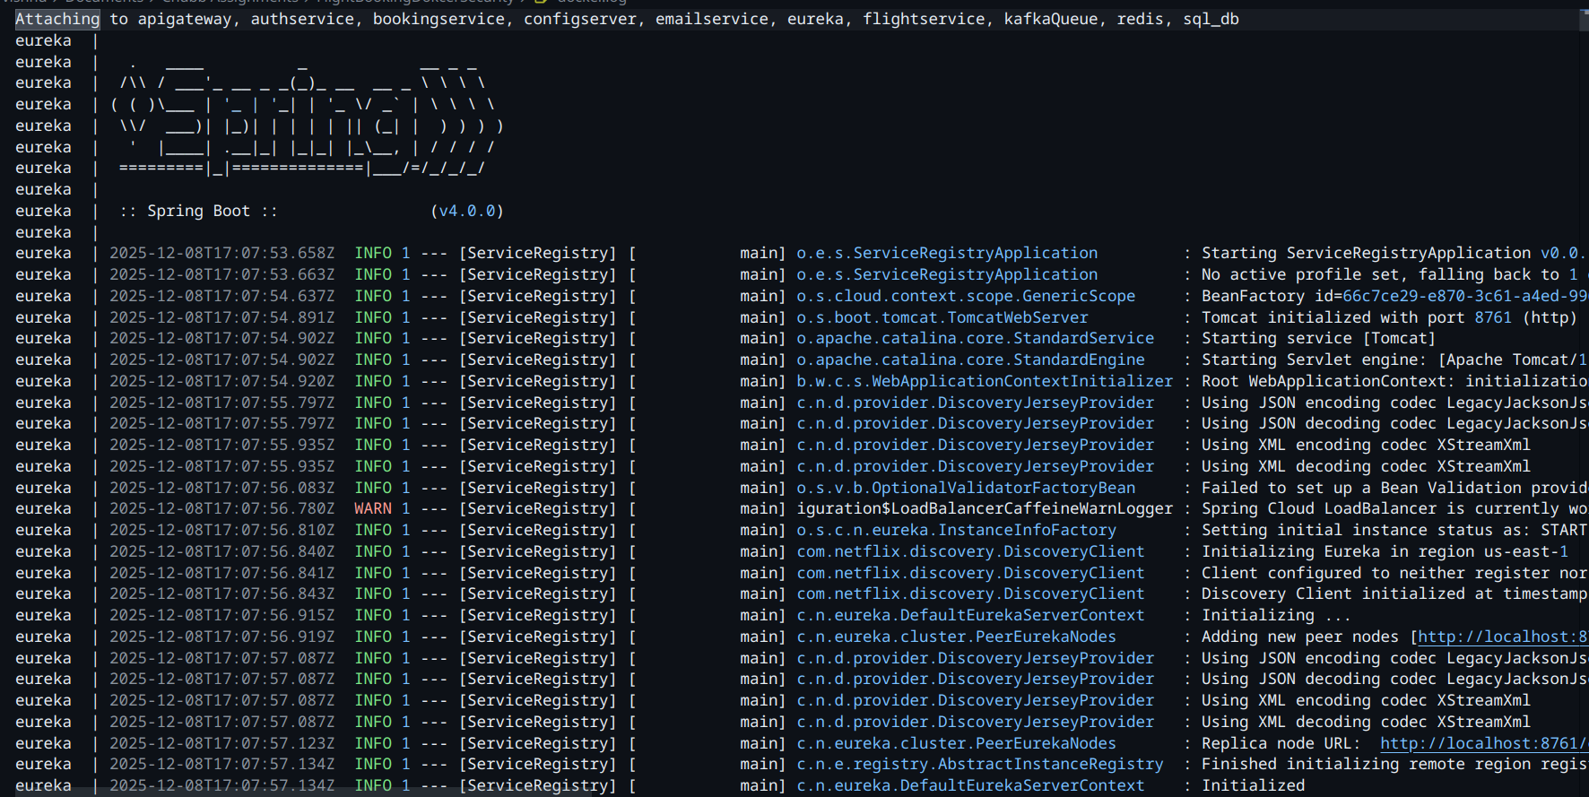

(note: Docker logs present in root folder)

Postman (Check full request body and response data at the end of this document)

1) http://localhost:9000/flightservice/api/flight/airline/inventory
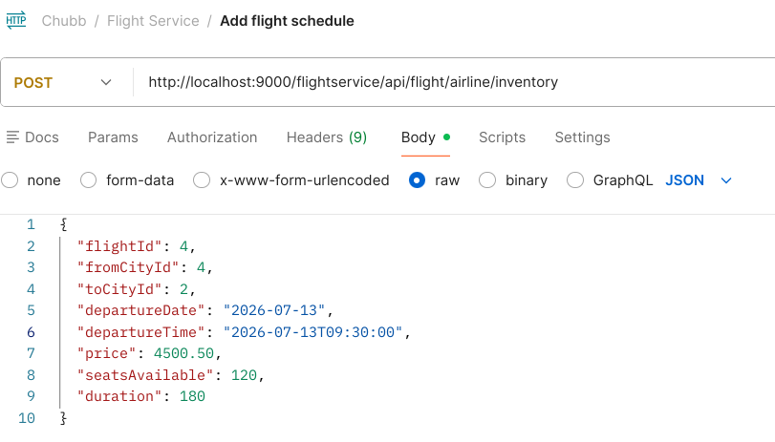
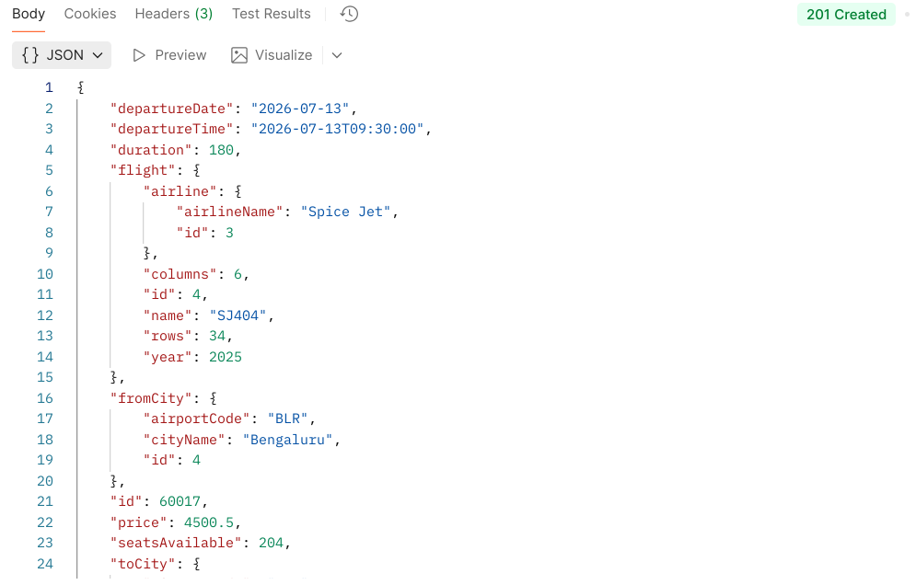
2) http://localhost:9000/flightservice/api/flight/search

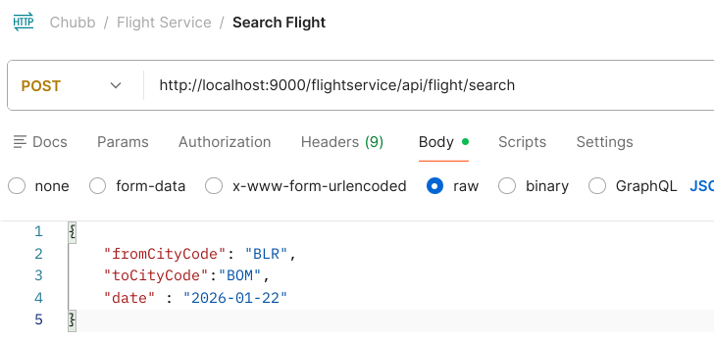
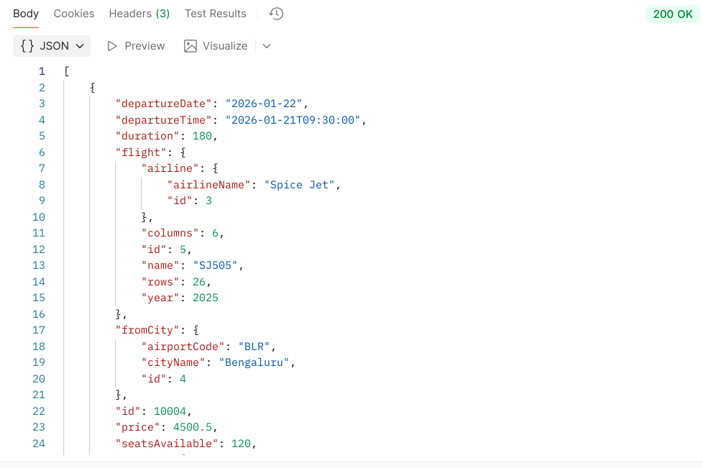
3) http://localhost:9000/bookingservice/api/flight/booking/3

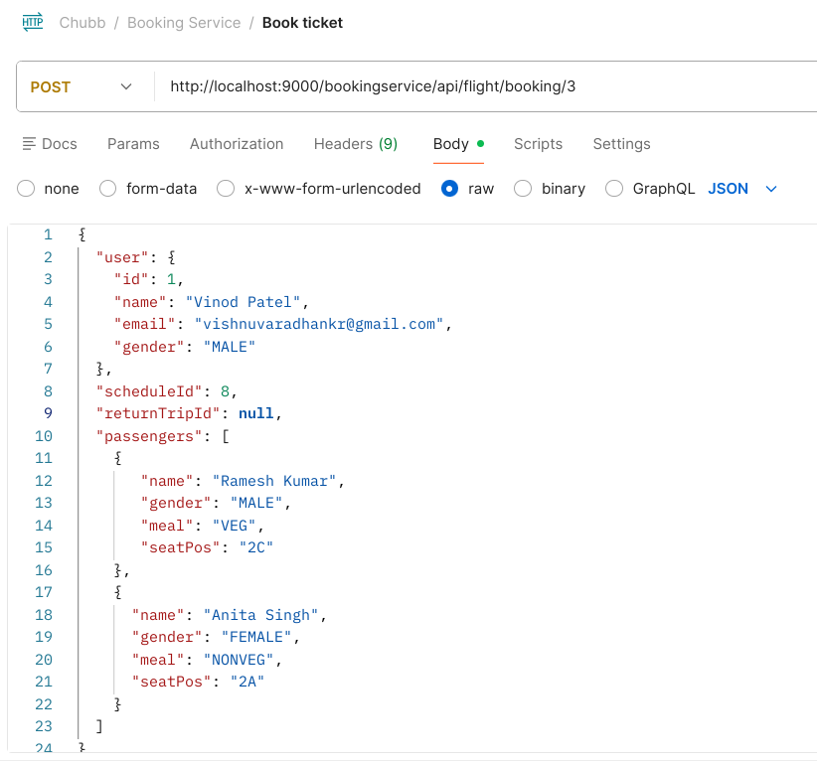
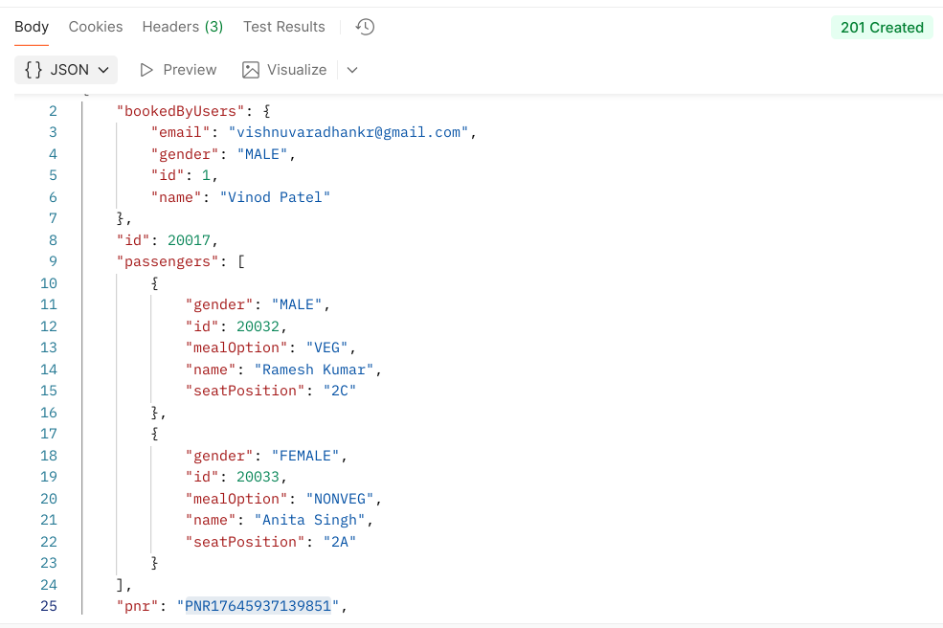
4) http://localhost:9000/bookingservice/api/flight/ticket/PNR17645920003131
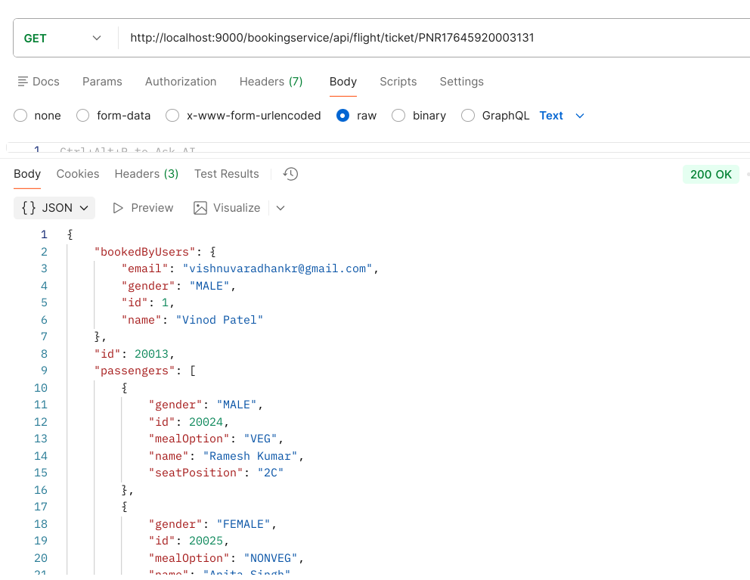
5) http://localhost:9000/bookingservice/api/flight/booking/history/vishnuvaradhankr@gmail.com

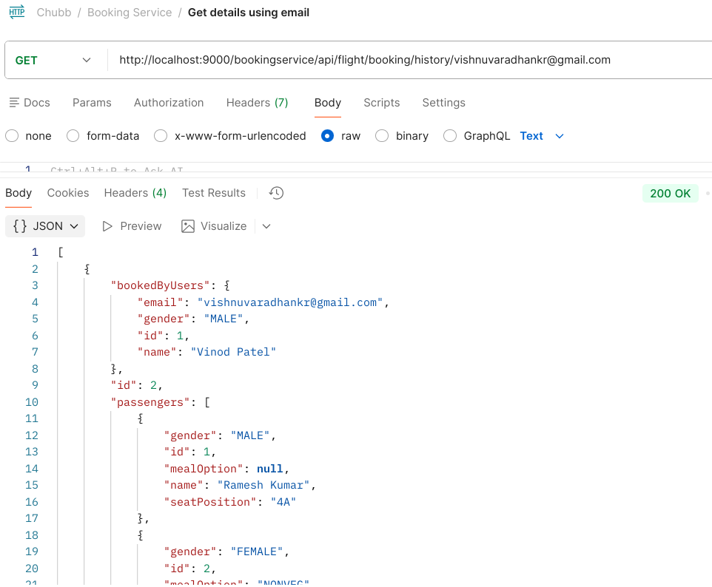
6) http://localhost:9000/bookingservice/api/flight/booking/cancel/PNR17645214757551
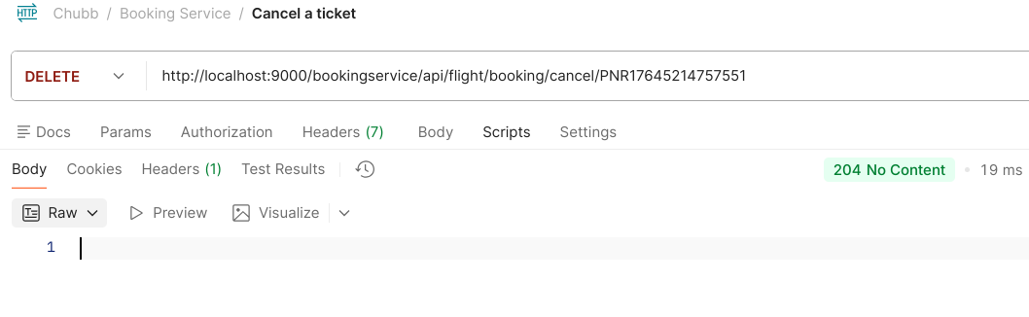
7) Signin
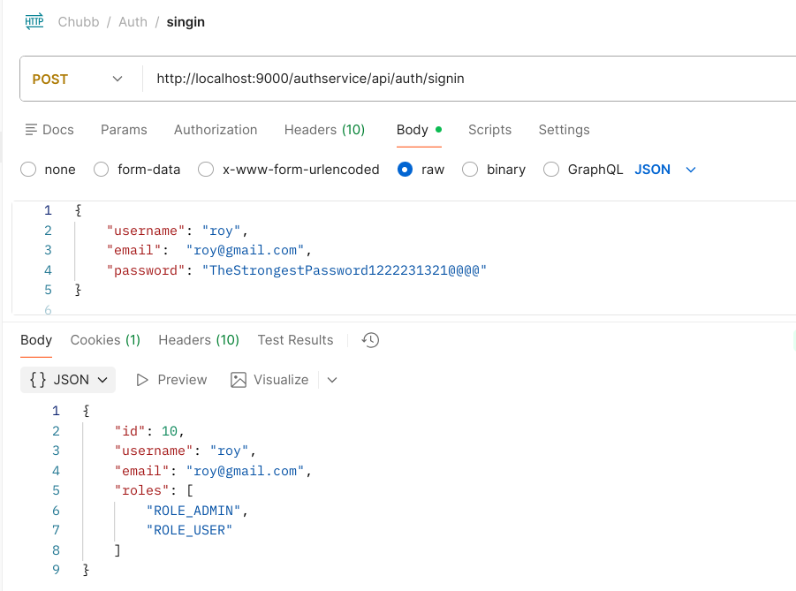
8) signup
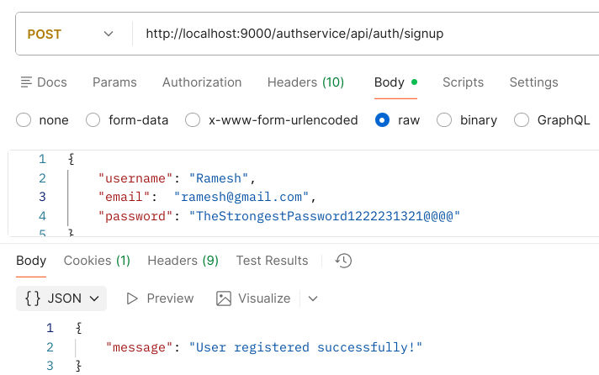
API Request body and example response:

1) http://localhost:9000/flightservice/api/flight/airline/inventory (add flight)

Request:
{
"flightId": 5,
"fromCityId": 4,
"toCityId": 2,
"departureDate": "2026-07-18",
"departureTime": "2026-07-18T09:30:00",
"price": 4500.50,
"seatsAvailable": 120,
"duration": 180
}

Response:
{
"departureDate": "2026-07-19",
"departureTime": "2026-07-19T09:30:00",
"duration": 180,
"flight": {
"airline": {
"airlineName": "Spice Jet",
"id": 3
},
"columns": 6,
"id": 5,
"name": "SJ505",
"rows": 26,
"year": 2025
},
"fromCity": {
"airportCode": "BLR",
"cityName": "Bengaluru",
"id": 4
},
"id": 70015,
"price": 4500.5,
"seatsAvailable": 156,
"toCity": {
"airportCode": "BOM",
"cityName": "Mumbai",
"id": 2
}
}

2) http://localhost:9000/flightservice/api/flight/search (Search for flight)

Request:
{
"fromCityCode": "BLR",
"toCityCode":"BOM",
"date" : "2026-01-22"
}

Response:
[
{
"departureDate": "2026-01-22",
"departureTime": "2026-01-21T09:30:00",
"duration": 180,
"flight": {
"airline": {
"airlineName": "Spice Jet",
"id": 3
},
"columns": 6,
"id": 5,
"name": "SJ505",
"rows": 26,
"year": 2025
},
"fromCity": {
"airportCode": "BLR",
"cityName": "Bengaluru",
"id": 4
},
"id": 10004,
"price": 4500.5,
"seatsAvailable": 120,
"toCity": {
"airportCode": "BOM",
"cityName": "Mumbai",
"id": 2
}
}
]

3) http://localhost:9000/bookingservice/api/flight/booking/3 (book ticket)
Request:
{
"user": {
"id": 1,
"name": "Vinod Patel",
"email": "vishnuvaradhankr@gmail.com",
"gender": "MALE"
},
"scheduleId": 10,
"returnTripId": null,
"passengers": [
{
"name": "Ramesh Kumar",
"gender": "MALE",
"meal": "VEG",
"seatPos": "13C"
}
]
}

Response:
{
"bookedByUsers": {
"email": "vishnuvaradhankr@gmail.com",
"gender": "MALE",
"id": 1,
"name": "Vinod Patel"
},
"id": 30023,
"passengers": [
{
"gender": "MALE",
"id": 30004,
"mealOption": "VEG",
"name": "Ramesh Kumar",
"seatPosition": "13C"
}
],
"pnr": "PNR17646382318681",
"returnTripScheduleId": null,
"scheduleId": 10,
"status": "BOOKED"
}

4) http://localhost:9000/bookingservice/api/flight/ticket/PNR17645920003131 (search using pnr)

Response:
{
"bookedByUsers": {
"email": "vishnuvaradhankr@gmail.com",
"gender": "MALE",
"id": 1,
"name": "Vinod Patel"
},
"id": 30023,
"passengers": [
{
"gender": "MALE",
"id": 30004,
"mealOption": "VEG",
"name": "Ramesh Kumar",
"seatPosition": "13C"
}
],
"pnr": "PNR17646382318681",
"returnTripScheduleId": null,
"scheduleId": 10,
"status": "BOOKED"
}

5) http://localhost:9000/bookingservice/api/flight/booking/history/vishnuvaradhankr@gmail.com
( Search history using email)

Response:
[{
"bookedByUsers": {
"email": "vishnuvaradhankr@gmail.com",
"gender": "MALE",
"id": 1,
"name": "Vinod Patel"},
"id": 2,
"passengers": [
{"gender": "FEMALE",
"id": 2,
"mealOption": "NONVEG",
"name": "Anita Singh",
"seatPosition": "5B"
}
],
"pnr": "PNR17643280656201",
"returnTripScheduleId": null,
"scheduleId": 1,
"status": "CANCELED"
},
{
"bookedByUsers": {
"email": "vishnuvaradhankr@gmail.com",
"gender": "MALE",
"id": 1,
"name": "Vinod Patel"
},
"id": 4,
"passengers": [
{
"gender": "MALE",
"id": 3,
"mealOption": null,
"name": "Ramesh Kumar",
"seatPosition": null
}],
"pnr": "PNR17643286947351",
"returnTripScheduleId": null,
"scheduleId": 2,
"status": "BOOKED"
}
]
6) http://localhost:9000/bookingservice/api/flight/booking/cancel/PNR17646373940441
(cancellation of ticket)

Response: 204 No content

