Flight Booking Frontend Report

SonarQube report:

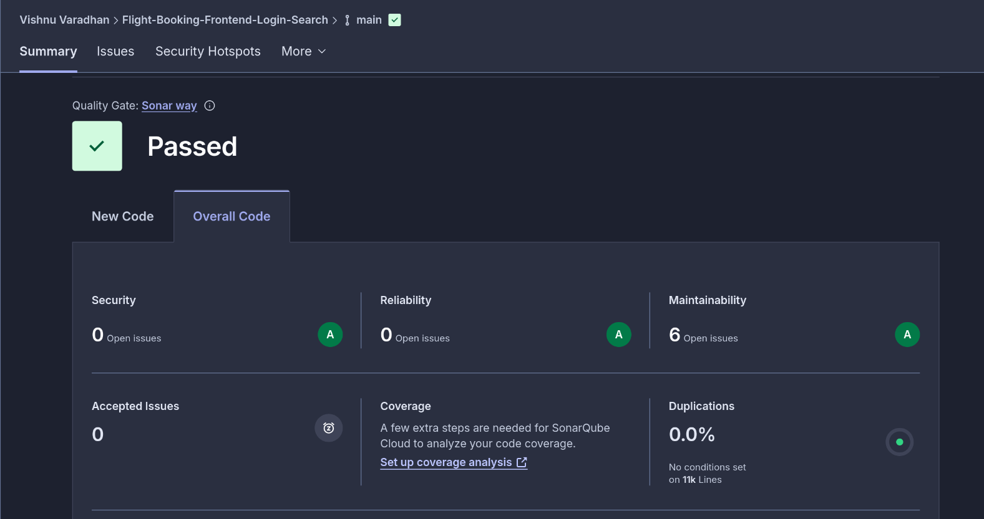
Link: https://sonarcloud.io/summary/overall?id=vi2hnu_Flight-Booking-Frontend-Login-Search&branch=main

Login Page:
on load:
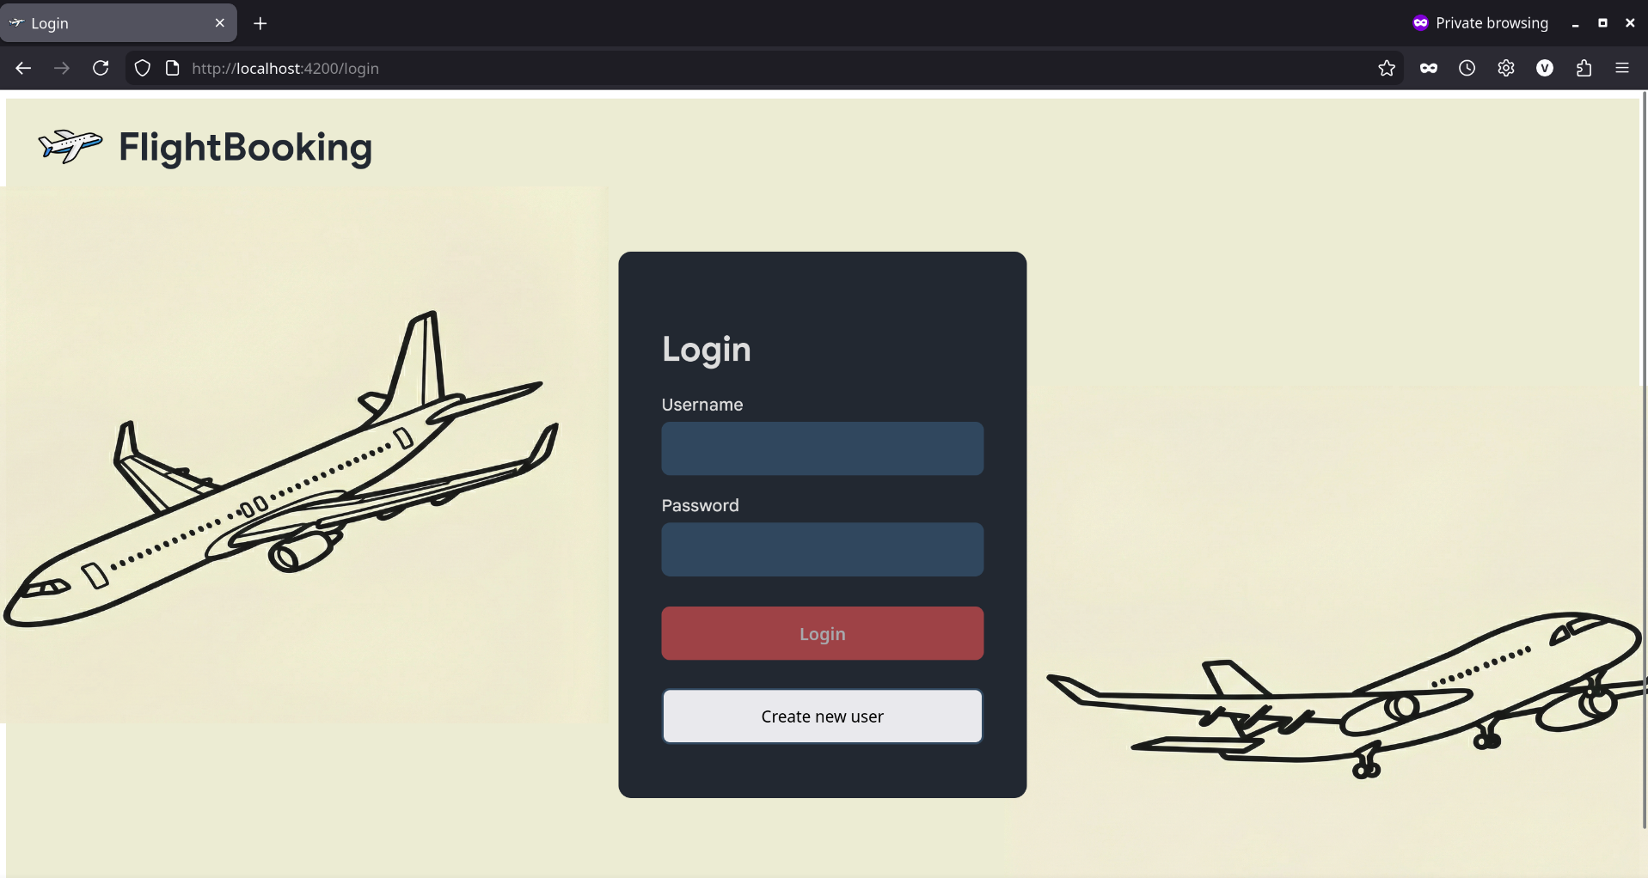
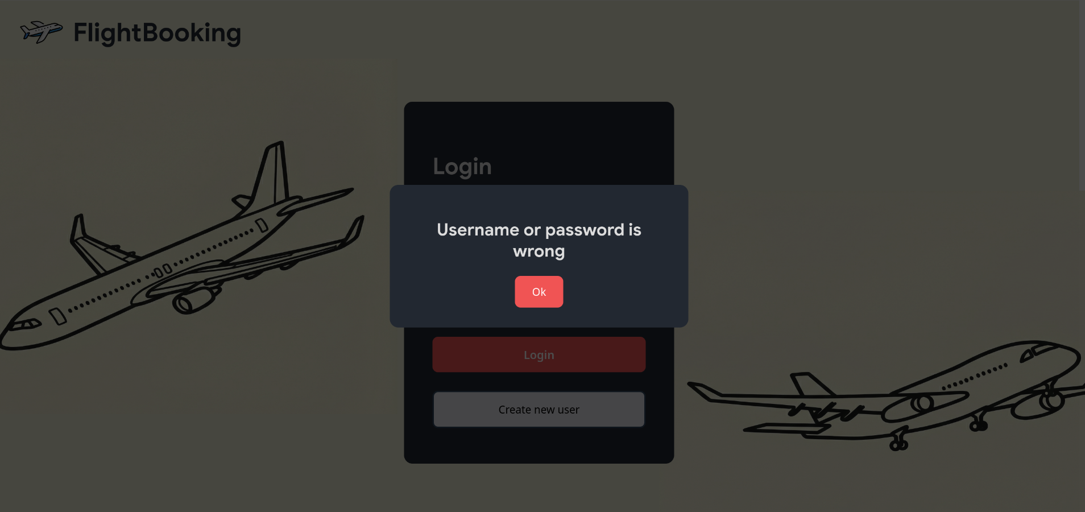
on entering wrong password or username
Sign Up
on load:
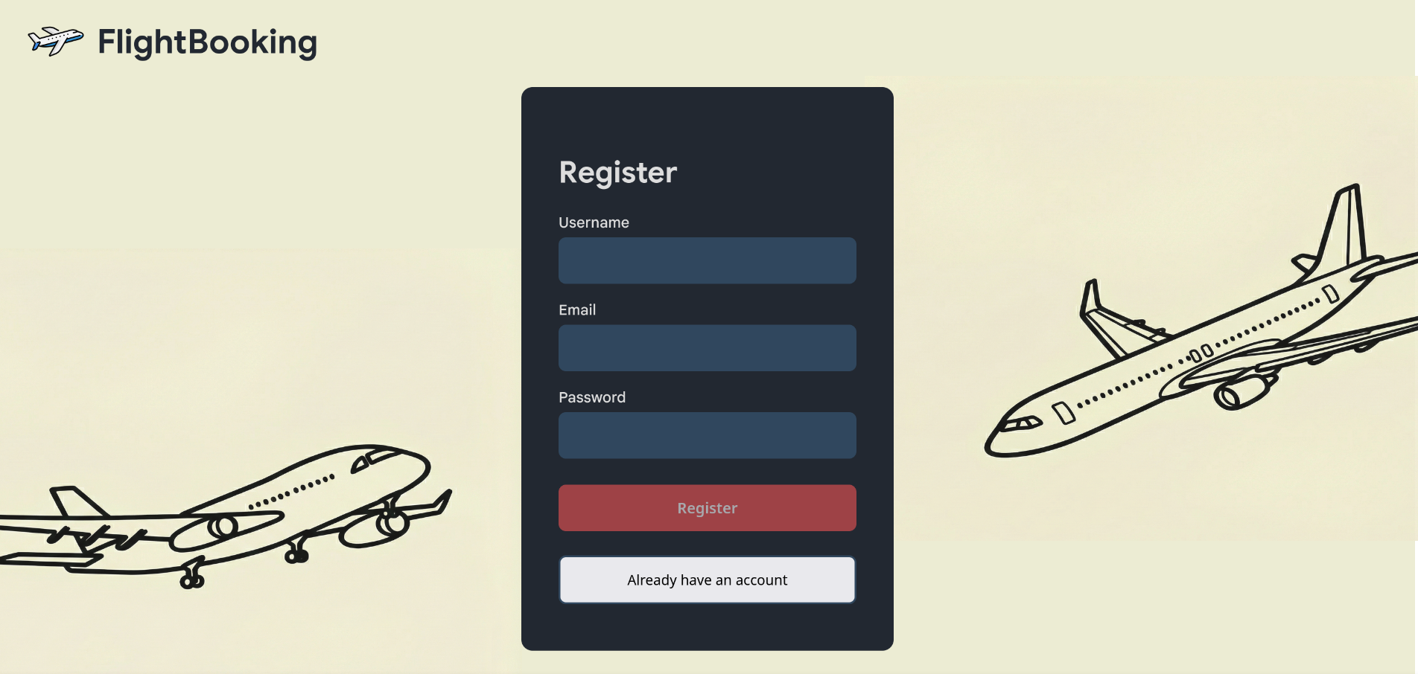
On entering invalid email or password:
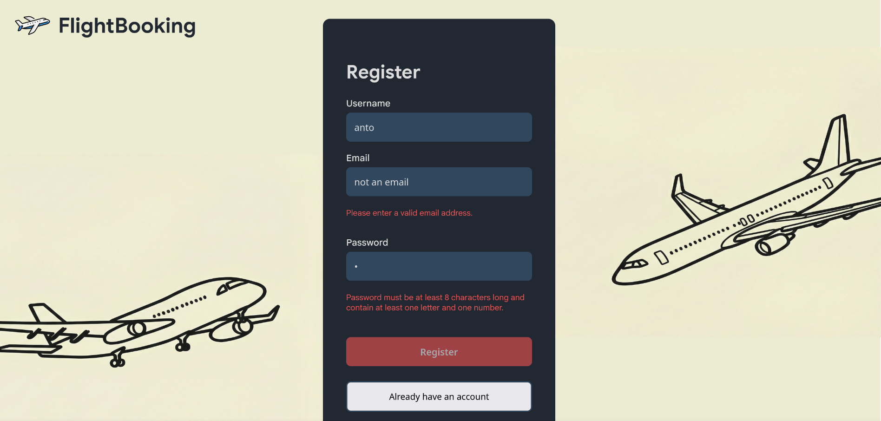

On entering already existing username or email
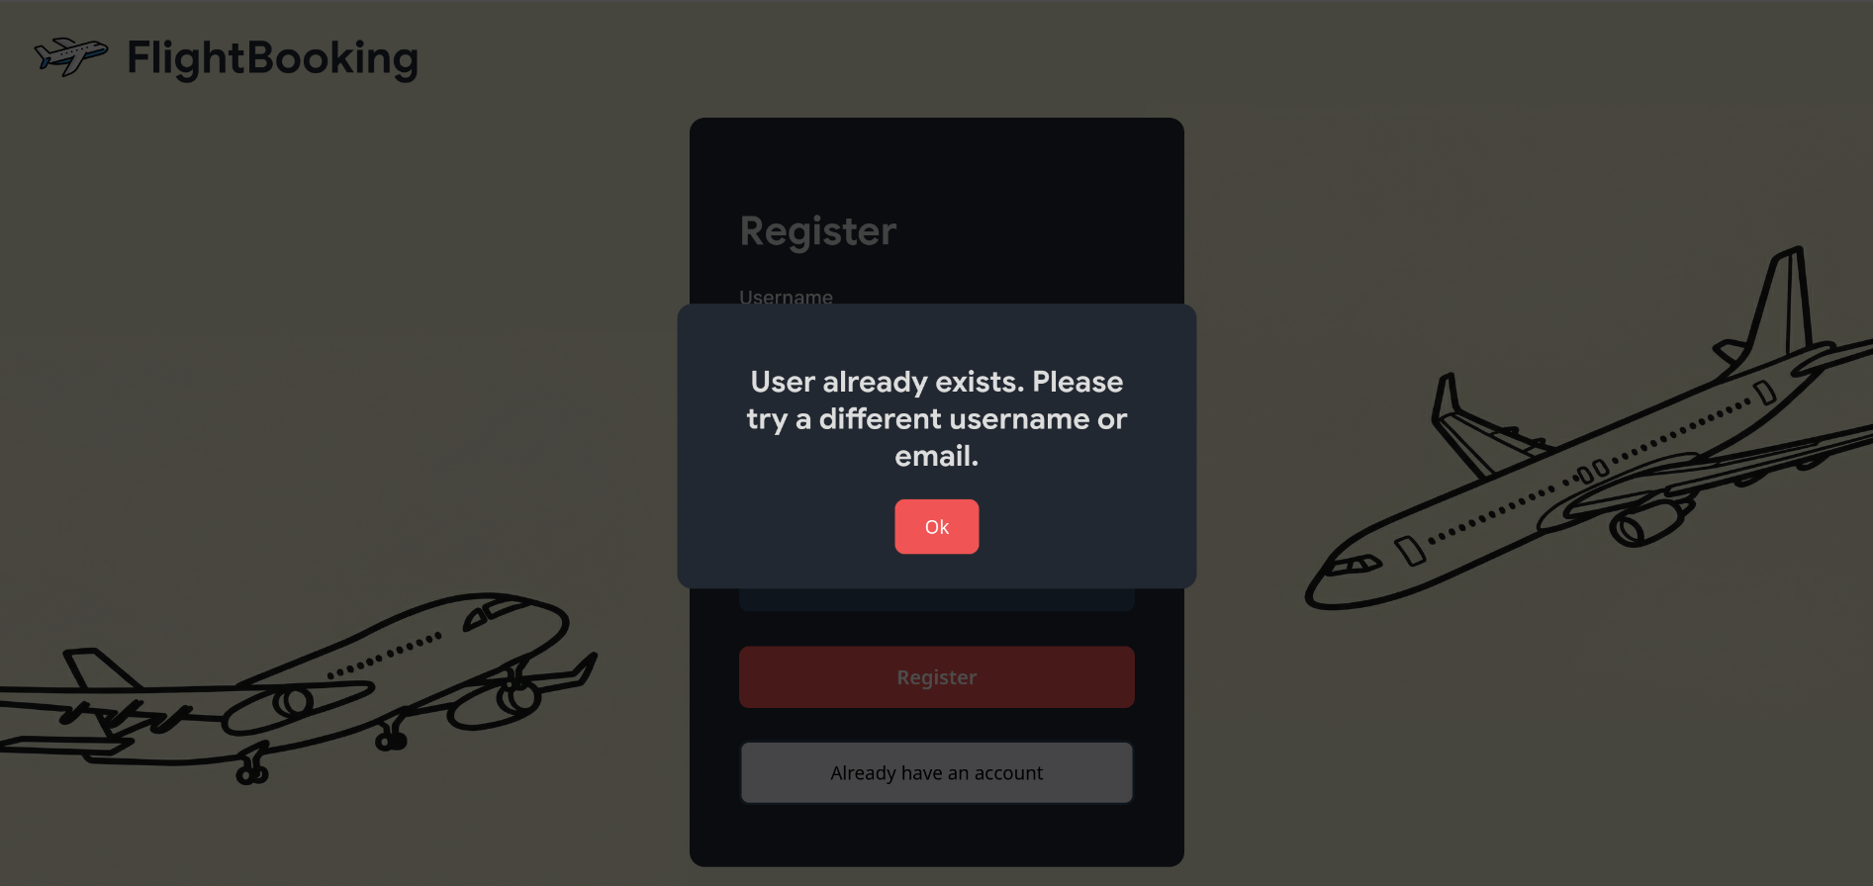
On success:
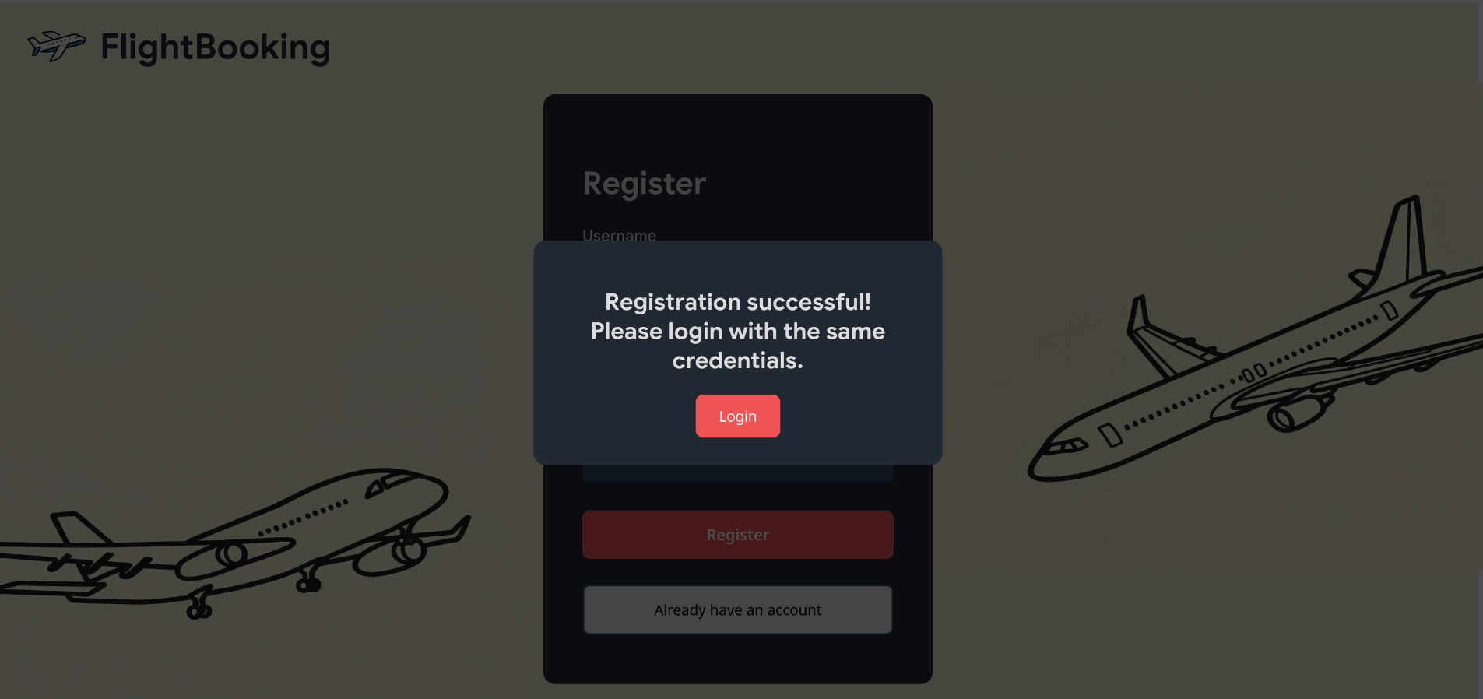
Search page:
On load:
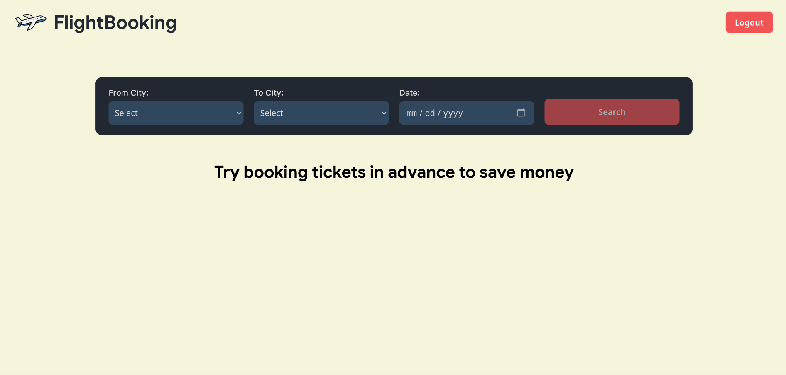
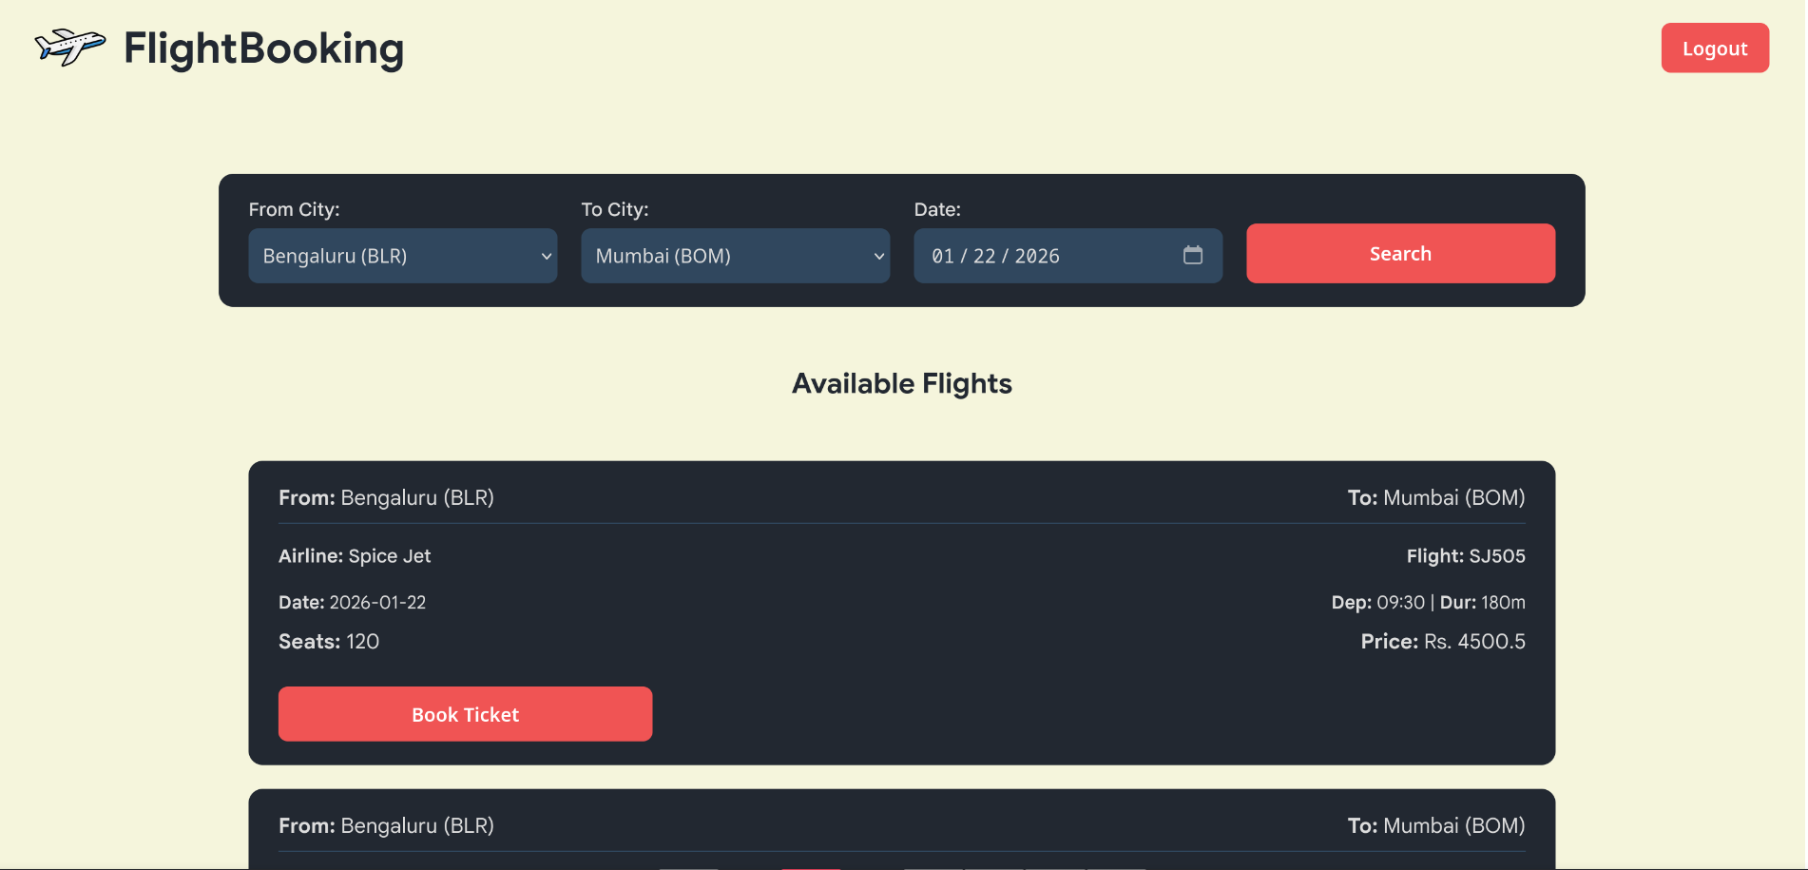
On success:
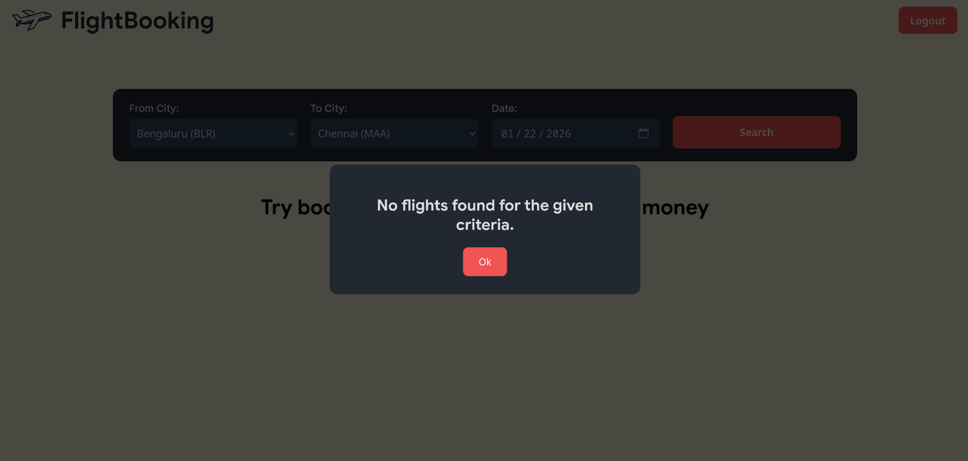
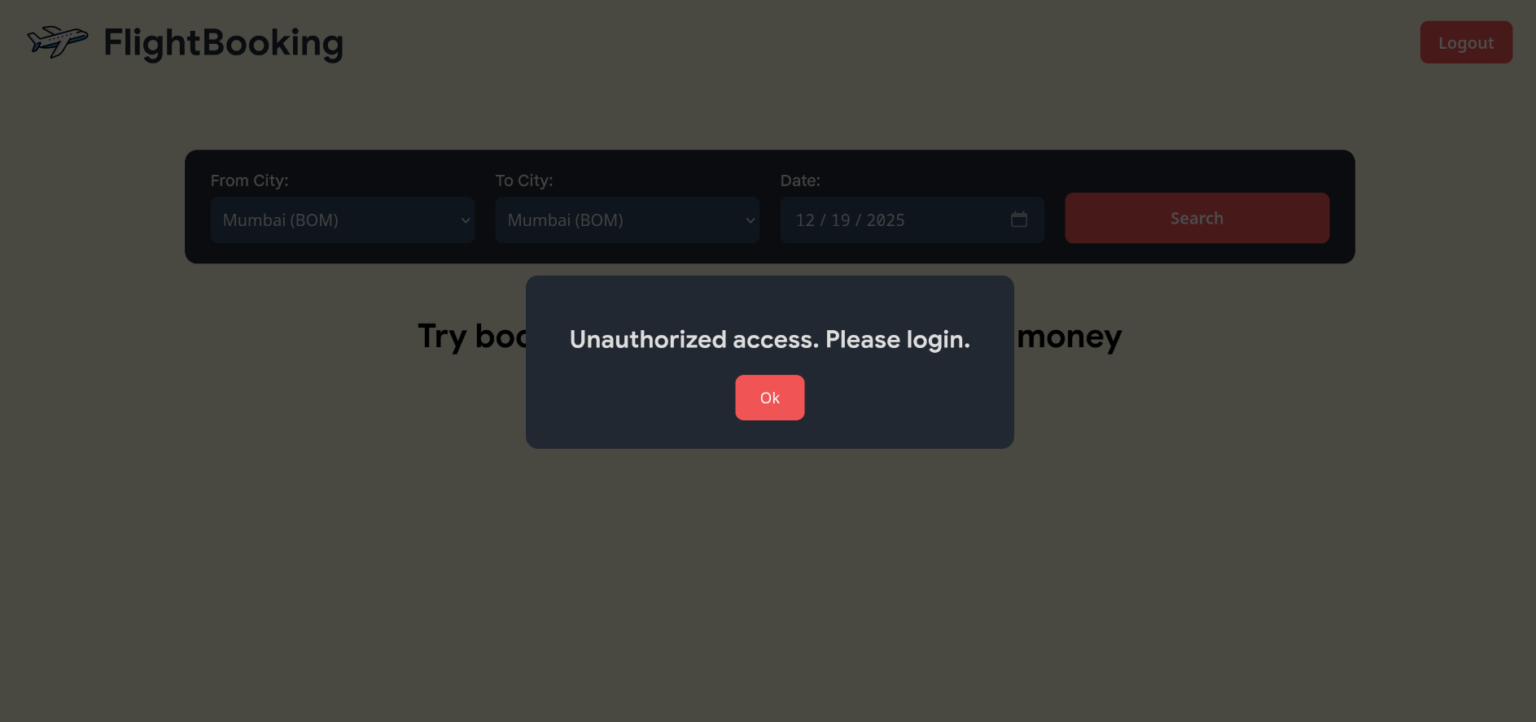
When no flight is scheduled between 2 cities on a particular day:
When unauthorized user tries to access search page:
Footer:

