Flight Booking Application Performance Report

SonarQube Report for CURRENT PROJECT (22.11.2025):

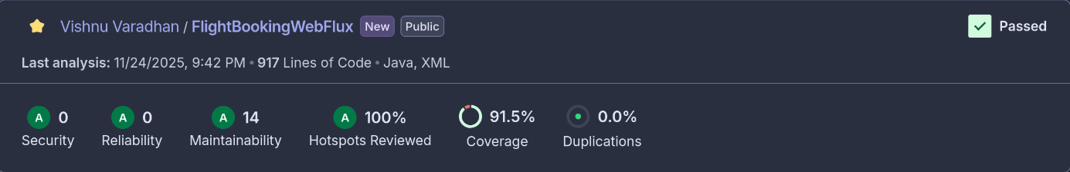
SonarQube Report for PREVIOUS PROJECT(15.11.2025):

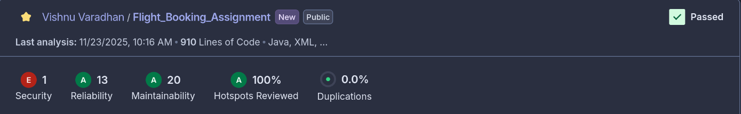

JaCoCo Report:

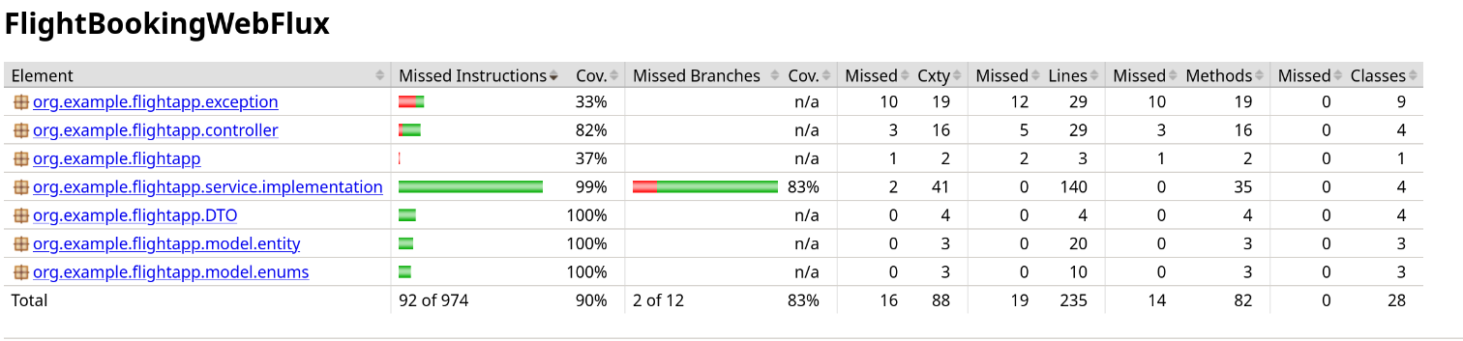

Jmeter Testing:
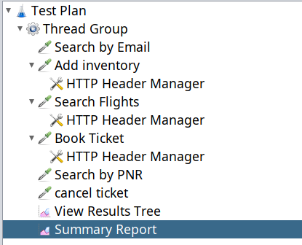

1) 20 request
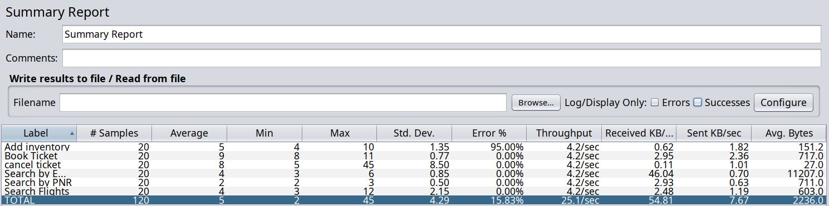

2) 50 Request

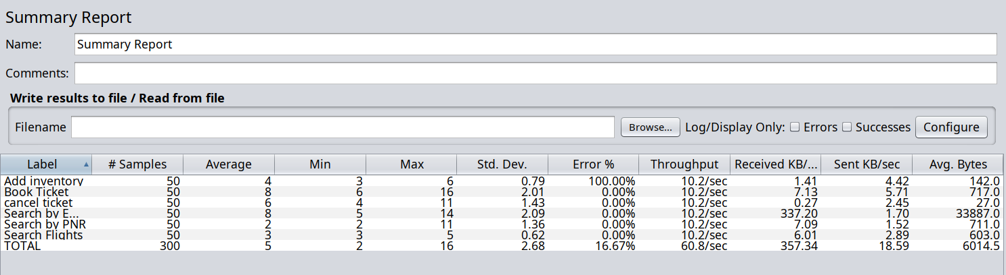

3) 100 Request

