Assignment: GitHub Assignment Date:- 10/31/2018

Q1 ) What is GitHub? When was it created? Why? By who? What similar platforms exist? Why would you use such a platform? (Answer between 5 and 10 lines)

Ans GitHub is a web based hosting service and we can create projects in GitHub and we can keep a track of projects suppose in a company we have testers developers and team. So GitHub will keep a track who edited code last. GitHub will provide access control and several collaboration features such as bug tracking, feature request, management of tasks, and wiki for having description for every project. It was created on February 8 , 2008. This was created to keep a track on every minute thing in software project this was created by Tom Werner, Chris Wanstrath, P.J Hyett and Scott Chacon. We have similar alternatives like Gitlab, BitBucket, Beanstalk, Launchpad, etc. Basicall GitHub is more easy to use as it is used by huge software companies.

Q2 ) Define the following terms in the context of Git (2 lines maximum):

Ans: Repository: It is a unique name given to the project. Suppose if it is my first sms project so I will create new repository and save name as myfirstsms project.

Commit: commit saves the snapshot to the project history and saves the change-tracking process. In short, a commit functions like taking a photo as we save a photo in gallery. Anything that’s been linked with git add will become a part of the snapshot with git commit.

Push: It updates the remote repository when we make any commit locally.

Branch: It will show branch when we work locally.

Fork: It will create a copy of a project under developer account.

Merge: It merges lines when we develop project. This is used to combine changes. We can merge two codes.

Clone: It creates a local copy of a project that already exists remotely. The clone includes all the project’s files, history, and branches.

Pull: pull will updates the local line of development with updates from its remote counterpart. Developers use this command if a teammate has made commits.

Pull request: This is basically permission to add our project to someone’s project.

Part 4:

Step 1: Initialise the git account



Step 2: Clone the file

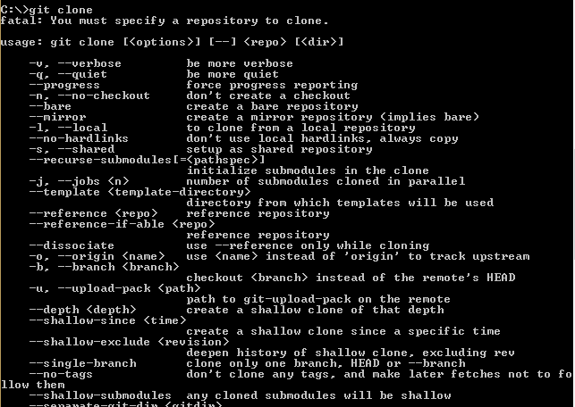

Step 3: adding git by using gitadd

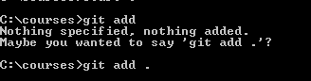

Step 4:

Commit using git commit



Step 5:

Git push using push request

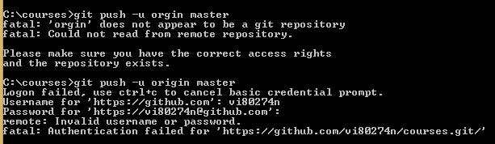

Step 6:

Pushing into origin master

