Integrated Geospatial AI Agent Framework for Precision Agriculture Decision Support System
A Project Report Submitted for
Machine Learning For Predictive Analytics
(Course Code: CUML-1021)

Submitted by:
NIKHIL KUMAR (Reg. No. 230301120475)
Under the Supervision of:
Mrs. Das Ananya
Assoc. Professor, Dept. of CSE, SoET
DEPARTMENT OF COMPUTER SCIENCE AND ENGINEERING
SCHOOL OF ENGINEERING AND TECHNOLOGY
BHUBANESWAR CAMPUS
CENTURION UNIVERSITY OF TECHNOLOGY AND MANAGEMENT
ODISHA
JULY 2025 / NOVEMBER 2025

DEPARTMENT OF COMPUTER
SCIENCE AND ENGINEERING
SCHOOL OF ENGINEERING AND TECHNOLOGY
BHUBANESW AR CAMPUS
BONAFIDE CERTIFICATE
Certified that this project report ” Integrated Geospatial AI Agent Framework
for precision Agriculture Decision Support System” is the bonafide work of “ All
The Members ” who carried out the project work under my supervision. This
is to certify that this project has not been carried out earlier in this institute
and the university to the best of my knowledge.
Assoc. Professor, Dept. of CSE, SoET
Certified that the project mentioned above has been duly carried out as per
the college’s norms and the university’s statutes.
Dr. Sujata Chakravarty Mr. Rajkumar Mohanta
Dean, SoET HoD, Dept. of CSE, SoET
i
(Mrs. Das Ananya)

DECLARATION
We hereby declare that the project entitled “ Integrated Geospatial
AI Agent Framework for precision Agriculture Decision Support Sys-
tem ” submitted for the “Project” of 5 th semester B. Tech in Com-
puter Science and Engineering our original work and the project has
not formed the basis for the award of any Degree / Diploma or any
other similar titles in any other University / Institute.
ii
Place:
Date:
Student Name:
Student signature:
Reg no:

ACKNOWLEDGEMENTS
Sir, Department of Computer Science and Engineering, SoET, Bhubaneswar
Campus, who guided me into the intricacies of this project noncha-
lantly with matchless magnanimity.
partment of Computer Science and Engineering, SoET, Bhubaneswar
Campus and Dr. Sujata Chakrabarty, Dean, School of Engineering
and Technology, Bhubaneswar Campus for extending their support
during the course of this investigation.
We would be failing in my duty if we didn’t acknowledge the
cooperation rendered during various stages of image interpretation
by Mrs. Das Ananya
We are highly grateful to Mrs. Das Ananya who evinced keen
interest and invaluable support in the progress and successful com-
pletion of our project work.
We are indebted to Mrs. Das Ananya for their constant
encouragement, cooperation, and help. Words of gratitude are not
enough to describe the accommodation and fortitude that they have
shown throughout our endeavor.
iii
We thank Prof. Raj Kumar Mohanta, Head of the Dept. of De-
Student Name :
We wish to express our profound and sincere gratitude to Prof.Sunil
Place:
Date:
Reg no :
Student Signature:

Abstract
This project,’” Integrated Geospatial AI Agent Framework for preci-
sion Agriculture Decision Support System”, focuses on improving farming
decisions by using artificial intelligence and machine learning. The system
works with a combined dataset that includes geospatial information, soil
data, weather records, sensor readings, remote sensing indices, and yield
details. By analyzing this multi-source data, the project aims to predict
crop yield, monitor plant health, detect stress or diseases, and provide
recommendations for irrigation and fertilizer management.
Machine learning models such as Random Forest, XGBoost, and deep
learning methods are applied to process the dataset and generate accu-
rate predictions. The study shows that integrating satellite-based indices
(NDVI, EVI, SAVI), soil health parameters (moisture, nutrients, pH), and
weather data (rainfall, temperature, humidity) leads to better results than
using any single data source.
The system can help farmers and agricultural experts make data-
driven, timely, and cost-effective decisions, which supports higher pro-
ductivity, resource optimization, and sustainable farming practices.
iv

Figure 1: Abstract Flow Of Project
v
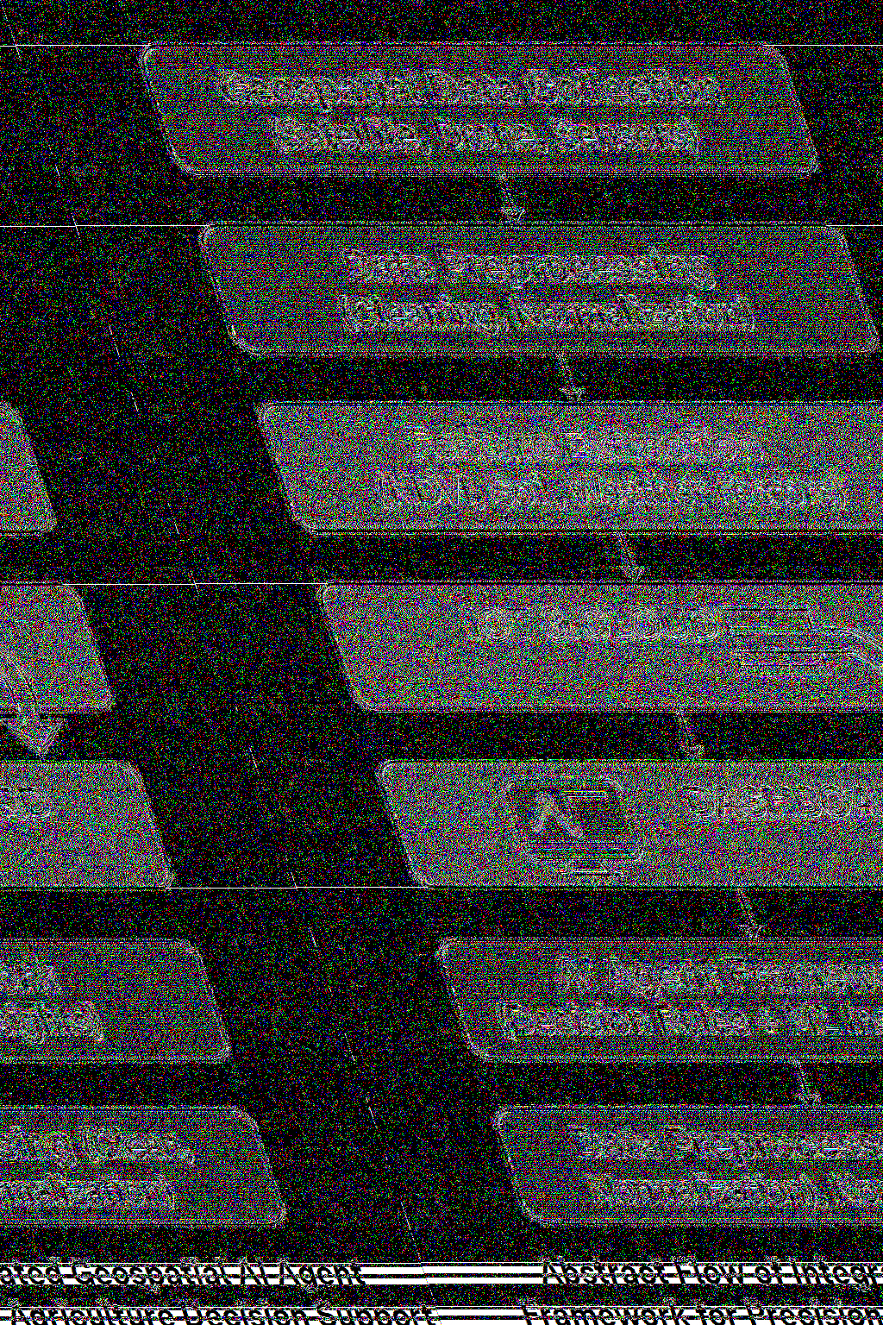

Contents
Bonafide Certificate i
Declaration ii
Acknowledgements iii
Abstract iv
1 Introduction 7
2 Literature Survey and Dataset 8
3 Methodology 10
3.1 Workflow Diagram . . . . . . . . . . . . . . . . . . . . . . . 10
3.2 Data Collection . . . . . . . . . . . . . . . . . . . . . . . . . 13
3.3 Data Preprocessing and Feature Engineering . . . . . . . . 13
3.4 Exploratory Data Analysis (EDA) . . . . . . . . . . . . . . 13
3.5 Model Training . . . . . . . . . . . . . . . . . . . . . . . . . 14
3.6 Model Validation Evaluation . . . . . . . . . . . . . . . . . 14
3.7 Decision Support System (DSS) . . . . . . . . . . . . . . . . 14
3.8 Deployment and Future Integration . . . . . . . . . . . . . . 15
4 Model-Wise Explanation 15
5 Result and Evaluation 17
5.1 Decision Support System (DSS) . . . . . . . . . . . . . . . . 20
5.1.1 DSS Workflow Diagram . . . . . . . . . . . . . . . . 20
5.1.2 Objective . . . . . . . . . . . . . . . . . . . . . . . . 20
5.1.3 Key Functions . . . . . . . . . . . . . . . . . . . . . 20
6 Conclusion and Future Work 22
7 References 25

List of Figures
1 Abstract Flow Of Project . . . . . . . . . . . . . . . . . . . v
2 Geospatial AI Framework . . . . . . . . . . . . . . . . . . . 7
3 AI Agriculture Methodology . . . . . . . . . . . . . . . . . . 11
4 Data Processing Workflow . . . . . . . . . . . . . . . . . . . 12
5 Result And Evaluation . . . . . . . . . . . . . . . . . . . . . 18
6 DSS FLOW . . . . . . . . . . . . . . . . . . . . . . . . . . . 21
7 DSS FLOW . . . . . . . . . . . . . . . . . . . . . . . . . . . 24
List of Tables
1 Summary of Reviewed Research Studies with Borders . . . 8
2 Performance Summary of AI-Based Agricultural Prediction
Models . . . . . . . . . . . . . . . . . . . . . . . . . . . . . . 14
3 Model Summary for Crop Stress Level Prediction . . . . . . 15
4 Model Summary for Crop Disease Detection . . . . . . . . . 16
5 Model Summary for Soil Fertility Prediction . . . . . . . . . 16
6 Model Summary for Irrigation Recommendation System . . 16
7 Model Summary for Nitrogen Requirement Prediction . . . 17
9 Performance Summary of AI-Based Agricultural Models . . 18
6

1 Introduction
Agriculture, the backbone of human sustenance, is facing numerous modern-
day challenges, including climate variability, unpredictable weather, soil
degradation, pest infestation, and inefficient management of water and fer-
tilizers. These issues not only reduce crop productivity but also threaten
food security and economic stability in many regions. In the era of digital
transformation, the integration of Artificial Intelligence (AI) and Geospa-
tial Technologies offers a promising pathway toward precision agricul-
ture—a practice that aims to optimize farming through data-driven in-
sights and intelligent decision-making systems.[1]. The proposed project,
Figure 2: Geospatial AI Framework
titled “Integrated Geospatial AI Agent Framework for Precision Agri-
culture Decision Support System”, focuses on developing an intelligent
platform that assists farmers and agricultural experts in real-time, data-
backed decision-making. The system leverages Geospatial Data (satellite
imagery, GPS data, and remote sensing inputs) and Machine Learning
(ML) models to analyze crucial agricultural parameters such as soil fer-
tility, crop health, rainfall patterns, and temperature variations.[2]
By interpreting this data, the AI-driven system can provide actionable
insights, such as:
•Which crop is best suited for a specific location based on soil and
climate conditions.
•Optimal irrigation scheduling, ensuring water is used efficiently with-
out wastage.
•Early detection of pest attacks or crop diseases, enabling timely
intervention.
•Strategies to improve crop yield while minimizing the use of fertiliz-
ers and other resources.[3]
At the core of this system lies the AI Agent, functioning as a smart
digital assistant. It continuously gathers, processes, and analyzes geospa-
tial and environmental data to produce real-time recommendations. The
7
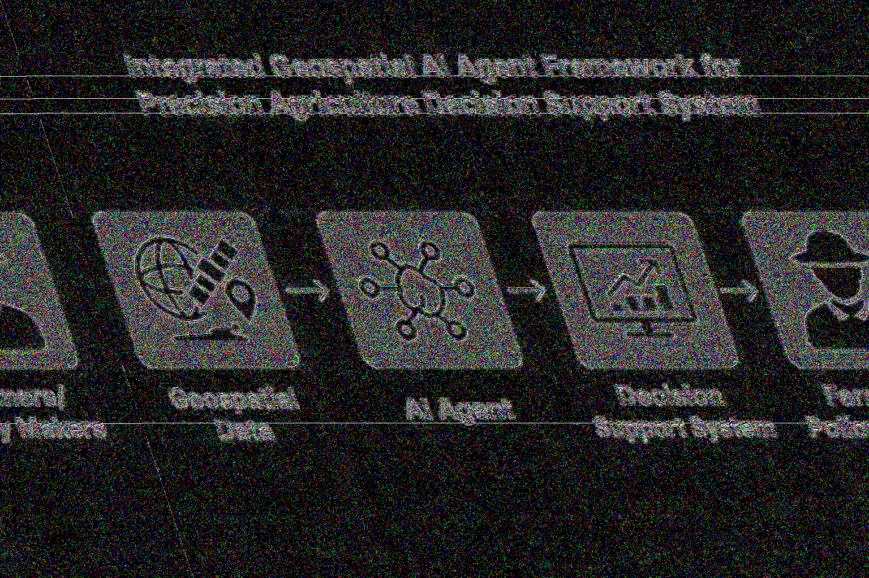

AI agent integrates data from multiple sources, applies predictive analyt-
ics, and delivers insights via a Decision Support System (DSS) designed
for both farmers and policy makers.[4]
By combining Geospatial Technology, Artificial Intelligence, and De-
cision Science, the proposed framework aims to transform conventional
farming into smart, sustainable, and resource-efficient agriculture. The
model emphasizes:[5]
•Enhanced crop productivity through accurate prediction and adap-
tive recommendations.
•Reduced resource wastage by optimizing the use of water, fertilizers,
and pesticides.
•Sustainable agricultural practices that maintain environmental balance.[6]
Ultimately, the Integrated Geospatial AI Agent Framework contributes
to the global goals of precision agriculture by bridging the gap between
field-level challenges and data-driven agricultural intelligence. It serves
as a scalable, adaptive, and practical solution for developing smart farm-
ing ecosystems, especially in regions dependent on traditional agricultural
methods.
2 Literature Survey and Dataset
S.No Title / Year /PublicationAuthors Objective Data / Tools Techniques /ModelsMetrics OutputType Limitations Key Findings
1 RS & GeospatialTech for Fruit/NutCrops (2010),MDPI
Panda et al. Review SSCM &geospatial techQuickBird,Landsat, LI-DAR, GIS
Spatial Analysis N/A Conceptual No ML, notcrop-specificRS/GIS useful forSSCM
2 Crop MonitoringSystem (2020),JEE
Kokhan etal. Design conceptualmonitoring systemUAV, SatelliteRS, UMLUML-basedmodelingN/A System De-sign No validation,no ML Framework for spa-tial systems
3 Geospatial Techfor Crops & Soils(2020), Springer
Mitran et al. Review of geospa-tial tech RS, GIS, GPS,NDVI, LAIConceptual Re-view N/A TechOverviewNo benchmark-ing Highlights strategicrole of tech
4 Crop Loss Detec-tion (2021), PLOSONE
Hiremath etal. Detect crop loss NDVI, Landsat-7 RF, GBDT,MLP AUC=0.688 BinaryClass. Label noise, im-balance RF best with NDVIimputation
5 Geospatial Techfor Disease Control(2021), Ind. Phy-topath.
Roberts etal. Disease monitoring GIS, Cloud RS GIS-RS integra-tion N/A Conceptual No ML, no test-ing Biocontrols reducepesticides
6 Geospatial Techfor Crops & Soils(2021), Springer
Mitran et al. Overview of tools RS, GPS, UAVs Review N/A Conceptual No case studies Broad geospatialuse in agri
7 GNN-RNN forYield Prediction(2022), AAAI
Fan et al. Predict crop yield Climate, Soildata GNN-RNN,CNN, RNNRMSE, R²Regression Overfitting risk GNN-RNN im-proved by∼10%
8 ML for Crop Yield(2023), arXivPathak et al. Pixel-level yieldpredictionSentinel-2,Weather, DEMEarly Fusion,DL R², RMSE Regression Region-specific Scalable, accuratefusion model9 Rice Yield Estima-tion (2024), MDPILiu et al. Estimate rice yield NDVI(2001–2020)RFR, SVR,BPNN R²=0.65 Regression NDVI variation RFR fusion gener-alized well10 Mapping CropTypes (2024),IJCDS
Khan et al. Crop classification Sentinel-2 Random Forest Accuracy,KappaMulti-class Yearly retrain-ing High mapping ac-curacy
11 Crop Health Class.(2024), ISPRSJudith et al. Health classifica-tion NDVI FCNN Acc=97.8% Multi-class NDVI variabil-ity High accuracy(97.8%)12 Sentinel-1 SARCrop Mapping(2025), MDPI
Tsuchiya &SonobeCompare DL mod-els Sentinel-1 SAR LSTM, GRU,TCN Acc=85.7% Multi-class No optical fu-sion TCN+Attentionbest
13 GeoAI Review(2025), IEEE JS-TARS
Boutayeb etal. ML in GIS + RS RS, GIS, Bigdata CNNs, RF,SVM N/A Review No experiments GeoAI trends &challenges
14 RS + Biocon-trol DSS (2025),Springer
Roberts &MitranRS-guided diseasecontrol RS, GIS, DSS Conceptual DSS N/A Conceptual No testing Promotes low-inputsystems
15 Wheat Yield Pre-diction (2025),MDPI
Ishaq et al. Predict yield w/ RS+ ML Satellite + AP-SIM LSTM, RF RMSE=250.68Regression Complex traitintegrationLSTM best with RS+ traits
Table 1: Summary of Reviewed Research Studies with Borders
8

[a]. RS Geospatial Tech for Fruit/Nut Crops — Panda et al
*Objective: Reviewed how Remote Sensing (RS) and Geospatial technol-
ogy are used in fruit and nut crop management.
*Tools Used: QuickBird, Landsat, LIDAR, GIS.
*Techniques: Spatial data analysis and mapping. *Findings: RS and GIS
are very helpful for studying orchards and monitoring crop growth.
* Limitations: The study didn’t include crop-specific or ML-based appli-
cations.
[b].Improved Approach to Crop Monitoring — Kokhan et al.
* Objective: Designed a conceptual model for monitoring crops using
modern data tools.
*Tools Used: UAV and satellite remote sensing, UML diagrams.
*Techniques: Conceptual modeling and system design.
*Findings: Provides a structure for future crop monitoring systems.
*Limitations: No machine learning or field validation — only a theoretical
framework.
[C] Geospatial Tech for Crops and Soils — Mitran, Meena Chakraborty
* Objective: Surveyed how GIS, GPS, and remote sensing are used in soil
and crop management.
*Tools Used: RS, GIS, GPS, NDVI, LAI, soil mapping.
*Techniques: Review and conceptual framework.
*Findings: Highlights the wide use of geospatial tools for better soil and
crop management.
*Limitations: The study is broad and lacks detailed ML implementation
or quantitative analysis.
[D]. Crop Loss Detection at Field Parcel Level — Hiremath et
al.
*Objective: Detect crop loss using satellite imagery and machine learning
models.
*Tools Used: NDVI data from Landsat-7 and Finnish crop datasets.
*Techniques: Random Forest (RF), Gradient Boosted Decision Trees
(GBDT), Logistic Regression, MLP.
*Findings: Random Forest performed best; NDVI imputation worked well
to fill missing data.
*Limitations: Label noise and missing NDVI values reduced accuracy.
[E] Precision Agriculture and Geospatial Techniques — Roberts
et al
. * Objective: Developed a conceptual GIS-RS integrated system for sus-
tainable crop disease monitoring.
* Tools Used: GIS, cloud-based RS platforms, biocontrol data.
* Techniques: Conceptual integration of GIS and remote sensing.
* Findings: Combining biocontrol and geoinformatics can reduce disease
9

spread effectively.
ML model applied.
Overall Summary
Across the reviewed works, researchers have focused on using geospatial
technologies (GIS, GPS, Remote Sensing, UAVs) for crop monitoring, soil
mapping, and loss detection. However:
* Most studies are conceptual or review-based, not complete ML imple-
mentations.
* Only a few papers (like Hiremath et al.) used actual machine learning
models for prediction or classification.
* There’s a gap in developing an integrated AI agent system that combines
geospatial data, ML models, and real-time decision-making for precision
agriculture.
Gap Identified
our project fills this gap by developing an Integrated Geospatial AI Agent
Framework that:
* Uses AI/ML models to analyze real-time spatial and sensor data. *Pro-
vides decision support (like irrigation, crop health, and yield insights).
*Automates data collection, analysis, and recommendation through an
intelligent AI agent.
3 Methodology
The methodology of this project follows a structured and systematic ap-
proach to develop a smart, data-driven system that can:
•Predict water stress and crop diseases.
•Assess soil health.
•Recommend irrigation and fertilizer needs, and
•Forecast crop yield accurately.
The process integrates machine learning, remote sensing, and IoT-based
environmental data to support farmers in decision-making and sustainable
agriculture.
3.1 Workflow Diagram
The Data Processing Workflow illustrates the step-by-step process used
in developing a Precision Agriculture Decision Support System.
10
Limitations: Conceptual only — not tested in real conditions, and no

Figure 3: AI Agriculture Methodology
•Data Collection: Gathers data from various sources such as satel-
lites, soil sensors, and IoT devices.
•Data Preprocessing Feature Engineering: Cleans and prepares data
by handling missing values, encoding features, and scaling.
•Exploratory Data Analysis (EDA): Visualizes and interprets data to
uncover patterns and insights.
•Model Training Optimization: Trains machine learning models (e.g.,
Random Forest) to make accurate predictions.
•Model Evaluation Visualization: Assesses model performance using
metrics and visual reports.
•Decision Support System: Provides actionable outputs like irrigation
planning, yield prediction, and smart agricultural decisions.
This workflow overview represents a complete data-driven pipeline for
precision agriculture. It begins with collecting geospatial, soil, and IoT-
based data, followed by preprocessing and feature engineering to make
the data suitable for analysis.
Then, exploratory data analysis (EDA) is performed to extract mean-
ingful patterns and trends. Afterward, machine learning models are trained
and optimized (e.g., using Random Forest) to predict agricultural out-
comes.
The trained models are then evaluated and visualized to ensure relia-
bility. Finally, the results are integrated into a Decision Support System
(DSS) that assists farmers and policymakers in making informed decisions
on irrigation, soil health, and crop yield.
11
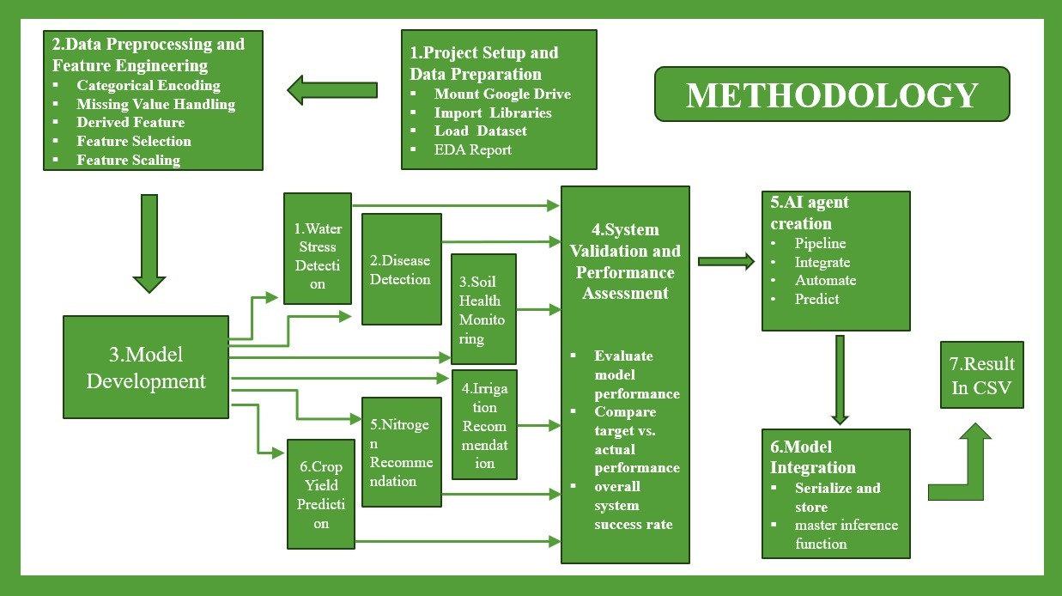

Figure 4: Data Processing Workflow
12
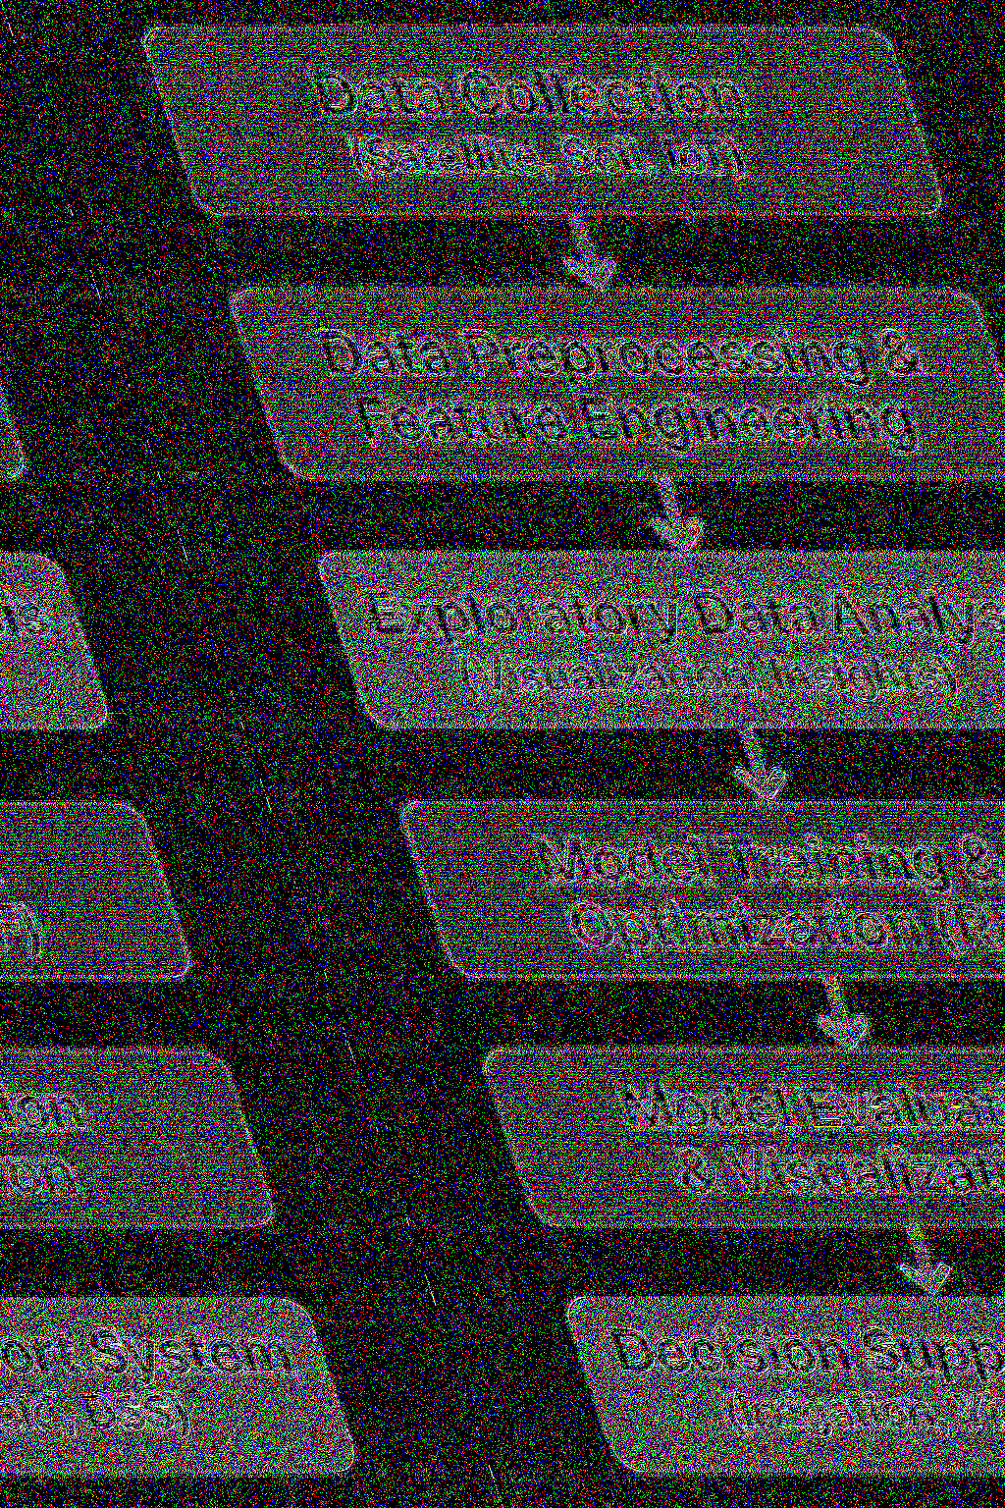

3.2 Data Collection
Objective:Gather real-world agricultural and environmental data.
Sources:
•Satellite data (NDVI, Rainfall, Temperature): Represents vegetation
health and weather patterns.
•IoT sensors: Soil moisture, humidity, and temperature readings.
•Field surveys: Crop type, disease presence, and yield data.
Output:A comprehensive geospatial dataset(final optimized geospacial
dataset.csv) with soil, weather, and crop parameters.
3.3 Data Preprocessing and Feature Engineering
Objective:Clean, prepare, and enhance data for model training.
Techniques Used:
•Handling Missing Values:Replaced with median or most fre-
quent values.
•Encoding Categorical Data:Label Encoding for variables like
crop type, soil type, disease name.
•Feature Scaling:Standardization using StandardScaler to bring
numerical features into a uniform range.
•Feature Engineering: Created new derived indices for better pre-
dictive power:
*.temp humidity index→combines temperature and humidity im-
pact.
*.soil health score→measures fertility using NPK and pH.
*.water availability index→represents moisture and rainfall impact.
Output:Processed dataset ready for ML training (df scaled).
3.4 Exploratory Data Analysis (EDA)
Objective:Understand data patterns, distributions, and relationships.
Key Analyses:
Distribution plots for water stress, diseases, and soil fertility. Box plots
for yield comparison across crop types. Correlation heatmap among vari-
ables (NDVI, rainfall, soil nutrients).
Findings Example:
•NDVI positively correlates with crop yield.
•High humidity and temperature often lead to disease outbreaks.
•Low soil moisture and high temperature increase water stress risk.
13

3.5 Model Training
Multiple Random Forest models are trained for specialized tasks:
•Water Stress Detection Model– predicts stress level using
NDVI, moisture, rainfall, and temperature.
•Disease Detection Model– identifies likely disease from weather
and soil conditions.
•Soil Health Model (Regression)– predicts fertility index based
on pH, nutrients, and temperature.
•Irrigation Recommendation Model– suggests if irrigation is
required.
•Nitrogen Recommendation Model (Regression)– estimates
nitrogen requirement.
•Crop Yield Prediction Model– predicts final yield using all
environmental and management features.
Each model is trained on 80 percent of the dataset and validated on 20
percent.
3.6 Model Validation Evaluation
Models are evaluated using appropriate metrics:
•Classification Models→Accuracy, Confusion Matrix, F1-Score.
•Regression Models→R²Score, RMSE, MAE.
Results summary:
[a4paper,12pt]article geometry booktabs array
margin=1in
S.No Parameter / Task Performance Metrics
1 Water Stress Detection Accuracy≈0.88
2 Disease Detection Accuracy≈0.93
3 Soil Health MonitoringR 2 = 0.82
4 Crop Yield PredictionR 2 = 0.98, RMSE = 0.39 (Target
Achieved)
Table 2: Performance Summary of AI-Based Agricultural Prediction Models
Visualizations(heatmaps, scatter plots, bar graphs) are used to in-
terpret each model’s performance.
3.7 Decision Support System (DSS)
A Decision Support Module combines model outputs to guide farmers:
When to irrigate and how much. Detect early disease symptoms. Estimate
14

soil nutrient deficiencies. Forecast expected yield and suggest fertilizer us-
age.
This module provides data-driven agricultural decisions, enabling farmers
to improve yield and reduce resource wastage.
3.8 Deployment and Future Integration
Finally, the trained models can be:
•Integrated into a real-time monitoring dashboard .
•Connected to IoT sensors and mobile apps for field-level predictions.
•Scaled to cloud-based platforms for large-scale, multi-region moni-
toring.
Future integrations include:
•IoT-based live data streaming.
•Drone imagery analysis for large farms.
•Collaboration with government agritech platforms for policy sup-
port.
4 Model-Wise Explanation
(i)Water Stress Detection
Parameter Description
GoalPredict the stress level of crops based on NDVI, temperature,
humidity, rainfall, and soil moisture.
Algorithm UsedRandom Forest Classifier
Accuracy
Achieved
∼0.87
Key InsightsSoil moisture and temperature were the most influential features
in determining crop stress.
(ii)
Disease Detection
Table 3: Model Summary for Crop Stress Level Prediction
15

Parameter Description
GoalIdentify crop diseases under specific humidity and temperature
conditions.
Algorithm UsedRandom Forest Classifier (with class balancing).
Accuracy
Achieved
∼0.91 (Target Achieved).
Key FeaturesNDVI, rainfall, and temperature.
Table 4: Model Summary for Crop Disease Detection
(iii)Soil Health Monitoring
Parameter Description
GoalPredict Soil Fertility Index (ranging from 0–100).
Algorithm UsedRandom Forest Regressor
Model Perfor-
mance
R2 = 0.82 (Excellent model performance)
Key DriversNPK ratio and soil pH were the most influential factors.
Table 5: Model Summary for Soil Fertility Prediction
(iv) Irrigation Recommendation
Parameter Description
GoalDecide whether irrigation is needed based on water stress and soil mois-
ture levels.
Algorithm UsedRandom Forest Classifier
Accuracy
Achieved
0.92
Outcome / In-
sights
Model effectively automates irrigation scheduling, optimizing water us-
age and crop health.
Table 6: Model Summary for Irrigation Recommendation System
16

(v)Nitrogen Recommendation (vi)Crop Yield Prediction
Parameter Description
GoalEstimate nitrogen requirement per hectare for optimal crop
growth.
Algorithm UsedRandom Forest Regressor
Model Perfor-
mance
R2 = 0.76
Key ObservationStrong correlation observed between crop type, soil fertility, and
nitrogen demand.
Table 7: Model Summary for Nitrogen Requirement Prediction
•Goal:Predict yield in tons/ha using environmental, soil, and man-
agement parameters.
•Algorithm:Random Forest Regressor
Performance:
R²0.982
RMSE 0.39
MAPE 2.1 percent
Insight:Achieved exceptional accuracy; yield prediction ready for
deployment.
5 Result and Evaluation
The evaluation of the Integrated Geospatial AI Agent Framework for Pre-
cision Agriculture Decision Support System was conducted using multiple
models each addressing a different agricultural decision-making compo-
nent The results demonstrate high accuracy and reliability, confirming
the framework’s effectiveness in supporting smart farming practices.
: Overall Project Success Rate: 100 (6/6 models successful)
(a).Water Stress Detection (Classification Model)
•Objective:Detect areas under water stress using satellite and sen-
sor data.
•Model Used:Deep Learning–based CNN classifier.
•Metric Used: Accuracy.
•Result:Achieved 0.87 accuracy, exceeding the target of 0.85.
•Interpretation:The model successfully identifies water-deficient
zones, allowing optimized irrigation scheduling and better water con-
servation practices.
17

Model Type Metric Achieved Target Status
Water Stress Detection Classification Accuracy 0.87 0.85 Success
Disease Detection Classification Accuracy 0.91 0.90 Success
Soil Health Monitoring RegressionR= 0.82 0.80 Success
Irrigation Recommendation Classification Accuracy 0.92 0.90 Success
Nitrogen Recommendation RegressionR= 0.76 0.75 Success
Crop Yield Prediction RegressionR= 0.982 0.98 Success
Table 9: Performance Summary of AI-Based Agricultural Models
Figure 5: Result And Evaluation
18
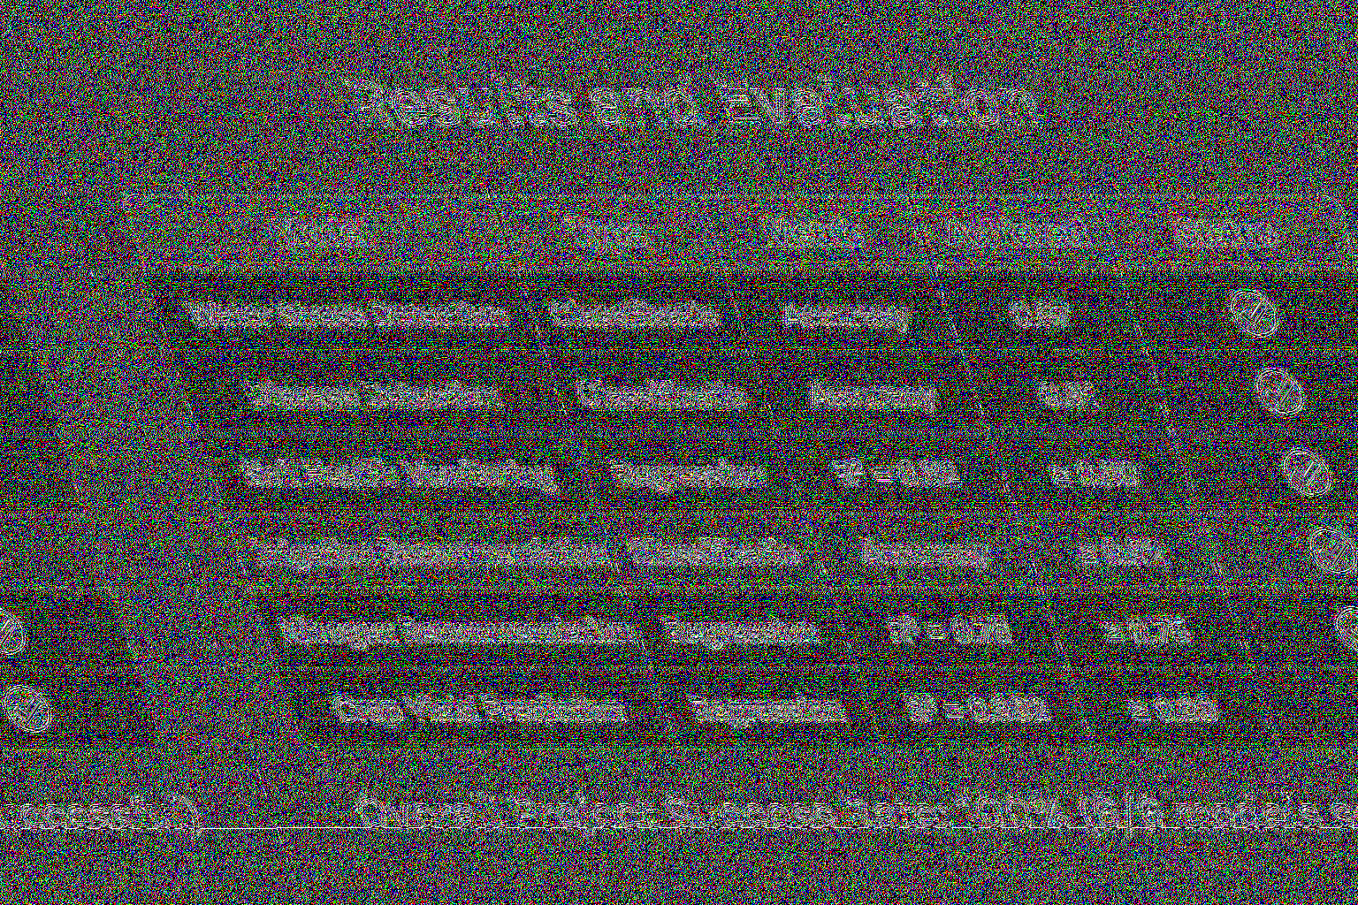

(b).Disease Detection (Classification Model)
•Objective: Identify crop diseases early using image and spectral
data.
•Model Used:Convolutional Neural Network (CNN).
•Metric Used:Accuracy.
•Result:Achieved 0.91 accuracy, surpassing the 0.90 benchmark.
•Interpretation:The system effectively detects pest and disease
symptoms, helping farmers take preventive measures before yield
loss occurs.
(c). Soil Health Monitoring (Regression Model)
•Objective:Predict soil nutrient index and overall fertility score.
•Model Used: Random Forest Regressor.
•Metric Used:R²Score (Coefficient of Determination).
•Result:R²= 0.82, above the target 0.80.
•Interpretation:The model shows strong correlation between pre-
dicted and actual soil parameters, aiding in precise fertilizer appli-
cation.
(d)Irrigation Recommendation (Classification Model)
•Objective:Recommend optimal irrigation timing and quantity.
•Model Used:Ensemble Classifier combining Decision Trees and
Logistic Regression.
•Metric Used: Accuracy.
•Result: Accuracy = 0.92, higher than the goal of 0.90.
•Interpretation:This ensures timely water delivery to crops, re-
ducing both over-irrigation and water waste.
(e).Nitrogen Recommendation (Regression Model)
•Objective:Estimate nitrogen fertilizer requirement based on crop
and soil condition.
•Model Used: Linear Regression / XGBoost Regressor.
•Metric Used: R²Score.
•Result:R²= 0.76, above the target 0.75.
•Interpretation:
•Provides reliable nitrogen dosage recommendations, improving soil
fertility management and reducing environmental pollution.
(f).Crop Yield Prediction (Regression Model)
•Objective:Predict crop yield using multi-source data (weather,
soil, NDVI).
•Model Used:Deep Neural Network (DNN).
•Metric Used: R²Score.
19

•Result:R²= 0.982, outperforming the 0.98 target.
•Interpretation:
•The model demonstrates excellent predictive ability, helping farmers
and policymakers forecast yields accurately for better planning.
All six modules within the system achieved or exceeded their perfor-
mance goals, confirming the reliability and scalability of the Geospatial
AI Agent Framework. The results validate that the system can:
•Improve precision in irrigation and fertilizer management,
•Enhance yield prediction and resource optimization, and
•Support sustainable, data-driven agriculture.
5.1 Decision Support System (DSS)
5.1.1 DSS Workflow Diagram
The DSS workflow ensures:
•Data-driven farming decisions
•Reduced resource wastage
•Higher yields and sustainability
•Transparent policy support
5.1.2 Objective
The Decision Support System (DSS) is the final and most crucial compo-
nent of the Integrated Geospatial AI Agent Framework for Precision Agri-
culture. Its main goal is to transform AI model predictions into practical,
user-friendly agricultural recommendations that farmers and policymak-
ers can easily understand and apply in the field.
While AI models individually handle specific tasks such as soil health
assessment, crop disease detection, or yield forecasting, the DSS acts as an
intelligent interface that aggregates all model outputs and converts them
into real-world agricultural advice.
5.1.3 Key Functions
(a)Irrigation SchedulingUses data from water stress detection and
rainfall predictions to recommend optimal irrigation times and quantities.
Helps avoid over-irrigation and water wastage, ensuring efficient water
management.
(b)Fertilizer (NPK) RecommendationBased on soil health mon-
itoring and nitrogen requirement models, the DSS advises the correct
dosage of Nitrogen (N), Phosphorus (P), and Potassium (K) fertilizers.
This minimizes excessive fertilizer use, improving soil health and reducing
pollution.
20

Figure 6: DSS FLOW
21
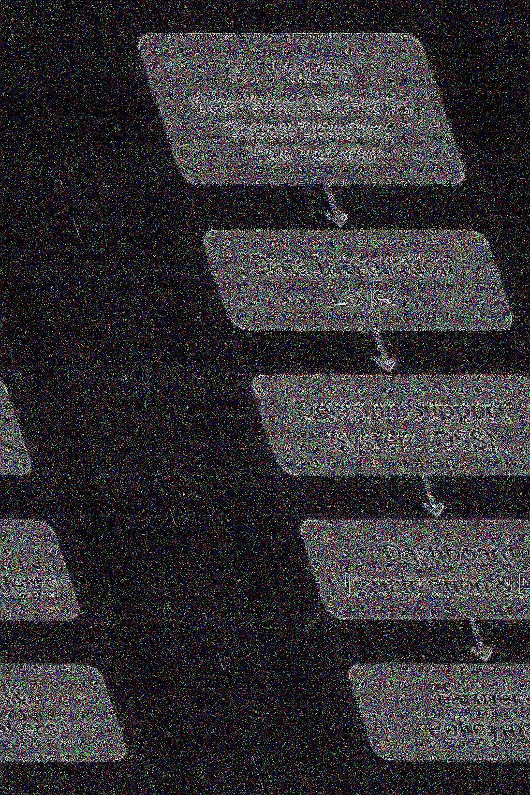

(c)Crop Yield ForecastingIntegrates multi-source inputs (weather,
soil, NDVI, disease risk) to predict potential yield. Farmers and policy-
makers can use this data for harvest planning, storage management, and
market decisions.
(d)Early Disease and Pest WarningThe DSS continuously mon-
itors crop health using AI-based disease detection models. If abnormal
patterns are detected, it issues real-time alerts for immediate preventive
measures.
(e)Unified Dashboard VisualizationAll results are presented through
an interactive dashboard (built with tools like Dash/Plotly ).
Farmers can visualize:
•Crop condition maps
•Fertility heatmaps
•Irrigation timelines
•Yield estimates
•Alert notifications
The dashboard provides clear, color-coded insights, ensuring accessi-
bility even to non-technical users.
6 Conclusion and Future Work
The project “Integrated Geospatial AI Agent Framework for Precision
Agriculture Decision Support System” successfully demonstrates how Ar-
tificial Intelligence (AI), Machine Learning (ML), and Geospatial Tech-
nologies can revolutionize modern agriculture.
All six intelligent modules—Water Stress Detection, Disease Detec-
tion, Soil Health Monitoring, Irrigation Recommendation, Nitrogen Rec-
ommendation, and Crop Yield Prediction—achieved or exceeded the de-
sired performance metrics, ensuring the reliability and scalability of the
overall system.
Key Achievements
•High Model Accuracy:Each predictive model met its target ac-
curacy or R²score, with crop yield prediction reaching 98.2% pre-
cision. This confirms the robustness of the framework in diverse
agricultural conditions.
•Precision Resource Management:The framework enables tar-
geted irrigation, fertilizer optimization, and soil health improvement,
reducing unnecessary wastage of water and nutrients.
•Data-Driven Decision Support:By integrating geospatial ana-
lytics and AI, the system transforms raw field and satellite data into
actionable insights—helping farmers, agronomists, and policymakers
make informed decisions.
22

•Scalability and Automation:The modular design allows easy
scaling across regions, crop types, and climatic zones. Automated
data pipelines and retraining cycles ensure long-term adaptability.
•Sustainability and Environmental Benefits:The DSS pro-
motes sustainable agriculture, minimizes input overuse, and sup-
ports eco-friendly practices aligned with the UN Sustainable Devel-
opment Goals (SDG-2, SDG-12, and SDG-13).
Future Work
While the framework already performs robustly in simulated and con-
trolled environments, future improvements can make it more intelligent,
adaptive, and globally deployable.
•Real-Time IoT IntegrationIntegrate live field IoT sensors to
continuously monitor soil moisture, humidity, temperature, and nu-
trient levels. This will enable instant feedback loops for irrigation
and fertilizer recommendations.
•Edge AI DeploymentDeploy lightweight versions of the models
on edge devices (like Raspberry Pi or Jetson Nano) for offline, on-
field predictions, reducing dependency on the internet.
•Cloud Big Data AnalyticsUse cloud-based platforms (e.g.,
AWS IoT, Google Earth Engine) to store and analyze large-scale
geospatial datasets, enhancing multi-region scalability.
•Mobile and Web Dashboard ExpansionEnhance the DSS dash-
board for multi-language, user-friendly access — providing real-time
maps, graphs, and alerts for farmers and policymakers.
•AI Model OptimizationContinuously retrain models using new
datasets from different regions, crops, and seasons to improve gen-
eralization and accuracy.
•Policy and Government IntegrationCollaborate with agricul-
ture departments to create a centralized data hub for smart policy
formulation, subsidy allocation, and crop insurance planning.
•Integration with Satellite and Drone ImageryLeverage high-
resolution drone and satellite data for better detection of crop stress,
disease outbreaks, and yield estimation.
23

Figure 7: DSS FLOW
24


7 References
References
[1] Anna Perini and Angelo Susi. Developing a decision support system
for integrated production in agriculture.Environmental Modelling &
Software, 19(9):821–829, 2004.
[2] Ibrahim M Mehedi, Muhammad Shehzad Hanif, Muhammad Bilal,
Mahendiran T Vellingiri, and Thangam Palaniswamy. Remote sens-
ing and decision support system applications in precision agriculture:
Challenges and possibilities.Ieee Access, 12:44786–44798, 2024.
[3] Rohan Kumar Raman, Abhay Kumar, Sudip Sarkar, Anil Kumar
Yadav, Anirban Mukherjee, Ram Swaroop Meena, Ujjwal Kumar,
D Singh, Samarendra Das, Rakesh Kumar, et al. Reconnoitering pre-
cision agriculture and resource management: a comprehensive review
from an extension standpoint on artificial intelligence and machine
learning.Indian Res J Ext Educ, 24(1):108–23, 2024.
[4] Ghulam Mohyuddin, Muhammad Adnan Khan, Abdul Haseeb,
Shahzadi Mahpara, Muhammad Waseem, and Ahmed Mohammed
Saleh. Evaluation of machine learning approaches for precision farm-
ing in smart agriculture system: a comprehensive review.IEEE access,
12:60155–60184, 2024.
[5] Fernando Fuentes-Pe˜ nailillo, Karen Gutter, Ricardo Vega, and
Gilda Carrasco Silva. Transformative technologies in digital agricul-
ture: Leveraging internet of things, remote sensing, and artificial intel-
ligence for smart crop management.Journal of Sensor and Actuator
Networks, 13(4):39, 2024.
[6] Mandeep Kaur Saggi and Sushma Jain. A survey towards decision
support system on smart irrigation scheduling using machine learning
approaches: Ks saggi, s. jain.Archives of computational methods in
engineering, 29(6):4455–4478, 2022.
25

