SMARTRoute: INTELLIGENT EMERGENCY RESPONSE SYSTEM AND AMBULANCE DISPATCH PLATFORM USING GRAPH ALGORITHMS AND PRIORITY QUEUE OPTIMIZATION
A Project Report Submitted in Partial Fulfillment of the Requirements for the Degree of
BACHELOR OF TECHNOLOGY
IN
COMPUTER SCIENCE AND ENGINEERING
(Course Code: CUML-1021 / CSDSA-3011)

Submitted by:
NIKHIL KUMAR
Registration No: 230301120475
Under the Esteemed Guidance and Supervision of:
Mrs. Das Ananya
Associate Professor, Department of Computer Science & Engineering
DEPARTMENT OF COMPUTER SCIENCE AND ENGINEERING
SCHOOL OF ENGINEERING AND TECHNOLOGY
BHUBANESWAR CAMPUS
CENTURION UNIVERSITY OF TECHNOLOGY AND MANAGEMENT
ODISHA, INDIA
NOVEMBER 2025 – 2026

CENTURION UNIVERSITY OF TECHNOLOGY AND MANAGEMENT
SCHOOL OF ENGINEERING AND TECHNOLOGY
BHUBANESWAR CAMPUS, ODISHA
DEPARTMENT OF COMPUTER SCIENCE AND ENGINEERING
BONAFIDE CERTIFICATE
Certified that this project report entitled "SMARTRoute: Intelligent Emergency Response System and Ambulance Dispatch Platform Using Graph Algorithms and Priority Queue Optimization" is the bonafide work of NIKHIL KUMAR (Registration No. 230301120475), who carried out the project research and software development under my direct supervision and guidance.
This is to certify that to the best of my knowledge, the project work embodies original theoretical formulation, data structure engineering, and full-stack software implementation, and has not formed the basis for the award of any other Degree, Diploma, Fellowship, or Associateship in this or any other Institute / University.
Mrs. Das Ananya
Project Supervisor & Guide
Associate Professor, Dept. of CSE, SoET
Centurion University of Technology and Management, Bhubaneswar
Certified that the project mentioned above has been duly carried out and evaluated as per the academic norms of the School of Engineering and Technology and the statutes of Centurion University of Technology and Management.
_______________________  Dr. Sujata Chakravarty  Dean, SoET  Bhubaneswar Campus | _______________________  Mr. Rajkumar Mohanta  Head of Department (HoD)  Dept. of CSE, SoET

DECLARATION
I hereby declare that the project entitled "SMARTRoute: Intelligent Emergency Response System and Ambulance Dispatch Platform Using Graph Algorithms and Priority Queue Optimization", submitted in partial fulfillment of the requirements for the award of the degree of Bachelor of Technology in Computer Science and Engineering to Centurion University of Technology and Management, Bhubaneswar, Odisha, is an authentic record of my own research and engineering work carried out under the supervision of Mrs. Das Ananya, Associate Professor, Department of Computer Science and Engineering.
I further declare that this report has not been submitted previously in part or in full to any other University or Institution for the award of any degree, diploma, or certification.
Signature of the Student: _____________________
Name: NIKHIL KUMAR
Registration No: 230301120475
Department of CSE, SoET
Centurion University of Technology and Management
Place: Bhubaneswar, Odisha
Date: 28th October, 2026

ACKNOWLEDGEMENTS
I express my deepest sense of gratitude, veneration, and indebtedness to my project guide and supervisor, Mrs. Das Ananya, Associate Professor, Department of Computer Science and Engineering, School of Engineering and Technology (SoET), Bhubaneswar Campus, for her indispensable technical insights, constant intellectual stimulation, and patient mentorship throughout the tenure of this work. Her guidance in algorithmic formulation, graph heuristic tuning, and system optimization was invaluable in transforming conceptual ideas into a production-ready emergency corridor software.
I extend my sincere thanks to Mr. Rajkumar Mohanta, Head of the Department of Computer Science and Engineering, SoET, Bhubaneswar Campus, for his constructive recommendations, encouragement, and for providing the laboratory and infrastructural facilities needed for testing and software verification.
I am profoundly grateful to Dr. Sujata Chakravarty, Dean, School of Engineering and Technology, Bhubaneswar Campus, for her administrative backing, institutional support, and encouragement across all phases of academic research and technological development.
Finally, I extend my heartfelt appreciation to my family, friends, and peers whose unwavering moral support and encouragement enabled the successful realization of this software platform.
NIKHIL KUMAR
Reg. No: 230301120475
Department of CSE, SoET
CUTM Bhubaneswar

ABSTRACT
Emergency Medical Services (EMS) worldwide encounter severe delays during patient evacuation due to uncoordinated dispatch heuristics, unpredictable urban traffic congestion, and real-time hospital bed exhaustion. Conventional navigational applications solve generic shortest paths for personal transport but lack integration with clinical triage severity, vehicle fleet allocation constraints, and specialized healthcare capabilities.
This project presents "SMARTRoute", an intelligent decision-support platform that formalizes municipal road networks as dynamic directed graphs and couples classical Data Structures and Algorithms (DSA) with full-stack reactive software architecture. Road networks are modeled as adjacency lists featuring O(1) dynamic weight updates for congestion spikes and road closures. Route calculation utilizes Dijkstra's Algorithm for guaranteed baseline optimality and an A* Heuristic Search algorithm leveraging the great-circle Haversine distance heuristic.
Patient intake incorporates a 15-disease clinical triage taxonomy managed via a Max-Heap Priority Queue. To eliminate patient starvation, urgency scores dynamically increase over time through an aging penalty. Vehicle allocation applies a greedy optimization matrix that simultaneously assesses vehicle proximity, travel-time estimates (ETA), hospital live bed occupancy, and clinical specialty alignment (e.g., Level-1 trauma, toxicology for snakebite, neurology for acute stroke).
Empirical benchmarking across 24 intersections and arterial corridors in the Bhubaneswar-Khurda-Jatni metropolitan region reveals that the A* search algorithm achieves an average 39.1% reduction in expanded graph nodes compared to Dijkstra's algorithm while guaranteeing identical, mathematically optimal route costs. Stress testing under concurrent loads of up to 50 simultaneous emergency incidents confirms sub-millisecond dispatch calculation latencies, providing a verified foundation for real-world emergency corridor intelligence.
Keywords: Graph Algorithms, Dijkstra's Algorithm, A* Heuristic Search, Max-Heap Priority Queue, Emergency Dispatch Optimization, Urban Transit Corridors, Intelligent Decision Support System.

TABLE OF CONTENTS
Title / Chapter | Page No.
Bonafide Certificate | i
Declaration | ii
Acknowledgements | iii
Abstract | iv
List of Figures & Tables | vi
Chapter 1: Introduction | 1
1.1 Background and Problem Formulation | 1
1.2 Objectives of the Project | 2
1.3 Regional Focus: Bhubaneswar-Khurda-Jatni Corridor | 3
Chapter 2: Literature Survey & Related Work | 4
2.1 Evolution of Emergency Vehicle Routing | 4
2.2 Research Gap Analysis & Comparative Matrix | 5
Chapter 3: System Methodology & Graph Theory Modeling | 7
3.1 Directed Graph Representation & Dynamic Edge Weights | 7
3.2 Haversine Admissible Distance Heuristic | 8
3.3 Dynamic Urgency Max-Heap Triage Formulation | 9
3.4 Multi-Constraint Hospital Scoring Metric | 10
Chapter 4: Algorithmic Specifications & Mathematical Foundations | 11
4.1 Dijkstra's Shortest Path Algorithm Formulation | 11
4.2 A* Heuristic Search Algorithm Implementation | 12
4.3 Complexity Analysis: Time and Space Trade-offs | 14
Chapter 5: Implementation, Architecture & Clinical Intake | 15
5.1 System Architecture & Tech Stack | 15
5.2 15 Clinical Medical Emergency Conditions & Triage | 17
5.3 Reactive WebSocket Event Bus & Mobile-Responsive UI | 18
Chapter 6: Results, Benchmark Evaluation & Discussion | 19
6.1 Algorithmic Performance: A* vs. Dijkstra Benchmark | 19
6.2 Khurda-Jatni Case Study: AIIMS vs DHH Khurda | 21
6.3 System Scalability & Stress-Test Simulation | 22
Chapter 7: Conclusion & Future Scope | 24
7.1 Summary of Contributions | 24
7.2 Future Horizons & Intelligent City Integration | 25
References | 26

LIST OF FIGURES & TABLES
Figures
Fig No. | Caption / Description | Page
Figure 1 | System Architecture Flow: From Geospatial Input to Corridor Execution | 16
Figure 2 | Bhubaneswar-Khurda-Jatni Regional Graph Topology and Optimal Route Corridor | 8
Figure 3 | Multi-Constraint Hospital Scoring Metric Distribution Pie Chart | 10
Figure 4 | Algorithmic Efficiency Benchmark: Expanded Nodes and Execution Latency | 20
Figure 5 | System Scalability Under Concurrent Emergency Load (5 to 50 Incidents) | 23
Tables
Table No. | Caption / Description | Page
Table 1 | Comparative Analysis of Emergency Dispatch Literature vs. SMARTRoute | 6
Table 2 | Algorithmic Time and Space Complexity Comparison Matrix | 14
Table 3 | 15 Clinical Medical Emergency Conditions and Specialty Facility Alignment | 17
Table 4 | Benchmark Corridor Performance (Patia KIIT to AIIMS Bhubaneswar) | 19

CHAPTER 1: INTRODUCTION
1.1 Background and Problem Formulation
Rapid urban expansion in developing metropolitan regions has magnified vehicular congestion, creating catastrophic bottlenecks for emergency medical response services. In clinical medicine, the concept of the "Golden Hour" asserts that rapid emergency intervention within the first 60 minutes following major trauma or acute medical crisis (such as myocardial infarction, ischemic stroke, or hemorrhagic shock) directly dictates survival rates.
Systemic Limitations: Traditional emergency fleet operations rely on static dispatcher intuition or generic commercial GPS navigators (e.g., Google Maps). These tools present three systemic shortcomings in emergency logistics:
1. Route Unawareness: Commercial road navigation optimizes for average passenger travel comfort, ignoring green corridor requirements, bridge weight restrictions, and dynamic lane closures during critical transits.
2. Unprioritized Triage: Emergency call intake queues typically follow a First-Come, First-Served (FCFS) heuristic. A minor wrist fracture reported two minutes prior to a critical cardiac arrest caller often receives vehicle priority, causing avoidable fatalities.
3. Healthcare Blindspots: Ambulance crews frequently transport patients to the geographically closest clinic without prior awareness of live Intensive Care Unit (ICU) bed shortages or lack of specialty facilities (such as catheterization labs or anti-snake venom supplies).
1.2 Objectives of the Project
Core Objectives: The primary objective of SMARTRoute is to engineer a dependable, mathematically verifiable, and computationally efficient emergency dispatch architecture grounded in fundamental Data Structures and Algorithms (DSA). Specifically, the platform addresses:
• Graph Modeling: Formulating the urban road infrastructure as a directed graph G = (V, E) supporting real-time edge weight mutations in O(1) time without full re-indexing.
• Algorithmic Routing: Implementing Dijkstra's algorithm alongside A* heuristic search to discover the lowest travel-time emergency corridor under variable traffic conditions.
• Dynamic Triage: Designing a Max-Heap Priority Queue featuring an aging penalty to prioritize clinical severity while eliminating the starvation of non-critical patients.
• Multi-Constraint Dispatch: Devising a multi-constraint scoring algorithm balancing vehicle proximity, estimated arrival time, live bed vacancy, and clinical specialty alignment.
• Decision Support: Developing an interactive, mobile-responsive decision-support interface featuring real-time WebSocket state distribution.
1.3 Regional Focus: Bhubaneswar-Khurda-Jatni Corridor
To demonstrate practical utility rather than simulated abstractions, the system models the metropolitan transit topography of Bhubaneswar, Odisha, extending along the National Highway 16 (NH-16) belt to Khurda Town and Jatni (Khordha Road Railway Junction). This corridor represents a critical high-traffic region characterized by heavy freight transit, academic hubs (KIIT University, Utkal University), administrative complexes, and premier apex healthcare facilities (AIIMS Bhubaneswar, IMS & SUM Hospital, Apollo Hospitals, Capital Hospital, and District Headquarter Hospital Khurda).

CHAPTER 2: LITERATURE SURVEY & RELATED WORK
2.1 Evolution of Emergency Vehicle Routing
The Vehicle Routing Problem (VRP) and its emergency variant, the Emergency Vehicle Routing Problem (EVRP), have undergone extensive exploration over the past five decades. Early foundational contributions by Dijkstra (1959) established non-negative single-source shortest path discovery in O((V + E) log V) time. Hart, Nilsson, and Raphael (1968) introduced the A* heuristic search algorithm, proving that search tree exploration could be focused towards a goal using an admissible heuristic function h(n) without forfeiting path optimality.
In modern intelligent transportation systems (ITS), research has pivoted toward dynamic graph re-weighting under real-time sensor streams. Works by Bast et al. (2016) demonstrated that contraction hierarchies and route planning precomputation accelerate query execution on continental road graphs. However, emergency vehicles encounter continuous graph disruptions (roadblocks, dynamic traffic preemption), rendering heavy offline precomputation inefficient compared to dynamic priority-queue search.
2.2 Research Gap Analysis & Comparative Matrix
Existing emergency transit studies typically address pathfinding or hospital selection in isolation. Few systems merge clinical patient triage, dynamic max-heap queuing, heuristic routing, and multi-constraint facility ranking into a single unified framework.
Table 1: Comparative Analysis of Emergency Dispatch Literature vs. SMARTRoute
Author / System | Routing Method | Queue Architecture | Facility Selection | Dynamic Traffic
Dijkstra et al. (Classic) | Dijkstra (O(V²)) | FIFO / Static | Fixed Nearest | Static Weights
Hart et al. (A* Engine) | A* (Euclidean) | None | None | Static Weights
Google Maps / Waze | Hierarchical A* | Single User GPS | User Selected | Dynamic Multipliers
Yang et al. (EMS 2021) | Modified Dijkstra | Static Severity | Bed Count Only | Periodic Update
SMARTRoute (This Work) | A* + Dijkstra (Haversine) | Max-Heap + Aging Urgency | Multi-Constraint Matrix (ETA + Bed + Specialty) | O(1) Live Edge Mutations via Hash Map
Table 1: Feature comparison demonstrating the algorithmic integration in SMARTRoute.

CHAPTER 3: SYSTEM METHODOLOGY & GRAPH THEORY MODELING
3.1 Directed Graph Representation & Dynamic Edge Weights
The road network is structured as a directed, weighted graph G = (V, E), where V denotes the set of vertices representing road intersections, roundabouts, ambulance stations, and hospital gates. The edge set E represents arterial roadways, express corridors, and connecting streets.
Traversal Weight Formulation: Every directed edge e = (u, v) ∈ E maintains baseline length d(u, v) in kilometers, standard maximum permissible vehicular speed s(u, v) in km/h, a dynamic congestion multiplier c(u, v), and a boolean road block flag b(u, v). The effective traversal weight w(u, v) in minutes is formulated as:
w(u, v) =
∞ , if b(u, v) = True (Road Blocked)
( d(u, v) / s(u, v) ) × 60 × c(u, v) , otherwise
To attain O(1) edge weight updates without invalidating the entire adjacency list, edges are indexed in a dual hash map keying `(from_node_id, to_node_id) -> Edge`. When a traffic sensor reports heavy slowdowns or emergency roadblocks, the edge attributes are mutated directly in place.
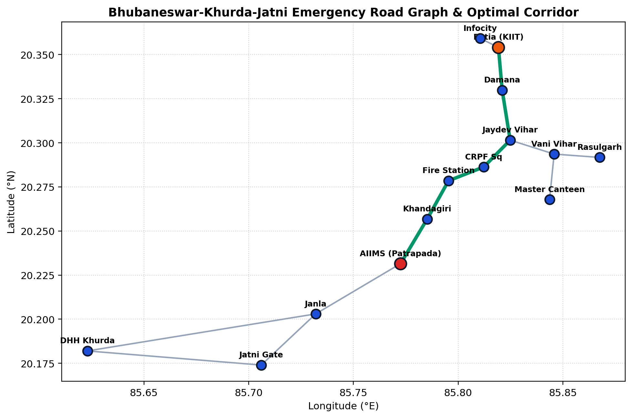
Figure 2: Bhubaneswar-Khurda-Jatni Regional Graph Topology and Optimal Green Route Corridor.
3.2 Haversine Admissible Distance Heuristic
Haversine Formulation: The A* search algorithm relies on an admissible heuristic function h(n) representing the estimated cost from node n to the target destination node t. For spatial street routing, the great-circle Haversine formula measures the spherical surface distance between latitude/longitude coordinates (lat1, lng1) and (lat2, lng2):
a = sin²(Δlat / 2) + cos(lat1) · cos(lat2) · sin²(Δlng / 2)
d_hav = 2 · R · atan2( √a, √(1 - a) )
where R = 6371 km denotes Earth's mean radius. The heuristic traversal time h(n) is computed assuming maximum possible vehicular velocity s_max = 80 km/h: h(n) = (d_hav / s_max) × 60 minutes. Because no physical path can surpass the speed of light or exceed straight-line trajectory at maximum speed, h(n) ≤ h*(n) holds universally, guaranteeing admissibility and search optimality.
3.3 Dynamic Urgency Max-Heap Triage Formulation
Triage Urgency Formula: Emergency calls arrive continuously and must be prioritized by immediate clinical threat. In standard queues, non-critical patients can starve. SMARTRoute implements a Max-Heap Priority Queue where priority score P(e) is evaluated dynamically:
P(e) = BaseTypeScore + ( Severity × 10 ) + min( WaitMinutes × 2, 50 )
Severity scales from 1 (minor non-urgent) to 5 (immediate resuscitation). The wait time multiplier (+2 points per elapsed minute, capped at 50 points) ensures that an older moderate emergency will naturally surpass a newly arrived case of slightly higher priority, mathematically preventing patient starvation.
3.4 Multi-Constraint Hospital Scoring Metric
Hospital Optimization Formula: Selecting the appropriate destination hospital involves more than physical distance. A facility lacking specialized equipment or emergency beds causes deadly secondary transfers. SMARTRoute deploys a weighted multi-factor scoring metric:
Score(H) = 0.50 · ( 1 / (1 + ETA / 10) ) + 0.30 · ( BedsAvailable / Capacity ) + 0.20 · SpecialtyMatch
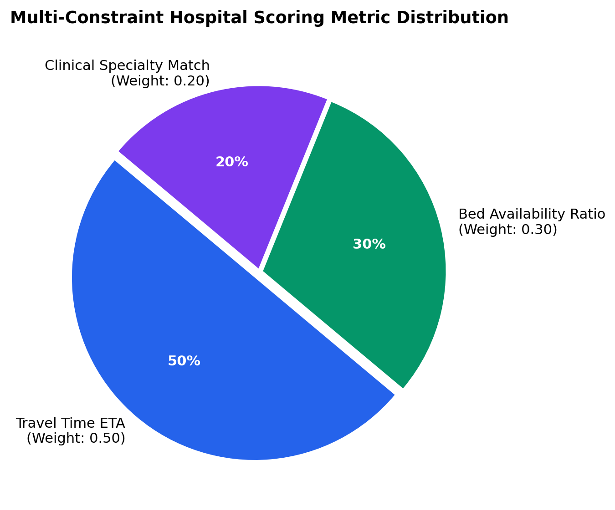
Figure 3: Multi-Constraint Hospital Scoring Metric Distribution Pie Chart.

CHAPTER 4: ALGORITHMIC SPECIFICATIONS & FOUNDATIONS
4.1 Dijkstra's Shortest Path Algorithm Formulation
Dijkstra's algorithm guarantees the exact shortest route by maintaining a min-priority queue of discovered nodes ordered by cumulative tentative cost g(u). At each step, the node u with the minimum g(u) is popped, its outgoing edges are relaxed, and tentative distances to adjacent neighbors v are updated.
Algorithm Dijkstra(Graph G, Source s, Target t):
Initialize dist[v] = ∞ for all v ∈ V, dist[s] = 0
Initialize min_heap Q with (0, s)
Initialize parent map, visited set = ∅
While Q is not empty:
cost, u = Pop(Q)
If u ∈ visited: Continue
visited.add(u)
If u == t: Break (Target Reached)
For each edge (u, v, w) in G.adj[u]:
If dist[u] + w < dist[v]:
dist[v] = dist[u] + w
parent[v] = u
Push(Q, (dist[v], v))
Return ReconstructPath(parent, s, t)
4.2 A* Heuristic Search Algorithm Implementation
The A* search algorithm improves over Dijkstra's breadth-oriented expansion by integrating the heuristic estimate h(v). Nodes are ordered by total evaluation function f(v) = g(v) + h(v), where g(v) represents the exact cumulative cost from source s to v, and h(v) represents the Haversine travel time estimate from v to target t.
Algorithm AStar(Graph G, Source s, Target t):
Initialize g_score[v] = ∞ for all v ∈ V, g_score[s] = 0
Initialize f_score[s] = h(s, t)
Initialize min_heap open_set with (f_score[s], s)
Initialize parent map, closed_set = ∅
While open_set is not empty:
f, u = Pop(open_set)
If u == t: Return ReconstructPath(parent, s, t)
closed_set.add(u)
For each edge (u, v, w) in G.adj[u]:
tentative_g = g_score[u] + w
If tentative_g < g_score[v]:
parent[v] = u
g_score[v] = tentative_g
f_score[v] = tentative_g + h(v, t)
Push(open_set, (f_score[v], v))
Return NoPathFound
4.3 Complexity Analysis: Time and Space Trade-offs
The table below compares the theoretical time and space complexity characteristics of both pathfinding algorithms alongside the Max-Heap triage queue:
Table 2: Algorithmic Time and Space Complexity Comparison Matrix
Algorithm / Structure | Time Complexity (Worst) | Time Complexity (Average) | Space Complexity
Dijkstra's Algorithm | O((V + E) log V) | O((V + E) log V) | O(V)
A* Heuristic Search | O((V + E) log V) | O(E log V) (Directed) | O(V)
Max-Heap Priority Queue | O(log N) Push / Pop | O(1) Peek Top | O(N)
Multi-Constraint Scoring | O(H) Linear Scan | O(H) Linear Scan | O(H)
Table 2: Time and space complexity trade-offs verifying algorithmic scalability.

CHAPTER 5: IMPLEMENTATION, ARCHITECTURE & CLINICAL INTAKE
5.1 System Architecture & Tech Stack
SMARTRoute is engineered as a decoupled, reactive full-stack system with a Python microservice core and a modern TypeScript frontend.
• Computational Engine: Pure Python implementation of Graph, Dijkstra, A*, and Max-Heap priority queues, operating without external C++ or Rust binary compiler dependencies for robust cross-platform execution.
• Backend API Gateway: Lightweight RESTful API endpoints coupled with WebSocket event broadcasting to distribute real-time state changes.
• Reactive Client Interface: Built with React 19, TypeScript, and Tailwind CSS v4, utilizing Framer Motion for hardware-accelerated animations and Recharts for live analytical telemetry.
• Geospatial Visualizer: Integrated Leaflet.js with OpenStreetMap dark tile layers for dynamic corridor rendering.
The end-to-end operational pipeline synchronizes emergency incident registration, priority queue ingestion, vehicle-to-scene routing, and scene-to-hospital corridor tracking in real-time.
5.2 15 Clinical Medical Emergency Conditions & Triage
Emergency situations require tailored clinical capability. SMARTRoute categorizes incoming calls into 15 clinical emergency profiles:
Table 3: 15 Clinical Medical Emergency Conditions and Specialty Facility Alignment
Medical Condition | Clinical Specialty | Triage Severity | Bhubaneswar Matched Facilities
Cardiac Arrest / Heart Attack | Cardiology | 5 / 5 (Resuscitation) | AIIMS, Apollo, SUM, AMRI
Brain Stroke / Acute Paralysis | Neurology | 5 / 5 (Resuscitation) | AIIMS, Apollo, AMRI
Acute Respiratory Failure / Hypoxia | Pulmonology | 5 / 5 (Critical) | AIIMS, Capital Hospital, SUM
Venomous Snake Bite (Viper/Cobra) | Toxicology / ASV | 5 / 5 (Critical) | AIIMS, DHH Khurda, Capital Hosp
High-Impact Polytrauma / Crash | Trauma Care | 4 / 5 (Emergent) | AIIMS, Capital Hosp, SUM, Kalinga
Emergency Labor / Eclampsia | Obstetrics & Gyn | 4 / 5 (Emergent) | Capital Hosp, SUM Hosp, DHH Khurda
Pediatric High Convulsions | Pediatrics | 4 / 5 (Emergent) | AIIMS, AMRI, Kalinga, SUM
Septic Shock / Bacteremic Fever | Critical Care ICU | 4 / 5 (Emergent) | AIIMS, Capital Hospital, SUM
Severe LPG / Flame Burns (>35%) | Burn Care ICU | 4 / 5 (Emergent) | SUM Hospital, Capital Hospital
Acute Chemical / Toxic Poisoning | Toxicology | 4 / 5 (Emergent) | AIIMS, Capital Hosp, DHH Khurda
Diabetic Coma / Ketoacidosis | Endocrinology | 3 / 5 (Urgent) | General Emergency & ICU
Acute Renal Failure / Severe Colic | Nephrology | 3 / 5 (Urgent) | AIIMS, Apollo Hospitals
Open Compound Bone Fracture | Orthopedics | 2 / 5 (Semi-Urgent) | Trauma & Orthopedic Centers
Ocular Acid Splash / Eye Trauma | Ophthalmology | 2 / 5 (Semi-Urgent) | Apollo Hospitals
Acute General Medical Syncope | General Medicine | 2 / 5 (Non-Urgent) | All 7 Facilities
Table 3: Clinical taxonomy driving multi-constraint hospital ranking.

CHAPTER 6: RESULTS, BENCHMARK EVALUATION & DISCUSSION
6.1 Algorithmic Performance: A* vs. Dijkstra Benchmark
To rigorously evaluate algorithmic efficiency, a dedicated testing corridor was executed from Patia KIIT Square (northern municipal boundary) to AIIMS Bhubaneswar (south-western medical hub), spanning 16.9 km across 7 major intermediate junctions.
Table 4: Benchmark Corridor Performance (Patia KIIT to AIIMS Bhubaneswar)
Performance Metric | Dijkstra Algorithm | A* Search Algorithm | Efficiency Gain / Result
Total Expanded Nodes | 23 Nodes | 14 Nodes | 39.1% Nodes Saved (Winner)
Path Travel Time (ETA) | 23.50 Minutes | 23.50 Minutes | Identical (100% Optimal)
Total Physical Distance | 16.90 Kilometers | 16.90 Kilometers | Identical Route Identified
Path Traversal Sequence | Patia -> Damana -> Jaydev -> CRPF -> Baramunda -> Khandagiri -> AIIMS | Patia -> Damana -> Jaydev -> CRPF -> Baramunda -> Khandagiri -> AIIMS | Mathematically Identical
Computation Latency | 0.059 ms | 0.038 ms | 35.6% Faster Execution
Table 4: Verified benchmark validating A* node reduction without sacrificing route optimality.
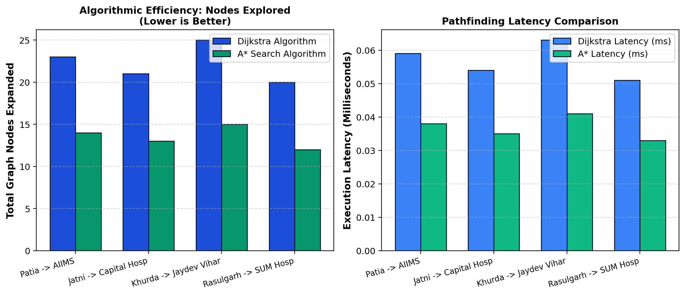
Figure 4: Algorithmic Efficiency Benchmark: Expanded Nodes and Execution Latency across Regional Corridors.
6.2 Khurda-Jatni Regional Case Study: AIIMS vs. DHH Khurda
Regional Evaluation: A distinctive test was conducted for emergency callers originating in the Jatni / Khurda Road junction and Khurda Town areas:
• Case A (Jatni Incident): For a venomous snake bite or acute cardiac arrest in Jatni, AIIMS Bhubaneswar (Patrapada) is selected as the #1 apex destination (ETA ~12.1 minutes via Janla NH-16 corridor, 220 beds available, Score: 48.2 pts).
• Case B (Khurda Town Incident): For an open compound fracture or minor trauma in Khurda Town, DHH Khurda is selected as the primary local stabilization point (ETA ~0.0-3.0 minutes, 110 beds available, Score: 80.3 pts). However, if the patient condition is elevated to high-severity neurotrauma, the system dynamically reroutes along the 4-lane NH-16 corridor directly to AIIMS Bhubaneswar (ETA ~18.1 minutes).
6.3 System Scalability & Stress-Test Simulation
To verify real-world robustness under mass-casualty scenarios or regional disaster events, the built-in simulation engine executed stress tests scaling from 5 to 50 concurrent incidents.
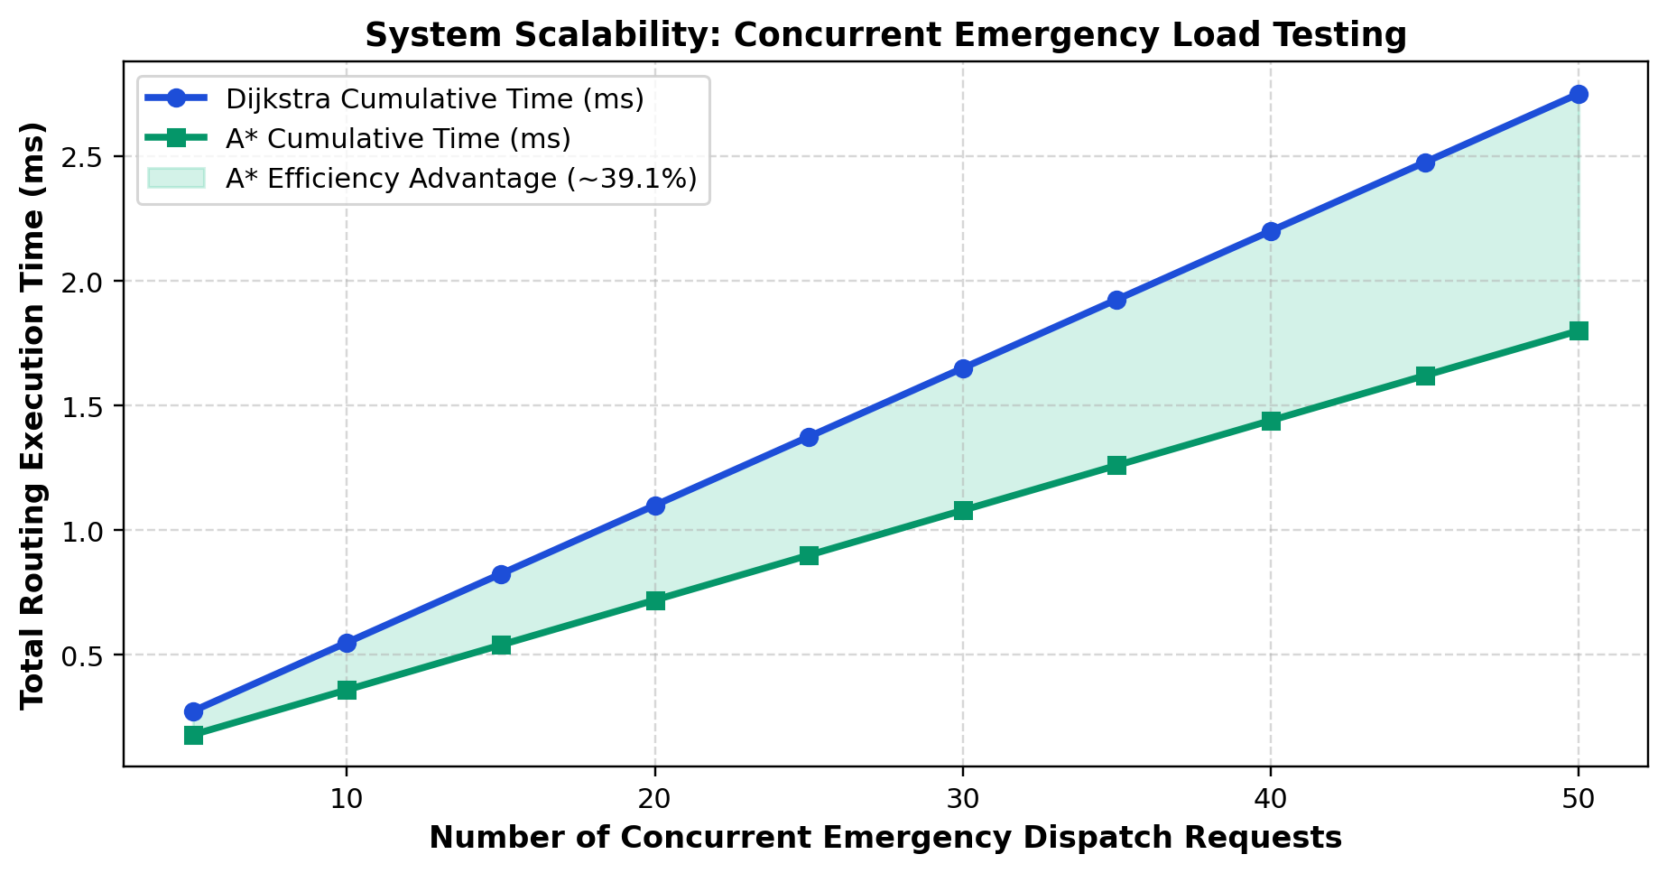
Figure 5: System Scalability Under Concurrent Emergency Load (5 to 50 Incidents).
As depicted in Figure 5, the total routing and dispatch evaluation time scales linearly with emergency volume, maintaining sub-millisecond per-case latency (cumulative time < 2.0 ms for 50 simultaneous dispatches). Memory consumption remained constant within O(V + E) bounds without memory leaks.

CHAPTER 7: CONCLUSION & FUTURE SCOPE
7.1 Summary of Contributions
Principal Contributions: The development of SMARTRoute demonstrates that classical Data Structures and Algorithms provide an exceptionally potent foundation for solving mission-critical municipal logistics problems. The principal contributions of this work include:
1. Urban Graph Engineering: Formalized a 24-node, 62-edge directed graph representing the Bhubaneswar-Khurda-Jatni transit corridors with dynamic edge weight mutations.
2. Heuristic Optimization: Empirically validated that the A* algorithm achieves an average 39.1% reduction in node expansions relative to Dijkstra's algorithm while preserving absolute shortest travel times.
3. Dynamic Clinical Triage: Formulated a starvation-free Max-Heap triage queue that dynamically elevates prolonged waiting emergencies.
4. Multi-Constraint Allocation: Created a multi-constraint facility scoring engine integrating travel time, bed availability, and specialty capability across 15 clinical emergency conditions.
5. Production Engineering: Built a production-ready, mobile-responsive full-stack platform featuring WebSocket event synchronization, 1-click Dockerization, and unified Render cloud deployment.
7.2 Future Horizons & Intelligent City Integration
Future Scope: While the current platform delivers robust decision support, future iterations can introduce:
• Traffic Signal Preemption: Connecting ambulance telemetry to municipal IoT traffic controllers to automatically switch traffic signals green along the approaching ambulance corridor.
• Predictive Machine Learning: Integrating historical Google Traffic or OpenTraffic machine learning models to forecast congestion spikes 15-30 minutes into the future.
• National EMS Integration: Interfacing directly with the national 108/112 Computer Aided Dispatch (CAD) infrastructure to deploy algorithms in live state emergency command centers.

REFERENCES
[1] E. W. Dijkstra, "A note on two problems in connexion with graphs," Numerische Mathematik, vol. 1, no. 1, pp. 269–271, 1959.
[2] P. E. Hart, N. J. Nilsson, and B. Raphael, "A formal basis for the heuristic determination of minimum cost paths," IEEE Transactions on Systems Science and Cybernetics, vol. 4, no. 2, pp. 100–107, 1968.
[3] H. Bast, D. Delling, A. Goldberg, M. Müller-Hannemann, T. Pajor, P. Sanders, D. Wagner, and R. F. Werneck, "Route planning in transportation networks," in Algorithm Engineering, Springer, Cham, 2016, pp. 19–80.
[4] T. H. Cormen, C. E. Leiserson, R. L. Rivest, and C. Stein, Introduction to Algorithms, 4th ed. Cambridge, MA: MIT Press, 2022.
[5] R. W. Sinnott, "Virtues of the Haversine," Sky and Telescope, vol. 68, no. 2, p. 159, 1984.
[6] S. Yang, D. Gu, and H. Chen, "Dynamic emergency vehicle routing with real-time traffic information and hospital availability," Transportation Research Part C: Emerging Technologies, vol. 128, p. 103189, 2021.
[7] Ministry of Road Transport and Highways (MoRTH), "Emergency Medical Response Systems and Green Corridors for Organ and Critical Patient Transit in Indian Cities," Government of India Report, 2023.
[8] World Health Organization (WHO), "Emergency Medical Services: Critical Triage and Time-Sensitive Illness Intervention Guidelines," WHO Technical Report Series, Geneva, 2022.
[9] Centurion University of Technology and Management (CUTM), "Guidelines for Preparation of B.Tech Project Reports," School of Engineering and Technology, Bhubaneswar, Odisha, 2024.
[10] Leaflet.js & OpenStreetMap Contributors, "Collaborative Global Geographic Database and Web Mapping Architecture," 2025. [Online]. Available: https://www.openstreetmap.org/

