ECS 273: Visual Analytics | UC Davis | Spring 2026

Homework 3: D3 and Interactive Visualization
Due: May 7, 2026

Submission Instructions and Important Notes

Step 1: Fork and Clone the Repository
First, fork the course repository. Then, clone the forked repository using the following commands:
- git clone https://github.com/<your-github-account-name>/ecs273-26s
- cd Homework3

Step 2: Create Your Submission Folder
Inside the Homework 3 directory in the forked repository, create a new folder like
Homework3/
|------ <your-ucd-email-id>/
The name of the folder should be the same as your UC Davis email account name (without ' @ucdavis.edu').
Important:
- Put ALL your code inside this folder
- Do NOT submit files outside your folder

Step 3: Choose a Template
We provide two starter templates:
- React + TypeScript
- React + JavaScript
You may choose either one, but submit only one version.
Step 4: Add and Commit Your Code

Each time you make a change in your code, it is good practice to commit your code, which makes it easy to revert to previous states if you want. Example:

- git add .
- git commit -m "Homework3"
- git push

Step 5: Create a Pull Request
When you are ready to submit:
- Follow the instructions here to create a pull request for this repository.
- Submit the hyperlink of the pull request to UCD Canvas.
The hyperlink should look like this: "https://github.com/via-teaching/ecs273-26s/pull/{your-pull-request-id}".
Do not include any intermediate files in your final submission unless your script depends on them to generate the final result. In general, your script should produce the final output without needing such files.

Introduction
In this homework, you will build interactive visualizations using D3 based on stock data from:
- Homework 1 (data collection)
- Homework 2 (t-SNE representation)

Data Requirements
In the data folder, there is a demo file (demo.json). In place of that, you will place your stock-related data (20 stocks) here. The structure should follow this organization:
data/
├── demo.json (demo file; not used in final submission)
├── stockdata/ (results from HW1 Task 1, for the past 2 years.)
│ ├── CAT.csv
│ ├── CVX.csv
│ └── …
├── stocknews/ (results from HW1 Task 2)
│ ├── AAPL/
│ ├── NVDA/
│ └── …
└── tsne.csv (stores the two-dimensional t-SNE projection of the latent representations from HW2. It has two columns, each representing one of the two-dimensional coordinates for each stock for the past two years.)

Layout
The layout is defined in App.tsx (or App.jsx in the JS version), where we will use Tailwind CSS, a CSS framework that offers ready-to-use utility classes for styling and layout. You may customize your layout with CSS syntax, but it is not a requirement.

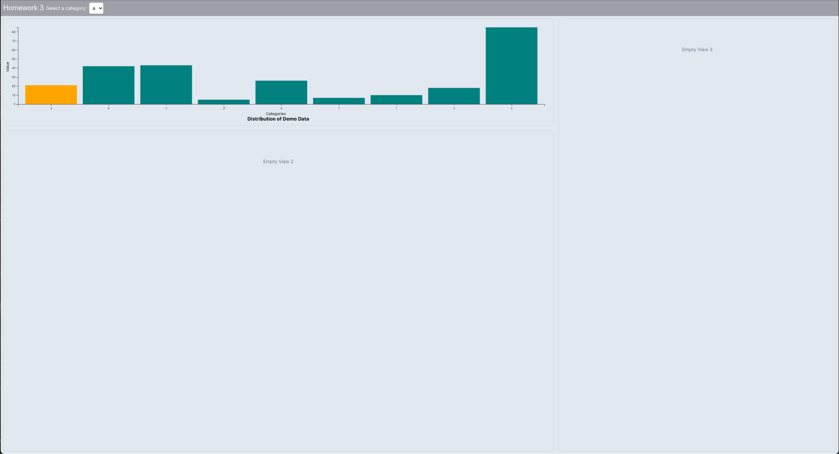
Fig 1: Provided Template

Visualization Components (100 pts)

The template (Fig.1) includes:
- A dropdown menu (stock selector)
- Three visualization panels

Where to Add your Components
For each visualization view, create a separate component file inside: src/component/
Example:
src/
└── component/
├── LineChart.tsx (or .jsx)
├── TSNEScatter.tsx (or .jsx)
├── NewsList.tsx (or .jsx)

Dropdown Menu (5 pts)
Replace the existing list in the drop-down menu with the 20 different stocks you queried in Homework 1.
- File to modify: src/component/option

Top left (View 1): Stock Overview Line Chart (35 pts)

I have placed an example demo bar chart view here, but it is not based on any of the data you will use for your submission!
Create a line chart that updates based on the selected stock from the drop-down menu, using the corresponding CSV file.
For example, if you select NVDA from the list, the chart should display the Open, High, Low, and Close values as four separate lines.
Requirements:
- A legend identifying each line.
- Properly labeled axes.
- Horizontal zooming.
- Horizontal scrolling when the time series is too long to fit in the visible area.

Bottom left (View 2): T-SNE Scatter Plot (35 pts)
Use the t-SNE coordinates generated from Homework 2 and visualize them in D3. Each point represents one stock. The tsne.csv file should come from your Homework 2 t-SNE result. It should contain one row per stock and include the stock ticker, two t-SNE coordinates, and the sector/category label.

Requirements:
- Color points by sector
- Highlight selected stock:
- Larger size
- Show stock name
- A legend identifying each sector/color
- Properly labeled axes
- Zooming

Right (View 3): List of News (25 pts)
Display a list of news for the selected stock.

Requirements:
- Show title and date
- On click, it should expand to show full content

Bonus (Optional: +5 pts)
- Linking interactions between views:
  - Selecting a stock in the drop-down updates the Scatter plot in View 1, updates the Line Chart in View 2, and expands the corresponding news in View 3

