A Micro-Payment System for Underprivileged Communities
Rasika Dayarathna – DSV, Stockholm University, Sweden
Eneas Hunguana
Motivation
Electronic micro-payment systems can be the alternative to unaffordable credit cards used in online payments. Payment systems for developing countries should take into account safety and the socio-cultural environment in which they are deployed. We propose a cashless micro-payment system based on SMS services.
Features
- No cash involved - Therefore more secure than solutions involving cash.
- Low cost – Simply requires SMS printing devices
- Banks already implement steps 1 and 2 – No additional work required.
- Other steps are similar to the traditional negotiable instruments – It makes the systems easily compliant with legal aspects
- Payer’s privacy is preserved – Only the Payee knows who sent the money. The merchant does not have to know the identity of the Payer.
- A printed (and signed) document makes it easy to settle disputes
- Payer and Payee can be the same person. In that case, some steps can be eliminated. This is needed for online transactions. This is not an advantage, but a property. A practical example is a scenario in which a use transfers money to another bank. In the following day, he withdraws the money.

Overview
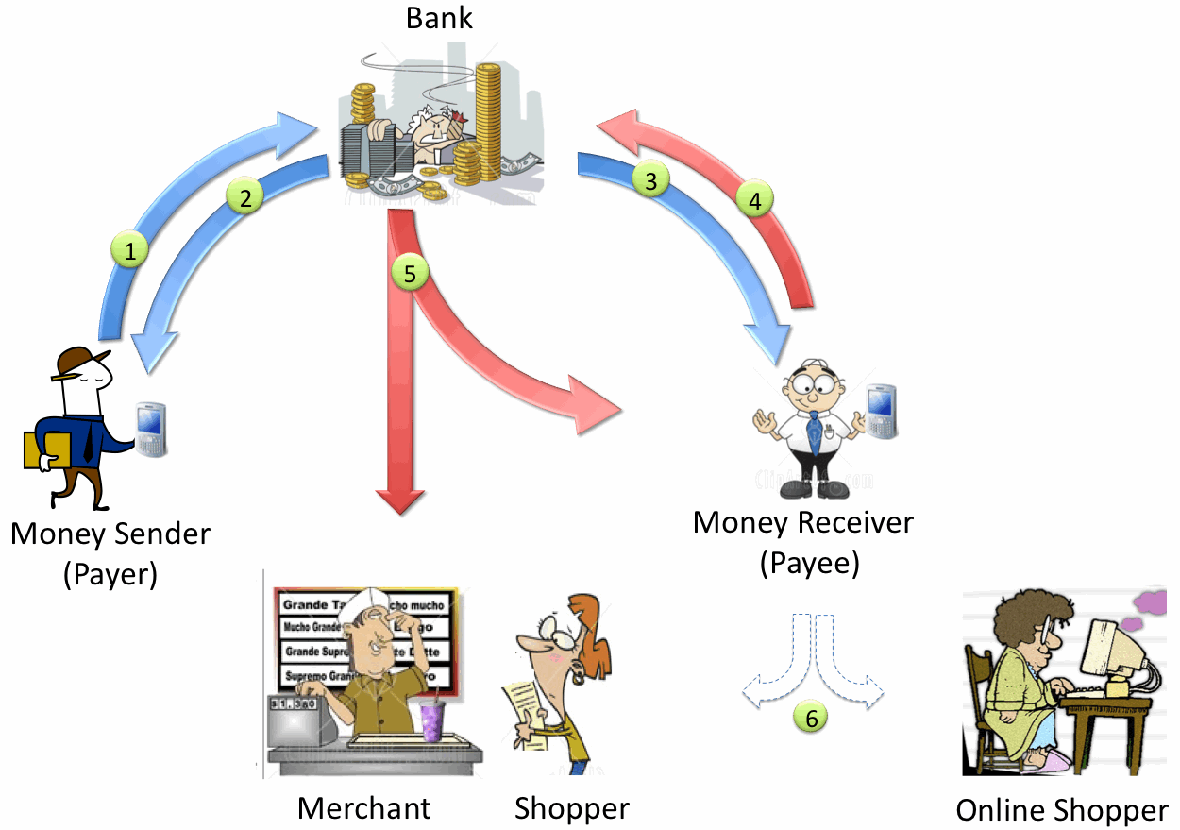
Step | Transaction Description | SMS Message Contents
 | The Payer sends a SMS to his bank requesting the transfer of a specified amount of money to the Payee. | - Payee’s phone number  - Amount to be transferred
 | The bank sends an SMS-based acknowledgement the money sender. | - Transaction ID  - Amount to be transferred  - Payee’s mobile number
 | The bank transfers money to the account number mapped to the phone number in the SMS, and sends an SMS notifying the beneficiary of the transaction. | - Transferred Amount  - Transaction ID  - Payer’s mobile number
 | In order for the receiver to pay goods/services, He/She sends a SMS to the bank requesting a money transfer to the merchant. | - Merchants’ mobile number  - Amount to be transferred
 | The bank notifies both the Merchant and the Payee, of the money transfer via SMS messages | - Merchant: The same as in step 3 (Note that the Payee now acts like a money sender)  - Payee: A unique code that can used for online shopping
 | The Payee prints and signs the SMS at the merchant’s shop, or uses the unique code send by the bank for online transactions

Risks | Countermeasures
- SMS spoofing at steps 1 and 3 | - SMS are sent to number previously registered at the bank
- Stolen mobile phones | - Use of a PIN code for transactions
- Physical threats | - Minimized since the payee has to be present before the merchant

Challenges
- SMS printing devices – There are special machines to print SMS messages. A machine costs around USD345. Merchants can share the cost. Other alternative is a merchant to have a small computer with SMS reader and a printer.
- Non-account holder – If the Payee does not own a bank account, some steps are modified:
Step 3: The bank sends to the Payee a unique code worth the transferred amount.
Step 4: To pay for goods/services, the Payee provides the code to the merchant.
Step 5: The Merchant sends a SMS to the Bank with the unique code and the amount to be deducted.
Step 6: The Bank transfers the requested amount to the merchant’s account and sends another unique code to the Payee, worth the balance of the transaction. The Payee can use it in future transactions.

Contacts
Rasika Dayarathnha <si-ika@dsv.su.se>
Eneas Hunguana <eneas@uem.mz>

