**Sign the firmware for POC4**

**In Windows system:**

1. Generate keys

Input ”make key“ in cmd.exe, then press key ‘Enter’ to generate private key and public key. Key files will be generated in the current directory. Please keep the private key safe and let us know the public key if we use this pair of keys to encrypt our firmware.

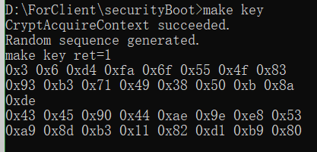

1. Sign firmware

Put the firmware(device_app.bin) in the ‘securityBoot’ directory and input “make” in cmd.exe, then press key ‘Enter’ to sign the firmware. The signed firmware(sig_device_app.bin) will be generated in the current directory.

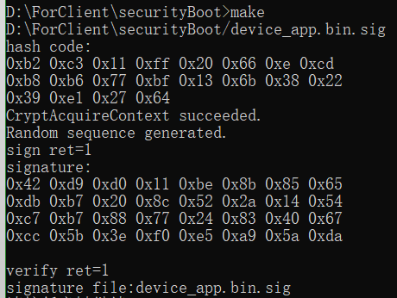

**In Linux system:**

1. Generate keys

Input ”make key“ , then press key ‘Enter’ to generate private key and public key. Key files will be generated in the current directory. Please keep the private key safe and let us know the public key if we use this pair of keys to encrypt our firmware.

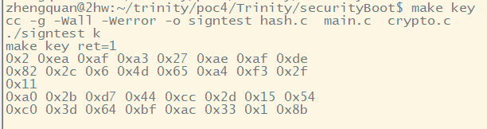

1. Sign firmware

Put the firmware(device_app.bin) in the ‘securityBoot’ directory and input ‘make’, then press key ‘Enter’ to sign the firmware. The signed firmware(sig_device_app.bin) will be generated in the current directory.

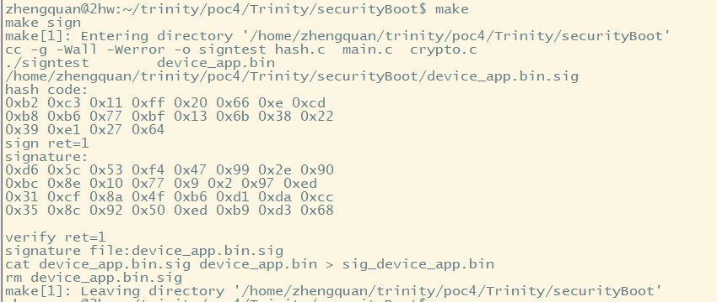

**Upgrading steps:**

Step 1.

Connect device to PC via a usb cable. Press the button to make sure that device is not in shutdown mode.

Step 2.

Open Pctool(ComPortTest.exe), select the serial port to be used, choose 115200 baud rate, and then open the serial port.



Step 3.

Select device, select suitable FW file(*.bin), then click update button.

POC2 & POC3 -> unsigned firmware (device_app.bin) POC4 -> signed firmware (sig_device_app.bin)

**Tip: please don’t modify the name of the firmware file to prevent upgrade failure.**

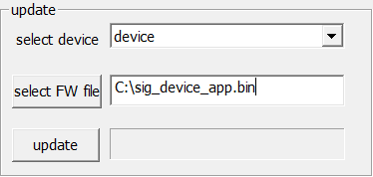

**Expected Performance:**

During the upgrade process, the progress bar keeps increasing. Until the upgrade is complete, a prompt box "flash ok" pops up, click the ‘Get Log’ button and you can see log prints: ‘idle log: xxxx’ which indicates the device app is running.

**Unexpected Performance:**

1. If update POC2 or POC3 device with signed firmware(sig_device_app.bin), or update POC4 device with unsigned firmware (device_app.bin), upgrade will fail and prompt box is same as the picture below. The device can not be used unless upgraded with suitable signed firmware file.

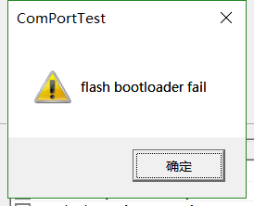

1. After Step 3, if progress bar does not increase at all and prompt box is same as the picture above, most probably the device is in shutdown mode. Please press the button on device to wake it up and update it again.
2. If serial cable is disconnected during the upgrade process or some uncertainties abort the upgrade, please check the connection and upgrade it again.

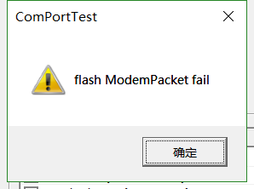

1. If using signed firmware file whose signature is fake to upgrade the POC4 device, firmware can be programmed in device successfully, then it will be erased due to the security boot Process. The device still can be upgraded with real signed firmware file.