## synonym.vialab.ca

# Text to transcribe:

* *Document Search*
* *Journal Search*
* *Need help?*
* *What would you like to search?*
* *Finding new ways to explore the Erudit corpus.*
* *Recent searches*
* *Upload a document*
* *Click here or drag and drop a document to upload*
* *Article*
* *Keywords*
* *View more*
* *Missing terms*
* *Query results*
* *Search*
* *Select a term*
* *Search for a keyword*
* *Suggestions for “x” …*

*Contextual examples can be found below for reference.*

## synonym.vialab.ca/

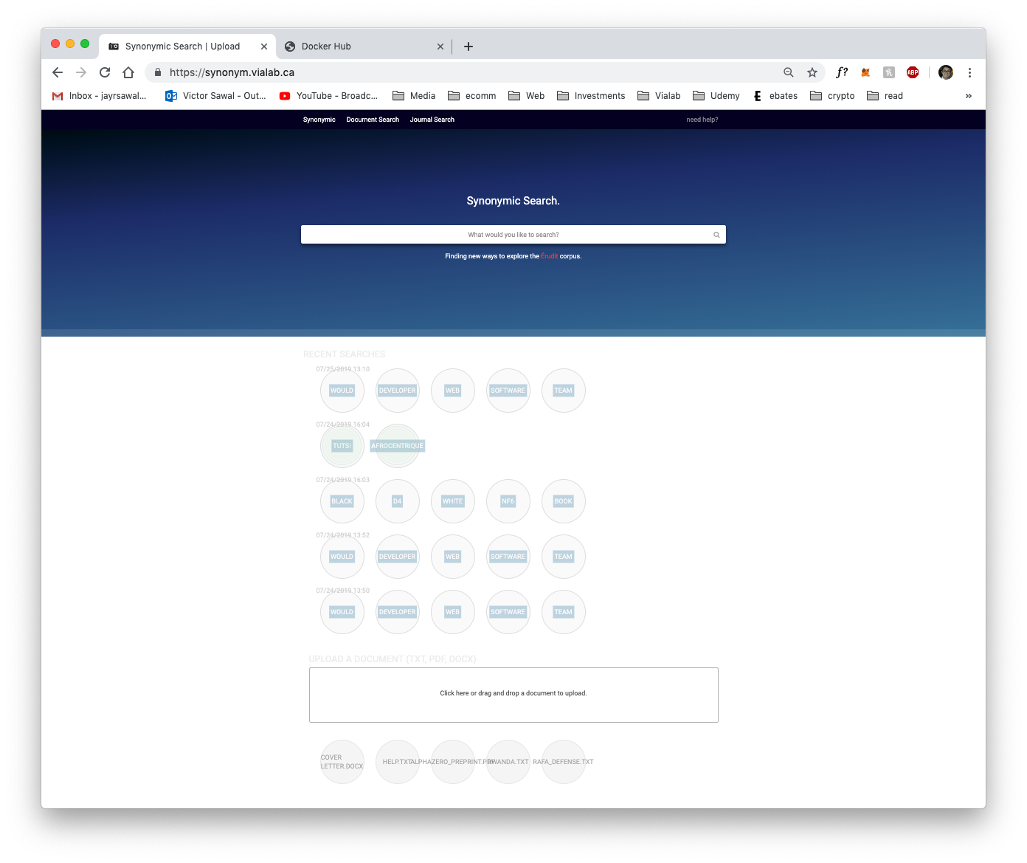

* *Document Search*
* *Journal Search*
* *Need help?*
* *What would you like to search?*
* *Finding new ways to explore the Erudit corpus.*
* *Recent searches*



* *Upload a document*
* *Click here or drag and drop a document to upload.*

## synonym.vialab.ca/analyzer

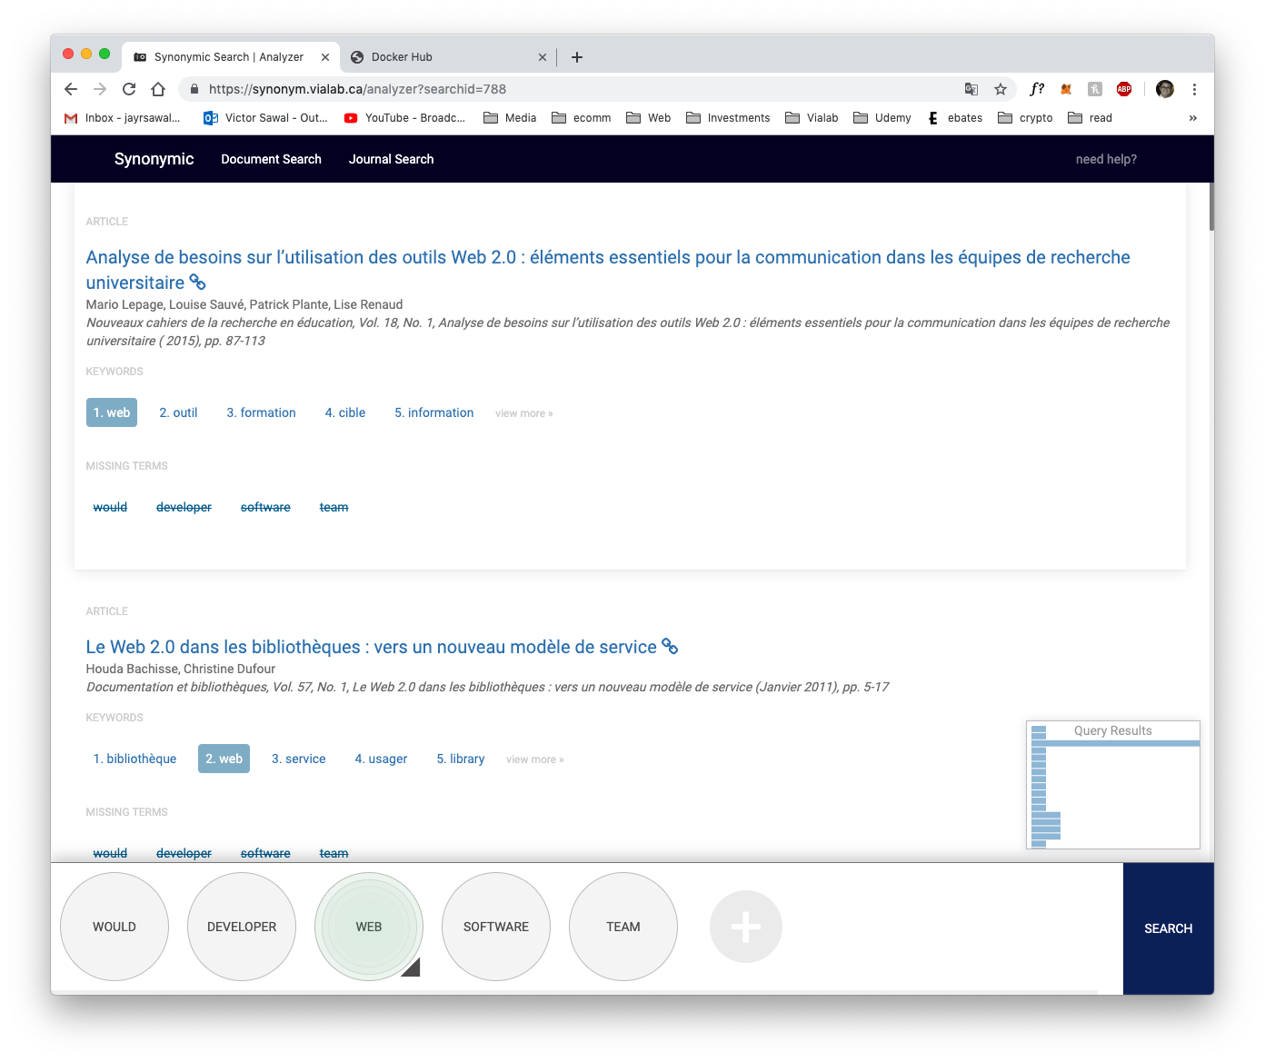

* *Article*
* *Keywords*
* *View more*
* *Missing terms*

**

* *Query results*
* *Search*

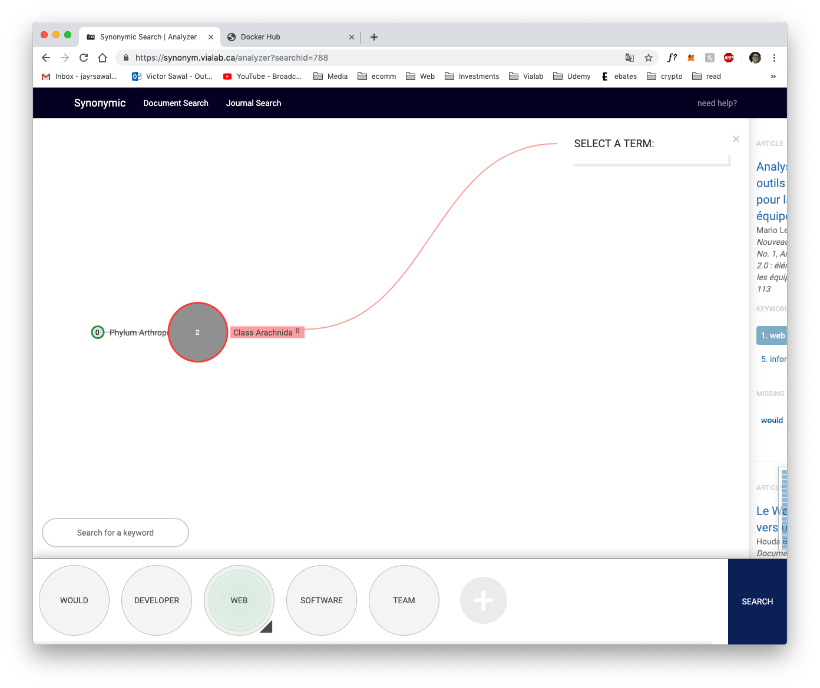

* *Select a term*
* *Search for a keyword*

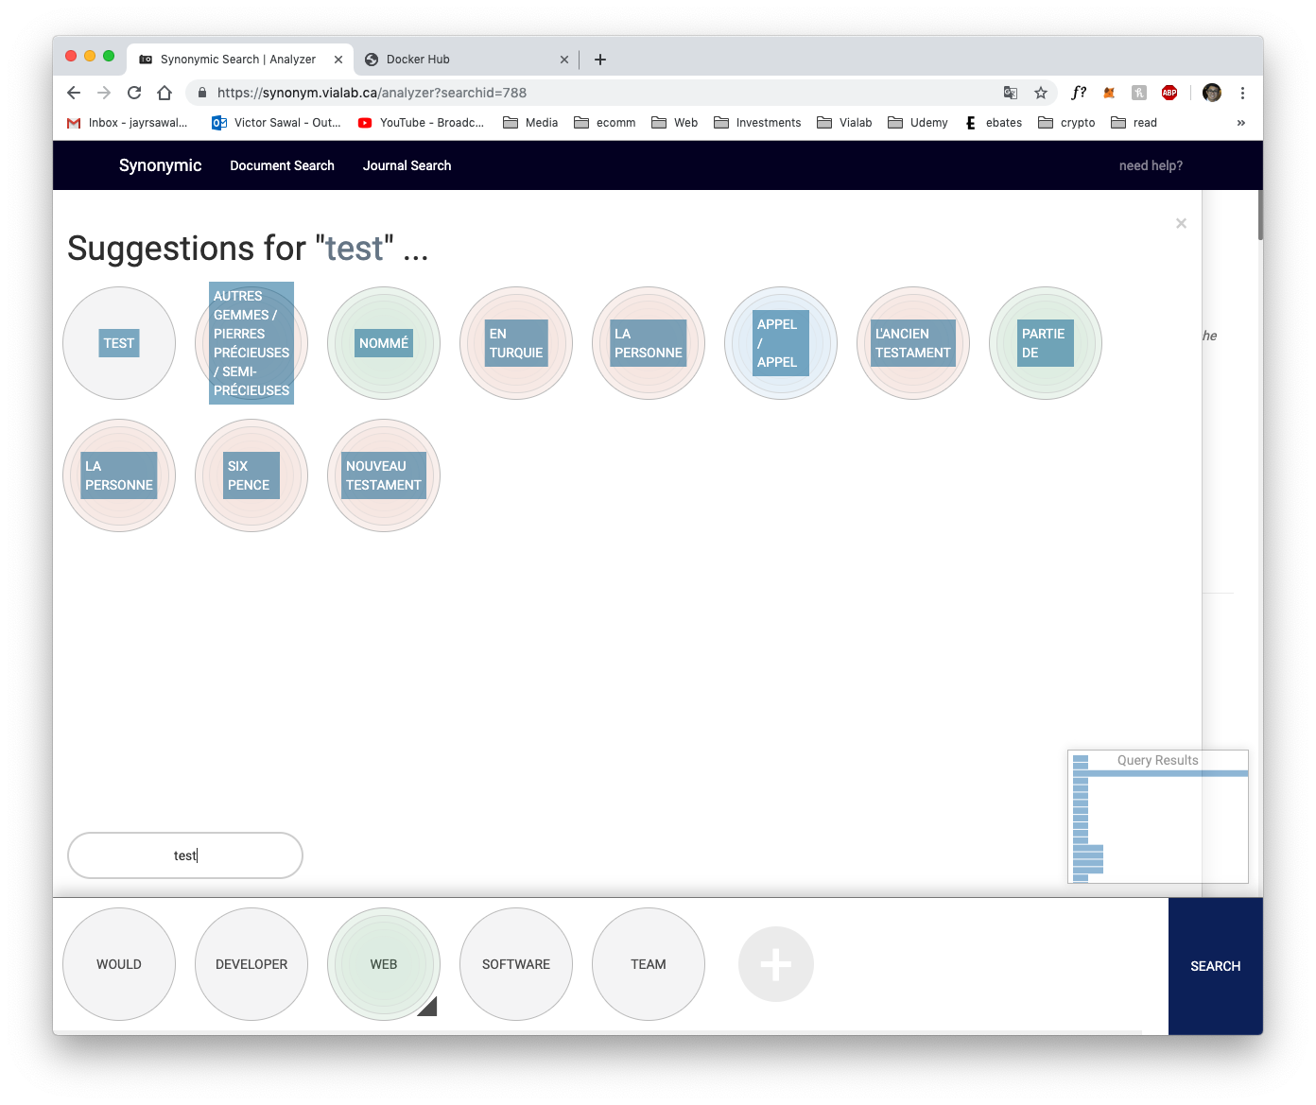

* *Suggestions for “x” …*