TARGET v1.0 user manual

1. License and code availability

TARGET is distributed under the Creative Commons Attribution-NonCommercial-ShareAlike 4.0 Generic (CC BY-NC-SA 4.0) license. TARGET code cannot be used for commercial purposes. The code can be downloaded from github at: <https://bitbucket.org/mothlight/target_java>

2. System requirements

TARGET requires Java Runtime Environment (JRE) 8 (or greater) and should run on any OS system. We have tested TARGET in Ubuntu 16.01, MacOS Sierra, and Windows 7. Do download and install JRE8 visit this [website](https://www.oracle.com/technetwork/java/javase/downloads/jre8-downloads-2133155.html).

Summary of requirements:

* Java JRE 8 or greater
* NetCDF 4.6.11 (jar file is provided in repository)
* SLF4J 1.7.14 (jar file is provided in repository)

3. Downloading the code

Java code can be downloaded from Github. Or by cloning the Git repository.

git clone https://mothlight@bitbucket.org/mothlight/target_java.git

Project was developed in Eclipse Neon.3 and can be easily opened and ran in Eclipse.

4. Input files and model setup

*4.1 Control file and directory setup*

There are 3 files needed to run the model:

* Control file
* Meteorology file
* Land cover file

The paths to these directories and the output directory should be defined in the control file.

In control file the user defines the following:

|  |  |  |
| --- | --- | --- |
| **Variable** | **Description** | **Format** |
| site_name | This is the name of site - an “output” and “input” folder will be created from the site_name | String  e.g. Mawson |
| run_name | Name of the run – a netcdf output file will be placed in the site_name folder, and will have the name defined by this variable. | String  e.g. Mawson_100m_grid |
| Inpt_met_file | Name and path of meteorological data input file | String |
| inpt_lc_file | Name and path of land cover data input file | String |
| output_dir | Path for output files | String |
| date_fmt | Date format used in meteorological file | String  e.g. %d/%m/%Y %H:%M  corresponds to 18/01/2016 12:30 |
| timestep | Model time step in seconds | String  e.g. 1800S (30 min) |
| Include roofs | Include impacts of roofs on canyon air temperature | String  Y or N |
| SpinUp | Spin up start date  Year,month,day,hour | integers  e.g. 2011,2,15,0 |
| StartDate | Simulation start date  Year,month,day,hour | integers  e.g. 2011,2,15,0 |
| EndDate | Simulation end date  Year,month,day,hour | integers  e.g. 2011,2,15,0 |
| mod_ldwn | Model incoming longwave radiation if observations are not available | String  Y or N |
| domainDim | Number of gird squares in the model domain (x,y) | integers  e.g. 50, 100 is 50 columns and 100 rows. |
| latEdge | Latitude of eastern edge of upper-left grid cell | Float  Decimal degrees  e.g. -37.505054 |
| lonEdge | Longitude of eastern edge of upper-left grid cell | Float  Decimal degrees  e.g. 144.647901 |
| latResolution | Latitude resolution | Float  Decimal degrees  e.g. 0.00004294 |
| lonResolution | Longitude resolution | Float  Decimal degrees  e.g. 0.0021849 |
| disableOutput | Suppress output of variables – remove any variables from this list you want outputted. | Strings  Default:  Fid, Utb, TsurfWall, TsurfCan, TsurfHorz, Ucan  Utb – above canyon air temp  Tsurfwall – wall surface temperature  TsurfCan – surface temperature inside the canyon  TsurfHorz – surface temperature, excluding walls  Ucan – wind speed in the canyon |
| z0m_rur | Surface roughness at the reference site.  See Table 4.2 “Urban Climate” Oke et al. (2017).  “Farmland crops” is typically a good value for airport sites – 0.05 – 0.15 m | Float  e.g. 0.15 |
| z_URef | Height of reference wind speed measurement height (m) | Float  e.g. 10.0 |
| z_TaRef | Height of reference air temperature measurement height (m) | Float  e.g. 2.0 |
| Zavg | Average building height in the domain (m) | Float  e.g 5.0 |
| ref_surf | Surface type at the reference site | String  This should be dry grass uncles otherwise known  e.g. dry |

*4.2 Meteorological data*

TARGET requires reference meteorological data to drive the model and calculate urban air temperature. The following meteorological variables are required: incoming shortwave (solar) radiation, incoming longwave (terrestrial), relative humidity, reference wind speed (typically at 10 m), and air temperature. The user must define the height above ground of reference wind speed and air temperature measurements. Ideally, meteorological data should be representative of a nearby airport. If this is unknown assume reference station land cover is 100% dry grass.

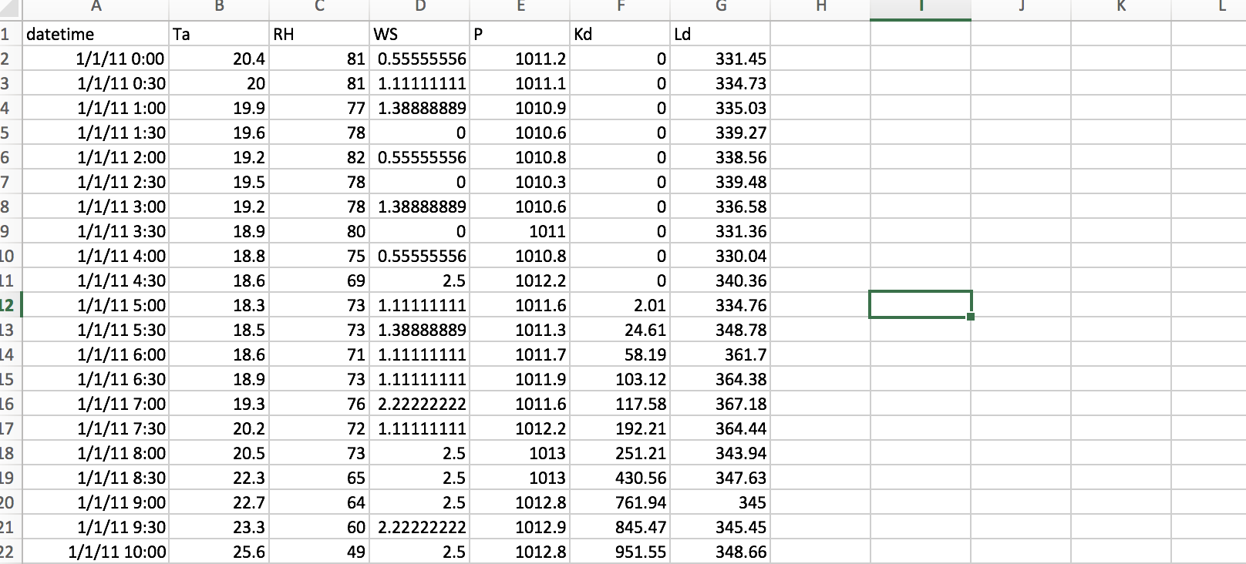

Meteorological data should be stored in csv format with the following column headers:

datetime – date and time, e.g. 1/1/2011 12:00

Ta – air temperature in degrees Celsius

RH – relative humidity in percentage

WS – wind speed in meters per second

P – atmospheric pressure in mb/hPa

Kd – incoming shortwave radiation in Wm-2

Ld – incoming longwave radiation in Wm-2

See example meteorological data file attached.

*4.3 Land cover data*

Land cover data should be provided for the entire domain. The planar fraction of land cover types and building heights and widths for each grid cell are defined in a csv file. The csv file should have land cover types fractions defined for grid square (grid cell etc.). Land cover fractions for grid square are placed in rows of the csv file and stacked on top of each other. The top row of the csv corresponds to top left pixel in the grid. See example land cover data files provided for further guidance.

Example of the numbering of the grid:

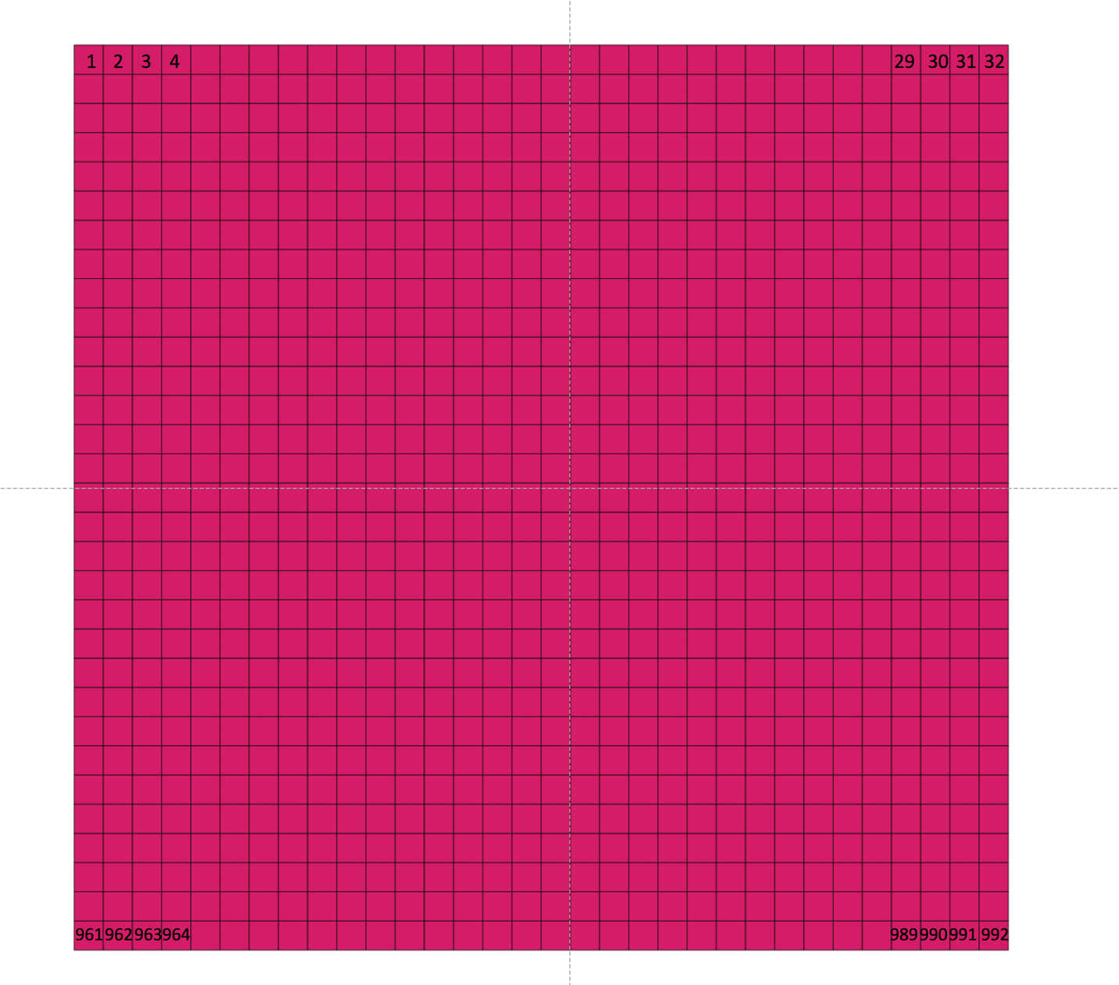

Example of land cover input file:

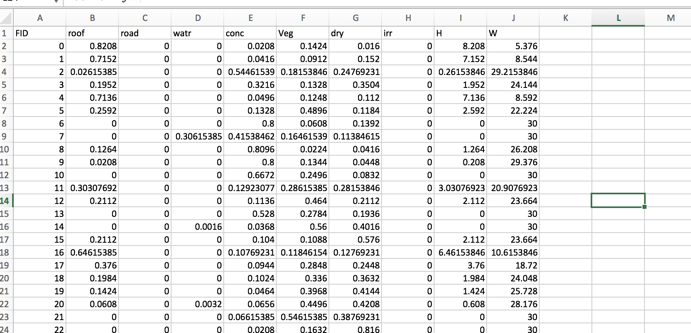

CSV format:

FID – cell identifier, unique numerical number for each grid point (can start at 0 or 1)

roof – fractional roof planar area

road – fractional road planar area

watr – factional water planar area

conc – fractional concrete planar area

Veg – fractional tree planar area

dry – fractional dry grass area

irr – fractional irrigated grass/low vegetation area

H – average building height (m)

W – average street width, distance between buildings (m)

These data can be derived at resolution of the user choice. A resolution of 100m is recommended for air temperature simulations. If the user has exiting raster land cover datasets, an easy way to tabulate these data is (1) define a fishnet with resolution 100m m and (2) use ArcGIS function “tabulate area”.

5. Executing the code

Code can be run from within Eclipse or from the command line, for example:

$ cd src/   
[$](mailto:kerryn@mu00038561:.../mothlight-target_java-85fc86f776fa/src$) cd Target/   
[$](mailto:kerryn@mu00038561:.../src/Target$) javac -cp ../../netcdfAll-4.6.11.jar *.java   
[$](mailto:kerryn@mu00038561:.../src/Target$) cd ..   
[$](mailto:kerryn@mu00038561:.../mothlight-target_java-85fc86f776fa/src$) java -cp ../netcAll-4.6.11.jar:. Target.RunToolkit /path/to/controlfile.txt

where “/path/to/controlfile.txt” represents the actual path on your machine to the control file. Also, see the “run_station_example.sh” script in example folder for more details.