http://120.26.112.74:8080/CrossTableInfo.aspx

http://120.26.112.74:8080/OptionMainInfo.aspx

http://120.26.112.74:8080/GetSelectOption.ashx? selectkind= 0

string kind = req.QueryString["selectkind"];

string json = "";

if (kind == "0")

{

BusinessSvc bs = new BusinessSvc();

json = JsonConvert.SerializeObject(bs.GetCfgPositions());

}

else if (kind == "1")

{

json = JsonConvert.SerializeObject(ASaleKind.GetSaleKinds());

}

else if (kind == "2")

{

json = JsonConvert.SerializeObject(CrossTableKindSelect.GetCrossTableKindSelects());

}

comboBoxPositionList.DataSource = bs.GetCfgPositions();

comboBoxPositionList.DataTextField = "PositionName";

comboBoxPositionList.DataValueField = "cfgOptionPK";

comboBoxPositionList.DataBind();

comboBoxCrossTable.DataSource = CrossTableKindSelect.GetCrossTableKindSelects();

comboBoxCrossTable.DataTextField = "crossTableName";

comboBoxCrossTable.DataValueField = "crosspk";

comboBoxCrossTable.DataBind();

comboBoxPositionKind.DataSource = ASaleKind.GetSaleKinds();

comboBoxPositionKind.DataTextField = "KindName";

comboBoxPositionKind.DataValueField = "KindName";

http://120.26.112.74:8080/GetCrossTableInfo.ashx?

输入

comboBoxPositionList

comboBoxPositionKind

comboBoxCrossTable

参数

返回json

public string FctCommandID { get; set; }

public int CommandType { get; set; }

public string Condition { get; set; }

public int Finish { get; set; }

public DateTime SendDateTime { get; set; }

public DateTime? CallBackDateTime { get; set; }

public string CommandResult { get; set; }

CommandResult =》json

public string Buy4 {get;set;}

public string Buy3{get;set;}

public string Buy2{get;set;}

public string Buy1{get;set;}

public string CurrentPriceID { get; set; }

public string Sell1 { get; set; }

public string Sell2 { get; set; }

public string Sell3 { get; set; }

public string Sell4 { get; set; }

public int[] intFlag = new int[9];

public Option[] KindOption = new Option[9];

展现见 CrossTableInfo.aspx

KindOption[i] =null的情况下

intFlag = 1 变LightPink intFlag = 2 变 LightGreen

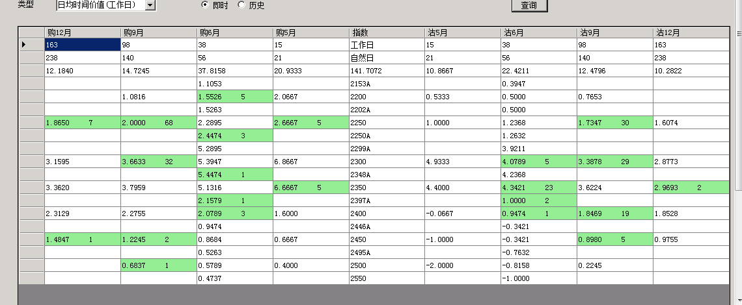

http://120.26.112.74:8080/ OptionMainInfo.aspx

输出： public string FctCommandID { get; set; }

public int CommandType { get; set; }

public string Condition { get; set; }

public int Finish { get; set; }

public DateTime SendDateTime { get; set; }

public DateTime? CallBackDateTime { get; set; }

public string CommandResult { get; set; }

CommandResult =》json

public string PositionName { get; set; }

public double NakedPosition{ get; set; }

建议出卖合约 还需要制作，应该放在OptionMainInfo下,会添加属性。

