http://120.26.112.74:8080/CrossTableInfo.aspx

http://120.26.112.74:8080/OptionMainInfo.aspx

标准格式code,data,msg

http://120.26.112.74:8080/GetSelectOption.ashx

返回标准格式

data的结构

public string Key { get; set; }

public List<WebSelect> Value { get; set; }

WebSelect

public string Value { get; set; }

public string Name { get; set; }

http://120.26.112.74:8080/GetCrossTableInfo.ashx?

输入

SelectList=%7b%22PositionID%22%3a%220%22%2c%22SaleKind%22%3a%22%e6%88%90%e4%ba%a4%e4%bb%b7%22%2c%22CrossTable%22%3a%220%22%7d

{"PositionID":"0","SaleKind":"成交价","CrossTable":"0"}

参数

返回标准格式

data =》json

public string Buy4 {get;set;}

public string Buy3{get;set;}

public string Buy2{get;set;}

public string Buy1{get;set;}

public string CurrentPriceID { get; set; }

public string Sell1 { get; set; }

public string Sell2 { get; set; }

public string Sell3 { get; set; }

public string Sell4 { get; set; }

public int[] intFlag = new int[9];

public Option[] KindOption = new Option[9];

展现见 CrossTableInfo.aspx

KindOption[i] =null的情况下

intFlag = 1 变LightPink intFlag = 2 变 LightGreen

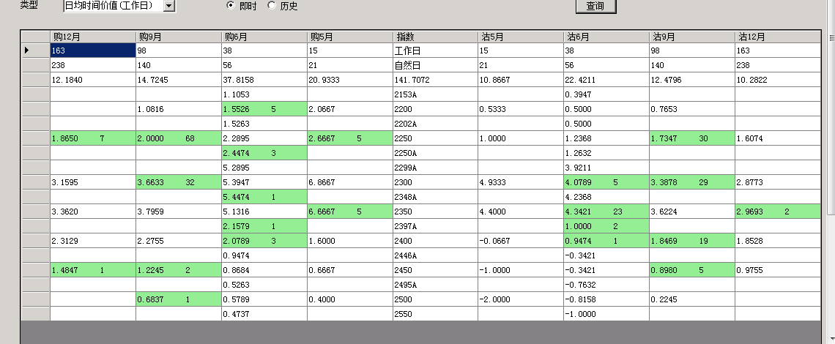

http://120.26.112.74:8080/GetSelectOption.ashx

输出：

data =》json

public string PositionName { get; set; }

public double NakedPosition{ get; set; }

这里会加属性，请留有余地。

