**Solar Spectroscopy**

**Via Nielson**

**ASTRO 361 Lab 6 Report**

**Abstract**

Using a SGS spectrometer, scattered sunlight off the atmosphere was captured to produce and analyze the solar spectra using python routines. This requires calibration spectra; in this experiment, helium and neon were utilized to allow cross-checking of the final wavelength solution used to identify solar features. First order linear-mapping of the form was integrated to calibrate and produce the results. Five Fraunhofer features were clearly recorded, namely, the C line of Hydrogen-alpha, the line of magnesium, the Sodium Na-D line, and two instances (lines A and B) of oxygen lines. Line broadening and smearing were detected, brought on by low-resolution grating used within the telescope and atmospheric distortion. The intensity and wavelength of these features were analyzed using a solar spectra consisting of two 20 second exposures to identify the presence and amount of specific elements that compose the sun. A SNR of 163.634 was calculated for this laboratory’s data.

**Introduction**

The object of this set of observations is to take, calibrate, and accurately define features of the solar spectrum. Once the pattern of the lines of a particular element have been observed in the laboratory, it can be determined whether those elements exist within the sun simply by matching the pattern of the absorption lines. In this laboratory, lines are matched to a best fit for calibration elements Ne and He to properly identify solar absorption lines. The motivation for accurately defining the features of the solar spectrum is to be able to define the elemental composition of our sun to provide a general basis for more advanced solar research.

The spectrum of an object is the flux of the light per unit wavelength. When the object emitting light is glowing due to hot gas (or absorbing due to cool gas), the locations of spectral lines are signatures​ of the elements contained in the gas. Spectral lines also can tell about stellar magnetic field properties and radial velocities. This information is valuable for a plethora of applications. For instance, a relevant Fraunhofer spectral absorption line determined in this experiment includes the Hydrogen-Alpha line. H-ɑ filters center on a wavelength of 6562.8 Å and allow through only a tiny part of the red light the sun produces, blocking all other colors. Solar flares and prominences are best seen through an H-ɑ filter. Moreover, high granulation and supergranulation detail, and impulsive-phase flare eruption kernels are visible at the Sodium Na-D line (5895.9 Å) which was also detected in this laboratory.

The second relevant motivation for this laboratory is to both identify and understand factors that produce error and inconsistencies between the theoretical and experimental data. The composition of the atmospheric background from the solar spectral data influenced several feature widths and shapes. Secondly, noise from the use of low-resolution grating was observed.

**Theory**

The main theory behind this experimentation lies within the physical processes of the SGS spectrometer used in this laboratory- specifically, the grating mechanisms. A spectrometer is an imaging system used to map plurality of monochromatic images of the entrance slit onto the detector plane. This slit determines the amount of light (photon flux) that enters the optical bench and is essential for the performance of spectrometers [2]. The installed slit ultimately determines the throughput and optical resolution of a spectrometer. Light that enters the optical bench of a spectrometer through the lens is focused onto the pre-mounted and aligned slit. The angle of the light that enters the optical bench is controlled by the slit. In this case, the entrance slit has a length of 18 microns. This, along with grating, acts as the driving force in the determination of spectral resolution, being the maximum number of spectral peaks that the spectrometer can resolve.

Grating is the dispersive element used in this lab. The reflection grating determines the total wavelength range of the spectrometer, as it consists of a mirrored surface ruled with close, equidistant, and parallel lines for the purpose of resolving light into spectra as shown in *Figure 1* [3].

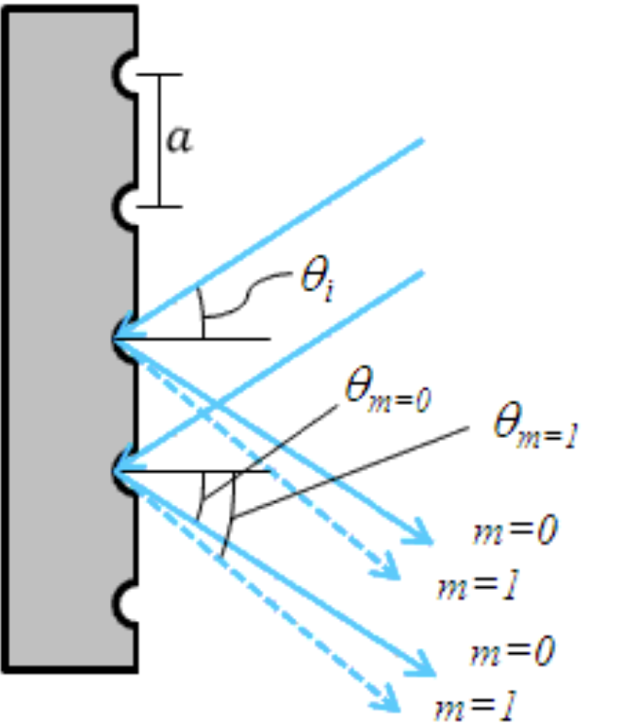

Figure 1

*Reflection grating is pictured above, where the blue arrows indicate the source light being reflected at a deviation angle . It also depicts the varying light can be deflected based upon the diffractive order m [3].*

*Figure 1* depicts how light is reflected off of the ruled surface at different angles corresponding to different orders and wavelengths. Using the geometry of the system, the grating equation for reflective gratings can be found as:

(1)

This equation is representative of narrow-width grooves separated by distance . The incident light impinges on the grating at an angle , as measured from the surface normal. The light of order exiting the grating leaves at an angle of , relative to the surface normal. It is easily observed from (1) that for a given order m, different wavelengths of light will exit the grating at different angles. For white light sources, this corresponds to a continuous, angle-dependent spectrum [4].

The solar spectrum achieved by this method was then calibrated using neon and helium spectra produced in the laboratory. This calibration is necessary to correct for the systematic error presences as mentioned in the introduction. This is done by comparing the experimentally-determined wavelengths to wavelengths obtained from literature. A convenient source of these are the lab neon and helium spectra. By using the theoretically-proven line sequence for each of these elements, calibration using first order linear-mapping of the form

(2)

was conducted to then accurately identify true spectral features from the raw, experimental data.

**Experiment and Methodology**

The SGS spectrometer mounted on the University of Michigan’s Angell Hall 0.4m telescope was used to take the relevant data. The imaging was handled by the SBIG ST-8 serial CCD. The ST-8 camera includes a primary imaging chip and a smaller autoguider chip. The SGS makes use of both, allowing the user to focus and center the object on the slit using the autoguider, then to capture the spectrum using the primary chip [5]. The telescope was not pointed at the sun because its intensity would immediately saturate the Angell detectors. Instead, the telescope was pointed away from the sun to capture the scattered sunlight off the atmosphere. The two calibration spectra of helium and neon were also taken using the SGS spectrometer. All data was taken using low-resolution grating as mentioned in the theory section, and without binning in the wavelength direction.

Using the low resolution grating (150 lines per mm), the spectrometer achieves 3200 angstroms of spectral coverage per frame, with a measured dispersion of ~2 angstroms per pixel. Dispersive spectrometers generate spectra by optically dispersing the incoming radiation into its frequency or spectral components. In this case, the slit of the SGS spectrometer is mirrored, so light from the object strikes the slit and is reflected to a path across the top of the spectrograph and back down to the autoguider. Light passing through the slit strikes the first plane mirror and is reflected to the curved collimating mirror, then to this grating, back to the collimating mirror, to another plane mirror, then finally to the primary CCD. This trajectory can be traced using *Figure 2* [5].

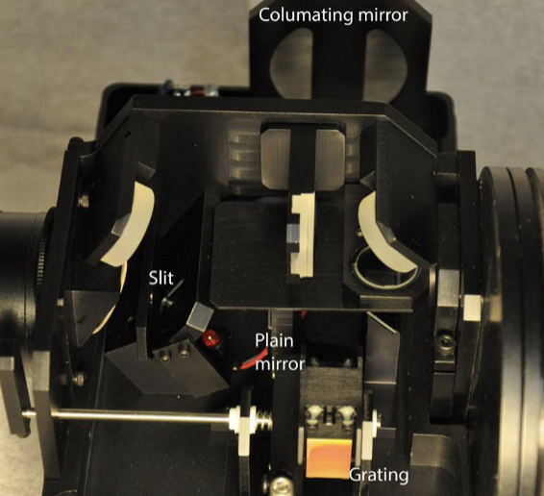

Figure 2

*The SGS spectrometer at Angell Hall [5].*

On November 5th, 2020 at 12:46:10 PM STD the telescope was pointed near the sun in Ann Arbor, MI from the Angell Hall Observatory dome to collect the aforementioned data. The telescope was initially left exposed for ten seconds for the sky, He, and Ne images using 1x4 binning (no binning in the wavelength dimension). Confirming no saturation took place, the exposure time was increased to twenty seconds to improve the SNR. All frames were ‘light’ and auto-data reduction was used by electing ‘AutoDark’ settings. From here, manual clipping took place for increased visual clarity of the spectral lines before saving the data and opening it through Google Colaboratory.

The data was loaded in and immediately flipped about the y-axis to allow wavelength to increase to the right. It was clear from the helium and neon images that the slit ranged from row 0 - 130 and experienced a small tilt. To avoid correcting for the tilt, it was sufficient for the purposes of this laboratory to simply extract a few acceptable rows over which the tilt was negligible. The location of the slit and the angle of the grating reflection affects the mapping between pixels and wavelengths. Since this spectrometer has moving parts that can be adjusted, we have to generally always take "arcs" to calibrate the wavelength scale.

To create a one-dimensional spectrum using these ‘arcs’, rows 10 through 20 were chosen to integrate along the slit to further improve the SNR. The counts from row 10 to 20 were averaged to produce plots of the pixels in the wavelength direction against the normalized flux (achieved by dividing each arc_spec by its maximum value) as shown in *Figures 3* and *4*.

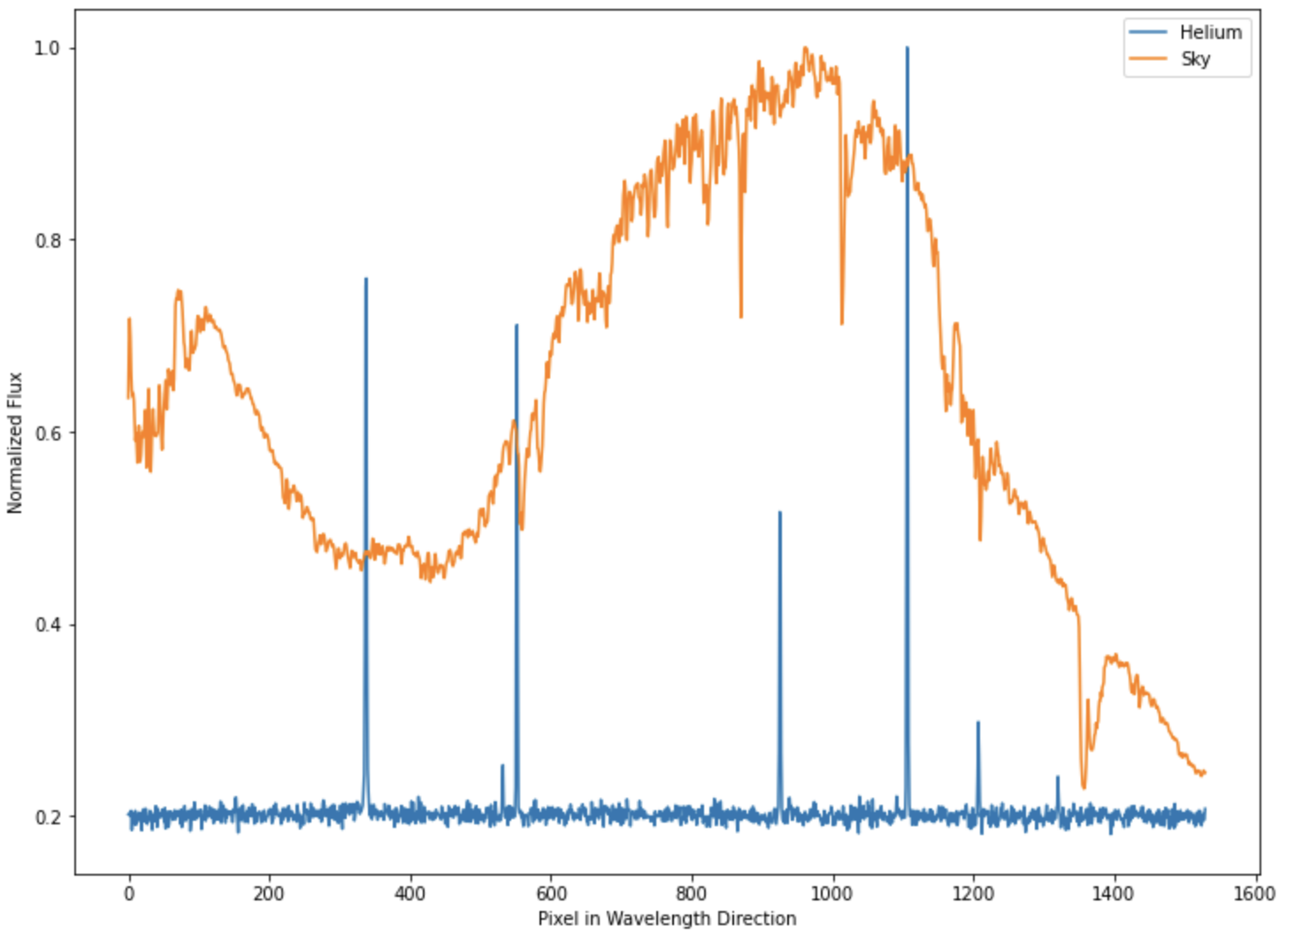

Figure 3

*Pixel number versus the normalized flux of both data from the He lamp and sky arcs.*

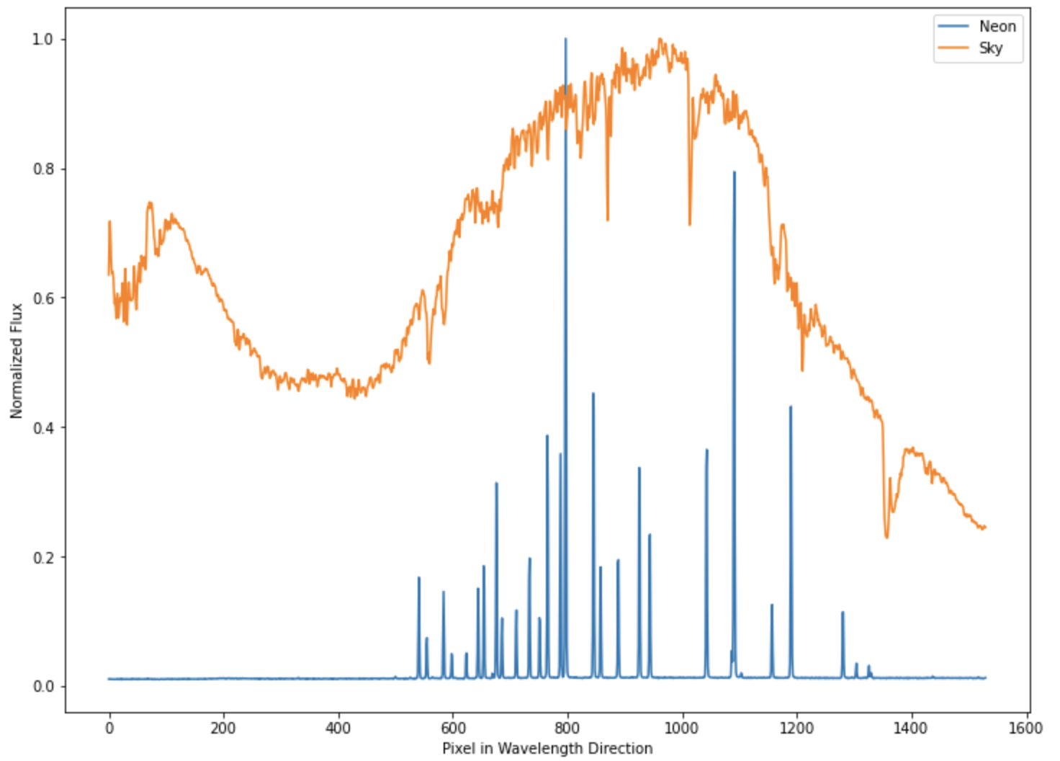

Figure 4

*Pixel number versus the normalized flux of both data from the Ne lamp and sky arcs.*

We observe a series of spikes from the He / Ne emission lines and a more smooth, but jagged, spectrum from the sky (solar spectrum). From here, the data underwent wavelength calibration.

Firstly, for each calibration element, wavelength was plotted against intensity. The results of setting an intensity threshold of 50 for He and 300 for Ne are shown in *Figures 5* and *6*. The red lines shown are indicative of wavelengths that exceed the set intensity threshold.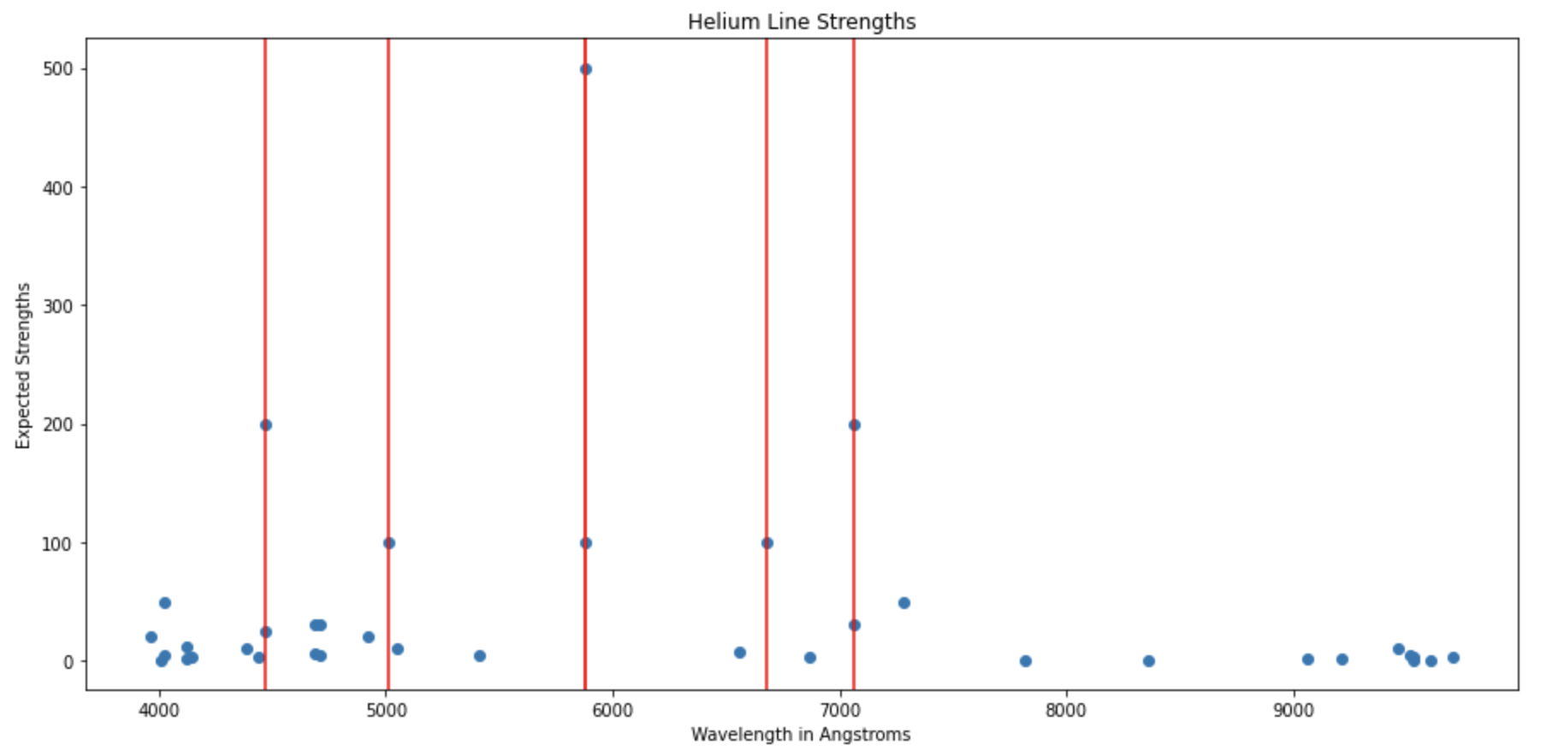

Figure 5

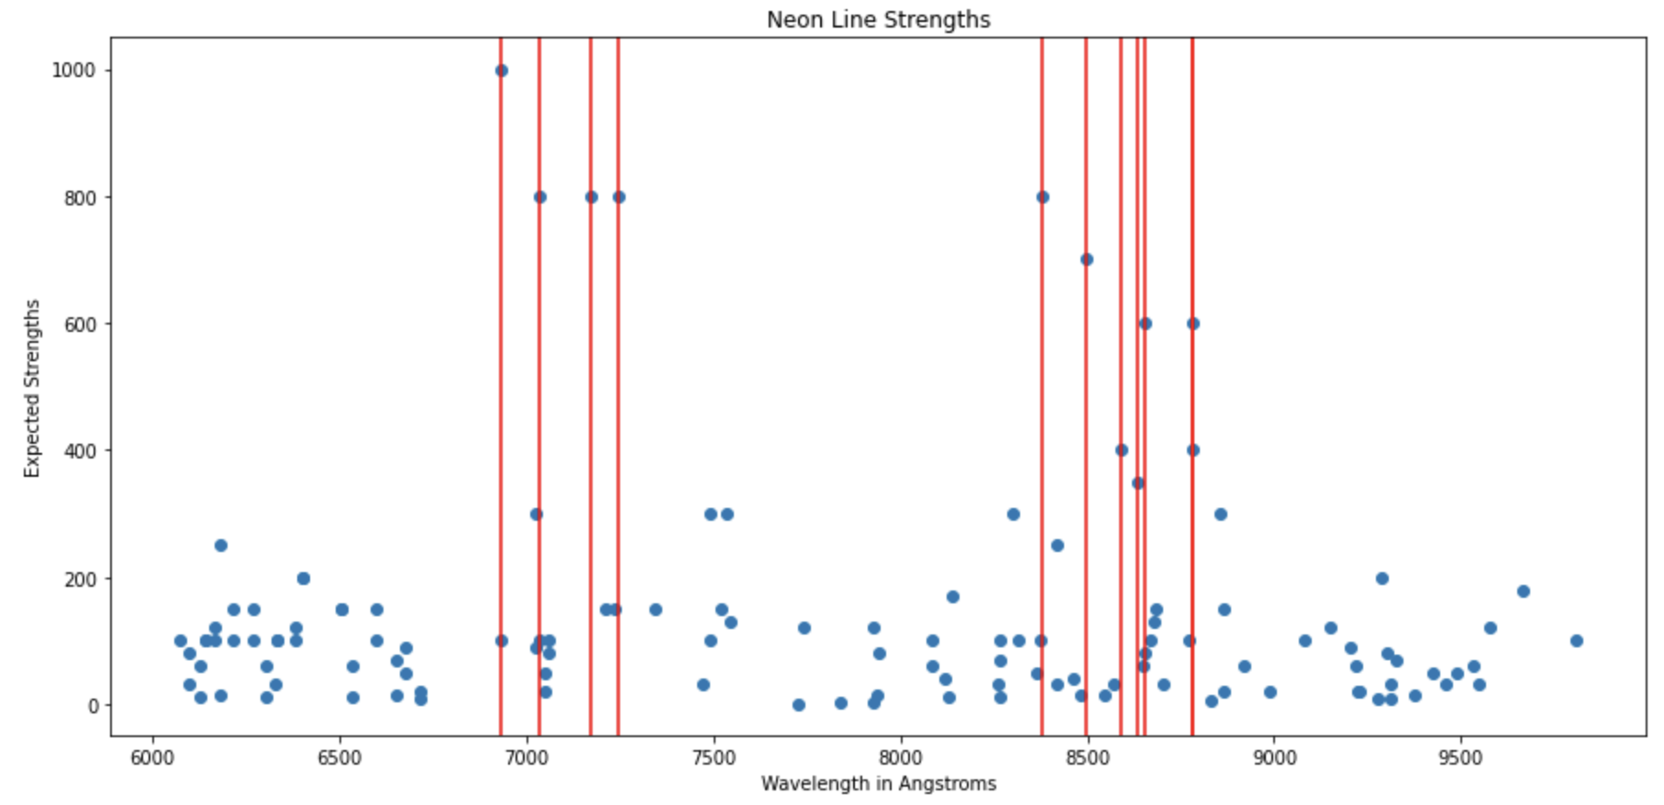

Figure 6

Originally, the calibration was conducted by anchoring the theoretical value overplot to the most intense wavelength for each element. However, this method was insufficient and inaccurate. Instead, using these plots, the calibration of each Ne and He datasets was conducted by eye rather than python fitting routines.

To attempt a wavelength solution, I began with a first order (linear) mapping, as discussed in the theory section of the form was used, where x is pixels and initial guesses began with manipulating and , the scaling of the overplot, was initially set to 2.0 given that the spectral resolution of the system is around 0.2 nm per pixel. These guesses were plotted against both the Ne and He arcs separately, as seen in *Figures 7* and *8* where again, the red lines shown are indicative of wavelengths that exceed the set intensity threshold. This time, the intensity threshold was set lower; He had a minimum intensity of zero whereas Ne had a minimum intensity of 70. This change was made to increase the number of red lines showing the theoretical spectral positioning to ultimately increase the accuracy of the fit.

The initial guesses for and were chosen by recognizing one of the most prominent features of the Neon spectrum. The proven emission line at 7032.413 Å (*Reference 1,* Appendix) was used for and to find the corresponding , np.where() was used. From there, all values were tweaked visually until a sufficient fit appeared.

**Results**

*Figures 7* and *8* below depict the final outcomes of the visually-fitted spectra where the green data was measured in this experiment and the red lines are part of the scalable, proven spectrum (drawn from separate .txt files).

Figure 7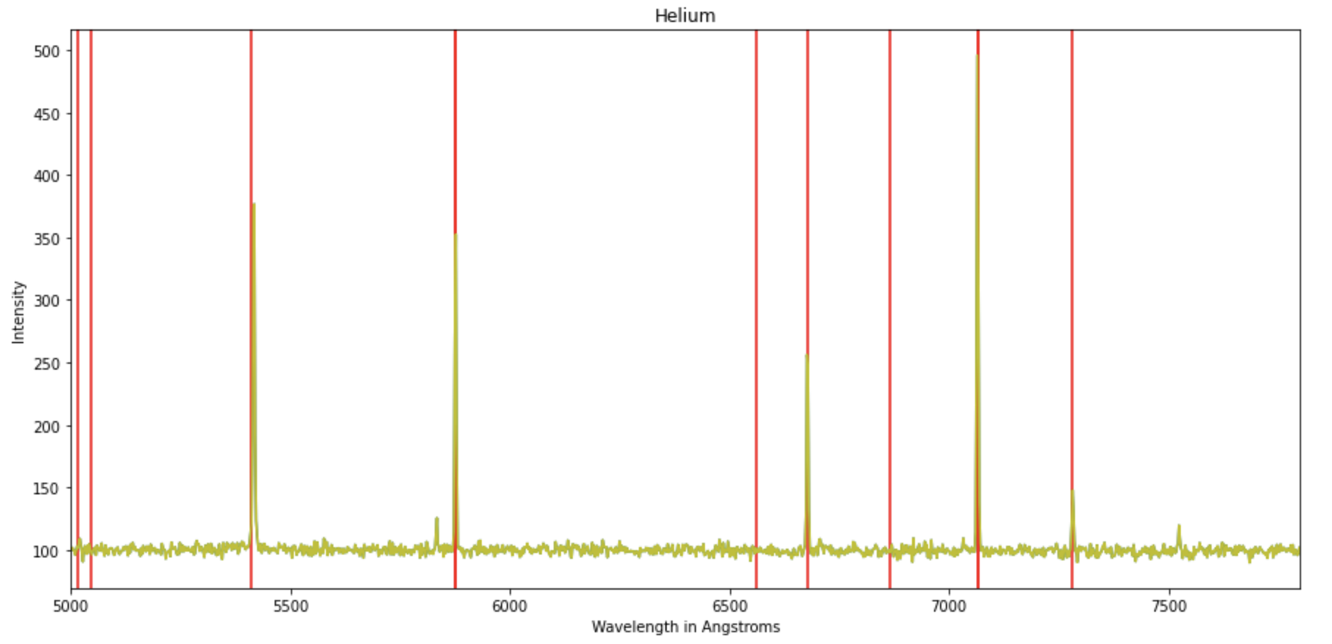

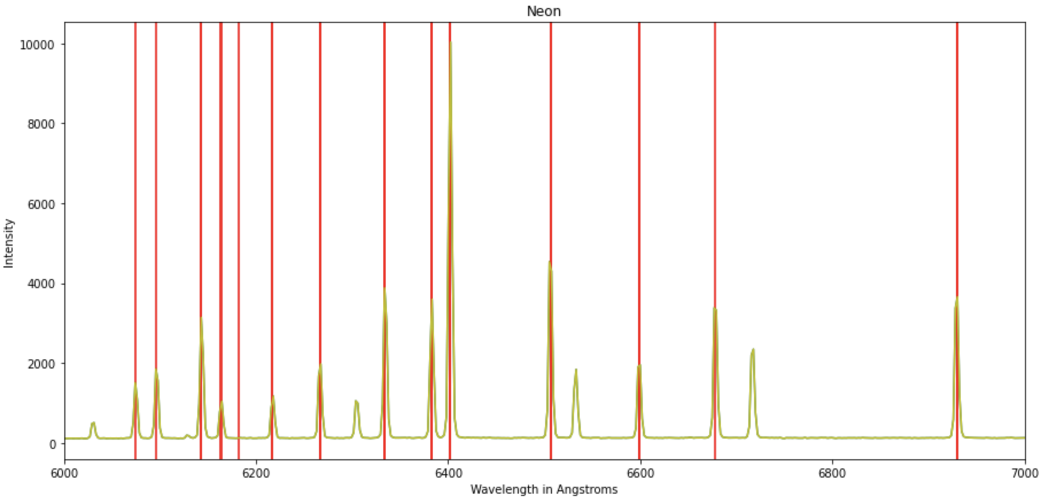

Figure 8

The final fit extracted from the calibration of *Figures 7* and *8* are detailed in *Table 1*. The fits for He and Ne are identical, just as would be expected under optimal conditions. This means that the optics were precise and stable. Even after fine-tuning the fit so that the overplot was dead-center on each peak, no corrections were needed from the He fit to the Ne fit. For a more detailed look into the precision of the centering, see Appendix *References 2* and *3*.

|  |  |  |
| --- | --- | --- |
|  |  |  |
| 7037.4 | 1093 | 2.145 |

Table 1

Upon careful inspection, deviation from linearity in the pixel mapping is measurable and therefore we may conclude that the fits to the known features may noticeably improve by adding a quadratic term of the form. This is seen especially within the lower wavelengths of helium in *Figure 7*. The accuracy of this fit is moderate; it allows most peaks to match, but still it leaves a few peaks unrecognized. There are a few cases where the red lines exist without an observed peak as well.

With this wavelength solution, the solar spectrum from the sky fit file was extracted from the same region of the chip. The spectra were normalized (by dividing them by their max values) before plotted for easier comparison, seen in *Figure 9*. Both spectra of the sky were taken at 20 second exposure times within a few minutes of each other.

Figure 9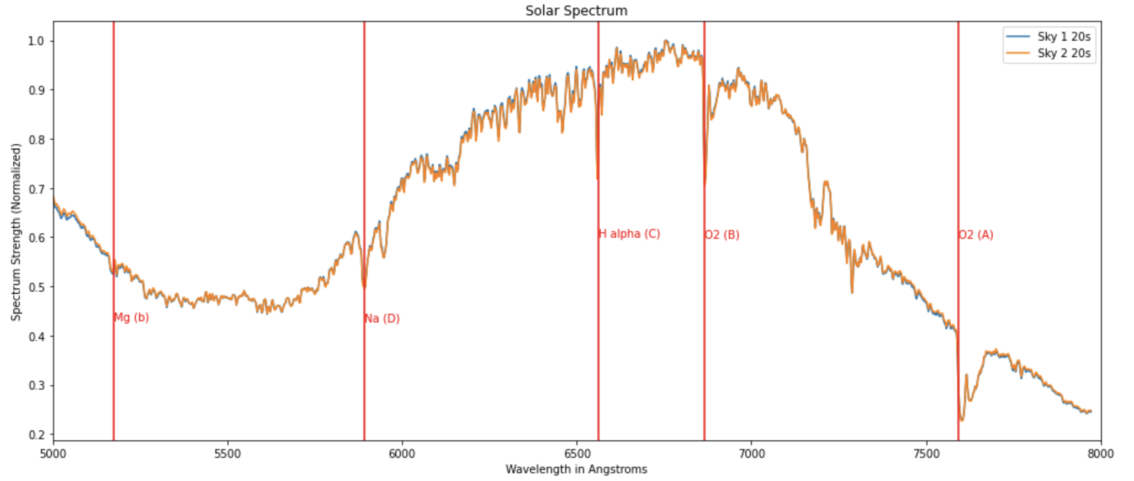

*This plot shows the features labeled according to their theoretical positions. For a graph of the features with the experimentally-determined values, see Appendix Reference 6.*

The spectrum appears to be accurate out to approximately 780 nm. The sky fits at first glance seem to overlap quite well. Zooming in, however, we note that there are observable differences and this provides motivation for calculating the SNR (*Reference 4*).

Taking the rms equal to the standard deviation of the difference between the two normalized fits, and then the SNR equal to the mean of the normalized fit over the mean rms, the SNR value retrieved was approximately 163.634. This is a desirable value for the purposes of this laboratory.

From *Figure 9*, five features were explicitly identified for this lab although further features are observable. These features are “Fraunhofer lines, a set of famous absorption lines named after a German physicist. Fraunhofer designated the principal features with the letters A through K from longer wavelength (redder) to shorter (bluer)” [7]. These features and their values are included in *Table 2*. The theoretical values were plotted first, and then visually adjusted based on the experimental data to retrieve the “measured” values.

|  |  |  |  |  |  |
| --- | --- | --- | --- | --- | --- |
|  | H alpha (C) | O2 (B) | O2 (A) | Na (D) | Mg (b) |
| Theoretical | 6562.81 | 6867.19 | 7593.7 | 5893 | 5172.7 |
| Measured | 6559.3 | 6866.8 | 7603 | 5893 | 5170 |

Table 2

*All measurements have units of Angstroms Å. The theoretical values were taken from source [6].*

These lines are caused by selective absorption of the sun’s radiation at specific wavelengths by various gas elements existing in its photosphere. This means that if we measure the wavelengths of these features, the elements that make up the sun can be determined. Moreover, the relative intensity of these lines tells how much of these elements are present. From *Figure 9*, we observe slight manipulation of the spectra due to the earth’s atmosphere because our data was taken as scattered sunlight. Most of the marked features exhibit expected shapes, although the O2 (A) and O2 (B) lines seem to be broadened. More noticeably, the O2 (A) line actually shows an unexpected “double-dip” more clearly shown in *Reference 5* available in the appendix. We observe line-broadening for a few possible reasons.

Because O2 is also present in our atmosphere, when using an earth-based detector, the O2 line will experience broadening due to the excess presence of this element. Furthermore, this line is smeared due to the limited spectral resolution of the Angell Hall facilities. Another explanation for the double-dip observed with O2 (A), however, is due to the structure of the O2 molecule itself. Although these are all sources of the broadening, the most prominent explanation is that one larger feature is, in actuality, just several smaller lines blurred together. Each element has several prominent, and many lesser, emission lines in a characteristic pattern that clump together in this lab. In part, this is due to the fact that the low-resolution grating was used to take this data. This is not only seen for O2, but also for the Na (D) line where the “sodium doublet” exists as a singular broad line in the results.

Ultimately, these results show that some of the sun’s most prominent compositional elements are oxygen, sodium, magnesium, and hydrogen. The specific relative abundance of these elements is elucidated quantitatively in *Figure 9*. We can draw conclusions upon realizing that H-alpha has the deepest peak, and is therefore the most abundant element of those identified. Conversely, Mg is the least abundant element in the sun of those identified. This conforms to what we already know about the chemical composition of our sun.

**Summary and Conclusions**

In conclusion, the first-order linear mapping chosen to calibrate the helium and neon spectra was sufficient in producing results for the purposes of this laboratory, although may have benefitted from the addition of a quadratic term for increased precision due to the presence of rogue lines and a few uncentered peaks. The five Fraunhofer features that were identified, namely, the C line of Hydrogen-alpha, the line of magnesium, the Sodium Na-D line, and two instances (lines A and B) of oxygen lines, tell that these are some of the major elements present in the sun. The intensity of the Hydrogen-alpha line suggests that it is the most abundant element of those observed, as expected. Although fairly precise, line broadening and smearing were detected, brought on by low-resolution grating used within the telescope and atmospheric distortion. Moreover, the two sky fits of 20 seconds exposure used did not overlap completely, although well enough to produce a SNR of 163.634. The identification of these solar features allow for the chemical characterization of the sun in meaningful and quantitative ways, as a whole.

**References**

[1] Jacksonville, Florida State College. “Studying the Sun | Introduction to Astronomy.” *Lumen Learning – Simple Book Production*, https://courses.lumenlearning.com/atd-fscj-introastronomy/chapter/studying-the-sun/. Accessed 14 Nov. 2020.

[2] “An Introduction to a Spectrometer - The Slit.” *AZoM.Com*, AZoM, 2 Dec. 2016, https://www.azom.com/article.aspx?ArticleID=13374.

[3] “Dispersive Spectrometers.” *SPIE Homepage*, https://spie.org/publications/tt61_121_dispersive_spectrometers?SSO=1. Accessed 13 Nov. 2020.

[4] “Thorlabs.Com - Tutorials.” *Thorlabs, Inc. - Your Source for Fiber Optics, Laser Diodes, Optical Instrumentation and Polarization Measurement & Control*, https://www.thorlabs.com/tutorials. Accessed 14 Nov. 2020.

[5] Spectrograph Instrument Overview Document (Provided for this laboratory)

[6] “Spectroheliograph - Solar Spectrum Atlas.” *Astrosurf - Astronomie*, http://astrosurf.com/spectrohelio/atlas-en.php. Accessed 12 Nov. 2020.

[7] “Fraunhofer Lines of the Sun | Universe of Spectroscopy.” *Universe of Spectroscopy*, http://prc.nao.ac.jp/extra/uos/en/no05/. Accessed 17 Nov. 2020.

**Appendix**

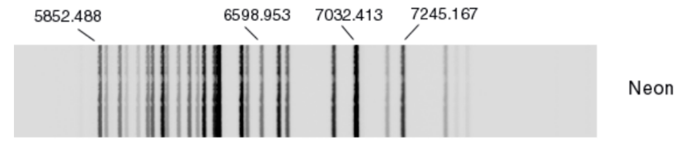

Reference 1

*From literature; proven spectra.*

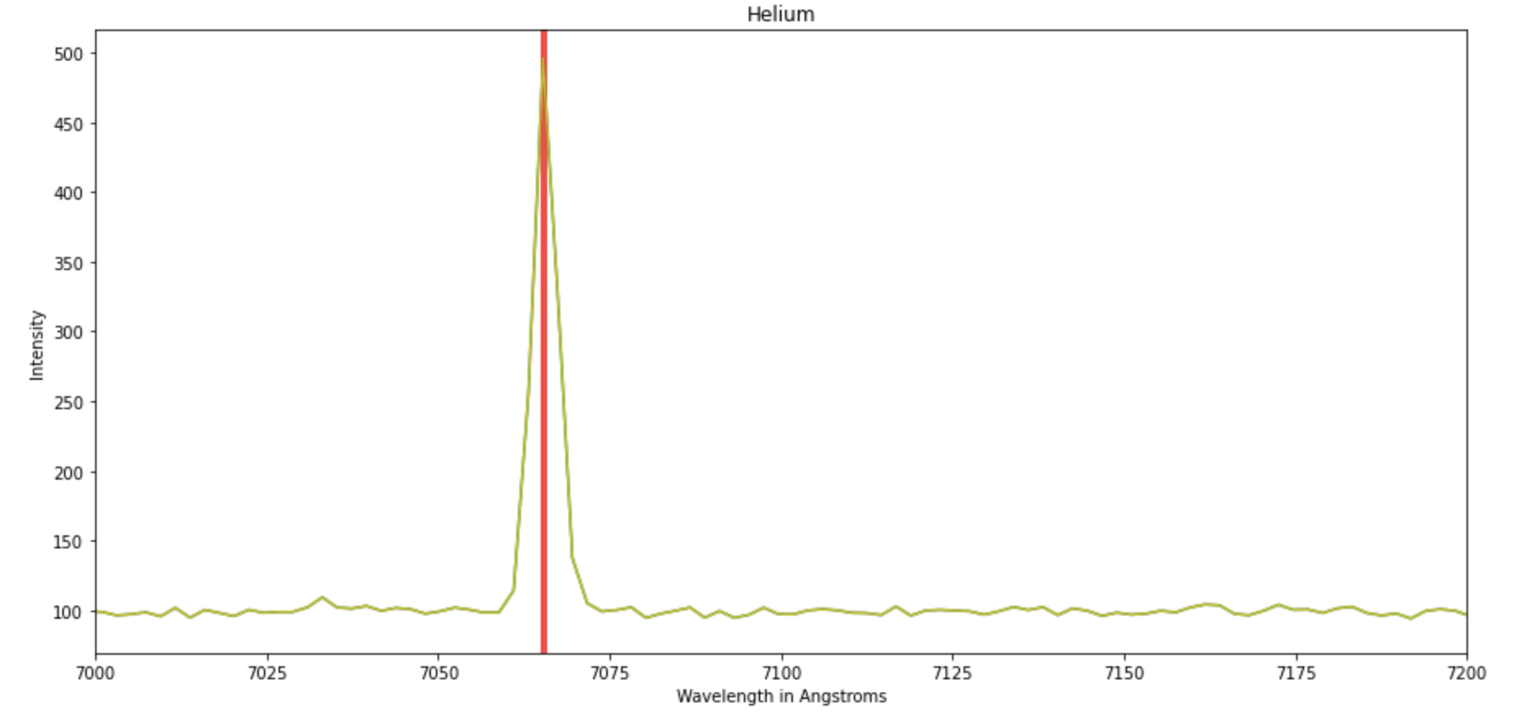

Reference 2

*Exact alignment of the He data, zoomed into an x-limited range of 7000-7200.*

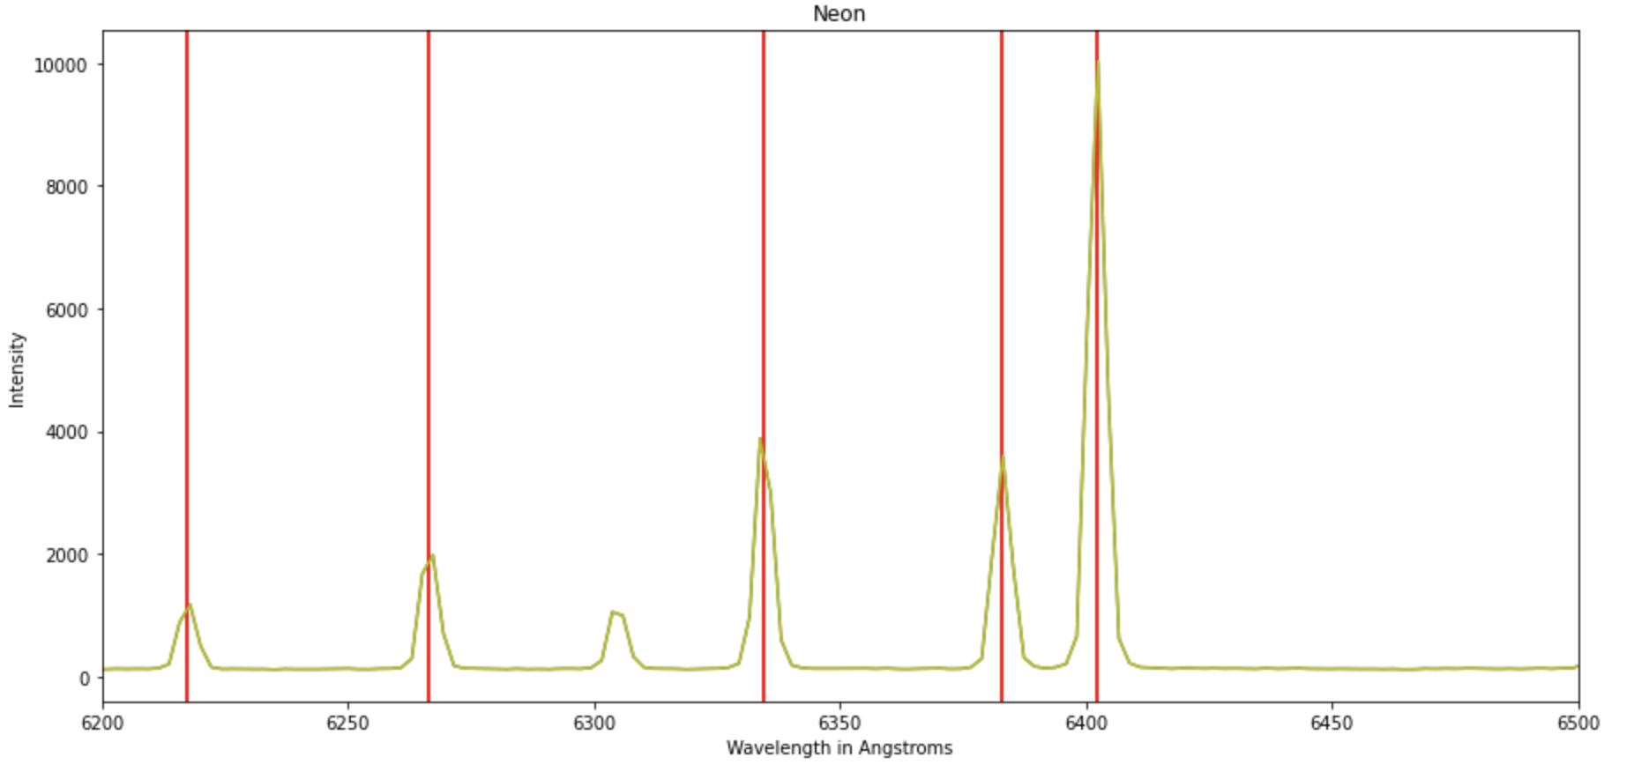

Reference 3

*Exact alignment of the Ne data, zoomed into an x-limited range of 6200-6500.*

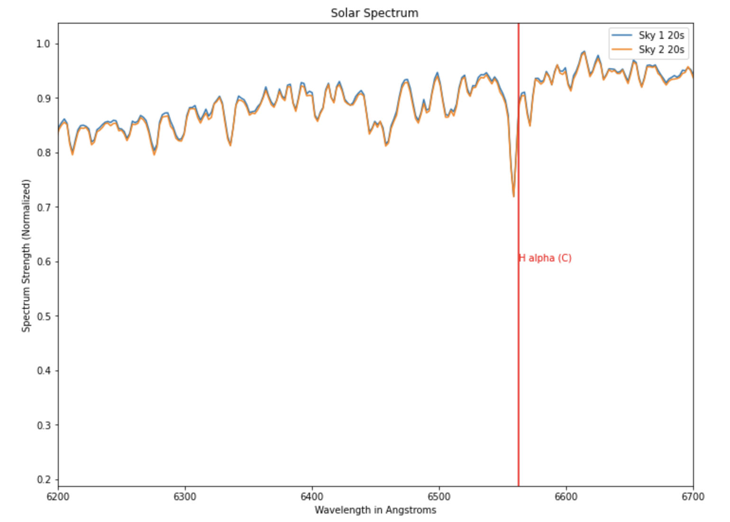

Reference 4

*Solar spectra of sky 1 and sky plotted against each other. This graph is an x-limited range of 6200 to 6700 Angstroms to show they don’t overlap completely. The H-alpha line is set to its theoretical value.*

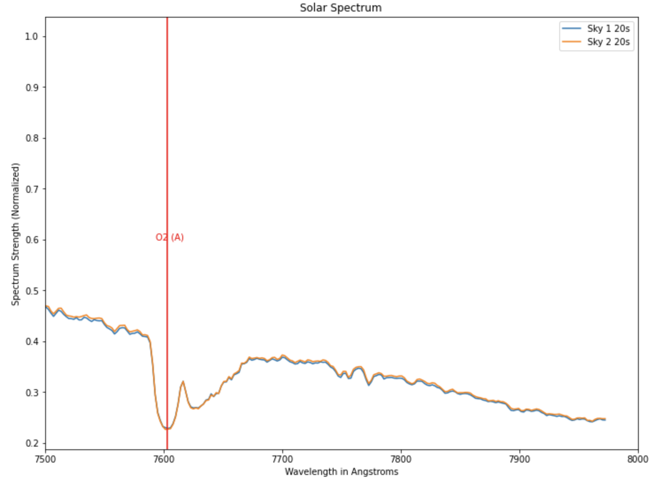

Reference 5

*The O2 (A) feature is set here to its experimentally-determined value. Note the “double-dip” appearance of the feature.*

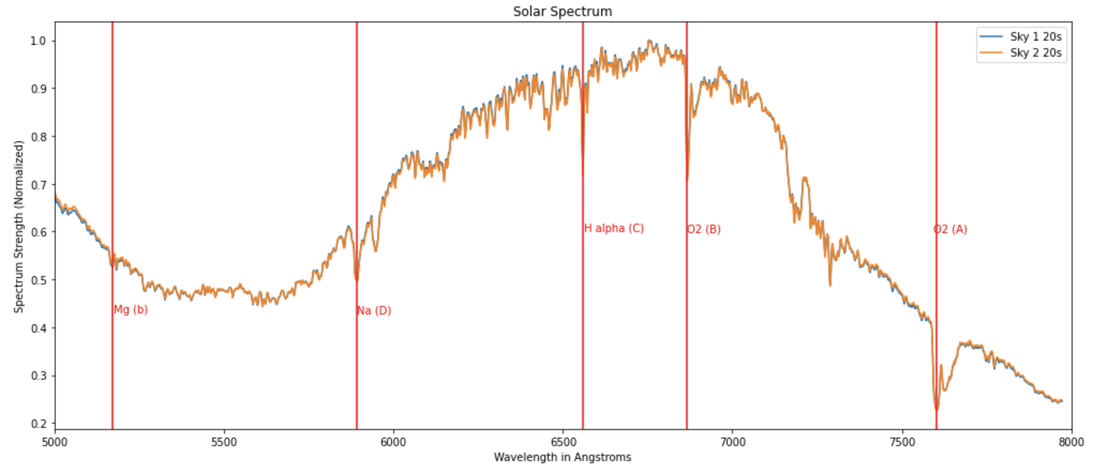

Reference 6

*This plot shows the features labeled according to their experimentally-determined positions. For a graph of the features with the theoretically-determined values, see Figure 9.*