**Radio Profiles of the Sun**

**Via Nielson**

**ASTRO 361 Lab 7 Report**

**Abstract**

Using the University of Michigan’s Small Radio Telescope (SRT), we measure the profile of the Sun and investigate the angular resolution of the SRT. This is accomplished through integrating over a range of frequencies for both elevation and azimuthal solar scans to derive a solar flux measurement. Determining the measured flux from the sun as a function of offset position produces a roughly Gaussian curve, which is finally compared to the expected widths based on the diffraction­-limit of the telescope and the angular size of the sun. We find that the SRT holds a power-space deviationof and a power-space full-width half-maximum of . The calculated FWHM values drawn from this laboratory fall within 0.03 radians for both azimuth and elevation files, noting the higher percent error of azimuth due to coordinate system distortion. We conclude by comparing this to the angular size of the sun to determine that the SRT antenna pattern is larger than the sun.

**Introduction**

The object of this laboratory is to measure the size of sun in azimuth and elevation scans to compare to theoretical value determined by the diffraction­-limit of the telescope and the angular size of the sun. We perform this experimentation to understand the point source response of the Small Radio Telescope based on the wavelength of light and the diameter of the telescope, and compare it to derived experimental values. Secondly, these measurements allow for the quantification of the true diffraction-limit of the telescope and the size of the antenna pattern. Discovering how the size of the antenna pattern relates to image size and quality is a secondary goal of this laboratory. Finally, the motivation to dissect this specific set of observations is to understand how the solar signal received by the SRT can be distorted.

These experimental motivators are important to study because a true understanding of the equipment in use is necessary to obtain not only precise, but generally correct measurements for further analysis. Understanding how the geometry of space and atmospheric distortion can affect signal is crucial to interpreting the data obtained in this laboratory, as will be discussed in further sections. Moreover, acknowledging the inherent limitations of the detector itself (i.e. the quality limitations due to its emphasis on minimizing spillover and interference) is also vital to calibrating one’s analysis of data. Therefore, this laboratory was performed to provide sufficient experimental data to compare to theoretically-derived measurements to ultimately define the noise and limits of the SRT and its environmental conditions.

**Theory**

In order to interpret the results obtained in this laboratory, the point source response of the Small Radio Telescope based on the wavelength of light and the diameter of the telescope must first be dissected. As for most radio telescopes, the SRT feedhorn beam does not uniformly fill the 2.1m telescope aperture of the SRT, but under-illuminates it to minimize spillover and interference.

FWHM is applied to such phenomena as the spectral width of sources used for optical communications. The convention of "width" meaning "half maximum" is also widely used in signal processing to define bandwidth as "width of frequency range where less than half the signal's power is attenuated", i.e., the power is at least half the maximum [2]. If the considered probability density function (pdf) for the Gaussian distribution with mean(expected value) and standard deviation σ is of the form

(1)

we can determine the relationship between FWHM and the Gaussian standard deviation.

First, we must convertfrom power-space (to -field space. Because it is known that, we know then that the sigma of the-field space is equal to. From here, if the data is centered at the origin, the mean is 0 and the FWHM is the distance between the and that produces the half of the peak [2]. For the normal distribution, the mean is the same as the mode (peak) and we have then to find the that will produce

so that we have (2)

(3)

For and solving for :

(4)

The FWHM is . Therefore,

(5)

Converting from power space by substituting , we see that

(6)

Converting again to finally retrieve the FWHM in E-field space, we substitute

(7)

into (6):

(8)

The Fourier transform of a Gaussian function is another Gaussian. FWHM on sky is inversely proportional to FWHM in spatial frequency: fat objects have thin Fourier transforms and vice versa. Again, we use theory in terms of electric fields and not in terms of power (intensity). Therefore, taking the 2-dimensional Fourier transform of the FWHM will result in a second Gaussian distribution of the diffraction-limited angular resolution as shown in *Reference 1*.

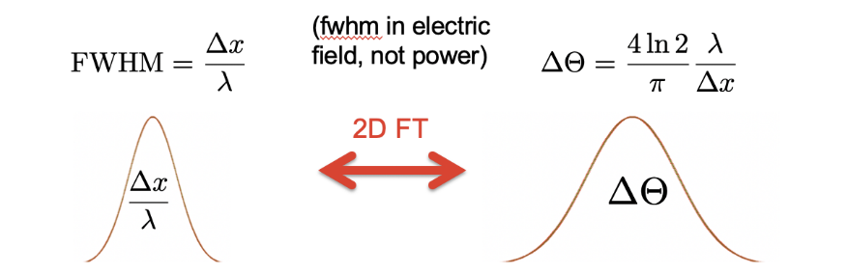

2-Dimensional

Fourier Transform

Reference 1

Using this, we can effectively find the diffraction-­limited angular resolution for the SRT assuming the aperture is a Gaussian beam.

To find the given that is 0.9 meters (not E-field amplitude), we use the relationship outlined above in (7):

Converting to units of wavelength, we use the 21 cm line:

Now that it is in electric space, we are able to invert this and multiply by the constant shown in *Reference 1*:

Converting back into power-space using (7), we retrieve

Squaring the E-field results in sharper Gaussian peaks and ultimately decreases the size of the FWHM. Finally, by (5) we have:

**Methodology and Results**

The Small Radio Telescope at the University of Michigan used for this laboratory’s data acquisition is located in the Angell Hall Observatory. It was developed at the Haystack Observatory and commissioned in 2001. It is capable of continuum and spectral line observations in the L-band (1.42 GHz). The SRT is a standard 7-foot (2.1-meter) diameter satellite television dish mounted on top of a fully motorized Az-El mount. The diameter of the SRT results in a beam width of roughly 5 degrees. The receiver is sufficiently good to detect several strong sources.

Using the SRT, the first step in the data collection process was logging into the SRT controller and pointing it in the direction of the sun (done by clicking against catalog positions). Because the sun was not centered due to inaccuracy of the guidance system, using the offset button, the offset location that gave the maximum detected power was chosen. Once there, a ten second exposure was performed.

Next, a series of observations with elevation offsets offsetting from this position were taken. Elevation offset ranged from -10 to +10 degrees. The SRT was guided in steps of 2 degrees. For each offset position recorded, an estimated 10 seconds of data was recorded. Centering back on the sun, this process was repeated for scanning in azimuth. Azimuth offset ranged from -10 to +6 degrees.

The collected data was formatted in such a way that the first line in the file held telescope positioning information, the second held frequency information, the third, the spectrum, and finally a fourth line containing a row of 1024 numbers (one for each frequency measured). These 4 rows repeat for each subsequent measurement until the exposure ends. Each 4th row of numbers contains a spectrum observed for a short period of time (a “scan”). Because the data was recorded for ~10s, around 5 or 6 or so scans were present in each data file. The spectrum is the flux value (uncalibrated) for a given frequency.

Every data file was read in separately and a ‘while’ loop was created to parse every fourth line from each file into floats for a NumPy array. All of these scans were then averaged together within a singular file. The frequency­ pixel mapping was given in the SRT data. The lower and upper limits of the spectrum in megahertz (MHz) are 1416 and 1426 respectively. The step in frequency from pixel to pixel is called the bandwidth, which for this set­up is 0.009766. Therefore, upon plotting the solar spectra as frequency versus flux, the x-axis is set using these spectra bounds (*np.linspace()*) shown in *Figure 1*.

Figure 1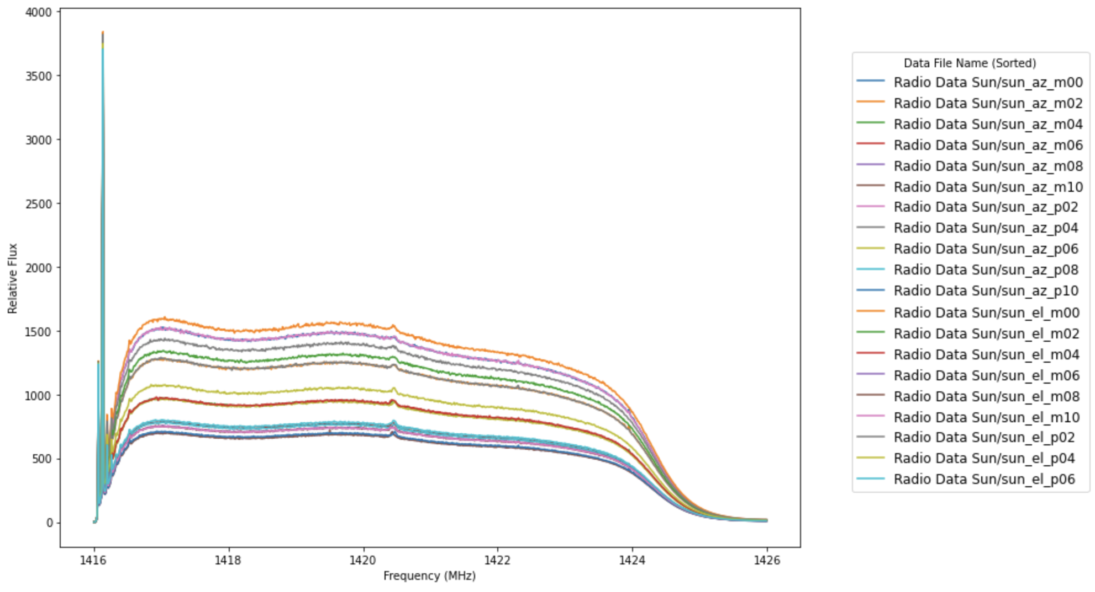

*Depicts every observed spectra for each offset position as a function of frequency and flux.*

However, to avoid radio interference spikes for a smooth integration, the axes were further constricted to produce *Figure 2*.

Figure 2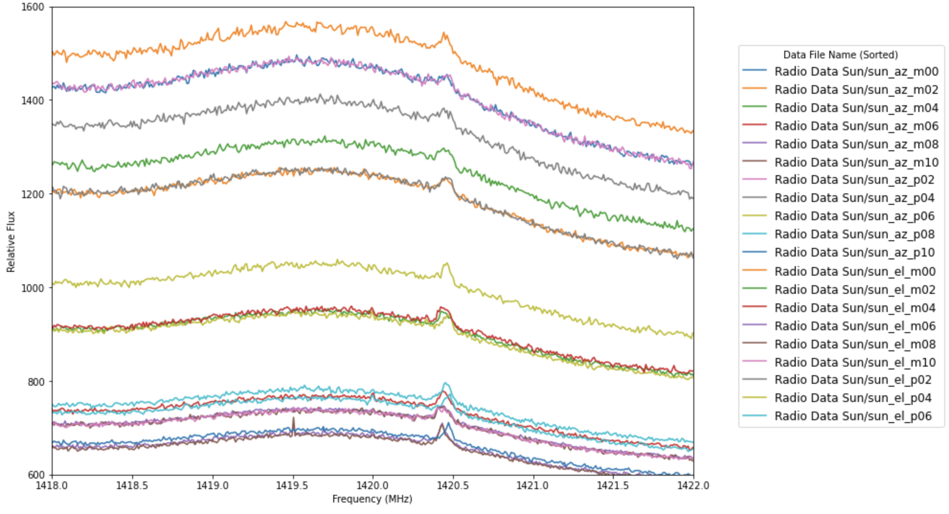

*Figure 1 data, but zoomed in to restrict noise and observe trends.*

Using this information, the measured flux from the sun as a function of offset position

in azimuth and elevation was determined by adding up the energy over the range shown in *Figure 2*. The frequency range 1418-1422 MHz corresponds to the pixel range of 200-600. To achieve this, first, the mean of the parsed data in this range was taken. Each file’s mean was appended to the array *run_avgflux*. Each offset position (in degrees) was put into a NumPy array from either -10 to +10 in the case of the azimuth files or -10 to +6 in the case of the elevation files. The corresponding flux at each position was determined by indexing *run_avgflux* according to the order of their file location as they were read in.

Both the azimuth and elevation curves produced by this method (*Figures 3 and 4*) are roughly Gaussian in shape on top of a constant background, so a Gaussian was fit to both profiles using NumPy’s *curve_fit()*. The Gaussian distribution function included an additional constant ‘d’ to account for the constant background present in the data. A more detailed x-axis was created using NumPy’s *linspace()* to smooth the Gaussian profile for each.

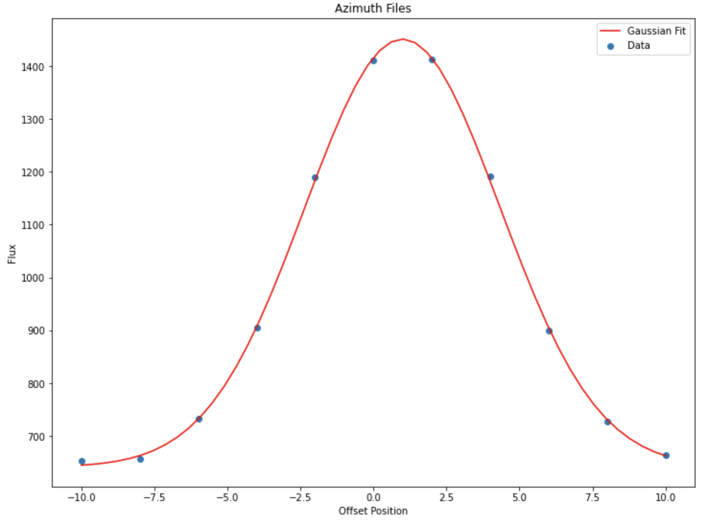

Figure 3

*Offset position is in units of degrees; flux is relative.*

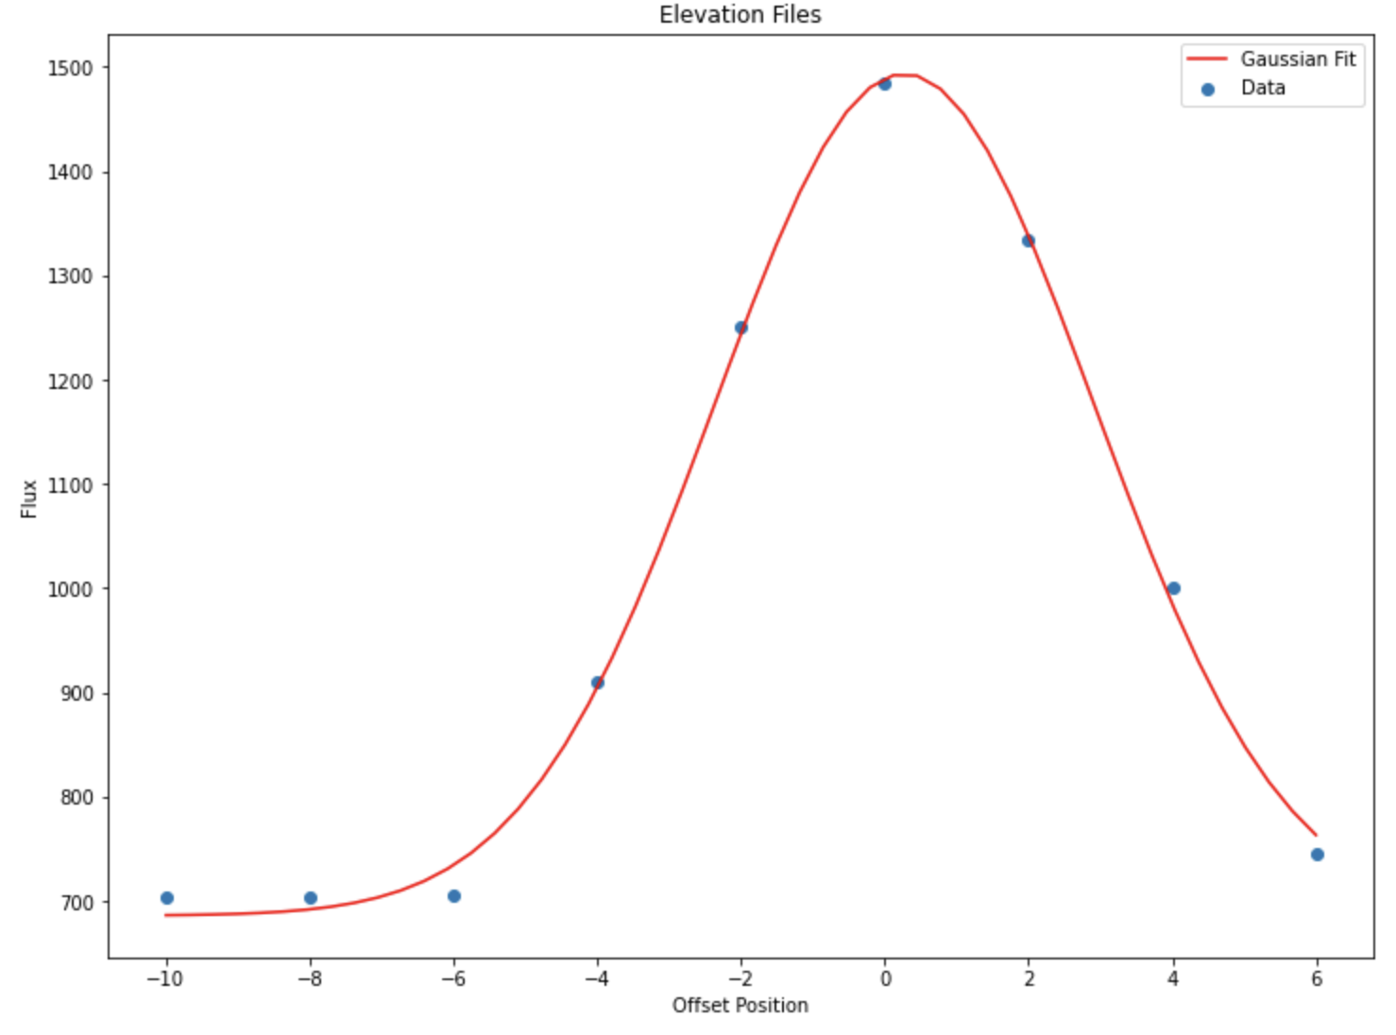

Figure 4

*Offset position is in units of degrees; flux is relative.*

The FWHM (Power) of both were calculated using (5):

|  |  |  |
| --- | --- | --- |
|  | Azimuth | Elevation |
| [deg] | 3.3431 | 2.6440 |
| [rad] | 0.0583 | 0.0461 |
| [rad] | 0.1373 | 0.1086 |

Table 1

*The values were obtained by the Figure 3 and 4 best fits.*

The abovevalues were found by NumPy’s *curvefit()* and are therefore precise. The expected widths based on the diffraction-limit of the telescope are, as derived in the Theory section,

Comparing to the values of *Table 1*, the of the elevation fit lines up quite nicely with that of with an error of about 5.60%. The of the azimuth fit is similar, although slightly higher than that of with an error of about 33.52%.

Thederived in *Table 1* are also very similar, again, with the elevation fit showing a smaller error than the azimuth fit. They are still both within ~0.03 radians of each other.

Knowing the angular diameter of the sun to be roughly 0.5 degrees, these methods are insufficient to determine the angular size of the sun because the estimates shown above in *Table 1* are all significantly higher than 0.5 degrees. The SRT’s beam is simply too big to provide a good estimate of this value. Although, this is expected, because the diffraction-limited angular resolution of the SRT is much bigger than the angular size of the sun (the antenna pattern is bigger than the sun). The is 5.9015 degrees which is about twelve times bigger than the diameter of the sun in degrees.

The sizes in azimuth and elevation do not match. In fact, we can see from *Table 1* that the FWHM of azimuth is larger than that of the elevation profile. This is because the SRT is located in Michigan at a latitude of 42.2808° N, and therefore observes at an angle that seems to distort the data, inflating azimuthally while elevation holds steady. This inflation is very small near the equator but accelerates with increasing latitude and is the most noticeable at the poles. This is because there lies inconsistencies between the geographic coordinate system and the celestial coordinate system. Although the beam pattern is symmetrical, the coordinate system is not. Although elevation remains unaffected by an increase in latitude, in azimuth, it is required that the observing device be rotated to observe an object, such as the sun, properly. The closer you are the poles, the more you have to spin because of dilution by the angle required. Therefore, the sizes in azimuth are slightly larger than that of elevation due to this coordinate system effect that increasingly distorts at higher latitudes.

**Summary of Conclusions**

Using the Small Radio Telescope (SRT), we measure the profile of the Sun and investigate the angular resolution of the SRT. We find that the SRT holds a power-space deviationof and a power-space full-width half-maximum of . The calculated FWHM values drawn from this laboratory fall within 0.03 radians for both azimuth and elevation files: of azimuth is determined to be 0.1373 [*rad*] and for elevation, 0.1086 [*rad*] showing that there exists some distortion in the azimuth sizing as it has greater percent error. The cause of this lies within the celestial-geographic coordinate differences, requiring azimuthal spin increasing with latitude.

These values were determined by integrating over a range of frequencies for both elevation and azimuthal solar scans to derive a solar flux measurement. Determining the measured flux from the sun as a function of offset position produces a roughly Gaussian curve, which is finally compared to the expected widths based on the diffraction­-limit of the telescope and the angular size of the sun. We conclude by comparing this to the angular size of the sun to determine that the SRT antenna pattern is larger than the sun because the diffraction-limited angular resolution of the SRT is much higher than the angular diameter of the sun. With noteworthy experimental error, we find that generally, the theory behind taking the Fourier transform of a Gaussian gives trustworthy values of the diffraction limit of the SRT as concluded by the comparisons with the FWHMs of the observed data.

**References**

[1] Wikipedia. “Full Width at Half Maximum.” Wikipedia, the Free Encyclopedia, Wikimedia Foundation, Inc., 25 Feb. 2002, https://en.wikipedia.org/wiki/Full_width_at_half_maximum.

[2] “Gaussian Kernels: Convert FWHM to Sigma | Brainder.” *Brainder.*, https://www.facebook.com/WordPresscom, 20 Aug. 2011, https://brainder.org/2011/08/20/gaussian-kernels-convert-fwhm-to-sigma/.