This is the concise and catchy title of my abstract on one or maximum two lines in Arial, bold face, 14 typographic points high
A. Author 1, B. Secondauthor 1,2 and C. Finalautor 3
enfi-2015@mh-hannover.de
- Affiliation of the first author, best on one single line ………………………
- Author’s Institute, Author’s University, Street and number, Postal Code City, Country
- Third affiliation if really inevitable …………………..
Abstract: Here comes the body of the abstract in no more than 6 lines and written in a clear and appealing style. Even colleagues, who are not really a specialist in your field, will find it worthwhile to listen to your lecture and to visit your poster and have an informal talk with you while drinking a cup of tea or coffee together.
Keywords: e.g. surfaces, linker molecules, photochemistry, cell cultures, nanotubes …

Introduction
This is the general introduction into your topic of research. We recommend using a couple of suitable references. To facilitate the type setting of the abstract booklet, please submit your abstract in WORD format. Files with endings like ‘.tex’ or ‘.pdf’ can cause unnecessary difficulties. There will be one abstract on one page of the abstract booklet and please stay within the length limit of 1 A4 page. The Scientific Advisory Board will select the session for which your contribution is most appropriate.
Results and Discussion
Here, you can summarize your scientific results like in a regular journal article, but it is not necessary to go into all possible details. There will be plenty of opportunity to tell the whole story during the EnFI-2015 workshop. Also, you are invited to submit an article for the conference proceedings, which will be published in Physica Status Solidi (A) – Applications and Materials Science. Please feel free to use equations such as:
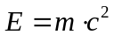
Make sure to use the Microsoft Formel-Editor 3.0 to guarantee an acceptable result. The new one , implemented in Word 2007 and higher, causes some unnecessary difficulties and quality loss.
You are also invited to use figures. An example of a figure would be the fancy logo of our workshop, showing silicon substrates with a coating of CVD synthetic diamond and covalently bound DNA fragments. The insert of Figure 1 illustrates the distribution of anions and cations close to an electrochemical sensor surface. To stay with this example, it is widely believed that charged bio molecules cause a band-bending effect in surface electronic structure of certain semiconductors [1].
At the end of this text passage, the text is going to wrap due to the two-column layout. Please take care of a symmetrical layout and insert a few blank

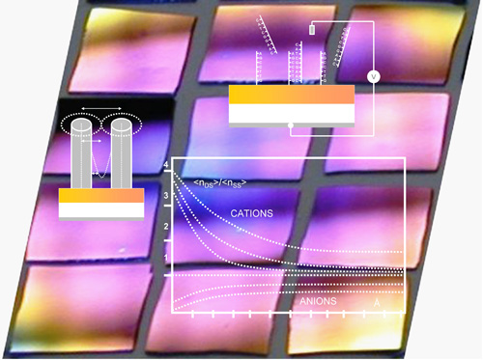
Figure 1: The EnFI logo shows diamond layers with covalently attached DNA.
lines, if necessary, to continue in the new column below the introduction heading on the left side.
Conclusions
Here comes the take-home message of your most important scientific results in a couple of sentences. Something that you can take home from this template is the insertion of the en dash, used in 456-567 in [1]. Insert this symbol by pressing Control + Alt + -.
References
- A. Author and B. Goodfriend, Physica Status Solidi (A) 213 (10), 456–567 (2012).
- F. M. Firstauthorfamilyname, F. M. Secondauthorfami-lyname and C. Lastauthorfamilyname, journal-name volume, pages (year).
- A. Firstauthorname, B. Secondauthorname and C. Thirdau-thorname, Here Goes the Title of the Book (Publisher, City, year), p. 111.
Acknowledgements
Please be kind to the sponsors of your work (BMBF, DFG, FWO, FNRS, FOM, IUP, EU, FP7, etc.) and acknowledge funding.

