|  |
| --- |
|  |
| DEMO PHPDOCX |
| Template      PHPDocX.com  9/2/2015 |

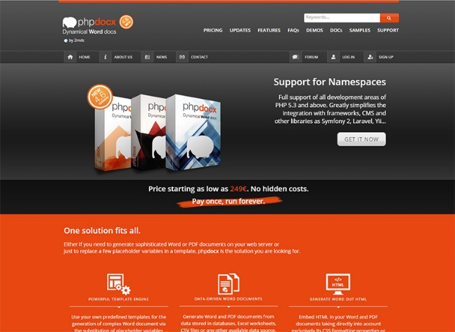

# Control Sheet

|  |  |
| --- | --- |
| DOCUMENT | Template_1.docx |
| VERSION | 1.01.0 |
| PROJECT | DEMO PHPDOCX |
| USER | DEMO User |
| CREATION DATE | 1/12/2020 |

## Versions

|  |  |  |
| --- | --- | --- |
| VERSIÓN | DESCRIPTION | DATE |
| 1.0 | Original | 1/12/2020 |

## Document distribution

|  |  |
| --- | --- |
| Company: | Distributed to: |
| Your company |  |
| 2mdc | PHPDocX Support Team |

# Introduction

**Resume:** This is a simple template that is going to be parsed by PHPDocX in order to insert the data coming out from a web form.

In this template you may find examples of how PHPDocX is able to include in an arbitrary Word template:

* Simple variables
* Iterative blocks of data as the ones needed to generate a table with a previously undefined number of rows
* Charts and graphs
* HTML chunks coming from a WYSYWIG editor

This DEMO does not cover even a 1% of the things you may do with PHPDocX but we hope it will be enough to convey the power of this tool.

If you download the “bare template” you may find here and there some variable names surrounded by $ signs that work as placeholders for the info to be inserted. If you want to know how exactly the system work, please, refer to the documentation online.

# Dynamical Data

## Insert an image

Here PHPDocX has inserted the image of your choice:



With PHPDocX you may control:

* The size and resolution
* The format and design
* The position

of your images, offering you maximum flexibility and control of your Word document.