
SANJIVANI UNIVERSITY
SCHOOL OF ENGINEERING AND TECHNOLOGY

PROJECT TITLE
Submitted By
Student 1 (Samiksha Gondkar)
Student 2 (Tanishka Shinde)
Student 3 (Vibha Chandane)

Career Craft Academy powered by HCL Tech
Trainer Name: Mr. Lalith
Department of Computer Science & Engineering
Date of Submission: 03/11/2026

Declaration
We declare that this report is our original work. All sources used have been acknowledged in the References section. The code in the project repository was written by our team, and any borrowed code or ideas are clearly cited.

Name | Signature | Date
Samiksha Gondkar | Samiksha | 03/11/2027
Tanishka Shinde | Tanishka | 03/11/2027
Vibha Chandane | Vibha | 03/11/2027

Acknowledgement
We express our sincere gratitude to our project guide, Mr. Lalith for his invaluable guidance, support, and constructive feedback throughout the development of this project. We also thank the Department of Computer Science & Engineering for providing the necessary infrastructure and software labs. Finally, we appreciate our peers for their helpful discussions and insights during testing.

Table of Contents

Chapter No. | Title | Page No.
Chapter 1 | Introduction | 3-6
Chapter 2 | Requirement Analysis | 7-10
Chapter 3 | Data Structures and Concepts Used | 11-14
Chapter 4 | System Design | 15-18
Chapter 5 | Implementation | 36
Chapter 6 | Testing and Validation | 25-28
Chapter 7 | Results and Screenshots | 29-31
Chapter 8 | Challenges and Learnings | 32-33
Chapter 9 | Conclusion and Future Scope | 34-35
References | References & Appendices | 36

CHAPTER 1

1.2 PROBLEM STATEMENT

Pharmacy Inventory and Expiry Management System
The Pharmacy Inventory and Expiry Management System is designed to manage medicine stock and expiry dates efficiently. In a pharmacy, maintaining medicine details manually can be difficult and may lead to errors, stock mismanagement, and the sale of expired medicines.
The main objective of this project is to develop a C++-based system that allows pharmacy staff to add, display, search, update, and delete medicine records. It also helps track medicine quantities, calculate bills during sales, and identify expired medicines to improve inventory management and reduce wastage.
The system uses Object-Oriented Programming (OOP) concepts such as classes, objects, constructors, and encapsulation, along with vectors to store medicine records.

1.3 INTRODUCTION
The Pharmacy Inventory and Expiry Management System is a menu-driven application developed using C++. It helps pharmacies manage medicine records and maintain stock efficiently. The system allows users to add, display, search, update, and delete medicine details. It also helps track medicine expiry dates, prevents the sale of expired medicines, and calculates bills during sales.
This project uses Object-Oriented Programming (OOP) concepts such as classes, objects, constructors, and vectors. It aims to make pharmacy inventory management simple, organized, and efficient.

1.4 OBJECTIVES
• To maintain medicine records in an organized way.
• To add, display, search, update, and delete medicine details.
• To manage medicine stock and quantities.
• To check medicine expiry dates.
• To prevent the sale of expired medicines.
• To calculate bills during medicine sales.
• To reduce manual work and improve inventory management efficiency.

1.5 SCOPE OF WORK
The Pharmacy Inventory and Expiry Management System is designed to simplify medicine stock management in small pharmacies. It provides the following features:
- Medicine Management: Add, view, search, update, and delete medicine records.
- Stock Management: Maintain and update medicine quantities.
- Expiry Tracking: Identify medicines that have expired.
- Sales Management: Sell medicines and generate bills.
- Expired Medicine Safety: Prevent the sale of expired medicines.
- Easy Operation: Provide a simple menu-driven interface for users.
Future Scope: The system can be improved by adding a database, user login, automatic low-stock alerts, near-expiry notifications, and a graphical user interface (GUI).

1.6 PROJECT OVERVIEW
The Pharmacy Inventory and Expiry Management System is a C++-based application developed to manage medicine stock and expiry information efficiently. It provides a simple, menu-driven interface that allows users to perform different pharmacy operations.
The system uses Object-Oriented Programming (OOP) concepts and a vector to store medicine records.
Main Features:
- Add new medicine details.
- Display all available medicines.
- Search for medicines using their ID.
- Sell medicines and calculate bills.
- Check expired medicines.
- Update medicine quantities.
- Delete medicine records.
The main aim of this project is to reduce manual work, maintain accurate stock records, and help pharmacies manage medicines in an organized manner.
Technology Used: C++
Concepts Used: Classes, Objects, Constructors, Functions, Vectors, Loops, and Conditional Statements.

CHAPTER 2

REQUIREMENT ANALYSIS

2.1 User Roles

Role | Description | Main Actions
Pharmacist (Admin) | Has full control over medicine inventory and stock records. | Add medicines, display records, update quantities, delete medicines, check expiry dates, and manage sales.
Pharmacy Staff | Handles daily medicine sales and stock checking. | Search medicines, sell medicines, check availability, and generate bills.

2.2 Functional Requirements

ID | Requirement | Priority (High / Medium / Low)
FR1 | The system shall allow users to add, display, search, update, and delete medicine records. | High
FR2 | The system shall check medicine expiry dates and prevent the sale of expired medicines. | High
FR3 | The system shall sell medicines, calculate bills, and automatically update the remaining stock quantity. | High

2.3 Non-Functional Requirements
• Reliability: The system should handle invalid user inputs properly without crashing.
• Usability: The system should provide a simple and user-friendly menu-driven interface.
• Performance: The system should perform medicine searches and stock updates quickly.
• Accuracy: The system should correctly calculate bills, update stock quantities, and check expiry dates.

2.4 Software and Hardware Requirements

Item | Details
Language | C++
Compiler / IDE | GCC Compiler / Visual Studio Code
Libraries | iostream, vector, string, ctime
Version Control | Git and GitHub (Optional)
Operating System | Windows 10/11
Minimum Hardware | 2 GB

CHAPTER 3

DATA STRUCTURES AND CONCEPTS USED

Concept | Where Used in the Project | Why Chosen
Classes and Objects | Medicine and Pharmacy classes | To organize medicine details and pharmacy operations.
Constructors | Medicine class constructor | To initialize medicine details when an object is created.
Functions | Add, display, search, sell, update, and delete operations | To divide the program into smaller, reusable modules.
Vectors (STL) | Store medicine records in vector<Medicine> | To store multiple medicine objects dynamically.
Loops and Conditional Statements | Menu-driven system and medicine operations | To repeat operations and make decisions based on conditions.
Searching | Search medicine by ID | To find a specific medicine record.
Date and Time (ctime) | Expiry checking function | To compare medicine expiry dates with the current date.
Encapsulation | Private medicine vector inside Pharmacy class | To protect inventory data from direct external access.

CHAPTER 4

SYSTEM DESIGN

4.1 System Overview

The Pharmacy Inventory and Expiry Management System is designed using a menu-driven approach. The user interacts with the system through a console interface. The Pharmacy class manages medicine records stored in a vector. Users can add, display, search, update, and delete medicines. The system also checks expiry dates and manages medicine sales.4.2 UML Class Diagram
The system consists of two main classes:
- Medicine Class: Stores medicine details such as ID, name, quantity, price, and expiry date.
- Pharmacy Class: Manages medicine records and provides functions for adding, displaying, searching, selling, updating, deleting, and checking expired medicines.

4.3 Flowcharts
The flowcharts represent the working process of important system operations.
- Add Medicine: Takes medicine details from the user and stores them in the inventory.
- Search Medicine: Searches for a medicine using its unique ID.
- Sell Medicine: Checks medicine availability and expiry status, calculates the bill, and updates stock.
- Expiry Checking: Compares medicine expiry dates with the current date and displays expired medicines.
START
|
|
PHARMACY INVENTORY
MANAGEMENT
|
-------------------------
| |
1. Add Medicine |
2. Display Medicines |
3. Search Medicine |
4. Sell Medicine |
5. Check Expired |
Medicines |
6. Update Quantity |
7. Delete Medicine |
8. Exit |
-------------------------
|
Enter Choice
|
Perform Operation
|
Return to Main Menu
|
Choice = 8?
/ \
No Yes
| |
Main Menu END

4.4 Menu Structure
The system provides the following main menu:
PHARMACY INVENTORY MANAGEMENT
|
--------------------------------
| |
1. Add Medicine |
2. Display Medicines |
3. Search Medicine |
4. Sell Medicine |
5. Check Expired Medicines |
6. Update Quantity |
7. Delete Medicine |
8. Exit |
--------------------------------
The user selects an option to perform the required operation. After completing the operation, the system returns to the main menu until the user selects Exit.

CHAPTER 5

IMPLEMENTATION

5.1 Project File Structure
The project is developed using C++ and consists of a single source file.
Pharmacy Inventory Management/
│
└── main.cpp

5.2 Module-wise Description

Module | Description | Developed By
Medicine Module | Stores medicine ID, name, quantity, price, and expiry date. | Samiksha Gondkar
Pharmacy Management Module | Manages adding, displaying, searching, updating, and deleting medicines. | Tanishka Shinde
User Interface Module | Displays the menu and accepts user choices. | Vibha Chandane

5.3 Key Algorithms
Algorithm 1: Search Medicine by ID
- Start the search operation.
- Ask the user to enter the medicine ID.
- Traverse the medicine vector.
- Compare the entered ID with each medicine's ID.
- If a match is found, display the medicine details.
- If no match is found, display "Medicine not found."
- End the operation.
Time Complexity: O(n), where n is the total number of medicines.

5.4 Important Code Snippets
1) Medicine Class
class Medicine {
public:
int id;
string name;
int quantity;
float price;
int day, month, year;

Medicine(int i, string n, int q, float p,
int d, int m, int y) {
id = i;
name = n;
quantity = q;
price = p;
day = d;
month = m;
year = y;
}
};

2) Store Medicine Records
class Pharmacy {
private:
vector<Medicine> medicines;
};
3) Search Medicine by ID
for (auto &med : medicines) {
if (med.id == id) {
med.display();
return;
}
}
cout << "Medicine not found!";

4) Check Expired Medicine
bool isExpired(Medicine m) {
time_t now = time(0);
tm *today = localtime(&now);

if (m.year < today->tm_year + 1900)
return true;

if (m.year == today->tm_year + 1900 &&
m.month < today->tm_mon + 1)
return true;

if (m.year == today->tm_year + 1900 &&
m.month == today->tm_mon + 1 &&
m.day < today->tm_mday)
return true;

return false;
}

CHAPTER 6

TESTING AND VALIDATION

6.1 Test Cases

TC ID | Feature Tested | Input | Expected Output | Actual Output | Pass / Fail
TC1 | Add Medicine | ID: 101, Name: Crocin, Quantity: 50, Price: 20 | Medicine added successfully | Medicine added successfully | Pass
TC2 | Search Medicine | Medicine ID: 101 | Medicine details displayed | Medicine details displayed | Pass
TC3 | Sell Medicine | ID: 101, Quantity: 5 | Bill generated and stock updated to 45 | Bill generated and stock updated to 45 | Pass

6.2 Input Validation and Exception Handling
• Checks medicine ID to prevent duplicate records.
• Validates medicine quantity and price.
• Checks medicine expiry before selling.
• Displays an error message if the medicine is not found.

6.3 Bugs Found and Fixed
Bug | Cause | Fix
Duplicate Medicine ID | Same ID entered multiple times | Added duplicate ID checking.

CHAPTER 7

RESULTS AND SCREENSHOTS
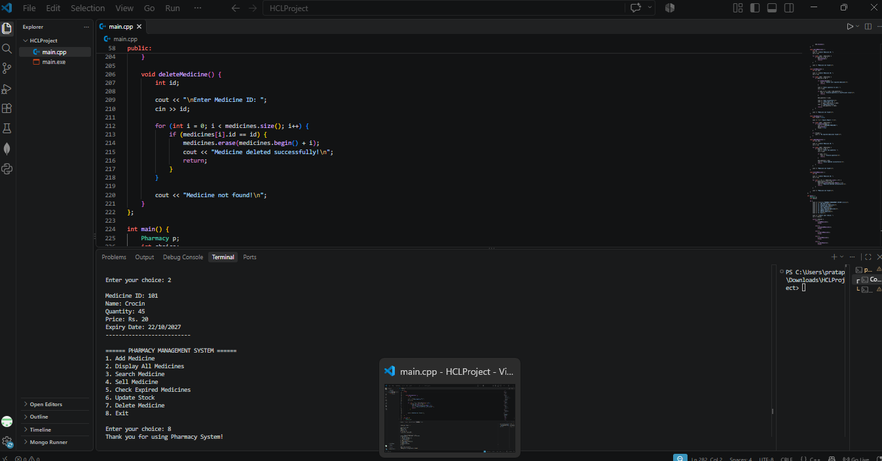

CHAPTER 8

CHALLENGES AND LEARNINGS

8.1 Challenges Faced
• Managing Medicine Records: Handling multiple medicine records using vectors was challenging. This was solved by using vector operations such as push_back(), erase(), and searching through records.
• Expiry Date Management: Comparing medicine expiry dates with the current date was challenging. This was solved by using the ctime library and date comparison conditions.
• Stock Management: Updating medicine quantities correctly during sales was challenging. This was solved by adding proper quantity checks and stock deduction.

8.2 Key Learnings
• Learned how to implement Object-Oriented Programming (OOP) concepts in C++.
• Gained practical knowledge of vectors, classes, objects, constructors, and functions.
• Improved problem-solving and debugging skills through project development.
• Learned how to develop a menu-driven application for real-world problems.

CHAPTER 9

CONCLUSION AND FUTURE SCOPE

9.1 Conclusion
The Pharmacy Inventory and Expiry Management System successfully provides a simple and efficient way to manage medicine records using C++. It helps users add, display, search, update, and delete medicine details. The system also manages medicine sales, calculates bills, updates stock quantities, and identifies expired medicines.
The project demonstrates the practical use of Object-Oriented Programming concepts and data structures such as vectors. It reduces manual work and makes pharmacy inventory management more organized and reliable.

9.2 Future Scope
• GUI Integration: Develop a user-friendly graphical interface using Qt.
• Database Integration: Use MySQL or SQLite to store medicine records permanently.
• Low Stock Alerts: Generate automatic alerts when medicine quantities are low.
• Expiry Notifications: Notify users about medicines approaching their expiry dates.
• Online Access: Make the system accessible through a web or mobile application.

REFERENCES & APPENDICES

Appendix A: Source Code Structure and GitHub Link
GitHub Repository: https://github.com/viatanishka/PHARMACY_MANAGEMENT_SYSTEM/settings/access?guidance_task=
Branch: main.cpp
How to compile and run: g++ HCLProject.cpp" -o pharmacy./pharmacy
README includes: project description, features, screenshots, setup steps, team details.

Appendix B: User Manual
• Add and display medicine records.
• Search medicine by ID.
• Sell medicines and generate bills.
• Check expired medicines.
• Update medicine quantities.
• Delete medicine records.

Appendix C: Team Contribution Log

Team Member | Tasks Completed | Hours / Weeks
Samiksha Gondkar | Developed core logic, Medicine and Pharmacy classes, and medicine management operations. | 3hours /1 weeks
Tanishka Shinde | Implemented medicine search, sales, stock updates, and expiry checking. | 3hours /1 weeks
Vibha Chandane | Worked on console menu, testing, debugging, and project documentation. | 3hours /1 weeks

