Gpu显存不够因此禁用了wanda
Debert_puting
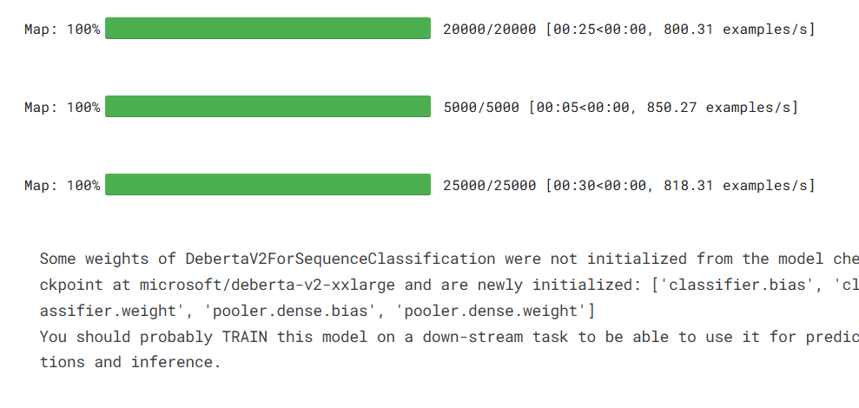
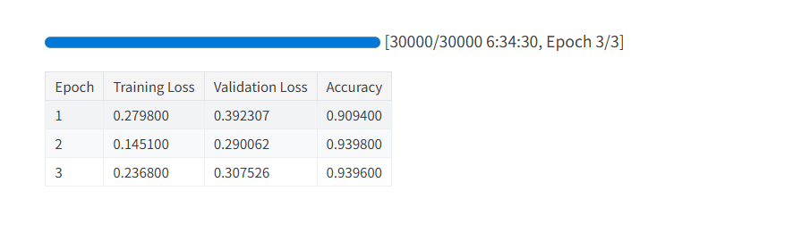
deberata_lora
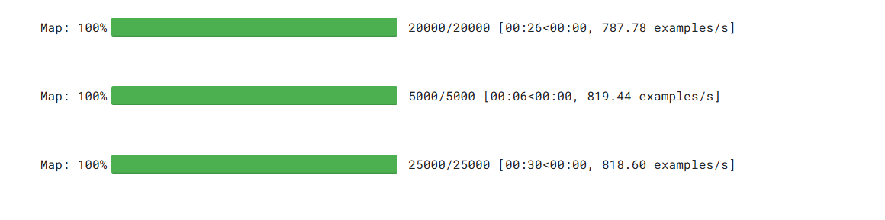
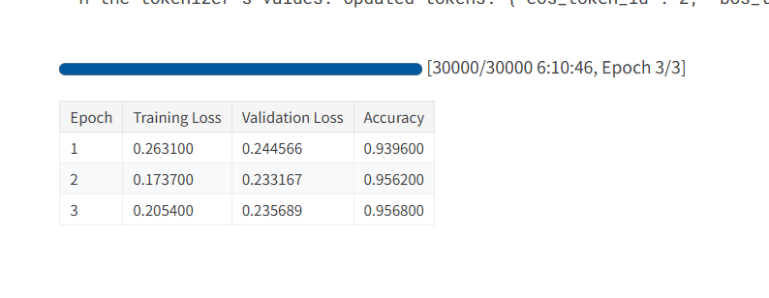
Debert_promting
